|  |  |
| --- | --- |
|  |  |
| ANSWERS |  |
|  |  |
|  | April 14 , 2023Data Warehousing &Data MiningPresented By: |
|  | **SP21-BCS-007 Asad Ali** |

### QUESTION 1:

Analysis Services Project created in Visual Studio:

### QUESTION 2:

Cube:

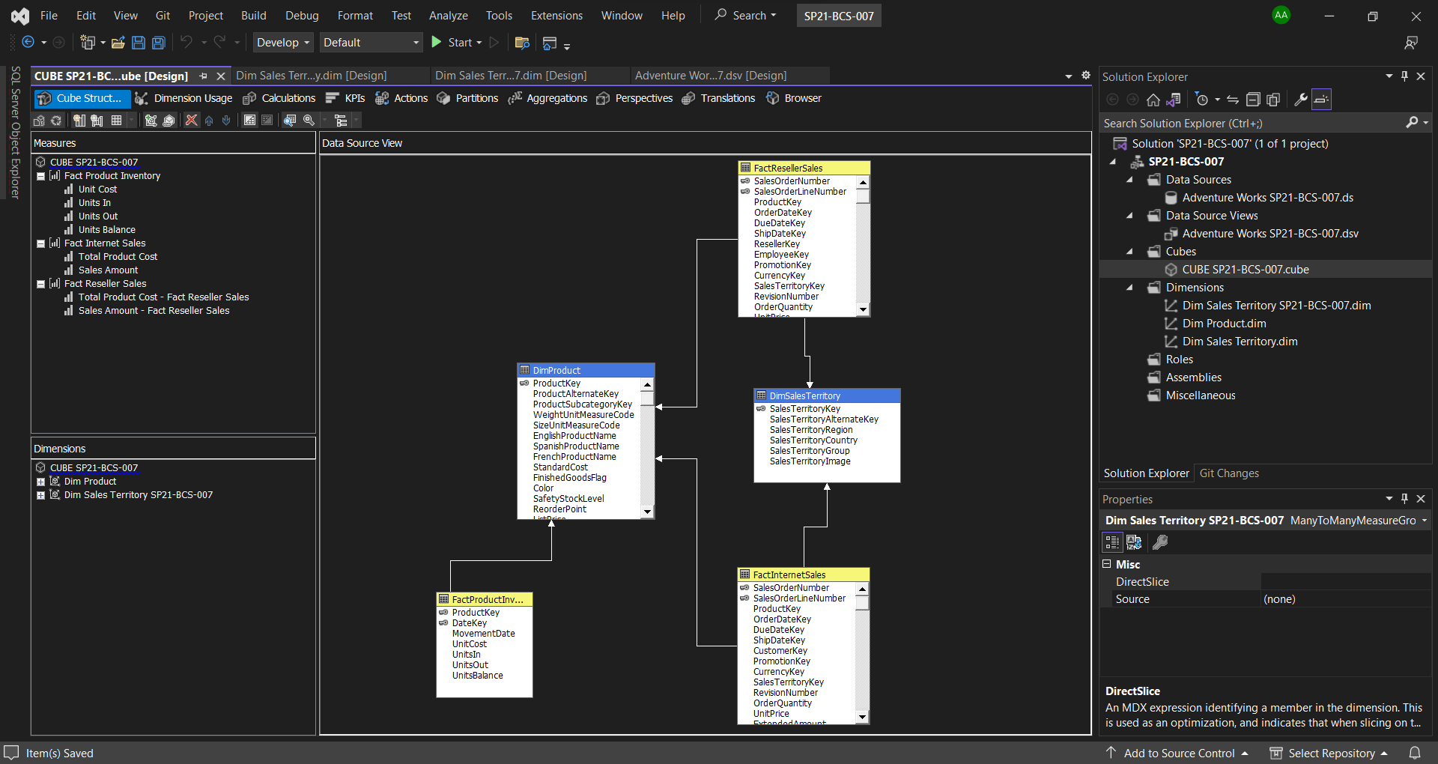

Excel Analysis of Units In, Units Out, Units Balance and Unit Cost:

Power BI Analysis of Units In, Units Out, Units Balance and Unit Cost:

### QUESTION 3:

Sales and product cost at different levels in time dimensions:

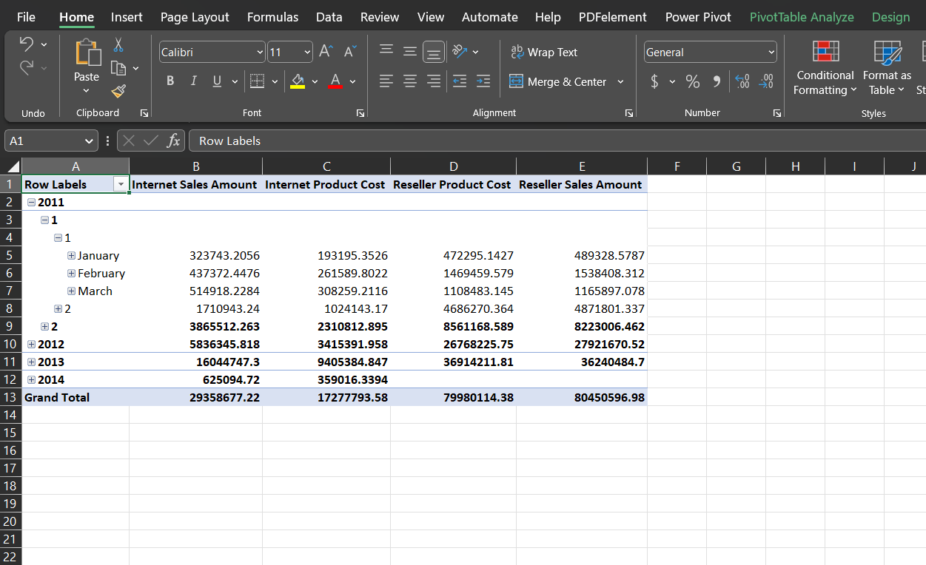

Sales and product cost at different levels in time dimensions:

### QUESTION 4:

Unit Balance of 7 Subcategory according to my Registration ID:

Unit Balance: 559329

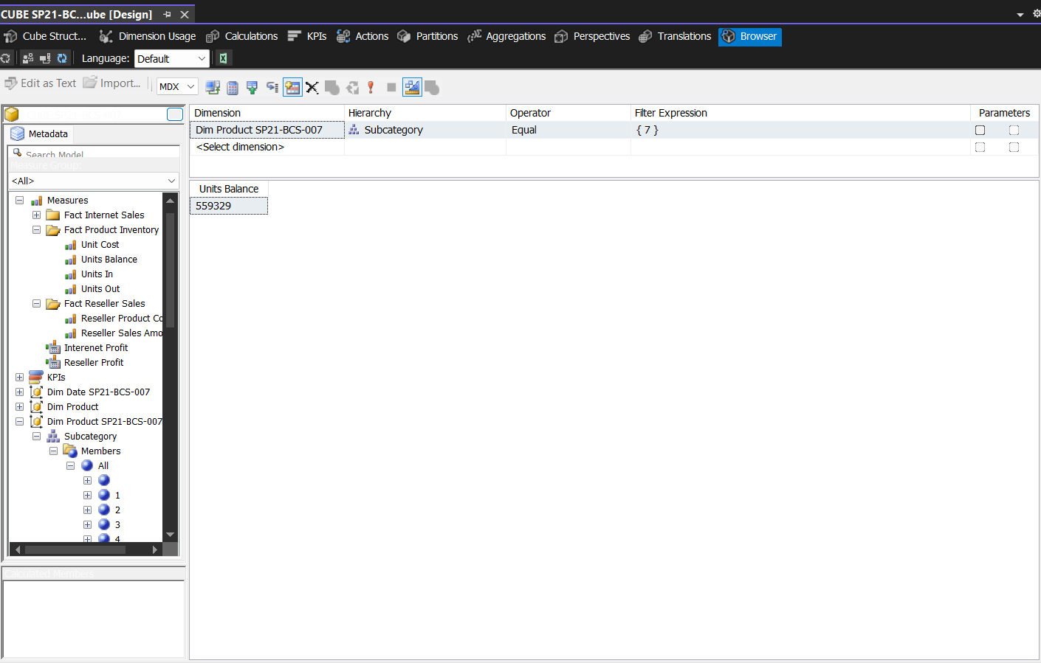

### QUESTION 5:

Formula:

[Measures].[Internet Sales Amount] - [Measures].[Internet Product Cost]

