Data Visualization Competition

Team: Visualizers

Members: Asad Ali, M Haroon Shahzad

ETL Pipeline

**Tools:** Microsoft SQL Integration Servies Extension, Visual Studio

This is our working project folder:

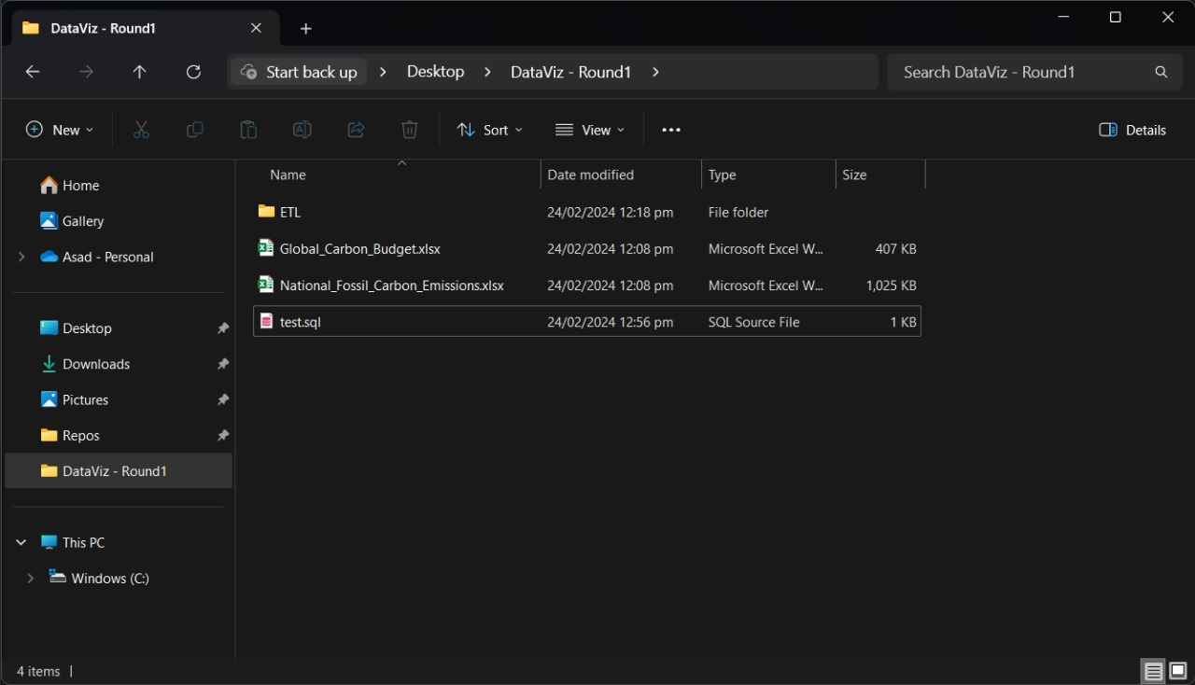

This is our ETL project in Visual Studio using SSIS extension provided by Microsoft to design ETL pipelines.

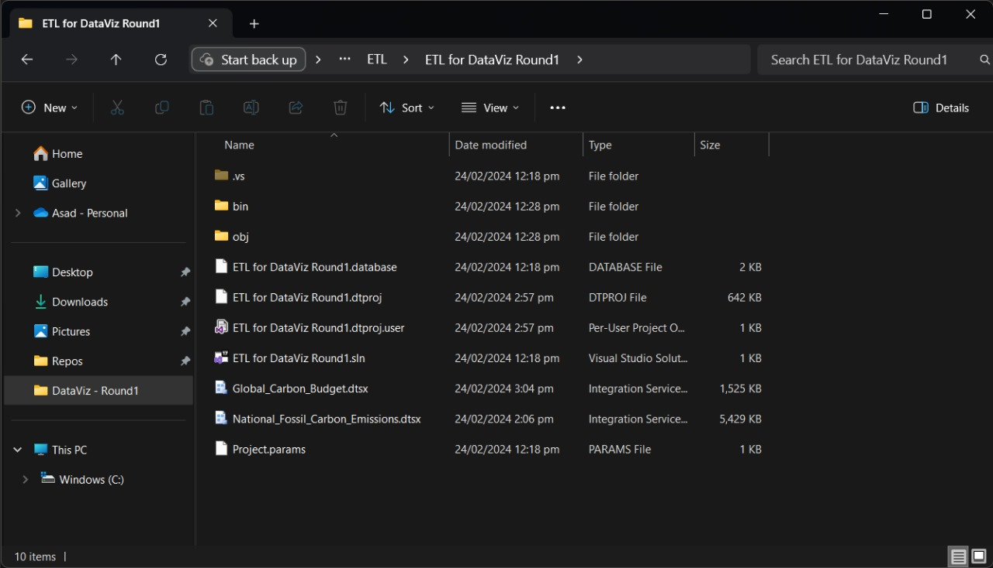

On the other hand, create a DB in MS SQL server using the query in DB Creation.sql file:

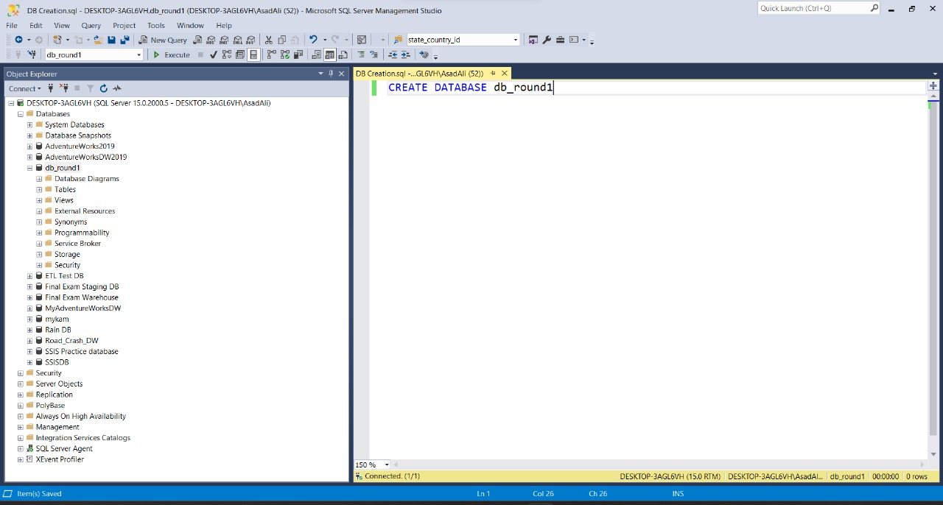

Created ETL 2 packages for 2 input excel files:

First of all use execute sql component to execute sql queries that first truncate our tables if the already exists other wise new will be created automatically:

Now load excel data to flat files to conveniently load in DB:

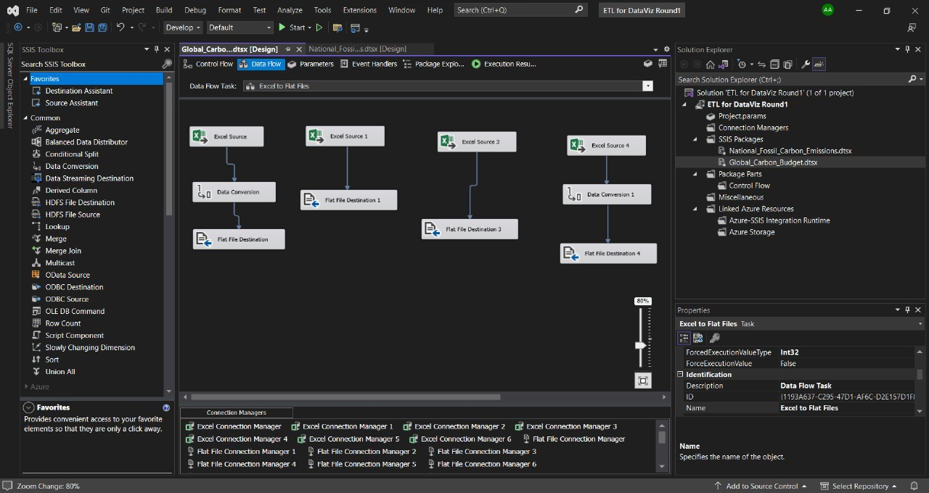

Connecting to Excel file and selecting a sheet and this step will be performed on all sheets:

While converting excel file to flat files there was an error of type mis match. We used data conversion component to convert data to NTEXT to TEXT format:

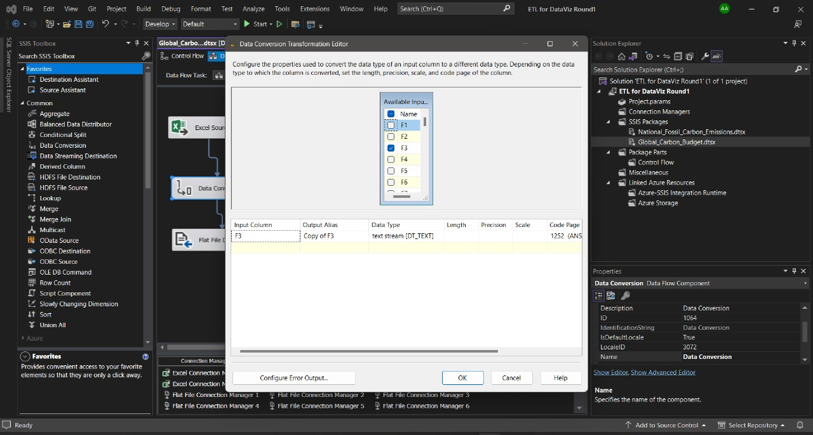

Save data from excel to Flat .txt files:

Now there will be text files for each excel sheet given in excel file:

This intermediate format conversion was used to skip extra text at the top of each excel sheet.

Now use these flat files to load data into DB:

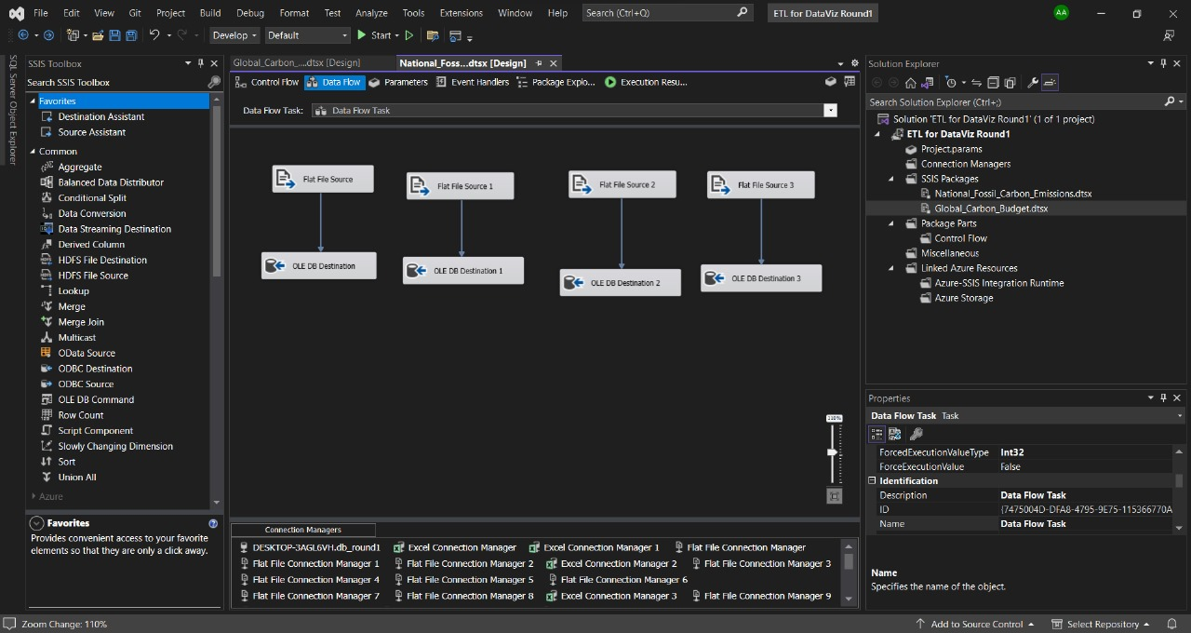

Check column names before loading data to DB:

Create tables from SSIS project using SQL query that will create a table:

After successful execution of all SSIS packages:

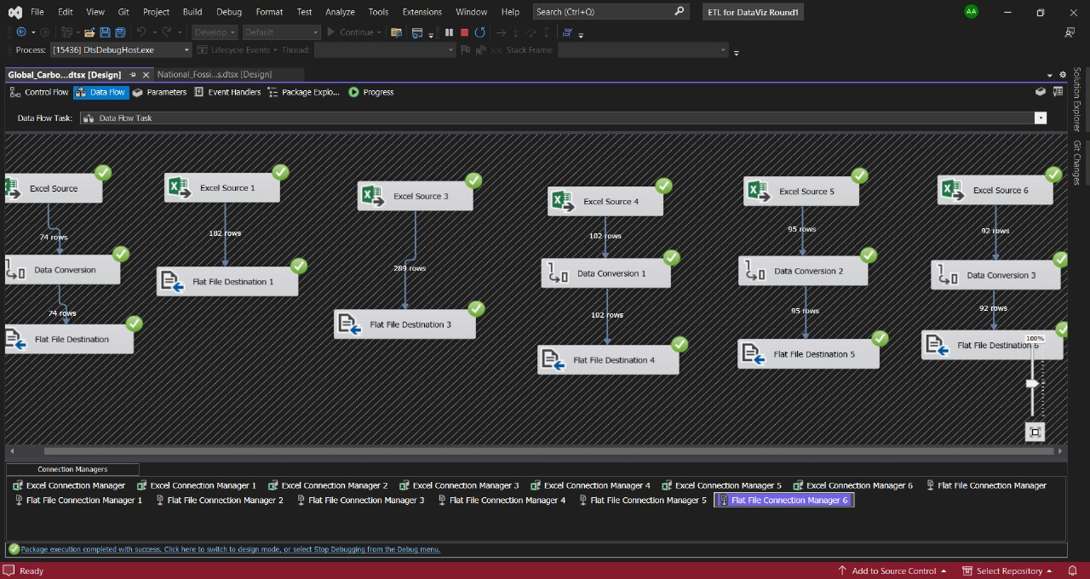

After that all the data from each excel sheet there will be a table in DB:

This is how all the data will be loaded in DB.

**Feature Engineering**

Now connect the DB in PowerBI:

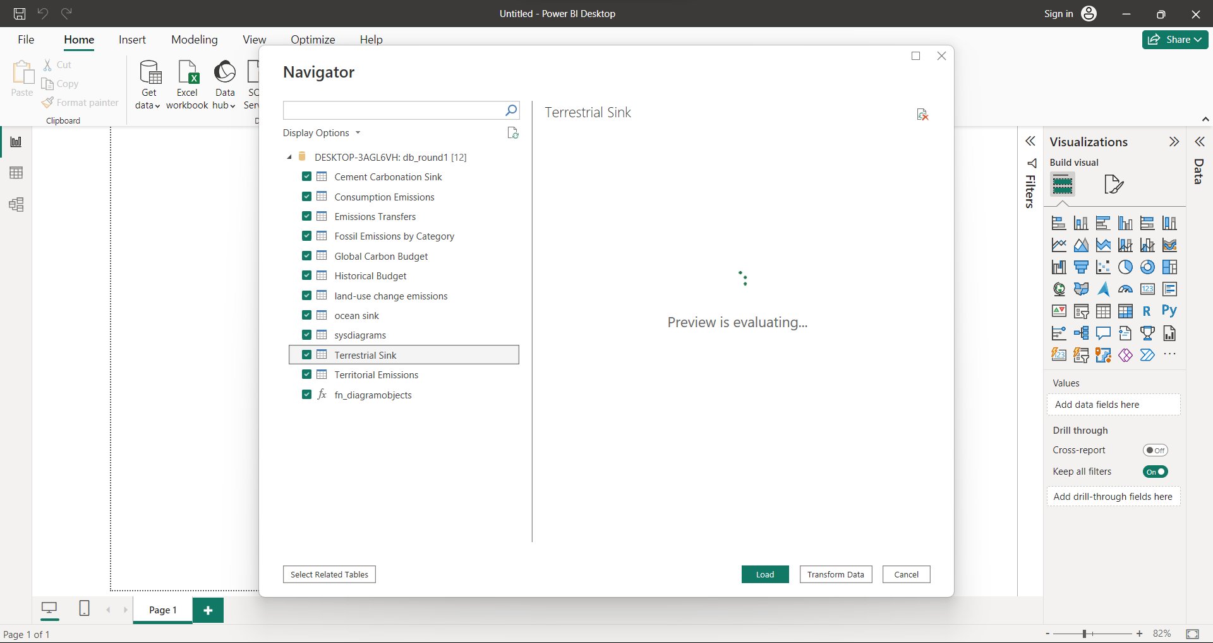

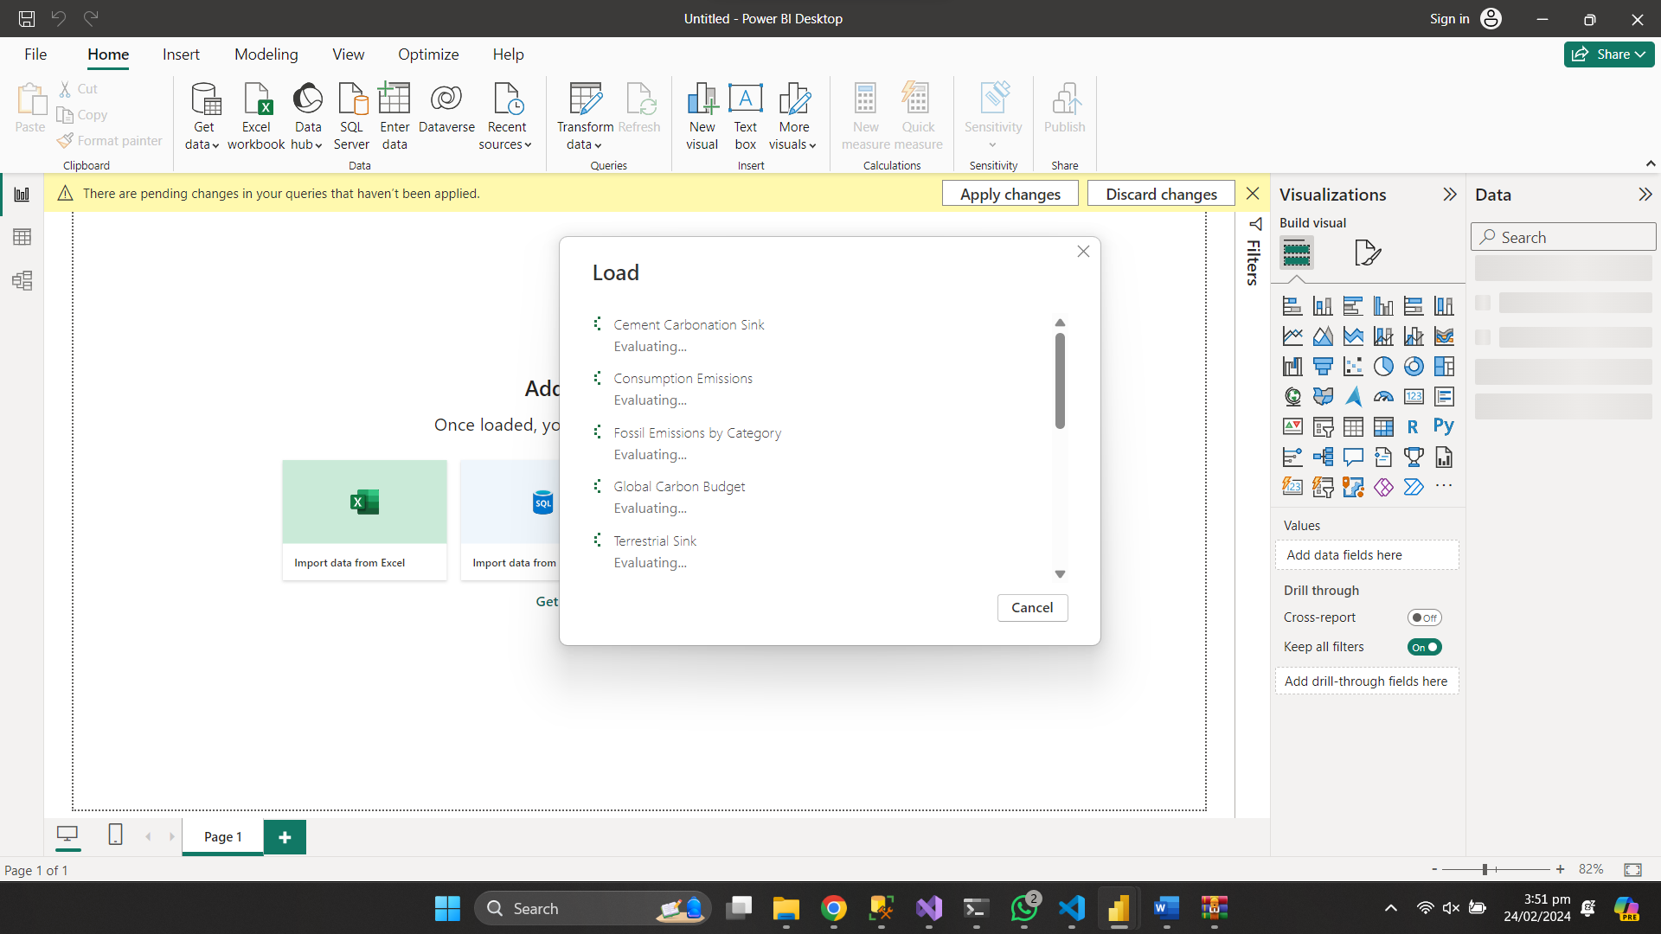

Transform this table:

