Style Guidelines for Final Year Project ReportsECG Analyser Toolkit

Final Year Project Proposal

Session 2021-2025

A 4th Year Student

A project submitted in partial fulfilment of the

COMSATS University Degree

of

BSc. (Hons.)BS in Computer Science / Software Engineering (CUI)



Department of Computer Science

COMSATS University Islamabad, Lahore Campus

09 March 2024

**Project Registration**

|  |  |  |  |  |  |  |  |
| --- | --- | --- | --- | --- | --- | --- | --- |
| Project ID (for office use) | | |  | | | | |
| Type of project | | | [ ] Traditional [ ] Industrial [ ] Continuing | | | | |
| Nature of project | | | [ ] **D**evelopment [ ] **R**esearch [ ] **R**&**D** | | | | |
| Area of specialisation | | |  | | | | |
| **Project Group Members** | | | | | | | |
| Sr.# | Reg. # | Student Name | | CGPA | Email ID | Phone # | Signature |
| (i) | Group Leader |  | |  |  |  |  |
| (ii) |  |  | |  |  |  |  |
| (iii) |  |  | |  |  |  |  |
| **Declaration:** FYP group members have cleared all prerequisites courses For FYP-I as per their degree requirements.  For BS(Computer Science)  (CSC241 Object Oriented Programming, CSC291 Software Engineering Concepts, CSC371 Database Systems-I, HUM102 Report Writing Skills)  For BS(Software Engineering)  (CSC241 Object Oriented Programming, CSE291 Introduction to Software Engineering , CSC371 Database Systems-I , HUM102 Report Writing Skills) | | | | | | | |

# Plagiarism Free Certificate

This is to certify that, I am ________________________ S/D/o _______________________, group leader of FYP under registration no CIIT/_________________/LHR at Computer Science Department, COMSATS Institute of Information Technology, Lahore. I declare that my FYP proposal is checked by my supervisor and the similarity index is ________% that is less than 20%, an acceptable limit by HEC. Report is attached herewith as Appendix A.

Date: ____________ Name of Group Leader: ________________________ Signature: _____________

Name of Supervisor: _____________________ Co-Supervisor (if any):____________________

Designation: _____________________ Designation: _____________________

Signature: _____________________ Signature: _____________________

**Project Abstract (mandatory)**

Heart disease is one of the biggest problems in the world today. Effective early detection methods are needed for timely intervention. This Project presents the comprehensive strategy and techniques to predict heart disease through the detailed analysis of electrogram (ECG) signals, and images both, using advanced machine learning techniques. By combining demographic information with ECG data and explorer the ECG signal processing. The project aims to make predictions accurate and give more ways to predicts things accurate. The Project mainly focused on combining demographic information about people’s age, gender, and medical history with their heart rhythms recordings like those found in the PhysioNet’s WFDB database to improve prediction. The project also works with image-based ECG signal and establishing a separate pipeline to convert ECG images into data that computers can understand. Once trained these machine learning models are deploy on the cloud service, then seamlessly integrated into user friendly web interface. The web interface makes it easy to upload bulk ECG data and provides essential features like user authentication, keep track of patient information, and see past predictions. The inclusion of a medical chatbot within web interface assists users to interpret with results and offer valuable medical guidance. The mobile app also helps users to upload their image and see the predictions. In essence This project represents a significant step forward in advancing heart disease prediction methodologies and offering scalable and user-friendly solution.

**Previous Project Objectives and Features (mandatory in case of Continuing project)**

# Introduction (mandatory)

1-Heart disease is very common and serious health problem that affects many people worldwide. Finding early is important so that people can get help sooner. Electrocardiogram (ECG) signals provide useful insights about heart health and can be used to make predictions. This project is called “ECG Analyser Toolkit” it uses machine learning techniques and models to achieve the better results.

2-The project focus to create a sturdy data pipeline that capable to integrate demographic information and ECG signals. The pipeline will source raw data containing both demographic information and ECG information. And converting into cohesive dataset. Leveraging the PhysioNet's WFDB database, and then converting the collected data into CSV files, which are easier to work with for analysis and prediction for later use.

3-When the data is organized and preprocess the project will use machine learning model to predict heart disease based on ECG signals. The model is tested thoroughly to make sure that it will predict accurate and efficient. The project will also explore image-based ECG signals processing, developing separate pipeline to convert ECG images into analysable signals. These image-bases signals will undergo same predictive modelling process as conventional ECG data, enriching the predictive capabilities of the models.

4-Upon successful training and validation, the trained machine learning model will be deployed on cloud service for scalability and accessibility. And it will relate to website to use. This way the doctor and the regular person can upload their heart rhythm data to get predictions. The website will even have the chatbot to help explain the result nicely This project also consists of mobile app for those who can simply upload their ECG image to predict result quickly.

# Success Criterion

Achieve a minimum accuracy threshold (e.g., 85% or higher) in predicting heart disease when using both ECG signals and demographic data. Compare this with models using ECG signals alone to determine if incorporating demographic information improves performance.

The model on the cloud can handle lot of ECG tests being uploaded at once without slowing down too much.

The user on websites should find it easy to use and understand the result it gives them.

The chatbot explains the result correctly and give advice base on medical guidance.

The system may be able to find heart disease earlier than normal tests doctors use now.

Compare when the system predicts heart disease versus when a doctor normally finds it in the same group of patients. Track if early prediction leads to better outcomes.

# Related Work (mandatory)

# The main reasons for using information from external sources are either to complement the contents of the work with relevant data or to provide a different opinion on the issue stated. In both cases, it means adding credibility to the project, making it look more trustworthy and complete. The author should create an analytical review of the previous scientific works on the topic or explore related development. The student has to provide the historical background and inform the reader about current achievements in research/development. Using only proven credible sources from journals, conferences, and books accepted in academic circles is vital. All the used sources have to be appropriately cited through the text. The bibliography is situated at the end of the paper. It should follow the provided format and display sources in alphabetical order. It is necessary to study the structure of such work to write a strong final year project proposal. Moreover, a clear scheme will make a formal proposal easier to read.

Use IEEE referencing style available in Microsoft word as shown in Fig. 3.

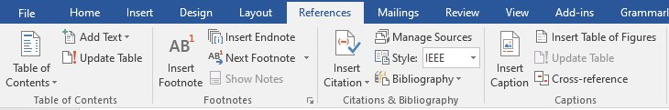

Figure 1. Word references tab.

# Project Rationale

Heart disease poses a critical global health threat, necessitating advanced methods for early detection and intervention. Traditional diagnostics often lead to delays in diagnosis, limiting treatment options and impacting patient outcomes. This project aims to develop a comprehensive heart disease prediction system leveraging electrocardiogram (ECG) signals and demographic data. This combination has the potential to improve prediction accuracy compared to existing methods. The development of image-based ECG processing pipelines will broaden input sources and enhance accessibility for diverse users.

This project is driven by the need for accessible and user-friendly prediction solutions. A cloud-based machine learning model that integrate with web interface and a dedicated mobile application will prioritize widespread access. The integration of a medical chatbot will empower users by offering real-time interpretation of results and guidance on next steps. Ultimately, this project aim to introduce early detection tools for heart disease management. The potential impact includes improving patient outcomes and help them to seek better treatment early.

## Aims and Objectives

The primary aim of this project to develop an advanced system for heart disease prediction that integrates ECG signals analysis, demographic information, image ECG processing, and user-friendly interface to improve accuracy, result accessibility and experiences.

Objectives

* Desing and construct the data pipeline that combine ECG signals and demographic data from The PhysioNet WFDV database.
* Make the pipeline that converting ECG images into the data(signals) that model can understand.
* Train test and optimize the machine learning model to accurately and precisely predict heart disease based on ECG signals and images.
* Deploy the optimized prediction model on a cloud platform to ensure the scalability and accessibility.
* Build the website and app where the user can upload their heart data, safely log in mange their record, and see medical history.
* Include the medical chatbot (only for website). that can explain result answer the question and give them basic guidelines.

## Scope of the Project

Scope defines what needs to be achieved and the work that must be done to deliver a project. It includes specific project goals, deliverables, features, functions, tasks, deadlines, and ultimately costs.

# Proposed Methodology and Architecture

Data Acquisition and Preprocessing:

The Project begins by collecting the ECG and demographic data from the PhysioNet WFDB database. Then system cleans and organize the collected data. This includes steps like noise filtering (removing extra signals), single segmentation by divide the signals into smaller part and then feature extraction (finding the most important insights within the data)

Data Integration:

This step represents the integration of ECG signal and demographic data. Then combined them into a format suitable for machine learning model that easily understand and use either training or making predictions

Machine Learning Model.

The system has two phase training and testing. In training phase, it uses the combine dataset to learn the machine learning model to find the pattern liked to heart disease. This involve splitting the data, practicing with some of it. And testing itself on the rest. In prediction phase the system uses the trained model to analysis the new person data and predict if they have risk of heart disease

Results and User Interface:

The system takes the prediction made by the machine learning model and prepare them to show the user on web and mobile devices. User can see past prediction and enter the new data to get another prediction. Finally the result shown and also chatbot for better understanding of result and medical guidance

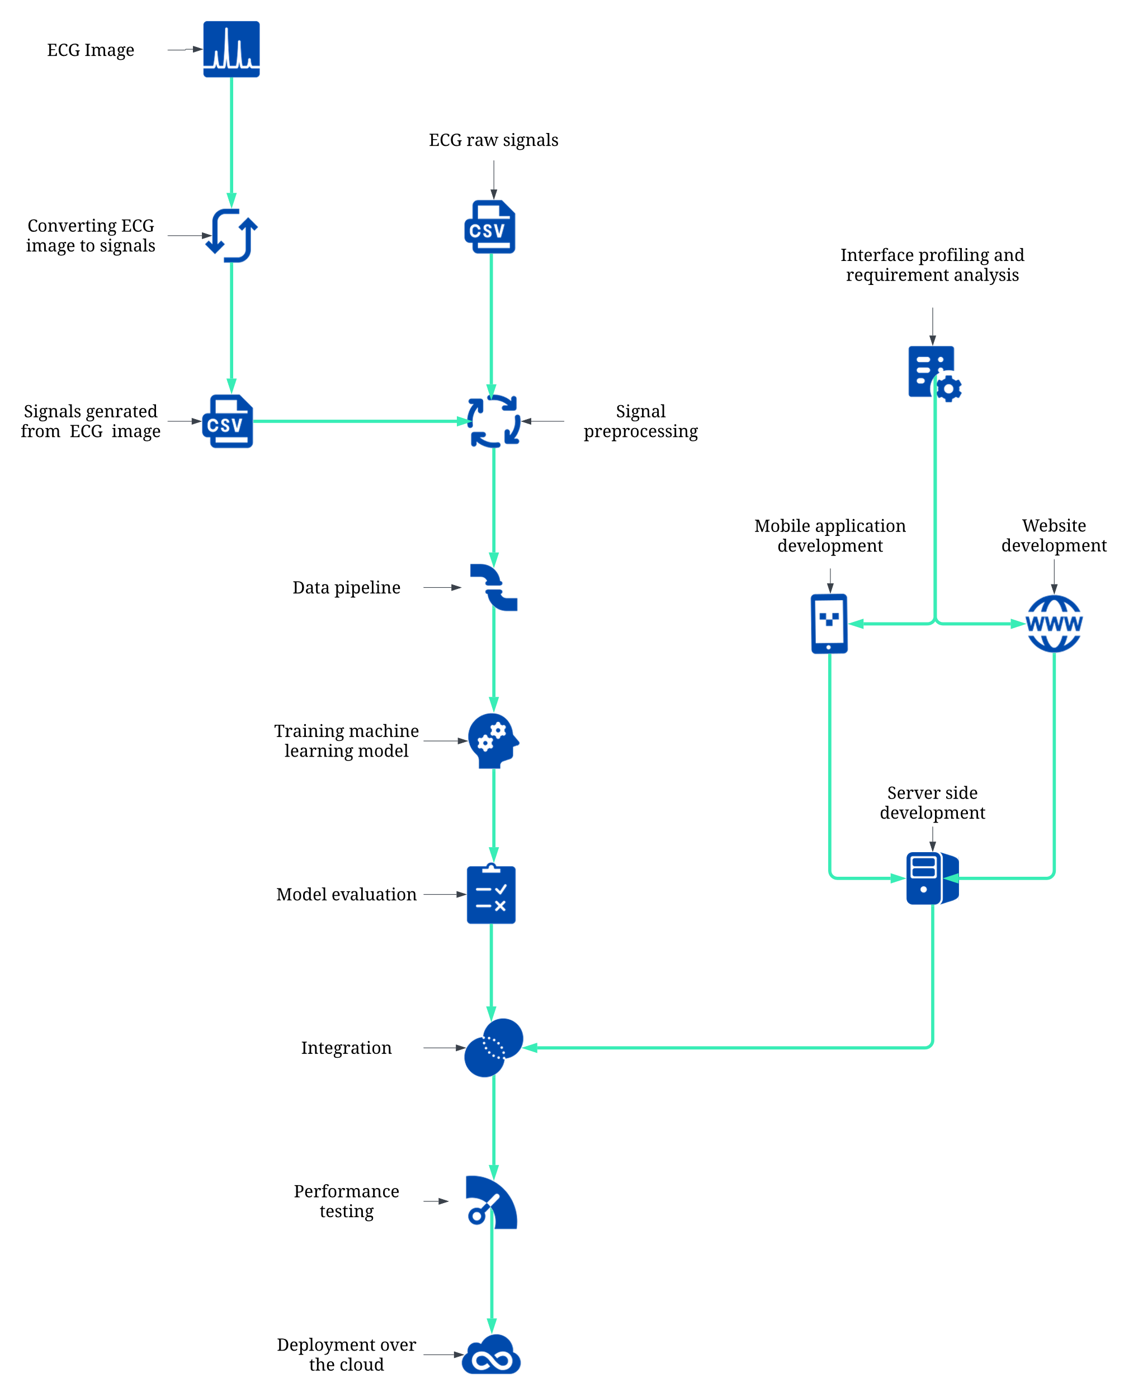

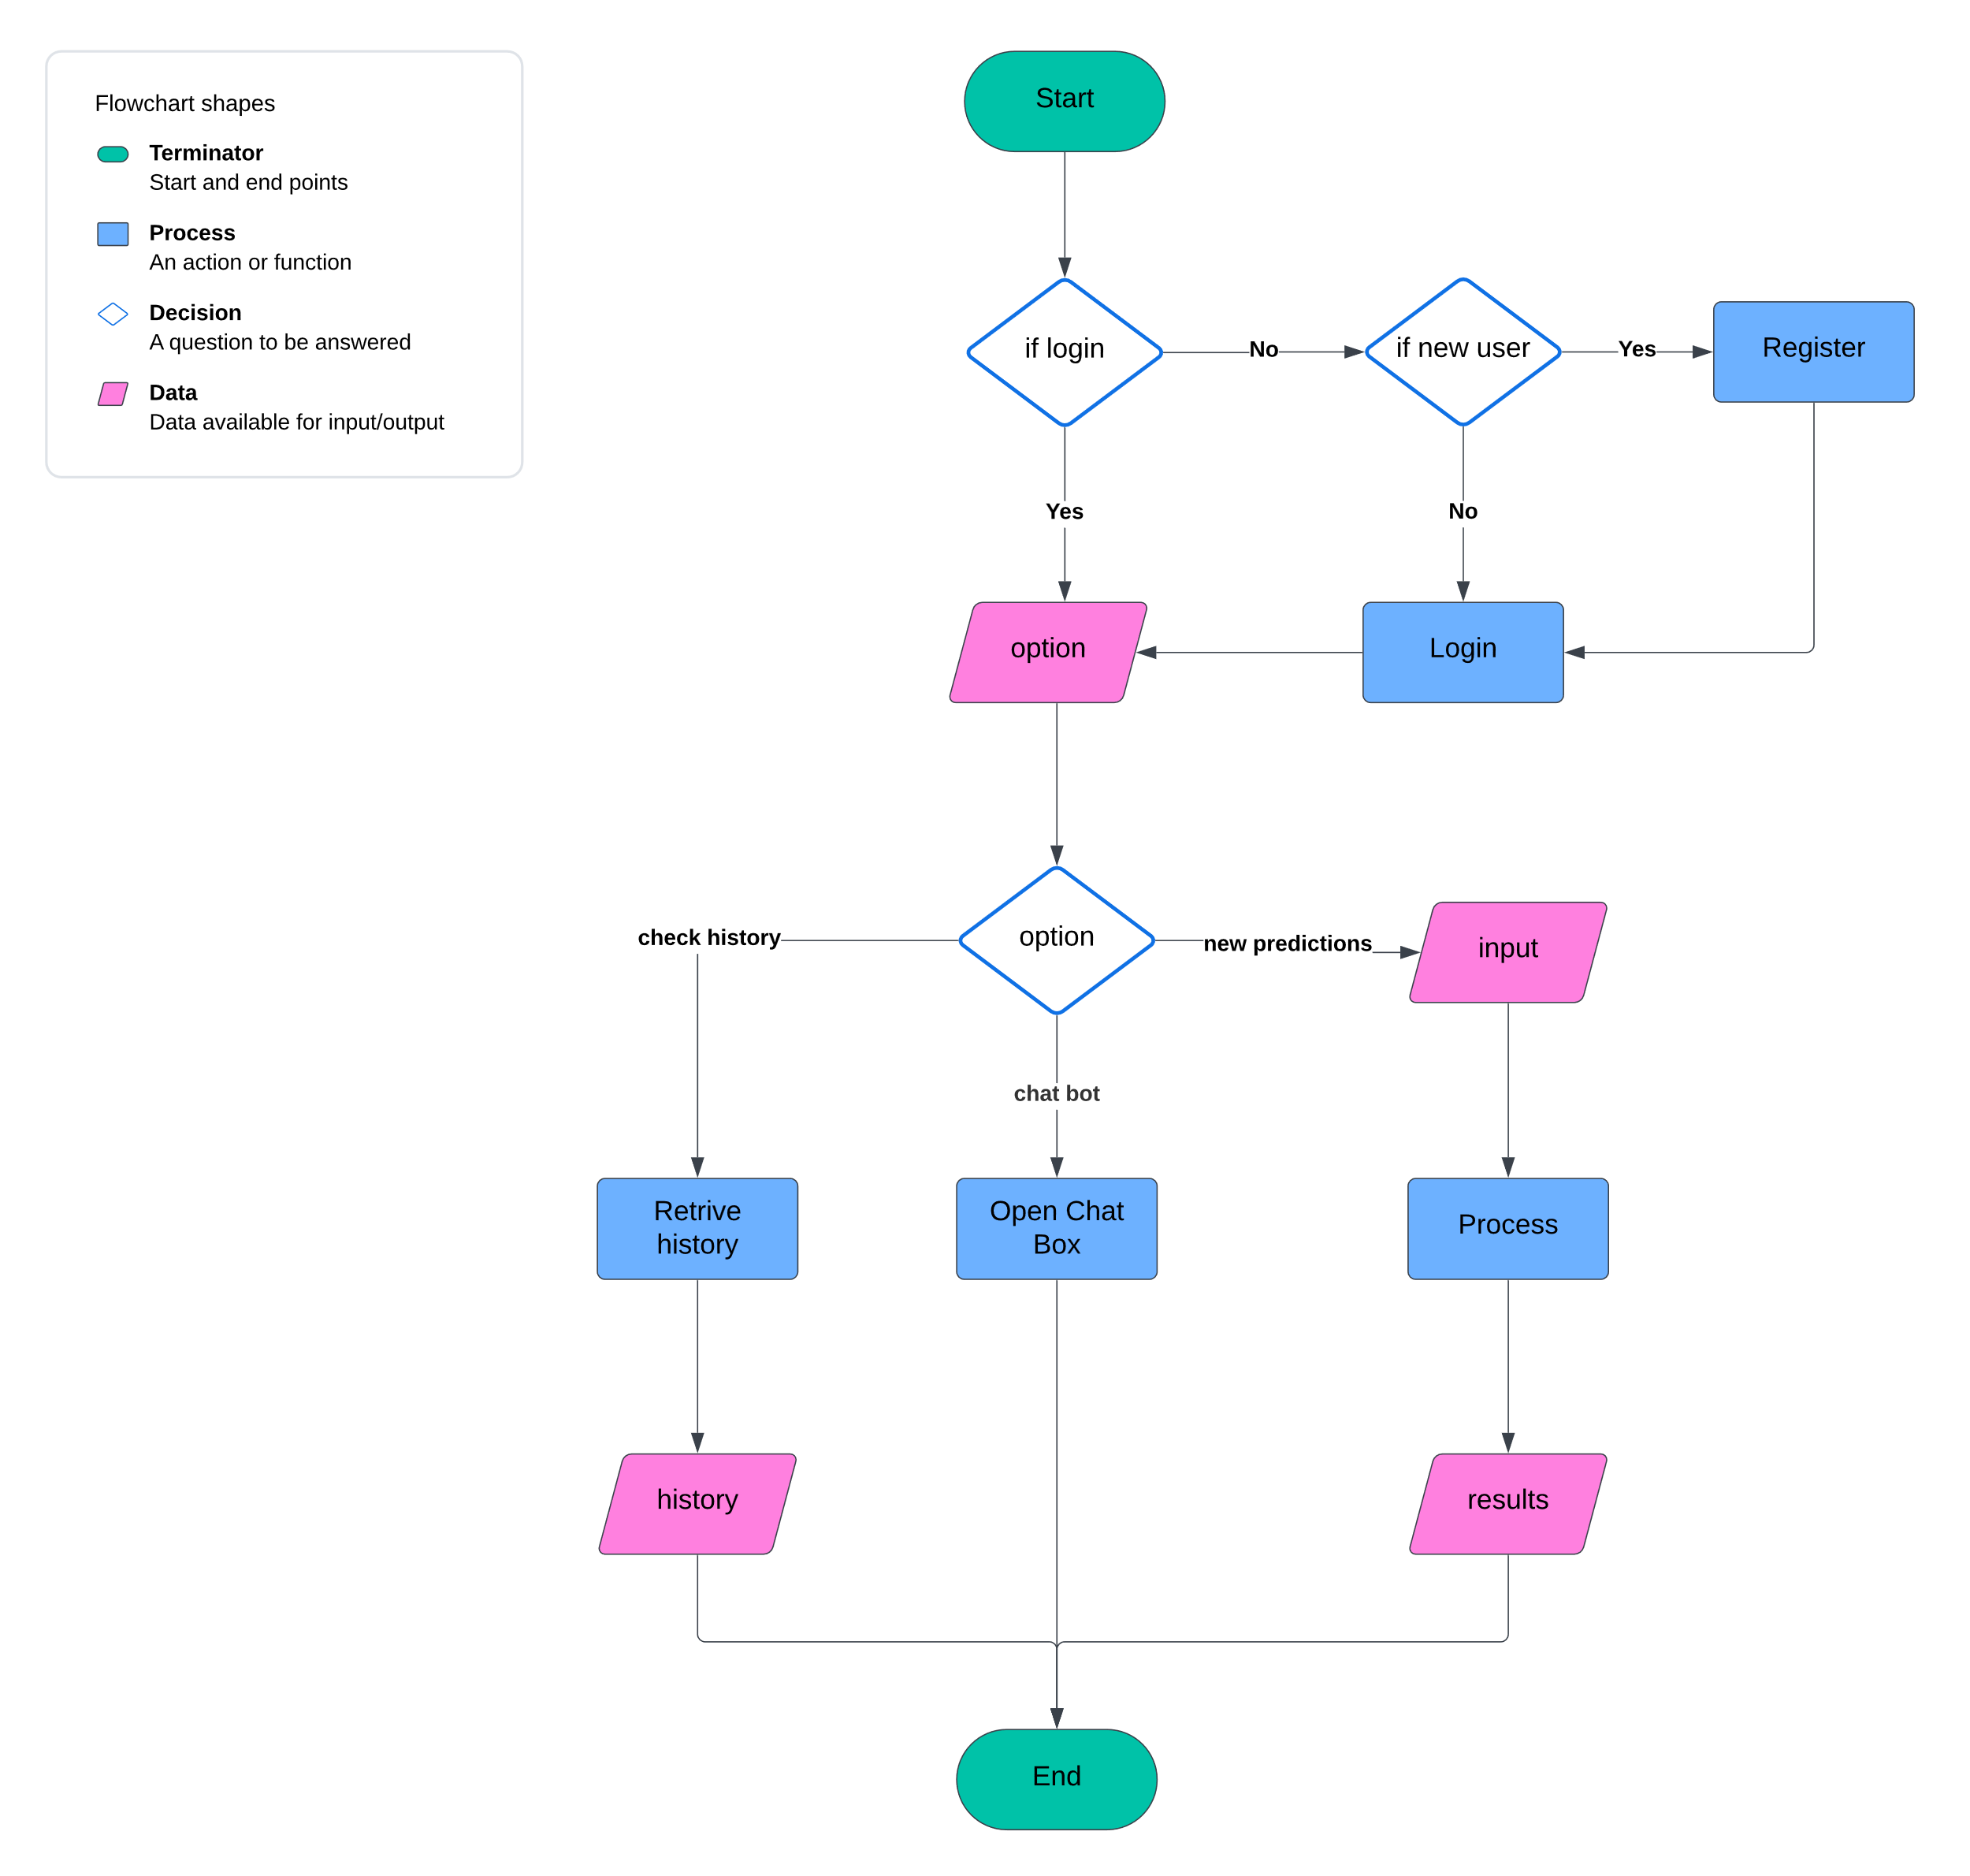

# Individual Tasks (mandatory if group project)

Please mention individual tasks in the table indicating individual tasks and justify the one-year effort of two or three students. The expected individual task list with the tentative plan is given below.

|  |  |  |
| --- | --- | --- |
| **Team Members** | **Activity** | **Tentative Date** |
| Asad Ali, Asad ur Rehman, Muhammad Haroon Shahzad | Research and Project Planning | 11 March 2024 – 07 April 2024 |
| Asad Ali, Asad ur Rehman, Muhammad Haroon Shahzad | Literature Review | 15 March 2024 – 07 April 2024 |
| Asad Ali, Asad ur Rehman, Muhammad Haroon Shahzad | Dataset Collection | 20 March 2024 – 29 March 2024 |
| Muhammad Haroon Shahzad, Asad Ali | Data Preprocessing and Pipeline Designing | 01 April 2024 – 12 April 2024 |
| Asad Ali, Asad ur Rehman, Muhammad Haroon Shahzad | Interface Profiling and Requirement Analysis | 11 March 2024 – 12 April 2024 |
| Asad Ali, Asad ur Rehman, Muhammad Haroon Shahzad | Model Development and Training | 15 April 2024 – 10 May 2024 |
| Asad Ali, Asad ur Rehman, Muhammad Haroon Shahzad | Website Development | 15 April 2024 – 10 May 2024 |
| Asad Ali, Asad ur Rehman, Muhammad Haroon Shahzad | Model Evaluation and Validation | 13 May 2024 – 24 May 2024 |
| Asad Ali, Asad ur Rehman, Muhammad Haroon Shahzad | Integration and Testing | 13 May 2024 – 24 May 2024 |
| Asad Ali, Asad ur Rehman, Muhammad Haroon Shahzad | Mobile App Development | 24 June 2024 – 09 Aug 2024 |
| Muhammad Haroon Shahzad, Asad Ali | Model Optimization and Enhancement | 24 July 2024 – 06 Sep 2024 |
| Asad Ali, Asad ur Rehman, Muhammad Haroon Shahzad | Interface Refinements | 11 Aug 2024 – 06 Sep 2024 |
| Muhammad Haroon Shahzad, Asad Ali | Backend Development and Integration | 11 Aug 2024 - 09 Nov 2024 |
| Asad Ali, Asad ur Rehman, Muhammad Haroon Shahzad | Deployment Process | 11 Nov 2024 – 30 Dec 2024 |
| Asad Ali, Asad ur Rehman, Muhammad Haroon Shahzad | Documentation and Reporting | 11 March 2024 – 30 Dec 2024 |

# Gantt Chart (Mandatory)

As per individual tasks mentioned in the previous section, the Gantt chart shall graphically represent which tasks would be done in which duration, i.e., starting date, end date. What tasks shall be done in parallel, and what tasks shall be done in series? Duration of individual task. (View few samples from the internet before making your own to get ideas)

|  |  |  |  |  |
| --- | --- | --- | --- | --- |
| **Activity** | |  |  |  | | --- | --- | --- | | Semester 7 | Summer Break | Semester8 | |
| |  |  |  |  |  |  |  |  |  |  | | --- | --- | --- | --- | --- | --- | --- | --- | --- | --- | | Mar | Apr | May | Jun | Jul | Aug | Sep | Oct | Nov | Dec | |
| Research and Project Planning | |  |  |  |  |  |  |  |  |  |  | | --- | --- | --- | --- | --- | --- | --- | --- | --- | --- | |  |  |  |  |  |  |  |  |  |  | |
| Literature Review | |  |  |  |  |  |  |  |  |  |  | | --- | --- | --- | --- | --- | --- | --- | --- | --- | --- | |  |  |  |  |  |  |  |  |  |  | |
| Dataset Collection | |  |  |  |  |  |  |  |  |  |  | | --- | --- | --- | --- | --- | --- | --- | --- | --- | --- | |  |  |  |  |  |  |  |  |  |  | |
| Data Preprocessing and Pipeline Designing | |  |  |  |  |  |  |  |  |  |  | | --- | --- | --- | --- | --- | --- | --- | --- | --- | --- | |  |  |  |  |  |  |  |  |  |  | |
| Interface Profiling and Requirement Analysis | |  |  |  |  |  |  |  |  |  |  | | --- | --- | --- | --- | --- | --- | --- | --- | --- | --- | |  |  |  |  |  |  |  |  |  |  | |
| Model Development and Training | |  |  |  |  |  |  |  |  |  |  | | --- | --- | --- | --- | --- | --- | --- | --- | --- | --- | |  |  |  |  |  |  |  |  |  |  | |
| Website Development | |  |  |  |  |  |  |  |  |  |  | | --- | --- | --- | --- | --- | --- | --- | --- | --- | --- | |  |  |  |  |  |  |  |  |  |  | |
| Model Evaluation and Validation | |  |  |  |  |  |  |  |  |  |  | | --- | --- | --- | --- | --- | --- | --- | --- | --- | --- | |  |  |  |  |  |  |  |  |  |  | |
| Integration and Testing | |  |  |  |  |  |  |  |  |  |  | | --- | --- | --- | --- | --- | --- | --- | --- | --- | --- | |  |  |  |  |  |  |  |  |  |  | |
| Mobile App Development | |  |  |  |  |  |  |  |  |  |  | | --- | --- | --- | --- | --- | --- | --- | --- | --- | --- | |  |  |  |  |  |  |  |  |  |  | |
| Model Optimization and Enhancement | |  |  |  |  |  |  |  |  |  |  | | --- | --- | --- | --- | --- | --- | --- | --- | --- | --- | |  |  |  |  |  |  |  |  |  |  | |
| Interface Refinements | |  |  |  |  |  |  |  |  |  |  | | --- | --- | --- | --- | --- | --- | --- | --- | --- | --- | |  |  |  |  |  |  |  |  |  |  | |
| Backend Development and Integration | |  |  |  |  |  |  |  |  |  |  | | --- | --- | --- | --- | --- | --- | --- | --- | --- | --- | |  |  |  |  |  |  |  |  |  |  | |
| Deployment Process | |  |  |  |  |  |  |  |  |  |  | | --- | --- | --- | --- | --- | --- | --- | --- | --- | --- | |  |  |  |  |  |  |  |  |  |  | |
| Documentation and Reporting | |  |  |  |  |  |  |  |  |  |  | | --- | --- | --- | --- | --- | --- | --- | --- | --- | --- | |  |  |  |  |  |  |  |  |  |  | |

# Tools and Technologies

Please describe the tools and technologies that the FYP group is planning to use in the project.

# References (Mandatory)

You must provide references (IEEE style) when appropriate to justify your study.

# General Guidelines

Before starting write up, first, confirm that the correct template has the correct paper size. This FYP proposal template has been tailored for output on the A4 paper size. Specify paper width according to dimensions shown in Figure 2.

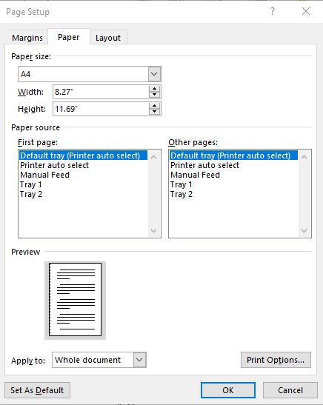

Figure 2. Paper size settings.

Ensure page margins are according to the margin values shown in Fig. 2.

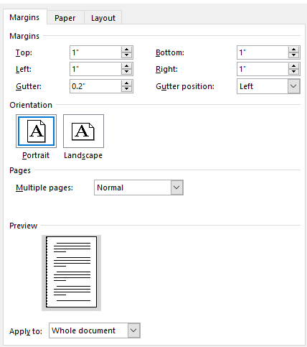

Figure 3. Template page margins.

# Template Heading (Heading-1)

Each section should start with heading font size 16, bold, and font face “Times New Roman”. First, outline the proposal in different sections and try to include relevant heading. If it is required to split the section into sub-headings, should use a font size of 13, bold, and font face “Times New Roman.

## Selecting a Sub Heading (Heading-2)

Describe FYP in detail problem background, problem complexity, and proposed solution.

### Selecting Sub Sub Heading (Heading-3)

Follow the numbering style for the sub-sub-section under the main section. In order to write the third level of subheading, use font size 12 and font face italic “Times New Roman.”

#### Body Text

All the body text should be in font size 12 and single line spacing. Moreover, ensure that the complete document must use only font-face “Times New Roman”.

# Figures and Tables

Use the following instructions to create tables and figures. All the figures and tables must be cross-referred in the text. For example, the figure is inserted in the introduction section in this document figure and can refer to the paper size, and margins see Fig. 1. In the same way, all tables should be cross-referred in the text.

## Figures and Tables

Figure captions should be below the figures; table heads should appear above the tables. Insert figures and tables after they are cited in the text. Use the abbreviation “Fig. 1”, even at the beginning of a sentence.

1. Table Type Styles

| Table Head | Table Column Head | | |
| --- | --- | --- | --- |
| Table column subhead | Subhead | Subhead |
| copy | More table copy |  |  |

1. Example of a figure caption. (*figure caption*)

Figure Labels: Use 11 point Times New Roman for Figure labels. Use words rather than symbols or abbreviations when writing Figure axis labels to avoid confusing the reader.

# Failure to Submit FYP proposal on time

Any student or group who fails to submit a project proposal on time breaches regulation and will not be registered in FYP-I.

Appendix A

*Include here the 1st page of Turnitin Report*

Every supervisor has his/her own Turnitin account. If not, then supervisors are requested to get the account from Library as soon as possible.