Book Ticket (Online Payment)

|  |  |
| --- | --- |
| Actor Action | System |
| 1. Traveler opens the website/portal. |  |
| 1. Enters his login information if he is a member. |  |
| 1. Traveler requests booking services. |  |
|  | 1. System opens a form asking user to enter information regarding mode of travel, departure date. |
| 1. The user enters the required information i.e. Mode of Travel and Departure date. |  |
|  | 1. The system contacts the specified system and displays a list of available tickets on that date. |
| 1. The user selects his desired option. |  |
|  | 1. The System checks the system for availability of seats and directs the user to a form where the user has to fill his details. |
|  |  |
|  | 1. The system saves the information. |
|  | 1. The system dispaly the form for his mode of payment. |
| 1. The user selects online as his mode of payment. |  |
|  | 1. The system redirects the user to a secure page where he can fill in his credit card details and make the payment. |
| 1. The user makes the payment through credit card. |  |
|  | 1. The system validates the credit card and payment and save the transaction as a record. |
| 1. The user request for ticket   17.The user request for receipt | **16. System generates the booking ticket.**  **18. System generates the receipt and update those thing that required after booking and save the booking information for reuse purpose.** |

Extensions:

2a: If the user is not a member, he is requested to enter his credentials to become a member.

7a : If the flight has no available booking slots, the flight is not booked and an error message is shown.

13a: If his credit-card number is not valid, an error message is shown and the traveler will be requested to enter a valid card number.

SSD:

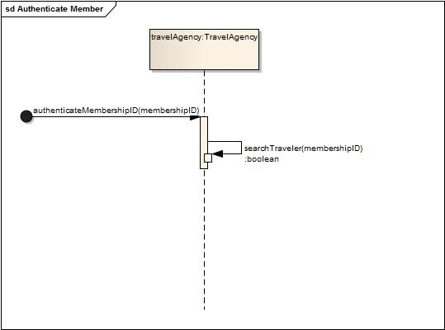

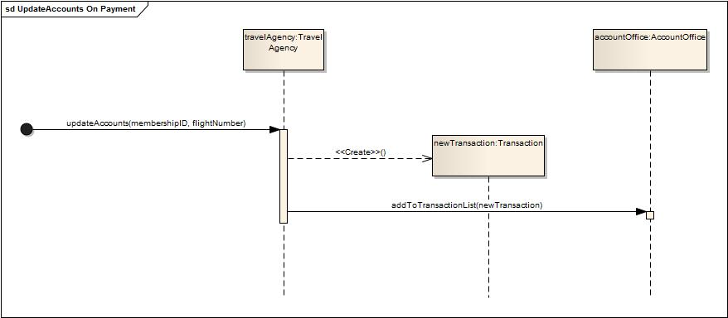

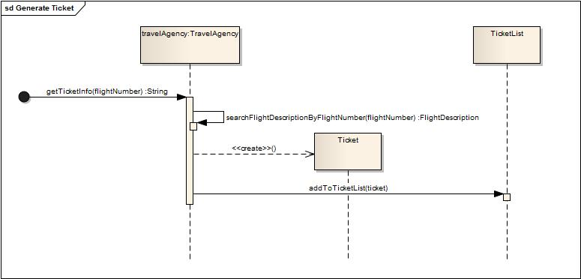









Operation Contract:

**Authenticate Member(memberShipId)**

Preconditions:

Member is already registered in the system.

Post Conditions:

Association of TravelAgency was formed with Traveler

**Search Desired Flight(departuredate,destination,airlinecompanyname):**

Preconditions:

Booking process is running.

Flight Description are present in the list

Post Conditions:.

Association of TravelAgency was formed with FlightDesription .

**CheckSeatAvailabilty(FlightNumber)**

Preconditions:

A process of booking seat is continue.

Post Conditions:

Association of TravelAgency was formed with FlightDescription

**AuthenticateCreditCard(CreditCardNumber)**

Preconditions:

Process of seat Booking is continue

Post Conditions:

Association of TravelAgency was formed with Bank

Update Accounts on Payment(MemberShipId,FlightNumber):

Preconditions:

Booking Process is running.

Post Conditions:

A new object for transaction “t”was made.(creation)

t.transactionID,t. amount, t.travelerMembershipID & t.flightNumber were initialized.

Association of TravelAgency was formed with AccountOffice .

**Generate Ticket(issue date,flightNumber):**

Preconditions:

Booking Process is running.

Post Conditions:

A new object for Ticket “t” was made.

t.issueDate,t.flightNumber was initialized.

Association of TravelAgency with FlightDescription,TicketList was formed..

**Generate Receipt(booking ID,flightNumber,TransectionID):**

Preconditions:

Booking Process is running.

Post Conditions:

A new object for Receipt “rp” was made.

Rp.bookingId,rp.transectionID,rp.flightNumber was initialized.

Association of TravelAgency with FlightDescription,ReceiptRecord was formed..