**Name:**ObtainMembership

**Scope:** Travel agency system

**Level:** User goal

**Primary Actor:** Customer

**Stakeholders:** Customer

**Preconditions:** NULL

**Success guarantee:** The customer becomes a member

|  |  |
| --- | --- |
| **CUSTOMER** | **SYSTEM** |
| * Customer enters the membership tab * The customer enters the requires information. | * System asks for customers name address, age, sex, passport number and other information require to authenticate him as a valid member. * Then the system   generates a new membership id for the customer and show to him. |

SSD:



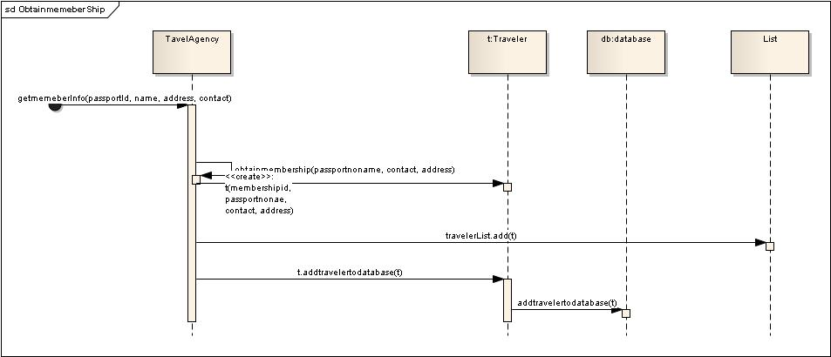

**Operation Contracts:**

**Name:enrterMemberInfo(passportid,travelerName,travellerAddress,travelercontac)**

**Preconditions:**

Process of ObtainMembership is running.

**PostConditions:**

New object of Traveler was initialized.

passportID, travelerName,travelerAddress,travelerContact of traveler are initialized.

TravelAgency has association formed with traveler.