Sample data saved for a patient. Now please fill Supper Bill Accordingly. So I can have idea that from the saved data what you enter in supper bill/ Order form below: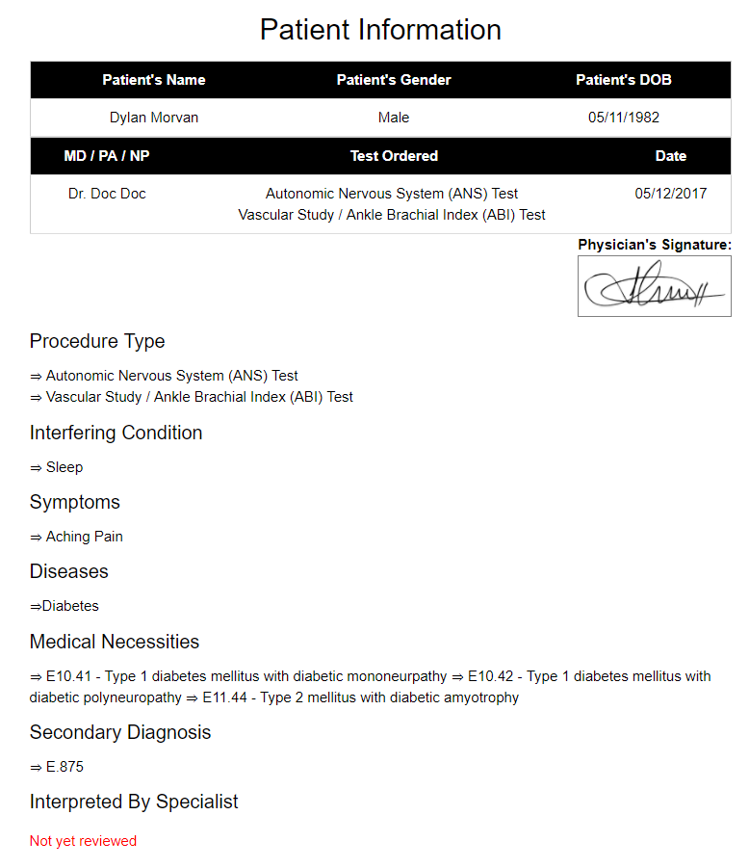

**Advanced Clinic Testing**

**Home Sleep Study and Allergy Test Specialist**

**4551 Pleasant Hill Rd, Kissimmee, FL 34746**

**Phone: (281) 693-5289 Fax: (281)693-3111**

|  |  |  |
| --- | --- | --- |
| **Date of service:** 11/13/2017 | **Insurance: P** BLS PPO | **Billing Information** |
| **Last Name:** Morvan | **Insurance:** S | Copay/Coins |
| **First Name:** Dylan | **Physician's Name:** Dr. Doc Doc | Deductible |
| **Time in:** 11:40 PM |  | CC, Cash, Cheque # |
| **DOB:** 05/11/1982 | **Age:** 35 | Total Paid: |

| **✖** | **Description** | **Code** | **MOD** | **Description** | **Code** | **MOD** | **Description** | **Code** |
| --- | --- | --- | --- | --- | --- | --- | --- | --- |
|  | DIAGNOSIS |  |  |  |  |  |  |  |
| ✖ | Obstructive Sleep Apnea | G47.33 | ✖ | HYPERSOMNIA W/SLEEP APNEA | G47.30 | ✖ | SNORING | R06.83 |
| ✖ | Sleep Related Nonobstructive Alveolar Hypoventilation | G47.34 | ✖ | RECURRENT HYPERSOMNIA | G47.13 | ✖ | Central Apnea | G47.31 |
| ✖ | Obesity Hypoventilation Syndrome (Morbid Obesity) | E66.2 | ✖ | HYPERSOMNIA | G47.10 | ✖ | Sleep Paralysis | G47.53 |
|  | SLEEP STUDIES |  |  |  |  |  |  |  |
| ✖ | Polysomnagraphy (PSG) – 1st night | 95810 | ✖ | Split Night Cpap Titration | 95811 |  |  |  |
| ✖ | Cpap Titration – 2nd night | 95811 | ✖ | CPAP/BIPAP Titration | 95811 |  |  |  |
| ✖ | PAP NAP (DESENZITATION | 95807 | ✖ | HST X 3 NIGHTS | 95800 |  |  |  |
|  | CPAP & SUPPLIES |  |  |  |  |  |  |  |
| ✖ | CPAP full face mask | A7030 | ✖ | CPAP full face mask | E0601 |  |  |  |
| ✖ | Replacement facemask interface | A7031 | ✖ | BIPAP w/o backup | E0470 |  |  |  |
| ✖ | Replacement nasal cushion | A7032 |  | BIPAP w/ backup | E0471 |  |  |  |
| ✖ | Replacement nasal pillows/td> | A7033 | ✖ | Humidifier heated | E0562 |  |  |  |
| ✖ | Nasal application device | A7034 | ✖ | HEATED TUBING | A4604 |  |  |  |
| ✖ | POS airway press headgear | A7035 | ✖ | Battery X 3 Nights | A4630 |  |  |  |
| ✖ | POS airway pressure tubing | A7037 |  |  |  |  |  |  |
| ✖ | POS airway pressure filter | A7038 |  |  |  |  |  |  |
| ✖ | PAP oral interface | A7044 |  |  |  |  |  |  |
| ✖ | Replacement exhalation port | A7045 |  |  |  |  |  |  |

Payment Type: ✖ Cash ✔ Cheque ✖ Credit Card

Total Amount: $_________ Monthly Payment: $________

I HEREBY AUTHORIZE MY INSURANCE BENEFITS TO BE PAID DIRECTLY TO ____________ ______________ AND I AM RESPONSIBLE FOR ANY NON-COVERED SERVICES. I ALSO AUTHORIZE THE RELEASE OF ANY INFORMATION REQUIRED FOR THE PROCESSING OF THE CLAIM.

*Advanced Clinic Testing LLC 4551 Pleasant Hill Rd, Kissimmee, FL 34746 Phone: (281) 693-5289 Fax: (281)693-3111*

**DIAGNOSTIC EVALUATION**

**OFFER FORM**

|  |  |  |
| --- | --- | --- |
| **Patient's Name:** Dylan Morvan | **Sex:** Male | **DOB:** 05/11/1982 |
| **Ordering** **MD/PA/NP:** Dr. Doc Doc | **Physician's Signature:** http://localhost:64011/Files/Signatures/Signature_3.png | **Date:** 11/13/2017 |

*Insurance card clear copy, patient demographics, state issued identification, ordering provider signature, and indication(s) for exam must be included or attached with this order. Incomplete orders without this information will be returned for completion.*

|  |  |  |  |
| --- | --- | --- | --- |
| [ ] ANS Evaluation |  | **Using Tilt Table** | **95924 + 95923** |
| ✖ | **Without Tilt Table** | **95921 + 95923 + 95943 or 95924 + 95923** |
| [ ] Arterial Evaluation | | | **93922** |

*Physician requires company to handle Billing****x****Global Technical only*

**Physician is ordering the test for the following reason(s):**

**[ ] ANS evaluation:** Indications, reasons, symptoms and/or diagnosis codes for exam:

1) 95943

2) 95923

**[ ] Arterial evaluation:** Indications, reasons, symptoms and/or diagnosis codes for exam:

1) 93922

Special Instructions___________________________________________________________________________________________________________________________________________________________________________________________________________________________

*Please send this completed order to our office*