Automated Gesture Recognitions Using Hidden Markov Model (HMM)
By

Mr. Naveed Shah
AUIC-14-0775
Master of Science in Electrical Engineering (MSEE)

A thesis proposal submitted in partial fulfillment of the requirements for the award of degree of Master of Science in Electrical Engineering at Abasyn University.

Supervisor
Dr. Imran Shafi



Department of Computing and Technology
Abasyn University Islamabad Campus

April 2016
TABLE OF CONTENTS

Sr # | Content | Page no.
I | Introduction | 3
II | Problem Statement | 4
III | Literature Review | 5
IV | Limitations of the Current Research Models | 5
V | Research Objectives | 6
VI | Significance of the Research | 6
VII | Research Design and Methodology  - Image Acquisition and Preprocessing  - Hand Detection and Segmentation  - Extract Trajectory  - Normalize Trajectory  - Recognizing using Hidden Markov Model (HMM)  - Research Flow Chart Overview | 6  7  7  8  8  9  10
VIII | Thesis Timeline | 10
IX | References | 11

INTRODUCTION
For the deaf, it is difficult to communicate with normal people. Deaf people do not understand normal human voices and corresponding Ordinary people do not understand the movements performed by deaf or hearing impaired person injured. The purpose of this project is to build a solution that can bridge the gap of communication between the disabled and ordinary people and allow these people to communicate with each other easily. Use Kinect v2 Microsoft entity, we can easily extend this software. Mute and Deaf people cannot speak and they have huge problems regarding communication. The most common and easy method for their communication is using Sign Language. Deaf and Mute can communicate with each other quite easily but they face problem when they communicate to normal people using Sign Language because most of the people might not be able to understand Sign Language. Sign Language is hand gestures and signs which is equivalent to natural language terms and phrases such as English Language terms and phrases.

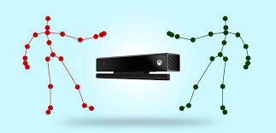

Figure 1. Points Detects by Kinect

The project uses a matching algorithm in real time and compares the gesture function with a gesture that is already in our database.
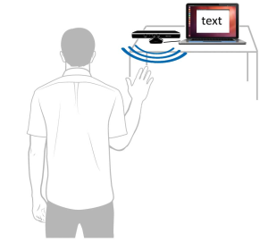

Figure 2. Gesture Recognized by Kinect device
There are various types of methods based on signal detection mode. Libraries use Kinect and OpenNI to pursue hands tend to focus more on applications, strategies containment and settlement and shows that the next hand OpenNI strategy is suitable for applications tested so far has not yet been tested, but Kinect sensors and other depth barriers for signal detection in applications and test situations.

PROBLEM STATEMENT
Gesture recognition is important not only for the deaf, but also for different purposes.
Real-time recognition of gestures is a difficult task. Each country has its own sign language and these signs are stored in the database. These signs are converted to word and the word translated into the spoken word. Using Kinect v1 can detect one user at real time for performing the gesture While Kinect V2 can detect 25 points of six people for performing gesture. Here is our main objective understanding of the basic symptoms that can occur in everyday life. This method describes the development and implementation of 3D-robust system, which allows simple control gestures to communicate spatial relationship in a complex environment.

LITERATURE REVIEW
Gesture Recognition Research is going all over the world. Some Languages like American Sign Language [2, 18], Japanese Sign Language [3], and Swedish Sign Language [4] have achieved good level of results using gesture recognition techniques. In countries like India, Pakistan and Afghanistan research on Sign Language began very late because of the absence of advance technology. In acknowledgment stage, distinctive techniques were utilized like Well [9, 10], KNN [7], SVM [5, 6] and DTW [8]. The majority of the scientists were used glove for hand detection. Use the glove over the skin; in this way it is easily to get hand the hand component. Kishore and Kumar [16] dealt with Sign Language using fuzzy logic and achieved about 96% accuracy. They used the extraction of components on the basis of the color.
There exist much research methodology for learning and recognition of visual manners. However because of recent research to the vision group, just a little numbers have been used Hidden Markov Models. We compress a couple of the fascinating works identified with the paper. Kalin and Jonas prepared the framework with Hidden Markov Models. 51 signs were tested and which were achieved 89.7% accuracy [4]. Moni M. A. and Ali have dissected different methodologies in motion acknowledgment for communication via gestures acknowledgment utilizing Hidden Markov Models [13].

LIMITATIONS OF THE CURRENT RESEARCH MODELS
There are many limitations in the current job. The first and main problem is to not read all 25 points in the backbone of the human body kinect v1, v2 so we will Kinect to 25 points of the human skeleton body for later processing.
The second one difficulty is processing issue. In all current modules the processing is very slow; Reade the image through kinect and then processing on these images is very lengthy process. These images have thousand numbers of pixels and processing on these pixels it is very consuming time.
The third one is the memory issue. Getting the image and store it in database take thousands numbers of bytes, sometime the system gives us error like memory out of range and damage the whole process. The methodology we are using will store path so it will take some number of bytes in memory and will be easily changed and updated.

RESEACH OBJECTIVES
My research objective is to provide ease to people who do not understand Sign Language by providing an intermediate to them which will translate Sign Language to Text and Speech. Kinect Sensor can capture 3D gesture which we will be using as input, on the bases of that particular gesture, we will find out what this particular gesture means by comparing it to stored information about gestures using complex Algorithms. Once we have translated the gesture to text then we will display this text as well as convert it to speech. This is how gestures will be translated to Text and Speech.

SIGNIFICANCE OF THE RESEARCH
The world is a global village and people connected via the Internet and telephone. The use of gesture recognition is important when communicating with deaf people because we cannot communicate verbally. With Kinect [15] to detect in real time the gestures, we must understand the signs of the deaf person. Gesture recognition module is a fundamental analysis of human activity. To communicate with a deaf need to recognize all parts of the human body, and know your body movements [16].

RESEARCH DESIGN AND METHODOLOGY
Our system consists of multiples modules like image acquisition, extract hand features and hand gestures recognition using Hidden Markov Models. In image acquisition module pixels depth, angles of coordinates and skeleton information are captured. In feature extraction the joint information of coordinate of the skeletons, angle between joints and then data normalization is applied on it. In hand gestures recognition module, maximum likelihood of Hidden Markov Models parameter is derived with the help of Baum Welch algorithms for the given set of sequence.

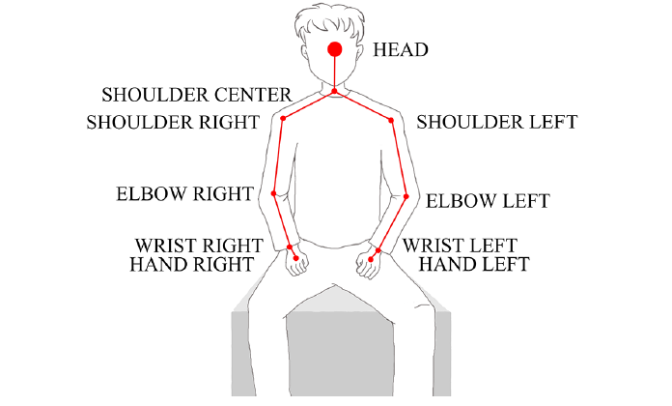
Figure 3. Kinect Skeleton

Image Acquisition and Preprocessing
Here the image is captured through Microsoft Kinect. Kinect camera is used to capture hand sign at rate of 30 frames per second. The dimension of each frame is 640 * 480.

Hand Detection and Segmentation
I have many approaches to try to solve the problem of robust detection and segmentation hand, most of which are divided into three categories based on a combination of color, depth, and based on the method, which process information about color and depth.

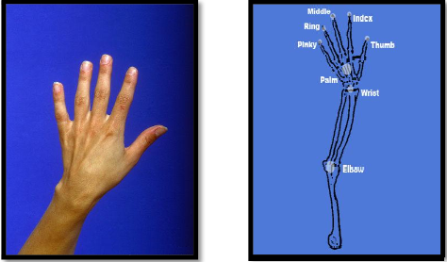

Figure 4. Hand Skeleton

Extract Trajectory
Extract 3D path of the hand from the given frame; take every tenth frame of the hand because the hand motion is very slow. When the hand moves from point to point the speed of the hand also varies with time, so just take the 3D road. The coordinates (x, y, z) is the distance of the point along (x, y, z) axis from the kinect camera.

Normalize Trajectory
Furthermore, 150 frames are sufficient for expediently acting any gestureAverage of angles of 30 frames forming one part of gesture. Considering the training set, the hand varies very slowly so take every tenth frame. The combination of 20 states and 15 surveillance symbols formed a Hidden Markov Model.

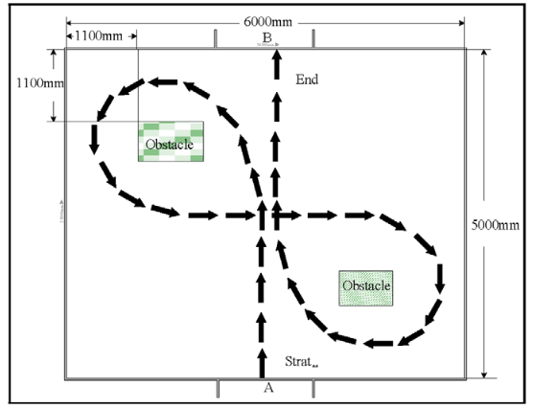

Figure 5. Trajectory Path

Recognizing using Hidden Markov Model (HMM)
The normalized feature of each trajectory form an observation signs for HMM stage. HMM is a best choice for sequential data.
Suppose we have two states Rainy and Sunny, three observations Walk, shop and clean.
Start probability for rainy is 0.6 and sunny is 0.4. The transition probability represents the change in the. In our example, we have only a 60% chance that tomorrow will be rain if today is sunny. The emission probability represents the activity on each day. If it is sunny, there is a 50% chance that he will shop; if it is rainy, there is a 40% chance that the person will clean his apartment.
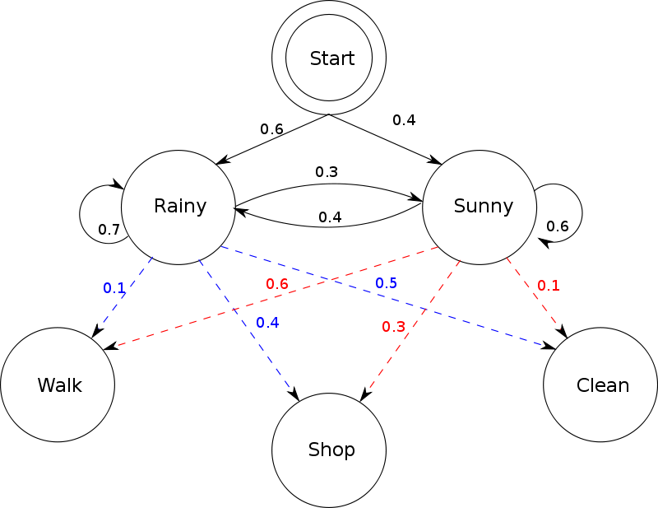

Figure 6. Hidden Markov Model

Research Flow Chart Overview
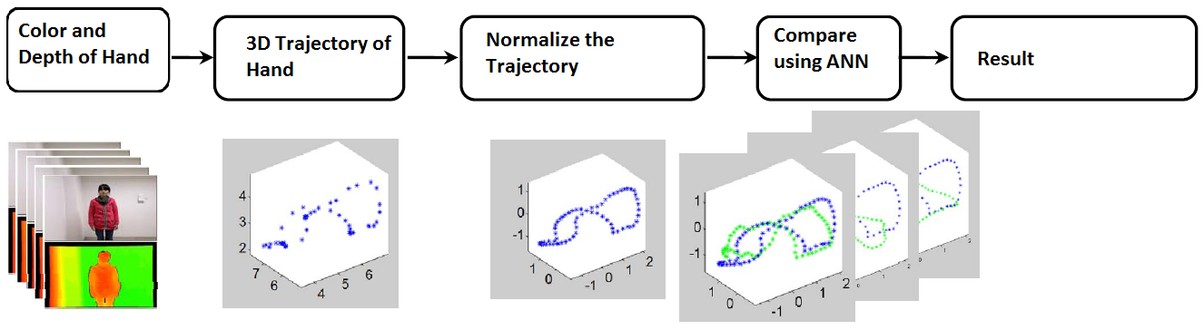
Figure 7. Thesis Flow Diagram

THESIS TIMELINE
According to University guidelines for master's degree thesis, the following structure and tentative timelines be for the remaining duration of the research.

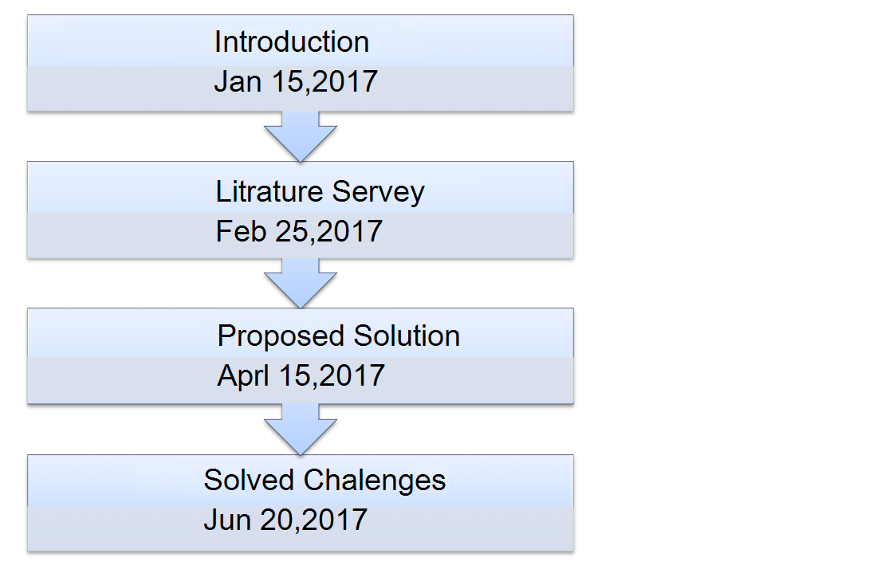
Figure 8. Thesis Time Line Overview

REFERENCES
- A. Ghotkar, G. Kharate 2015. Dynamic Hand gesture recognition for sign words and Novel Sentence Interpretation Algorithm for Indian Sign Languagne using Microsoft Kinect Sensor. Journal of Pattern Recognition Research, 10(1), pp.25-38.
- G. Kharate and A. Ghotkar 2016. Vision based Multifeature Hand gesture Recognition for Indian Sign Language Manual Signs. International Journal on Smart Sensing and Intilligent System,9(1),pp. 124-147.
- C. Vogler, D. Metaxas 2001. A Framework for Recognizing the Simultaneous Aspects of American SignLanguage. Computer Vision and Image Understanding pp.358-384.
- Y. Sun,N. Kuwahara and K. Morimoto 2013. Analysis of recognition system of Japanese sign language using 3D image sensor. IASDR pp.1-7.
- K. Stefanovand J.Beskow 2013. A kinect corpus of Swedish sign language Signs. Proceedings Work-shop on Multimodal Corporation pp.1-5.
- A. Kuznetsova, L. Leal-Taixe, and B. Rosenhahn 2013. Real-time sign language recognition usingconsumer depth camera pp.83-90.
- Z.Hu, L.Yang, L. Luo, Y. Zhang, and X.Zhou 2014.The Research and Application of SURF AlgorithmBased on Feature Point Selection Algorithm. Sensor and Transducers IFSA publishing pp.67-72.
- T. Shanablehand K. Assaleh 2007. Arabic sign language recognition in user-independent mode. InProc. int. Conf. Intell. Adv. Syst pp.597-600.
- J. Lichenauer, E. Hendriks and M. Reinders 2008 .Sign Language Recognition by Combining Statistical DTW and Independent Classification IEEE Transaction on Pattern Analysis and Machine Intelligence 30(11) pp. 2040-2046.
- Elmezain, M. , Al-Hamadi, A. , Michaelis B 2009. Hand trajectory based gesture spotting and recognition using HMM 16th IEEE International Conference on Image Processing (ICIP)
- Elmezain, M. , Al-Hamadi, A. , Michaelis, B 2008. A Hidden Markov Model-based continuous gesture recognition system for hand motion trajectory Pattern Recognition19th International Conference , ICPR.
- Shrivastava R. A 2013. Hidden Markov model based dynamic hand gesture recognition system using OpenCV Advance Computing Conference (IACC).
- Gaus, Y.F.A. ,Wong, F 2012. Hidden Markov Model Based Gesture Recognition with Overlapping HandHead/Hand-Hand Estimated Using Kalman Filter, Intelligent Systems, Modelling and Simulation (ISMS) Third International Conference.
- Moni M.A., Ali A.B.M.S. 2009. HMM based hand gesture recognition: A review on techniques andapproaches, Computer Science and Information Technology ICCSIT 2009.
- Wilson, A.D. Media Lab. MIT, Cambridge, Bobick, A.F. Parametric hidden Markov models for gesture recognition, Pattern Analysis and Machine Intelligence, IEEE Transactions ,21(9).
- P. Kishore, Rajesh Kumar, E. Kiran Kumar and S.Kishore 2011. Video Audio Interface for Recognizing Gestures of Indian Sign Language. International Journal of Image Processing (IJIP),5(4), pp. 479-503.
- J. Han, L. Shao, D. Xu and J.Shotton 2013. Enhanced Computer Vision with Microsoft Kinect Sensor: A Review. IEEE transaction on Cybernetics,43(5), pp.1318-1334.
- S. Wu, F. Jiang, and D. B. Zhao 2012. Hand gesture recognition based on skeleton of point clouds. IEEE fifth International Conference on Advanced Computational Intelligence (ICACI), pp. 566-569.
- Y. Zhang, S. Zhang, Y. Luo, and X. D. Xu 2010. Gesture trajectory identification and application based Kinect depth image. Application research of computer, vol. 29, no. 9.
- Z. Ren and J. S. Yuan 2013. Robust part-based hand gesture recognition using kinect sensor. IEEE Transactions on Multimedia, vol. 15, pp. 1110-1120.
- P.Karthick , N.Pratibha, V.B.Rekha, S.Thanalaxmi 2014. Transforming Indian Sign Language into Text using Leap Motion. International Journal of Innovative Research in science, Engineering and Technology, pp:10906-10907.
- Shiguo Lian, Wei Hu, Kai Wang 2014. Automatic User State Recognition for Hand Gesture Based Low Cost Television Control System. IEEE Transaction on Consumer Electronics. pp: 107-112.
- Murat Kus , Umit Kacar, Murvet Kirci, Ece Olcay Gunnes 2013. ARM Based Ear recognition Embedded System. Eurocon, pp: 2021-2024.
- Yuan Yao, Yun Fu 2013. Contour Model Based Hand Gesture Recognition Using Kinect Sensor. IEEE Transaction on circuits and System for video Technology. pp: 1-6.
- Cao Dong, Ming C. Leu, Zhaozheng Yin 2015. American sign language Alphabet Recognition Using Microsofy Kinect. Computer vision and Pattern Recognition workshop, IEEE conference.

