**P632 - Spring 2016**

**InsecurePay**

**Cigital Project**

**How To Run Manual**

Amish Shah (shah7)

Ankit Sadana (asadana)

Jaini Vora (voraj)

Janak Bhalla (jbhalla)

Madhukiran Radhakrishnan (madhradh)

## **TABLE OF CONTENTS**

1. Overview 2
2. Docker 2
   1. Running Docker 2
   2. Checking Server 4
3. Application Functionality 5
   1. Login 5
      1. Login function 5
      2. Change Server Address 5
   2. Forgot Password 6
   3. Home Page 6
   4. Navigation Drawer 7
   5. Account Management 8
      1. Updating Account 8
      2. Change Password 9
   6. Transfer Funds 9
   7. Activity History 10
   8. Interest Calculator 11
   9. Support Chat 11
      1. Sending Message 11
      2. Uploading File 12
   10. Logout 13

## **Overview**

InsecurePay is an Android banking application with vulnerabilities and security flaws implemented in all modules. This app is aimed at security enthusiasts and developers for exploring, testing and/or training purposes.

This document gives the instructions on how to build and deploy the dockerized server for the application, as well as an overview of the features of InsecurePay Android application. It also serves as the usage manual.

## **Docker**

Docker allows us to make a portable server to be deployed quickly on any machine so that InsecurePay can connect to it.

### **Running Docker**

Navigate to the docker folder containing both dockerTomcat and dockerPostgres folders and the executable script.

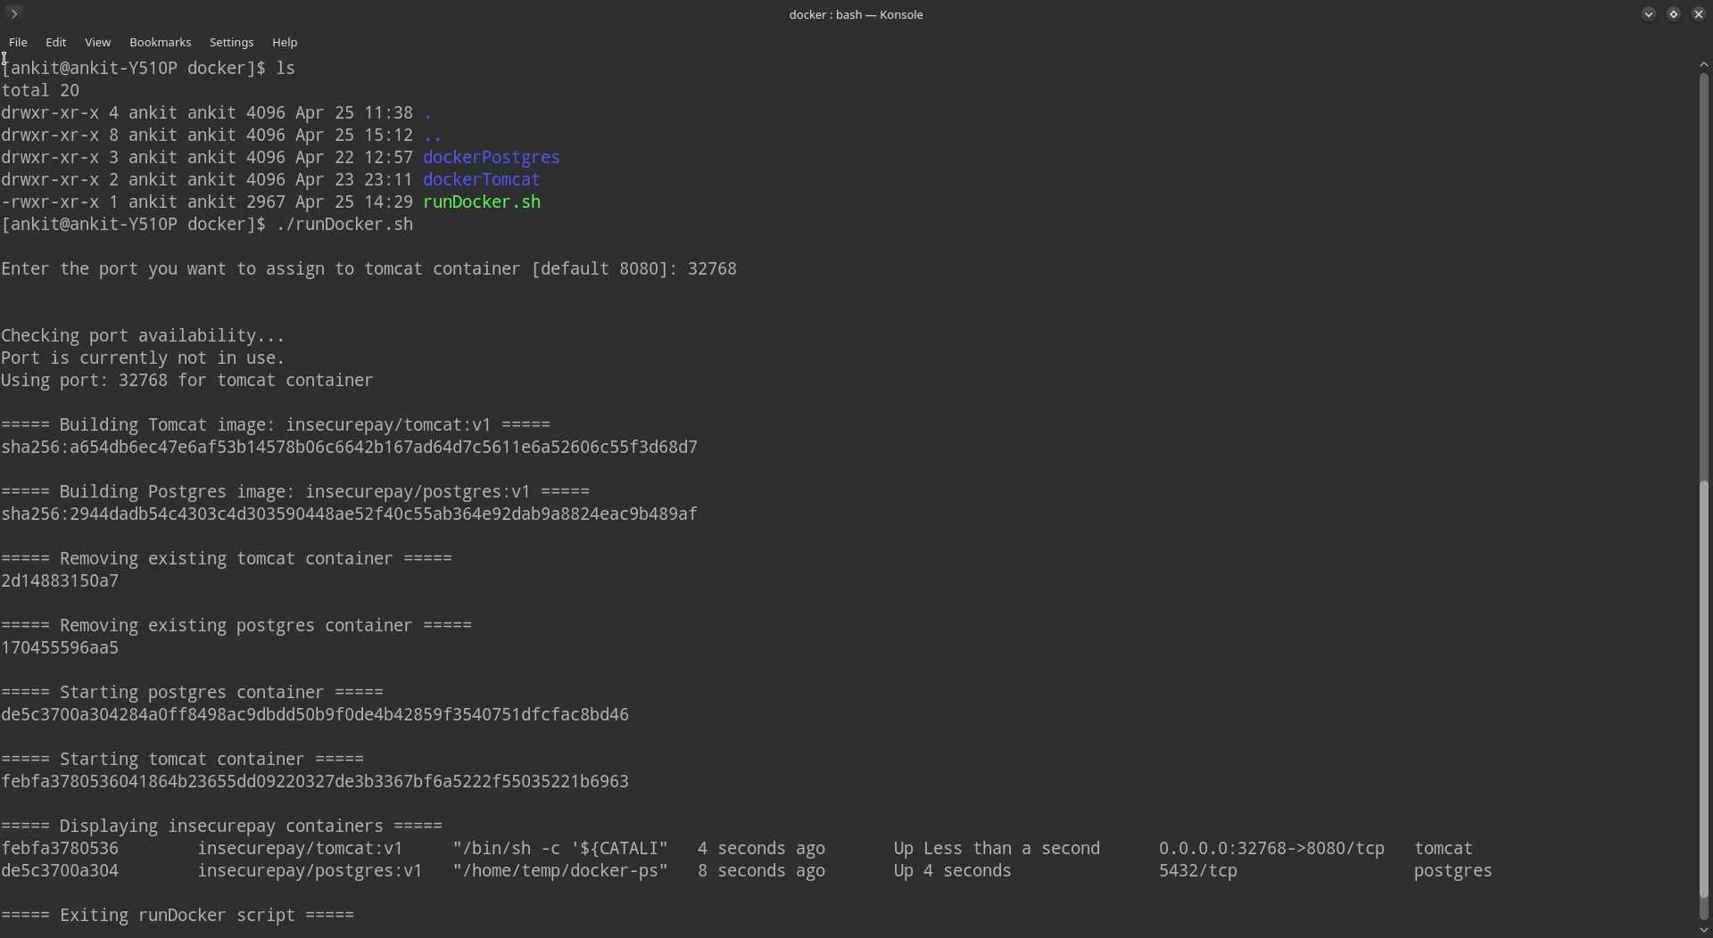

If the script is not executable, please run,

chmod +x runDocker.sh

To build and run the docker, simply run the script. The script allows the user to set a custom port, if no port or invalid port is specified, then default (8080) port is used.

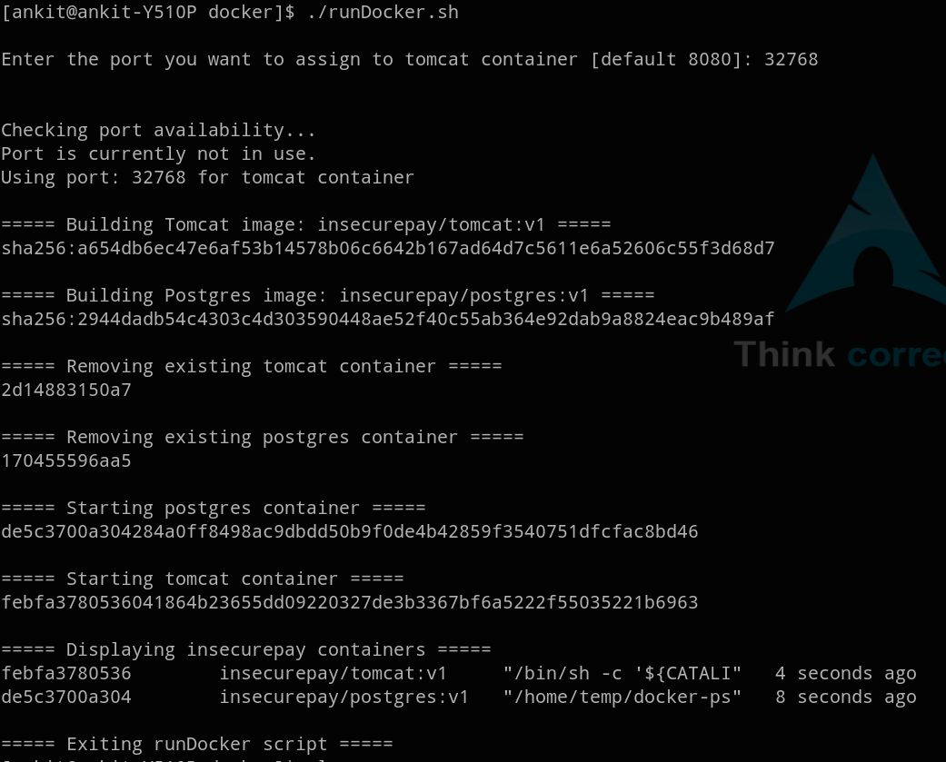

The script also checks if the the port is already in use.

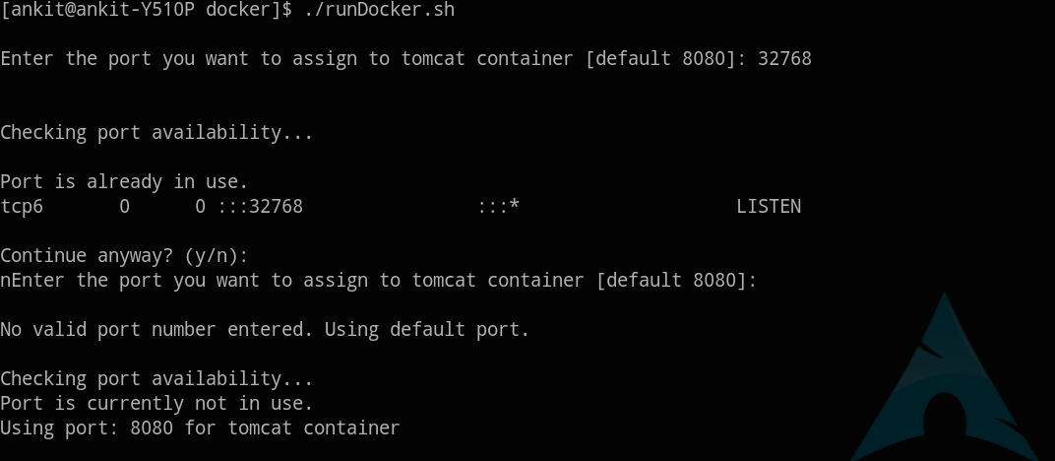

### **Checking Server**

Once the server has been started, the user can either access the GUI of tomcat to see the status of the server or use a tool like Postman can be used to ping the server.

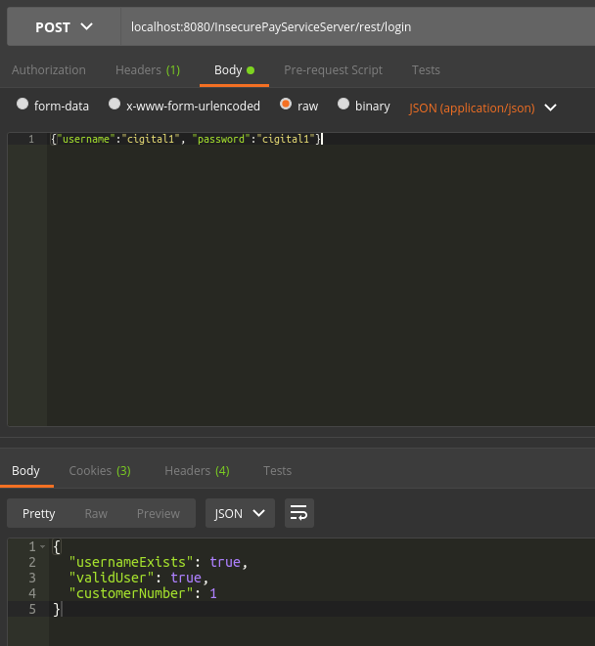

## **Application Functionality**

### **Login**

Login is the entrypoint of InsecurePay. It allows the user to validate his/her credentials before being allowed to access other services.

#### **Login function**

Valid set of username and password fields are required to log in to the mobile application. One can use “Remember Me” to store the credentials. If “Remember Me” is checked, then the username and password will be populated automatically in the respective fields for the next login.

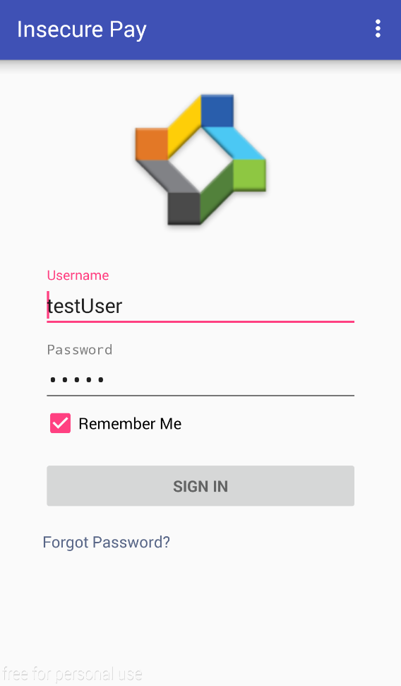

#### **Change Server Address**

For ease of using a custom server, there is an option in the Overflow Menu called “Change Server Address”. There are pre-entered values to minimize the changes a user would have to perform.

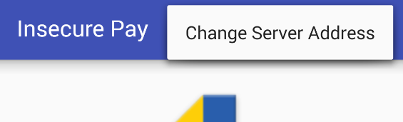

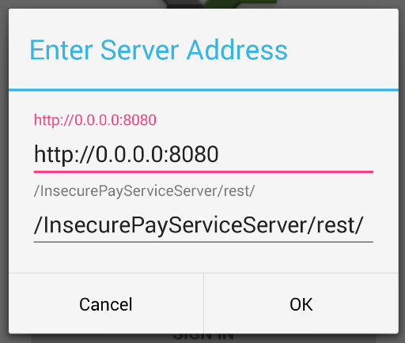

### **Forgot Password**

If the user does not remember his/her password, this option allows the user to reset it by entering selected account details, namely Account number and Social Security Number.

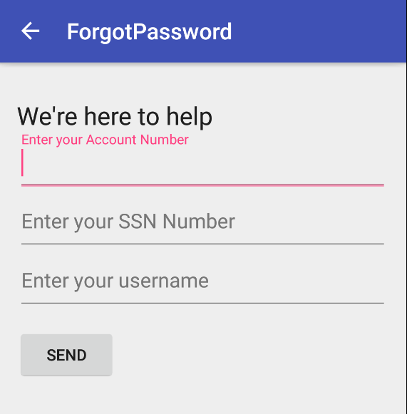

### **Home Page**

Once the user’s credentials are validated, the application logs in. Home Page is the entrypoint after that process. Here the user is shown his/her account number and the current balance.

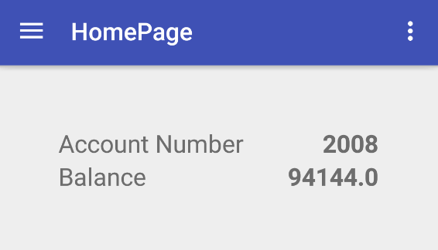

### **Navigation Drawer**

The navigation drawer is accessible only after user is logged in. On pressing the Navigation button on top left corner of the application, a list of Services is shown that the user can use. By default the user is on Home or HomePage Service.

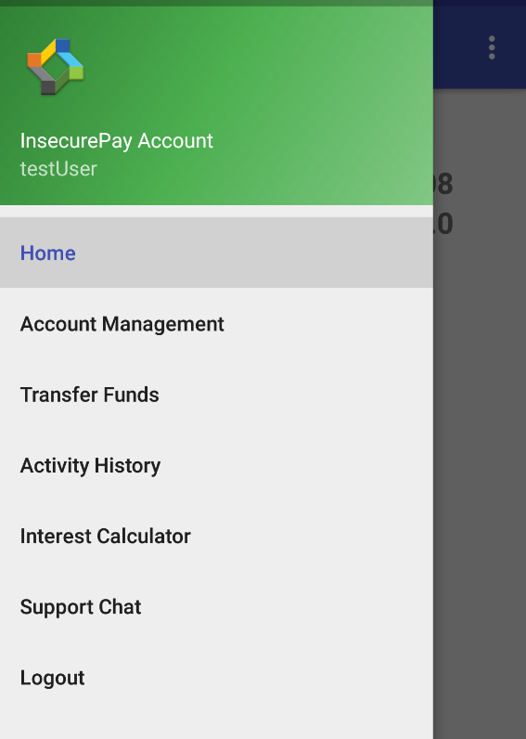

### **Account Management**

This service is only available after the user is logged in. Account Management allows the user to manage his/her user details.

#### **Updating Account**

When the user updates any of his/her details, then the Update button becomes active. A confirmation is displayed when the update is a success.

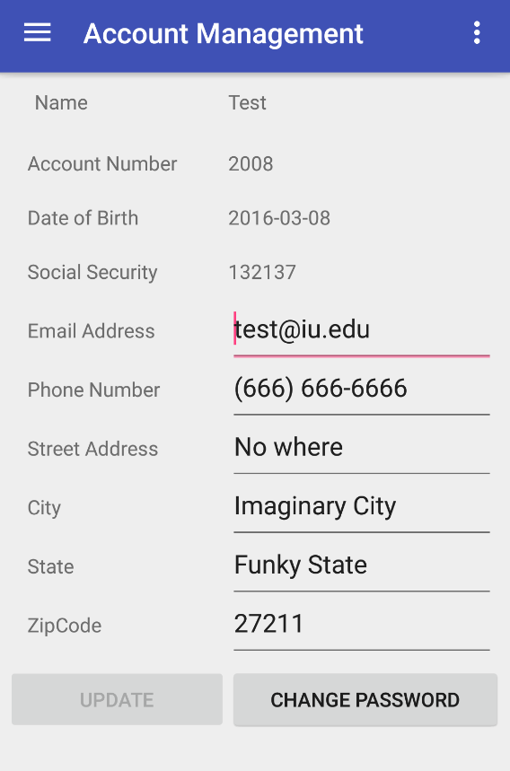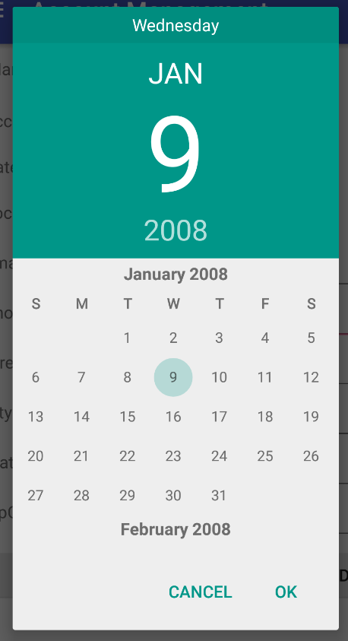

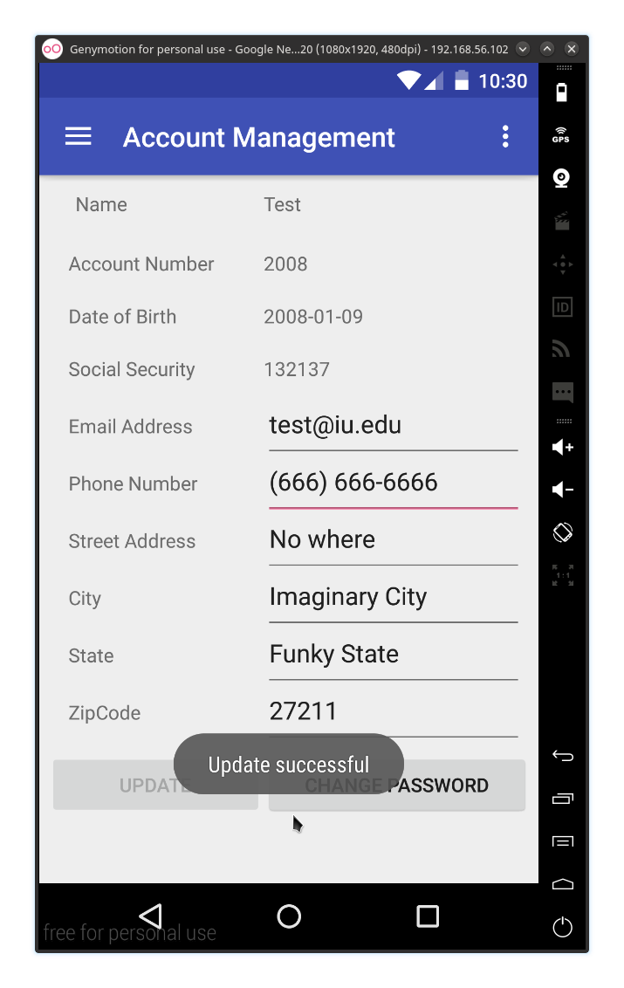

#### **Change Password**

This option allows the user to change his/her password. A confirmation is displayed if the password change is successful.

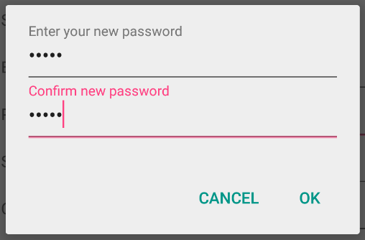

### **Transfer Funds**

This service is only available after the user is logged in. Transfer Funds allows the user to send money to other users of InsecurePay. Simply fill the details and confirm the transaction.

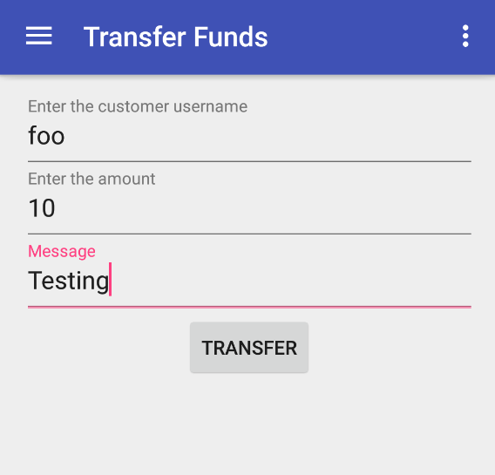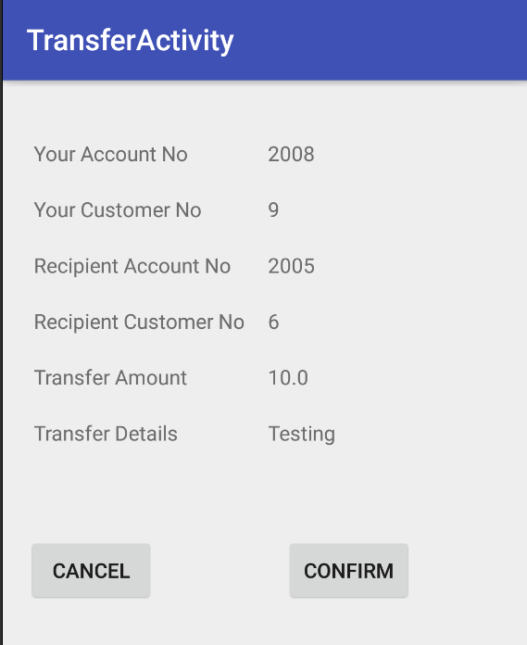

### **Activity History**

This service is only available when the user is logged in. Activity History allows the user to see the transaction history of the money sent and received by the user. Blue represents credit, while red represents debited amount.

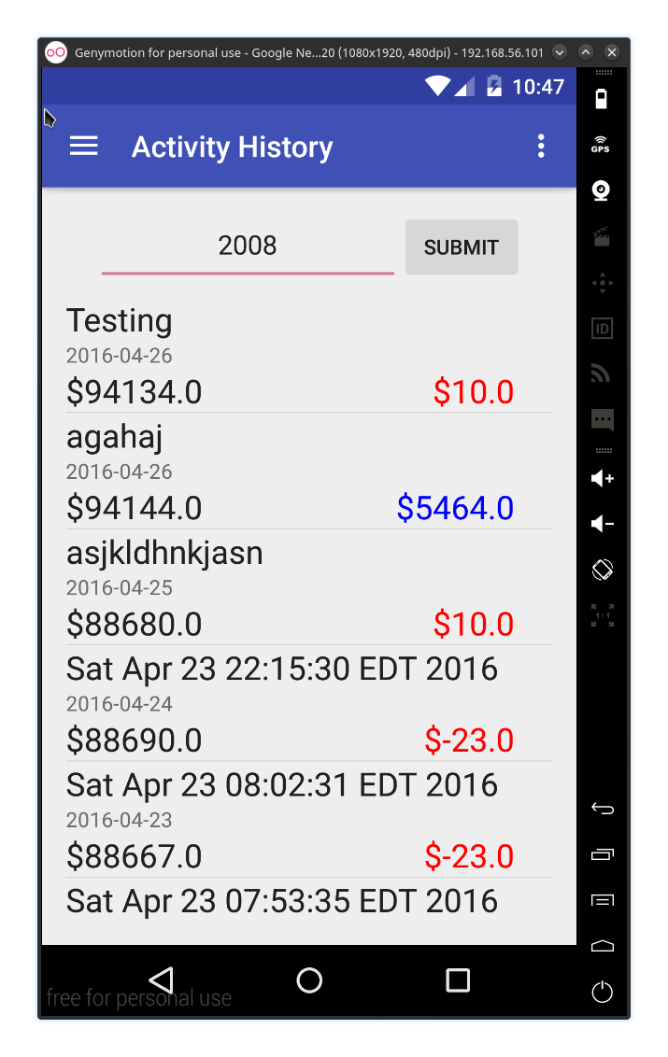

### **Interest Calculator**

This service is only available when the user is logged in. Interest Calculator allows the user to see his/her credit score, enter the loan amount and time period, and see what the payments are going to be.

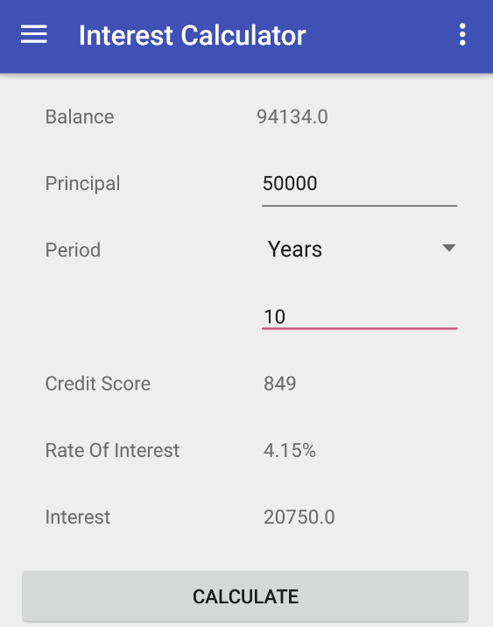

### **Support Chat**

This service is only available when the user is logged in. Support Chat allows the user to send messages to the server and/or upload a file.

#### **Sending Message**

This option lets the user send message to the server. When the server successfully receives the message, a confirmation is displayed.

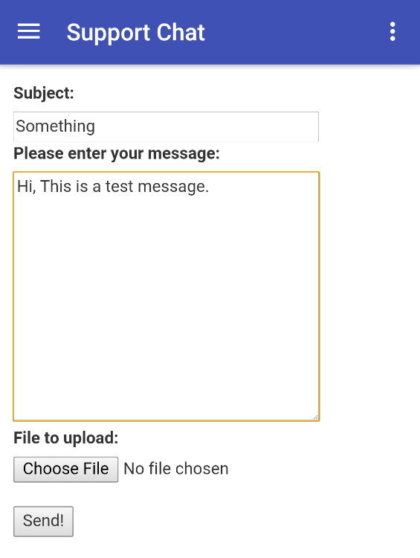

#### **Uploading File**

This option allows the user to upload a file to the server.

If the file is uploaded successfully, a confirmation is displayed.

If the file is too big to be uploaded, an error is displayed.

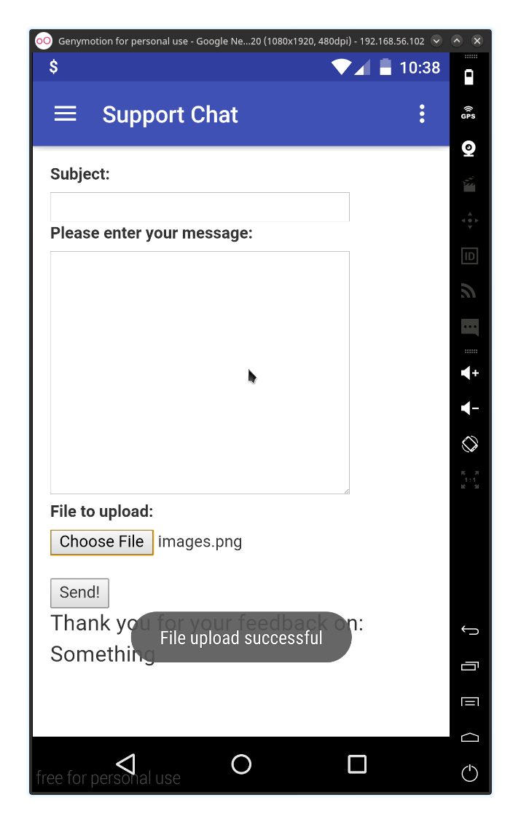

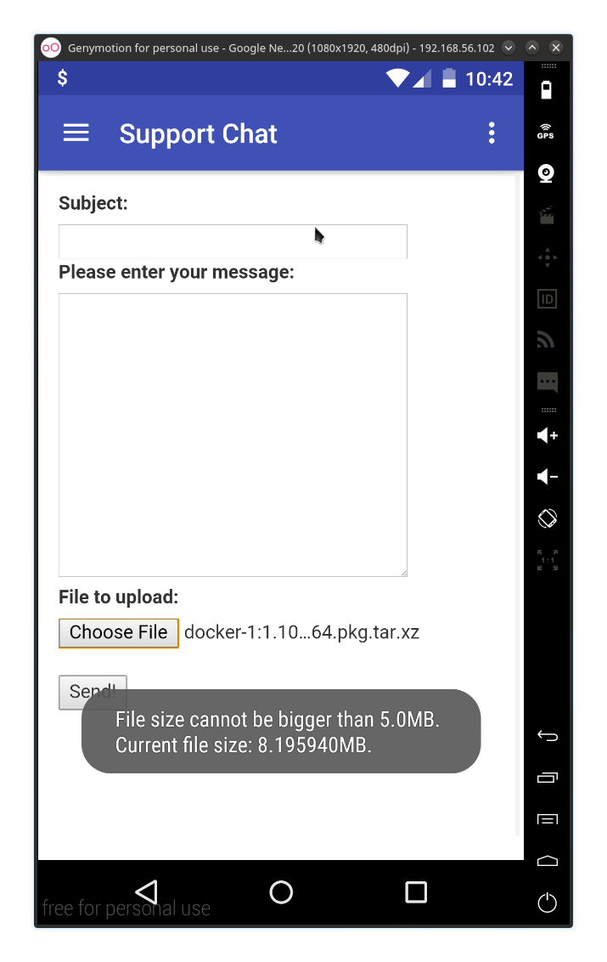

### **Logout**

This allows the user to end the current session and Logout. This can be done from the Navigation drawer or the Overflow Menu option.