## Stylistic classification of the English vocabulary

From stylistic point of view, it is important to classify the English vocabulary, as many stylistic devices are based on the interplay of different stylistic aspects of words. According to I.R. Galperin, the vocabulary of the English language can be divided into three main layers:

1. the literary layer;
2. the colloquial layer;
3. the neutral layer.

Each of these layers has its own feature: **the literary** layer has a bookish character and includes common literary words, terms, poetic words, archaic words, barbarisms and foreign words, neologisms; **the colloquial** layer has a spoken character and includes common colloquial words: slangs, jargons, professional words, dialectical words, vulgar words; **the neutral** layer is deprived of any colouring and may unite both the literary and colloquial vocabulary.

Diagram 1. Stylistic classification of the English vocabulary

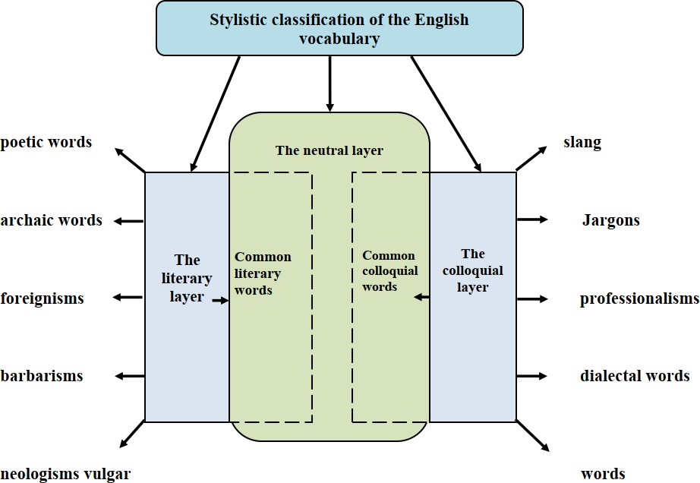

Let’s analyse each layer in details. This layer is more or less stable. The aspect of the colloquial layer is its lively spoken character – it makes this layer unstable and fleeting. As we mentioned above, the literary layer consists of common literary words, terms, poetic words, archaic words, barbarisms and foreign words, neologisms. This layer is more or less stable.

**Common literary words.** It is a well-known fact that common literary words have a bookish character. Compare:

common (neutral): *food, to eat;* bookish: *provision, to consume;* colloquial*: grub, to cram;*

**Terms** are words denoting meanings of special field of social structure. Here are some examples: linguistic terms: *synonyms, stylistics;* chemical terms: *allotropy, chemical reaction, diatomic, halogens;* medical terms: *kedneys, nephritis, embryonic, diagnosis, anatomical, blood, dieting, antibiotic, virus, syndrome* . One of the most characteristic features of a term is its usage in the language of science.

Terms are words, which can denote concepts – direct our mind to the essential quality of the thing, phenomenon or action. In this case, terms usually belong to scientific or technical style but they may as well appear in other styles – newspapers (publicistic).

**Poetic words.** This group of words has characteristic features of terms and archaic words, this is due to the fact that terms are monosemantic and archaic are out of use. Here are illustrations: morn, beauteous, woe, steed, brow, behold.

The most use of these words is to produce a satirical effect. Generally poetic words are used in poetry:

*Music to hear, why hear’st thou music sadly?*

*Sweets with sweets war not, joy delight in joy.*

*Why lovest thou that which thou reseivest not gladly,*

*Or else receivest with pleasure thine annoy?*

*If the true concord of well-tuned sounds,*

*By unions married, do offend thine ear,*

*They do but sweetly chide thee, who confounds*

*In singleness the parts that thou shouldst bear.*

*Mark how one string, sweet husband to another,*

*Strikes each in each by mutual ordering,*

*Resembling sire and child and happy mother*

*Who all in one, one pleasing note do sing:*

*Whose speechless song, being many, seeming one.*

*Sing this to thee: ‘thou single wilt prove none’.*

(W. Shakespeare. Sonnet VIII)

**Archaic words** are those which are out of use now except for special cases: *Hath (has), thy (you), methinks (it seems to me), a squire (an older man), a losel ( a lazy fellow).*

From stylistic point of view, archaic words can be found in the style of official documents, in legal language, in all kinds of statutes, in diplomatic documents, e.g. *aforesaid, hereby, therewith, here in after named etc. in poetry, in historical novels (they maintain “local colour”)*

**Barbarisms and foregnisms**. Barbarisms are words of foreign language which have not entirely been assimilated into the English language. In many cases they have English variant or synonyms, e.g. chic = stylist, bon mot = a clever witty saying, en passant = in passing, ad infinitum = to infinity. It is very important for purely stylistic purpose to distinguish between barbarisms and foreign words proper. Barbarisms are words which have already become facts of the English language. They are part of the English word-stock, though they remain on the outskirts of the literary vocabulary. Foreign words used for some stylistic purposes, do not belong to the English vocabulary and are not registered in dictionaries. In a written language they are often italicized. Both foreign words and barbarisms are widely used in various styles to supply local colour. Ex: *In press advertising, the French say that wine has “de la robe du bouquet, dela cuise”*. Ex: *The use of foreign word to describe the peculiarities of the German menu.* (Thackeray: “Vanity Fair”) “*The little boy, too, we observed, had a famous appetite, and consumed schinken, and braten, and kartoffeln, and cranberry jam… with a gallantry that did honour to his nation*”. We see that by using several German words, the author gives and indirect description of the peculiarities of the German menu and the environment on general.

**Neologisms** are words which express new ideas, notions, innovative approach and etc**.** They can produce with the help existing word-formation models of the English language, particularly due to affixation, word compounding and etc. The stylistic function of neologisms may be different when used in written text they express special stylistic effect, show the emotive meaning of words. Here are some examples: *internet, cheeseball, clickbait, filmsetter, kindertransport, viewgraph, neuroplasticity* and etc.

## Colloquial layer of the vocabulary. Common colloquial words. Colloquial words include the following large groups: 1) words which can change their phonetic form: *kina (kind of), ‘kew (thank you), doc (doctor), bunny (rabbit)* etc.; 2) words which change their form and meaning: *dolly, nestling, cully, quickie, back number,* etc. ; 3) words which change their meaning in certain contexts: he was *getting along* in years – he was growing old , let me know how you *come out* – let me know the results. etc. ;

**Slang and** j**argons.** In most cases by slangs we mean words which are used to create “names for some things” (9). Sometimes they are vulgar and cunical.

It is important to define that slangs are informal words and expressions. There are some examples from different slangs: *hat, lemon, nut, second story man, it’s a long drag (about a dull and long journey), go crackers (go mad), a big head (a boaster).* It’s quite natural that slangs are commonly used in colloqual speech.

The functions of slang depend on its usage in types of speech, particularly in the written texts may be the following: to characterize the speech of the person, to produce a special impression and humorous effect, whereas on the other hand, in oral speech it has a great expressive force.

There is an opinion according to which jargon is defined as the language difficult to understand, this might be because it is spoken badly. The vocabulary of jargon are the words existing in the language but which have acquired new meanings: there are the jargon of builders, of farmers, of thieves, of the army, of sportsmen, of businessmen, etc. Here are some examples of jargon from different field of human’s activity: *loaf (head), ec (economics), a big gun (an important person), an egg (an unexperienced pilot), a big shot (an important person), exam (examination), a great gas (talked too much without saying anything useful).*

**Professional words** are such words which are used in human’s social activity. Here are some illustrations of professional words which are used in education: *teacher, schoolboy, pupil, textbook, computer, blackboard, piece of chalk, student, university, dean, a desk and etc. The function of these words may be different: to clarify the speech of a person, to make the description more specific and realistic.*

**Dialectal words** are words belonging to a certain region or district: *daft, fash, a lass, volk, zee, collen to coom, cows, poppy* and etc. Dialectal words are widely used in speech, especially in oral and in emotive prose. The following function of dialectal words may be distinguished: characterising a person, his breeding and education through his speech.

Cockney is a special dialect of the working class of London. Cockney dialect is made up of a collection of slang words. Here are some typical expressions of Cockney “*Put us in for a cows. I’ve done me poppy and the linens reckon the favourite’ll walk it* “. The translation is: *Lend me ten shillings. I have lost my money and the newspapers say the favourite will win it.* “

## Questions for discussion:

1. What are the main layers of the English vocabulary?
2. What are the functions of terms in the different types of text?
3. What are functions of archaic words in the text?
4. Do you see the difference between barbarisms and foreign words?
5. Give the dictinctions existing between a slang and a jargon?
6. What is the role of professional words in the text ?
7. What functions do dialectical words?
8. What is cockney?

## Text 1.Complete the text using the words given below and define the type of their layer

Uzbekistan is known to be the land of one of the most ancient civilizations on the /1/ __-Bactria and Sogdiana. The hand of statue of Buddha made of /2/______in thé 2nd-3rd centuries has been found during archaeological /3/_____ of a Buddhist temple on the site of Dalverzintepa in

the south of Uzbekistan. The ceramic /4/ ___of Botisatva-Buddha’s disciple, dating from the 6th-7th centuries — were also found in Kashkadarya Region of Uzbekistan. The findings enabled the scientists to conclude that Budhism had /5/ ____here from ancient Bactria.

The Uzbek /6/ ___was being formed at the turn of the 15th century under

Sheibani-khan. The achievements of the Uzbek people in agriculture, irrigation, science, arts, /7/___ and crafts in the Middle Ages are worthy of comparison with any other ancient peope living in those times. Important was

the role of the Great Silk Road. It /8/ ___several cities of Uzbekistan and

bound together Europe and Asia. All kinds of goods including the wares of the

local /9/____ were brought and spread the world over by the /10/ Great Silk Road.____of the

|  |  |  |  |  |  |  |  |  |  |
| --- | --- | --- | --- | --- | --- | --- | --- | --- | --- |
| 1 | 2 | 3 | 4 | 5 | 6 | 7 | 8 | 9 | 10 |

* 1. Gypsum; b) nation ; c) excavations; d) globe; e) warfare;

f) passed through; g) penetrated; h) caravans; i) effigies; j) potter-masters.

## Text 2. Complete the text using the words given below define the type of their layer

A book is our old and faithful friend, which opens access to knowledge, ideas, spiritual and moral values, to understanding of the beauty and creative /1/ ___of the mankind. It introduces to the customs and traditions of the like a window into the world of cultural /2/__, links different civilizations in space and time.

It was born in Mesopotamia five thousand years ago. Instead of sheets of paper it had clay /3/ ___with scratched letters, and a wooden box instead of a /4/___ . Soon the tablets were replaced by long strips of /5/___. A reed with black paint served for writing, and the first line was traditionally /6/__. This is how a paragraph was originated.

A couple of centuries later papyrus was replaced by paper, which was initially made from /7/___ /, /8/___, soaked and boiled with ashes. Later on it was made of wood /9/____. Soon it was used everywhere, and with the

/10/___ of time gave the birth to the concept of ‘copyright’

|  |  |  |  |  |  |  |  |  |  |
| --- | --- | --- | --- | --- | --- | --- | --- | --- | --- |
| 1 | 2 | 3 | 4 | 5 | 6 | 7 | 8 | 9 | 10 |

а) flax and cotton; b) lapse; c) shavings; d) achievements; e) red; f) diversity; g) rags; h) cover; i) tablets; j) papyrus.

## Text 3. Complete the text using the words given below and define the type of their layer

To be given an Arabic trotter as a gift is not unusual for a ruler, especially in countries in Asia and the Near East. To be presented with a hunting /1/ is quite a rare stroke of luck --- it is like a /2/ in a beautiful setting.

One can imagine the relaxation, fun and amusements the /3/ enjoyed during their times of falconyry when looking at art miniatures and poems /4/ such as “ The Turmoil of the Sacred”, “Farkhad and Shirin”, “Leili and Mejnun”, “Seven Planets”, “Alexander’s Wall” and “The Language of Birds”. The 12 th sheet, kept at the Oxford University Bodlean Library, describes the scene “Awaiting the hunt”: courtiers with a falcon adorned with special /5/ made of gold, wearing a harness made of the finest leather. The golden /6/ has a decorative diamond while the cap is decorated with a small /7 / plume made of owl feathers and a silver bell.The hunter uses a special glove for protection. An

Arabic dapple-white /8/ makes a beautiful contrast with the emerald surroundings. This gift is presented to mighty rulers in the guest of honour.

The revival of birds hunting, an ancient tradition throughout Central Asia is quite significant. A well-trained balloban falcon, skilled in hunting wild birds, or a golden eagle, able to overtake a fox, a jackal or even a young wolf, may cost the same as one or two / 9 / cars. This is not surprising --- Mercedes cars are being produced one after the other, while it takes several years to train a falcon in a special /10 / for hunting.

|  |  |  |  |  |  |  |  |  |  |
| --- | --- | --- | --- | --- | --- | --- | --- | --- | --- |
| 1 | 2 | 3 | 4 | 5 | 6 | 7 | 8 | 9 | 10 |

a) diamond ; b) accoutrements ; c) trotter ; d)school; e) helmet;

f) falcon; g) emirs; h) by Alisher Navoi; i) plume; j) Mercedes