## 7. Functional styles

Functional styles - scientific, conversational, business, poetic, oratorical, and journalistic-are subsystems of the language, each of which has its own specific features in lexeme and phraseology, in syntactic constructions, and sometimes in phonetics.

The emergence and existence of functional styles is due to the specifics of the conditions of communication in different spheres of human activity. It should be borne in mind that styles differ both in the possibility or impossibility of using certain elements and structures, and their frequency ratios. A special technical term , for example, can occur in a colloquial style, but the probability of its appearance here is completely different than in a technical text on this specialty, because the terms for the colloquial style are not typical. A number of scientists are already engaged in obtaining statistical data that assess the probability of each element of the language structure in terms of its functioning in different functional styles. Statistical patterns are revealed in relation to the length, morphemic and etymological composition of words, the distribution of parts of speech, the semantic fields represented in the texts, the length of sentences, etc.

The name "functional style" seems to be very successful, because the specifics of each style follows from the features of the functions of the language in this area of communication. So, for example, the journalistic style has the main function of influencing the will, consciousness and feelings of the listener or reader, and the scientific style-only the transmission of intellectual content.

I.R. Galperin gives the following definition of functional styles : “ An FS is a patterned variety of literary text characterized by the greater or lesser typification of its constituents, supra-phrasal units (SPU), in which the choice and arrangement of interdependent and interwoven language media are calculated to secure the purport of the communication ”

As to Ashurova D.U. “ passing over to the problem of functional styles, it should be stressed that each functional style serves a definite aim in communication fulfilling specific functions.In other words, a functional style is regarded as a product of a certain concrete communicative task set by the sender of the message. The correlation between communicative aim and functional styles can be presented as follows:

Belles-letters style - to produce an aesthetic influence on the reader (listener);

Publicistic style - to exert a constant and deep influence on the public opinion and to cause the reader to accept the point of view expressed in the text;

Newspaper style – to inform and influence the public opinion on political and other matters;

Scientific style – to prove a hypothesis, to create new concepts;

The style of official documents – to reach agreement between two contrasting parties.

M.A. Socolova states that “ the category of style is not new in linguistics. The branch of linguistics that is primary concerned with the problems of functional styles is called **functional stylistics**. Stylistics is usually regarded as a specific devision of linguistics, as a sister science, concerned not with the elements of the language as such but with their expressive potential.

In the well-known conception suggested by academician V.V. Vinogradov, three functions are distinguished, that is the function of communication (colloquial style), the function of informing (business, official and scientific styles) and the emotive function (publicistic style and the belles-lettres style). Classification of this kind actually reflects some of the aspects of stylistic phenomena. Nowever, the criterion of distinguishing styles does not seem accurate enough. Schematically it can be presented as:

**I.V. Аrnold’s clаssificаtion of functionаl styles:**

**Diagram 6.**

|  |  |  |  |
| --- | --- | --- | --- |
| Functionаl styles | | |  |
|  |  | | |
|  | Colloquial | |
|  |
|  | | |
|  | Oratorical | |
|  |
|  | | |
|  | Poetic | |
|  |
|  | | |
|  | Publicistic | |
|  |
|  | | |
|  | Newspaper | |
|  |
|  | | |
|  | Official | |
|  |
|  | | |
|  | Scientific | |
|  | |

**I.R.Galperin’s clаssificаtion of functionаl styles:**

**Diagram 7.**

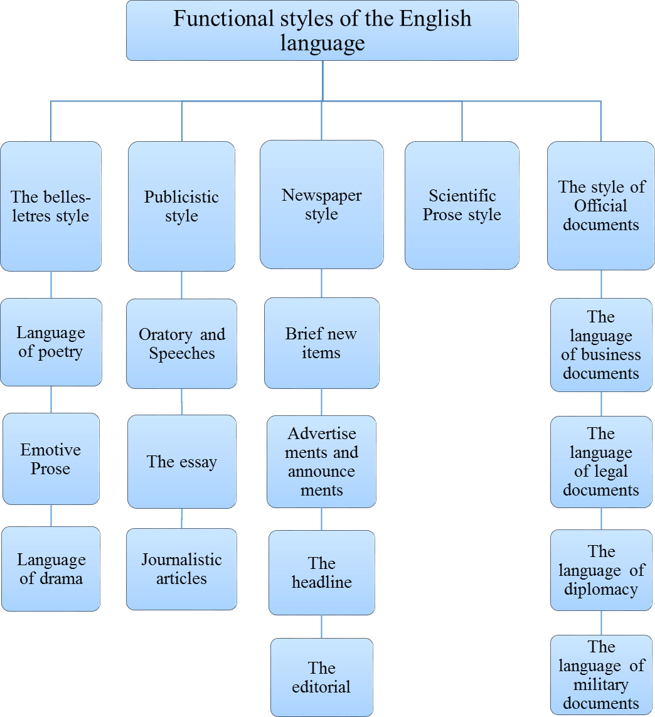

**M.D.Kuznets` clаssificаtion of functionаl styles:**

**Style Classes**

**Litrary, or “Bookish” style**

Publicistic Style

Scientific (Technological) style

Official documents

**Free (“Colloqual”) Style**

Litrary Colloquial style

Familiar Colloquial style

**Diagram 8.**

**A.N.Morokhovsky`s clаssificаtion of functionаl styles:**

**Diagram 9.**

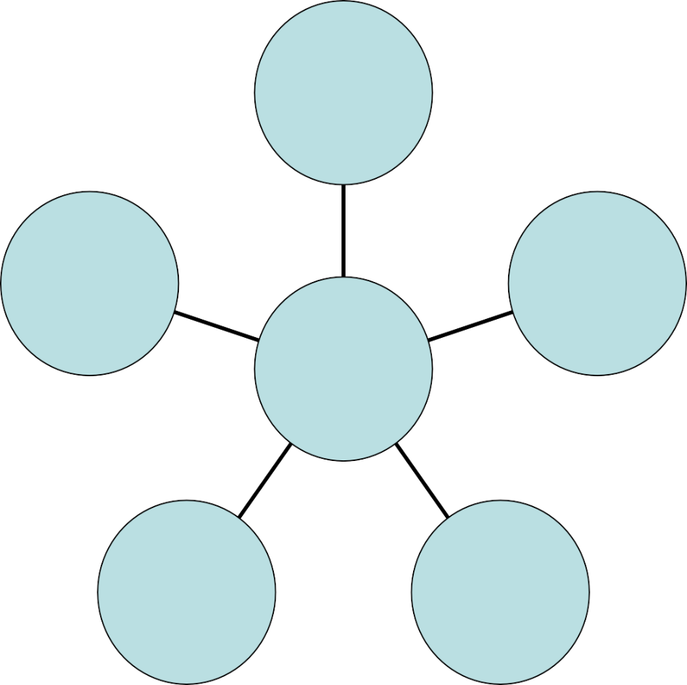

Official Business Style

Publicistic Style

Scientific- professional Style

**Style**

**Classes**

Familiar Colloquial Style

Litrary Colloquial Style