A New Algorithm for Second Order Perturbation Theory
Andrey Asadchev and Mark S. Gordon

Abstract
A new second order perturbation theory (MP2) algorithm is presented for closed shell energy evaluations. The new algorithm has a significantly lower memory footprint, a lower FLOP (floating point operations) count, and a transparent approach for the disk/distributed memory storage of the MP2 amplitudes. The algorithm works equally well on a single workstation, small cluster, and large Cray cluster. The new algorithm allows one to perform large calculations with thousands of basis functions in a matter of hours on a single workstation. While traditional MP2 calculations are frequently eclipsed by density fitting and resolution of the identity methods, the approaches and lessons learned in the implementation presented here are applicable beyond the MP2 algorithm.

1. Introduction

The integral transformation, also known as the 4-index transformation, is required for many electronic structure computations, including methods that include electron correlation and the analytic computation of energy second derivative. Of particular interest in the present work is the use of this transformation in second order perturbation theory (called MP2 for second order Moller-Plesset or MBPT2 for second order many body perturbation theory). In general, the 4-index transformation typically transforms atomic integrals to molecular integrals via the simple formula:

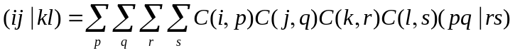 (1)

Using a common convention, occupied molecular orbitals (o) are designated by indices 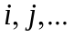, virtual molecular orbitals () are designated by indices 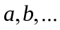, and atomic orbitals () are designated by indices 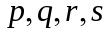.

Typically, several classes of molecular integrals are needed, e.g., 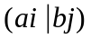, 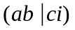, etc. In the particular case of MP2, one only needs integrals to compute the amplitudes and energy, respectively:

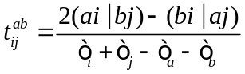 (2)

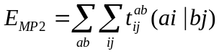 (3)

In Eq. (2) the denominator contains the orbital energies for the occupied and virtual molecular orbitals (MOs). Note that only the integrals (sometimes called (vo|vo) integrals) are needed to form the 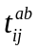 MP2 amplitudes and the MP2 energy. The integrals, and consequently the amplitudes have symmetry such that 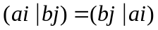 which can be used to halve the storage requirements and the number of computations.

The MP2 energy calculation scales as 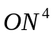 and requires 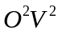 integral storage, where N, O, and V refer to the number of atomic basis functions, the number of occupied MOs and the number of virtual MOs, respectively. The MP2 method is the least computationally demanding many-body method; it is also the many body method with the lowest compute to I/O ratio.

A number of different MP2 algorithms have been developed over the years, [1,2,3,4,5] due to the simplicity of the method and its popularity. [There are many errors in the references that must be corrected. See ref. 1 for example. The authors names in reference 3 are incorrect and should not be all caps. Check ALL references carefully. Do the same for the CC paper.] The above methods all have shortcomings. The algorithm described in reference [1] is a serial direct method; the integrals are computed on-the-fly and the algorithm does not require any storage other than core memory. However, if the storage required is greater than the available memory, the integrals must be re-evaluated, making the algorithm expensive. The algorithm described in reference [2] is a serial semi-direct method: partially transformed integrals are stored. However, the algorithm does not scale beyond a few hundred basis functions. The distributed memory algorithm [3] does run in parallel, using distributed memory to store partially transformed integrals. However, the implementation is inefficient: the innermost loops have an unfavorable structure, the I/O overhead is high due to poor data locality, and the core memory overhead limits the size of the job. The disk-based parallel algorithm in reference [5] is the recent improvement over the existing set of algorithms: it has favorable I/O patterns, fast execution, and low memory overhead. Its only drawback is the reliance on fast disk, which is often not available on large clusters with only network file systems. [There are some missing references that must be included. For example, the I. Nielssen method is the most well known paper on parallel MP2. This aspect is important and relevant.]

The aim of the present work is to improve the MP2 algorithm according to the following guidelines:
- Keep the number of operations low and use optimized math libraries to carry out all integral transformations.
- The memory overhead must be low enough to allow computations with several thousand basis functions and several hundred occupied orbitals on current computer hardware. This means that per-core memory overhead must not be more than a gigabyte or two.
- The algorithm must be adaptable to using either file system or distributed memory as a storage medium. Furthermore, the algorithm should be able to run efficiently on systems with various memory, storage, and interconnect configurations.
- The I/O overhead must be low enough to run off a network file system efficiently
With these guidelines in mind, a new algorithm is developed that runs at least as fast as the current fastest parallel implementation [5], runs equally well on a single workstation and the 1024-core Cray XE6 cluster, can use either disk or distributed memory storage, and can handle an input problem of more than 4000 basis functions.

2. Matrix chaining
There exists a simple matrix multiplication property [6], which, surprisingly, is not very well-known in computational chemistry. Given three (or more) matrices (e.g., B, C, D), the matrices can be multiplied without changing the outcome by two different orders:
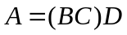 (4)
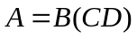 (5)
At first glance, the above fact may appear to be uninteresting, until one considers the number of operations required for the two expressions. Suppose, for example, that the general dimensions are 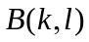, 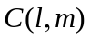, 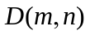, and 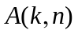. The number of operations are 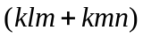 and (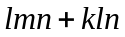) for Eqs. (1) and (2), respectively. Of course, if B, C, and D are all square matrices with the same dimension, there is no difference between and ().

The difference in the number of operations that are required for Eq. (4) vs. Eq. (5) can be exploited to dramatically reduce the number of operations in integral transformations. Note that the un-factorized 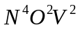 complexity of the integral transformation in Eq. (1) can be reduced to either 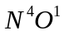 or 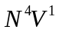by doing one transformation at a time at the cost of the storage of the partial transformation intermediates. Suppose the integral transformation (using Einstein convention) is applied in the naive left-to-right order, virtual index first:
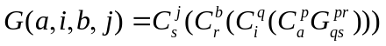

Then, the total number of operations is:

If the transformations are applied occupied index first,

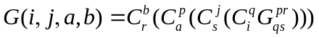

then the number of operations is:

and the difference between the two is on the order of the factor 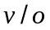. Considering that typically , the computational savings can be significant. The second benefit comes from reduced memory requirements. Since the first two occupied transformations “shrink” atomic indices to much smaller occupied dimension, the entire tensor is quickly reduced to 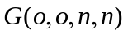 storage, rather than much larger 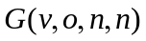 storage. For example, with 19H₂O cluster and aug-cc-PVQZ basis the difference between the two approaches is 12.3 times with respect to the number of operations and memory.

3. General Algorithm Considerations
To have a scalable algorithm, a special attention needs to be paid to memory footprint, I/O patterns, and I/O optimization by means of aggregation of smaller transfers into larger blocks.

1. Memory
The algorithm must have small memory print, under 1G per core on current hardware, even for large computations with several thousand basis functions. In terms of basis functions and shells, the memory overhead must be on order of 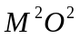, where M is some adjustable blocking factor, for example the size of largest shell in the basis set, otherwise any significant computation would require nodes with ten or more gigabytes of memory per core. For example, a computation with 3000 basis function and 300 occupied orbitals requires 22GB per core if memory were to scale as 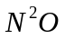. The blocking factor must be adjustable to adapt to computers with different number of cores and memory.

2. I/O Considerations
For any significant problems size, the integral arrays size is too great to store in core memory. GAMESS [6], for example has several MP2 algorithms, including two which are parallel disk-only [5] and distributed memory [3] implementations. However, using modern programming techniques, the same algorithm can be adapted to both, disk and distributed memory. The efficient access patterns between distributed memory and disk are the same: large contiguous transfers are preferred. Typically disk has much worse throughput than the distributed memory. If an algorithm works well with disk, it is guaranteed to work well with distributed memory, even when running over slow Ethernet networks.
The general efficacy for using disk is outlined by Pulay [4]. In short, smaller research groups may not have access to computers with large memory, but access to workstations with large fast disks is very common.
There is one important detail: due to buffering, writes tend to be significantly faster than reads. Therefore, algorithms which both read and write large datasets should be optimized in favor of reads.
The latency of storage access can be hidden by overlapping I/O and computations. This can be accomplished either by having a number of threads perform computations and I/O independently of one another or having a single I/O thread perform data transfers while the other thread perform computations.
Implementation transparency, e.g. distributed memory or file implementation, is easily accomplished using polymorphic functions, i.e function calls that may resolve to two or more implementations during runtime without affecting the logic of the caller. For example, the MP2 program would choose to use distributed memory if enough is available, otherwise it would default to filesystem backend. But regardless of the runtime decision, the algorithm itself and its implementation would be exactly the same.
In C++, the language of the implementation, this is done using virtual functions.

3. File I/O considerations
There are two de facto file format and their corresponding libraries that allow easy manipulation of multidimensional scientific data on filesystem, HDF5 [7] and NetCDF[8]. For the purposes of implementing dense tensor storage, the two file formats are comparable in performance and capabilities.
Storing data on the single node is straightforward. However, parallel storage requires parallel file system. There are number of parallel filesystems, for example PVFS and Lustre. PVFS is easily configurable filesystem, suitable for local clusters. Lustre is more complicated filesystem, found for example on Cray supercomputers. Regardless of a particular filesystem, the principle is similar to that of RAID0: an entire file is stripped over a number of I/O nodes. The performance of parallel filesystem primarily depends on the strip size and the number of I/O nodes. Both HDF5 and NetCDF have facilities for parallel I/O.

4. Naive Approach
A simple MP2 approach is described in Listing 1.

allocate V(O*O/2,N,N); // (ia|jb) storage
for S in Shells {
for Q <= S {
for R in Shells {
for P in Shells {
// skip insignificant ints
if (!screen(P,Q,R,S)) continue;
t1(i,R,Q,S) = eri(P,Q,R,S)*C(i,P);
}
t2(i,j,Q,S) = t1(i,R,Q,S)*C(j,R);
}
// exploit symmetry
V.store(t2(ij,Q,S));
V.store(t2(ji,S,Q));
}
}
// 3rd index
for s in N {
t2(ij,Q) = V(ij,Q,s); // load NO^2 tile
t3(ij,a) = t2(ij,Q)*C(a,Q); // transform
V(ij,a,s) = t3(ij,a)); // store VO^2 tile
}
// 4th index + energy computation
for a in V {
t3(ij,S) = V.load(ij,a,S); // load NO^2 tile
t4(ij,b) = t3(ij,S)*C(b,S); // transform
E += Energy(t4); // evaluate energy
}
Listing 1. Naive approach

The main points about the simple implementation:
- The integral symmetry is exploited in Q,S shells. The half transformed integrals 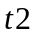 are written as triangular matrices, 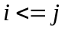 as well as its transpose 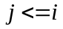. If running on multiple cores, each Q,S pair can be evaluated independently, allowing to benefit from overlapping computation/write.
- Integral computation and first transformation are screened using Schwarz method. Subsequent transformations are not screened.
- The matrix transformations can be done using BLAS matrix routine. Several shells can be transformed at the time to increase efficiency. The temporary memory is on the order of 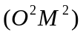.
- 3rd transformation is straightforward, temporary memory required is 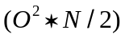 where  is the number of basis functions.
- the fourth transformation requires noncontiguous read. As mentioned above, the disk is not efficient to handle noncontiguous read. For a large problem, the 4th step becomes increasingly slow, rendering this approach extremely inefficient.

5. Better Algorithm
What is desired is an algorithm which still exploits symmetry but is somehow able to load untransformed index contiguously to maximize throughput.
If the integrals were stored as 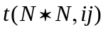 arrays, then it would be a simple matter of reading contiguous blocks corresponding to an occupied index, transforming them, and evaluating energy, all at a cost of single read only. Keep in mind that the quantity 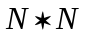 is a relatively small, only 200MB for 5000 basis functions.
The problem is then how to write such data efficiently since it is generated as 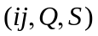 shell pair at the time. Writing individual shell pairs at a time to form 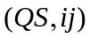 is inefficient, for example in the case of s-shell pair, it would require a long noncontiguous write. However one can notice that to generate occupied transformation, very little memory is needed. This fact can be exploited to evaluate and to write a block of 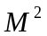 functions at a time. For example, assuming 500 occupied orbitals, working memory required is 1MB per shell function, therefore a block of 256 functions, e.g. 16 sp-shell pairs, is only 256MB but those 16 separate writes can now be aggregated into a single large write.
By writing and its symmetric transpose 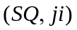 next to each other, the contiguous section of write can be further doubled.
The fact that the virtual index transformation is also relatively small in terms of memory can be used to further improve I/O. If an entire node has 2 GB of memory, 10 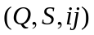 blocks can be loaded at once. This means the tensor storage can be re-dimensioned from 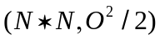 to 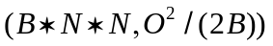, with 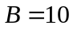 in the example, and consequently the writes can now be 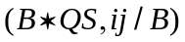, with atomic and occupied orbitals interleaved. If 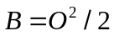 then the algorithm is essentially in-core version. The graphical depiction of the access patterns is outlined in Figure 1.
INCLUDEPICTURE "\\\\vmware-host\\Shared Folders\\home\\andrey\\writings\\mp2\\figure.eps" \* MERGEFORMATINET 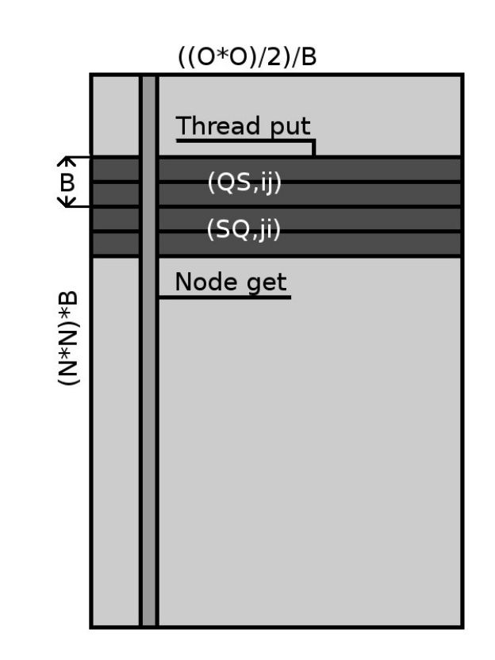
Figure 1. Integral access patterns
Combining the above ideas, one can develop the following algorithm, Listing 2, which has contiguous writes of size 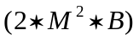 and reads of size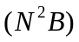, with  and  factors determined by setting runtime memory limits.

B = ...; // some blocking factor, according to available memory
allocate V( N*N*B, (O^2/2)/B );
for (S,Q) in Blocks(Q <= S, M) {
// block QS pairs into blocks of M functions
for R in Shells.blocks {
for P in Shells.blocks {
// skip insignificant ints
eri.screen(P,Q,R,S));
t_(i,S,R,Q) = eri(S,R,Q,P)*C(i,P);
t1(i,S,Q,R) += t_(i,S,R,Q);
}
t2(j,i,S,Q) = t1(i,S,Q,R)*C(j,R);
}
t(QSB,ij/B) = t2(j,i,S,Q); // the shell order is scrambled
V(QSB,ij/B) = t(QSB,ij/B); // write block
V(SQB,ji/B) = t(QSB,ij/B); // and symmetrical transpose
}
// 4/3 index
for ij in (O^2/2)/B {
t(QSB) = V(QSB,ij);
for (i,j) in B {
t2(Q,S) = t(QS(i,j)); // unscramble shell order
t3(a,S) = t2(Q,S)*C(a,Q)
t4(a,b) = t3(a,S)*C(b,S);
E += Energy(t4);
}
}
Listing 2. Better approach

The main points about the above implementation:
- The integral symmetry is exploited in Q,S shells. The half-transformed integrals are written independently and can be computed in parallel.
- The QS list is processed in terms of blocks of shell pairs, rather than individual shells pairs. The optimal block size will depend on the available memory. The bigger the block size, the better in general.
- The transformed integrals are scrambled such that shells are interleaved with blocks of indices of size B. The contiguous size of this noncontiguous write is 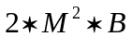.
- The 3rd/4th transformation reads the contiguous interleaved blocks. The shell order is unscrambled one occupied pair at a time, the unscrambled block is transformed and the corresponding energy is computed.
- The read operation to fetch next block can overlap with computation.
The 2 innermost transformations are responsible for most of the computational work, therefore it is important to have it as efficient as possible in terms of performance and memory footprint. For any given shell pair 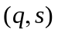, the entire 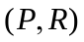 ERI list is evaluated in terms of blocks of identical shells, to minimize integral initialization overhead. Each individual block is contracted to first occupied index. Once a given  block is finished, it is then transformed to second occupied index. Each transformation can be carried out using dgemm, making sure that screened out integrals are absent from transformation.

6. Performance
There are a number of points which are useful to judge performance, scalability, and flexibility of the algorithm:
- How the new approach compares to similar algorithm
- how to network interface affects performance
- The relative time spent in ERI, transforms, and I/O

The two computer systems used to carry out benchmarks are:
- Exalted, an Intel cluster connected by InfiniBand (IB). Each node has one 6-core Intel X5650 processor, 24 GB of RAM, one Fermi C2050 graphics processor. Two hard drives in RAID0 configuration.
- Cray XK6, with Gemini interconnect. Each node has two 16-core AMD 6200 processors, 64 GB of RAM. Lustre parallel filesystem, 8 I/O nodes.

All inputs used to carry out benchmarks are listed in Table 1.

Table 1. Inputs and Basis.
Input | Atomic | Occupied | Virtual | Storage (GB)
Taxol/6-31G | 660 | 164 | 434 | 47
Taxol/6-31G(d) | 1032 | 164 | 806 | 115
Taxol/cc-pVDZ | 1185 | 164 | 959 | 151
Taxol/aug-cc-pVDZ | 2009 | 164 | 1659 | 434
19H₂O/aug-cc-pVTZ | 1995 | 76 | 1653 | 92
Valinomycin/cc-PVTZ | 4080 | 222 | 3300 | 3300

First, lets compare performance to DDI and IMS implementations in GAMESS to show poor performance of the former and much better performance of the latter on the Exalted cluster connected by InfiniBand. The two inputs are a Taxol molecule, with small 6-31G and larger 6-31G(d) basis, Table 2. Due to distributed memory (DM) requirement, the DDI algorithm cannot run on a single node unless the input is very small. Furthermore, the DDI code is extremely slow compared to both, the IMS and the new implementation, by more than a factor of 10X. Furthermore, DDI MP2 memory requirement scales as 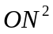 making it suitable only for small calculations: anything beyond 1000 atomic basis functions would require over 1GB of local memory per core, leaving little room to scale.
Table 2. Exalted Benchmarks, compared to DDI [3] and IMS [5].
Input | Cores/Nodes | Algorithm | Storage/Network | Time(mins)*
Taxol/6-31G | 24/4 | DDI | DM/IB | 39.7
Taxol/6-31G | 24/4 | IMS | Disk/IB | 3.7
Taxol/6-31G | 24/4 | New | DM/IB | 3.1
Taxol/6-31G(d) | 36/6 | DDI | DM/IB | 86.3
Taxol/6-31G(d) | 36/6 | IMS | Disk/IB | 7.5
Taxol/6-31G(d) | 36/6 | New | DM/IB | 5.4
Taxol/cc-pVDZ | 6/1 | IMS | Disk/IB | 116.6
Taxol/cc-pVDZ | 6/1 | New | Disk/IB | 76.0
Taxol/cc-pVDZ | 60/10 | IMS | Disk/IB | 12.7
Taxol/cc-pVDZ | 60/10 | New | DM/IB | 7.9⁽¹⁾
Taxol/cc-pVDZ | 60/10 | New | DM/1Gbe | 19.3
19H₂O/aug-cc-pVTZ | 6/1 | IMS | Disk/IB | 858.5
19H₂O/aug-cc-pVTZ | 6/1 | New | Disk/IB | 498.3
19H₂O/aug-cc-pVTZ | 60/10 | IMS | Disk/IB | 121.0
19H₂O/aug-cc-pVTZ | 60/10 | New | DM/IB | 49.9⁽²⁾
19H₂O/aug-cc-pVTZ | 60/10 | New | DM/1Gbe | 54.5
* superscripts ^{(1),(2)} refer to computation breakdown, Table 3.

The next set of benchmarks, to illustrate advantage of the new approach over the IMS algorithm, are Taxol/cc-pVDZ and 19H₂O/aug-cc-pVTZ, Table 2. The first input, Taxol/cc-pVDZ, is less computation intensive but requires 50% more storage and consequently I/O whereas the second input, 19H₂O/aug-cc-pVTZ, is computation heavy due to diffuse (less screening) functions. The new implementation is a clear improvement over the existing IMS disk algorithm, especially when diffuse functions are present, being faster by almost factor of two. The implementation scales on small cluster, even when running over the 1Gbe Ethernet interface, although more I/O bound Taxol/cc-pVDZ calculation performance deteriorates quickly. In case of computationally heavy water cluster input, the difference between Ethernet and InfiniBand is about 10%.

The breakdown of each step of Taxol/cc-pVDZ and 19H₂O/aug-cc-pVTZ calculations is given in Table 4: T1-T4 are the transformation steps and sync is the overall synchronization time. In both cases the integral calculation (Eri) accounts for significant fraction of time. The water cluster calculation has almost all of its work concentrated in the integral and first transformation (T1) part due to much less screening, as opposed to sparser Taxol calculation. In both cases, the total I/O (WRITE and READ) accounts for around 1% of the total runtime. If the computational power were to suddenly increase, the algorithm would still be viable due to low I/O overhead.

Table 3. Exalted Parallel Benchmarks Breakdown. All values are the percent of total runtime.
Benchmark | Eri | T1 | T2 | WRITE | READ | T3+T4 | sync
(1) | 38.2 | 28.9 | 6.2 | 0.77 | 0.37 | 23.7 | 1.9
(2) | 39.3 | 45.5 | 6.1 | 0.003 | 0.7 | 4.0 | 4.4

The next set of benchmarks is to illustrate capability the algorithm on a large cluster, Cray XE6. Two inputs are used, Taxol/aug-cc-pVDZ and Valinomycin/cc-PVTZ.
The timings are given in Table 4 and the overhead of each step in is given in Table 5.
When considering timings given below, is important to keep in mind that those numbers are for one thread only and do not give the exact nature of the system as a whole.
Table 4. Cray Benchmarks.
Input | Cores/Nodes | Storage | Time (mins)*
Taxol/aug-cc-pVDZ | 512/16 | Lustre | 63.9⁽¹⁾
Taxol/aug-cc-pVDZ | 512/16 | DM | 52.5⁽²⁾
Taxol/aug-cc-pVDZ | 1024/32 | DM | 25.3⁽³⁾
Valinomycin/cc-PVTZ | 256/8 | Lustre | 313.8⁽⁴⁾
Valinomycin/cc-PVTZ | 512/16 | Lustre | 204.6⁽⁵⁾
* superscripts ⁽¹⁻⁵⁾ refer to computation breakdown, Table 5.

Table 5. Cray Parallel Benchmarks Breakdown. All values are the percent of total runtime.
Cores | Eri | T1 | T2 | WRITE | READ | T3+T4 | sync
(1) | 14.1 | 52.8 | 10.0 | 0.1 | 3.5 | 5.5 | 14.0
(2) | 17.2 | 53.1 | 15.4 | 0.1 | 0.1 | 8.1 | 6.0
(3) | 18.2 | 40.6 | 9.9 | 0.1 | 0.1 | 8.4 | 22.7
(4) | 17.8 | 16.4 | 18.0 | 9.3 | 17.5 | 18.2 | 2.8
(5) | 7.2 | 20.5 | 16.3 | 18.1 | 7.1 | 28.3 | 2.5

The smaller Taxol/aug-cc-pVDZ computation storage is small enough to fit in distributed memory (DM). The run with Lustre storage take longer, which can be expected considering that the system has 64:1 compute to I/O node ratio. When running in distributed memory entirely, the I/O overhead is hardly noticeable, due to fast Gemini interconnect. The super-linear speed-up is most likely due to cache effects of reduced memory pressure on individual nodes.

The larger computation, Valinomycin/cc-PVTZ, requires 3.3TB, which is beyond the aggregate memory of the system. The half-integral file is stored on Lustre filesystem, with stripping size set to 32MB. For this computation the I/O overhead is significant, on the order of 25%, again due to more effective screening in the absence of diffuse functions. The scalability suffers as well, both due to more I/O and unfavorable 64:1 ratio compute to I/O nodes when running on 512 cores. Nevertheless, running the calculation that would otherwise require around 2000 cores to just run should illustrate the efficacy of the algorithm with its flexible memory/filesystem storage.

7. GPU Implementation
There is a considerable interest in porting core quantum chemistry algorithms to GPU. Previously we were able to get moderate performance with Hartree-Fock code [9]. However, the MP2 GPU implementation turned out to be much less successful.
The following points about innermost implementation kernels must be first highlighted:
- The integral block evaluated at once is relatively small, to keep the memory footprint low.
- The integrals are screened, therefore the coefficient matrix needs to be repacked according to block-sparse structure of the integral block.
- The first transformation is a series of relatively small matrix-matrix multiplications.
While the CPU can handle the above tasks rather efficiently, the GPU runtime is inefficient at handling many small tasks, rather than few large tasks. As a result, the GPU is poorly utilized, even if using multiple streams to run several small kernels simultaneously.
The results of utilizing GPU using this particular approach are disappointing, see Table 6.
The highest performance gain was less than 5%. Although the overall performance of the algorithm is superior, especially over DDI algorithm, that contribution is due to better algorithm implementation itself rather than the raw performance of the GPU.
Table 6. GPU. All times are in minutes.
Input | Cores/GPUs | No GPU time | With GPU time | Speed-up
Taxol/6-31G | 24/4 | 3.1 | 3.4 | -8%
Taxol/6-31G(d) | 48/8 | 5.3 | 5.4 | -2%
Taxol/cc-PVDZ | 60/10 | 9.5 | 9.3 | +2%
19H₂O | 60/10 | 49.9 | 48.9 | +2%

The only place where GPU math libraries could make a difference are the last two transformations where the bulk of work is handled by two large consecutive matrix multiplies. However they don’t account for much of the runtime, 30 % at most in the above examples. Speeding up those alone computations is unlikely to improve general case performance significantly.
The above finding does not mean an efficient MP2 GPU algorithm is not possible. However, to achieve good GPU utilization, an approach significantly different from the above is needed. This is in contrast with RI-MP2 GPU implementations [10] where the bulk of work is handled by few large matrix multiplies without need to accommodate the sparse nature of electronic integrals directly.

8. Conclusions
The work described in this paper offers an improvement over the existing MP2 energy algorithms both in terms of execution time and resources utilization. A flexible data storage model allows to transparently use either filesystem or distributed memory to store partially transformed integrals. A number of sample calculations showed implementation to work well with small clusters and scale into a thousand cores on Cray supercomputer. However, translating the CPU approach into GPU implementation proved to be unsuccessful, since the GPU runtime handles the workload composed of large number of small computations poorly.

References
[1] M. Head-Gordon, J.A. Pople, and M.J. Frisch. MP2 energy evaluation by direct methods. Chemical Physics Letters, 153(6):503–506, 1988.
[2] M.J. Frisch, M. Head-Gordon, and J.A. Pople. Semi-direct algorithms for the mp2 energy and gradient. Chemical physics letters, 166(3):281–289, 1990.
[3] B.G.D. FLETCHER, P.R. ALISTAIR, and P. Sherwood. A parallel second-order møller-plesset gradient. Molecular Physics, 91(3):431–438, 1997.
[4] A.R. Ford, T. Janowski, and P. Pulay. Array files for computational chemistry: Mp2 energies. Journal of Computational Chemistry, 28(7):1215–1220, 2007.
[5] K. Ishimura, P. Pulay, and S. Nagase. A new parallel algorithm of mp2 energy calculations. Journal of computational chemistry, 27(4):407–413, 2006.
[6] T.H. Cormen, C.E. Leiserson, R.L. Rivest, C. Stein (2001). Introduction to Algorithms. Second Edition. MIT Press and McGraw-Hill, 2001, pp. 331-338
[7] M. S. Gordon and M. W. Schmidt. Advances in electronic structure theory: GAMESS a decade later, pages 1167–1189. Elsevier, Amsterdam, 2005.
[8] M. Folk, A. Cheng, and K. Yates. Hdf5: A file format and i/o library for high performance computing applications. In Proceedings of Supercomputing, volume 99, 1999.
[9] R. Rew and G. Davis. Netcdf: an interface for scientific data access. Computer Graphics and Applications, IEEE, 10(4):76–82, 1990.
[10] A. Asadchev and M. S. Gordon. Submitted, not yet published.
[11] M. Watson, R. Olivares-Amaya, R.G. Edgar, and A. Aspuru-Guzik. Accelerating correlated quantum chemistry calculations using graphical processing units. Computing in Science & Engineering, 12(4):40–51, 2010.

