**Define and explain following terms**

**Saturation of light.**

Saturation is the intensity of a specific hue. It is based on color’s purity. High saturated hue has intense color while less has gray color. The saturation of a color is determined by a combination of light intensity or how much it is distributed across spectrum.

**RGB Color Coordinates.**

Red, Green, Blue are three colors in this system.

**Resolution of Raster system.**

Total number of pixels present on a raster system called resolution of raster system.

**List some 3D viewing devices:**

1. Stereoscopic systems

2. Virtual reality systems

**Interlacing:**

It is the method of incrementally displaying a visual on a CRT. On some raster scan systems, each

frame is displayed in two passes using an interlaced refresh procedure. In the first pass, the beam seeps

across every other scan line from top to bottom. Then after the vertical retrace, the beam sweeps out the

remaining scan lines.

**Interpolation:**

In the context of computer animation, interpolation is filling in frames between the key frames. It typically calculates the in between frames through use of (usually) piecewise polynomial Interpolation to draw images semi-automatically.

**Write all phases of graphics pipeline:**

In order to take an animated movie character from an idea or storyboard drawing to a fully polished 3D rendering, the character passes through six major phases:

1. Pre-production
2. 3D Modeling
3. Shading & Texturing
4. Lighting
5. Animation
6. Rendering & Post-production

**What is meant by scan code?**

When a key is pressed on the keyboard, the keyboard controller places a code carry to the key pressed into a part of the memory called as the keyboard buffer. This code is called as the scan code.

**What do you understand by projection?**

The process of converting the description of objects from world coordinates to viewing coordinates is known as projection. The process of displaying 3D into a 2D display unit is known as projection. The projection transforms 3D objects into a 2D projection plane.

**Differentiate raster and random scan displays:**

In a raster scan displays the electron beam is swept across the screen, one row at a time from top to

bottom. Contrasting in random scan displays the electron beam is directed to the parts of the screen

where a picture is to be drawn.

**What do you mean by scan conversion:**

A major task of the display processor is digitizing a picture definition given in an application

program into a set of pixel intensity values for storage in the frame buffer. This digitization process is

called scan conversion.

**Which two classes of transformations are parts of Rigid Body Transformation?**

Translation and rotation.

**Write a matrix which gives a rotation of angle 60 degrees about the origin**

Cos60 –sin60

Sin60 cos60

**What do you understand by homogenous coordinates?**

To perform more than one transformation at a time, use homogeneous coordinates

or matrixes. They reduce unwanted calculations intermediate steps saves time and

memory and produce a sequence of transformations.

**Raster System**

**1.Suppose RGB raster system is to be designed using on 8 inch x 10 inch screen with a resolution of 100 pixels per inch in each direction. If we want to store 6 bits per pixel in the frame buffer, how much storage (in bytes) do we need for frame buffer?**

Here, resolution = 8 inch X 10 inch

First, we convert it in pixel then

Now resolution = 8 X 100 by 10 X 100 pixel = 800 X 1000 pixel

1 pixel can store 6 bits

So, frame buffer size required = 800 X 1000 X 6 bits

= 800 X 1000 X 6/8

Bytes = 6 x 10^5 bytes.

**2. How much time is spent scanning each row of pixels during screen refresh on a raster system with a resolution of 1280 x 1024 and refresh rate of 60 frame per second?**

Here, resolution = 1280 X 1024

That means system contains 1024 scan lines and each scan line contains 1280 pixels

refresh rate = 60 frame/sec.

So, 1 frame takes = 1/60 sec.

Since resolution = 1280 X 1024

1 frame buffer consist of 1024 scan lines

It means then 1024 scan lines takes 1/60 sec

Therefore, 1 scan line takes ,

1/60 X 1/1024

Sec = 0.000015 sec

**3. Find out the aspect ratio of the raster system using 8 x 10 inches screen and 100 pixel/inch.**

We know that,

Aspect ratio =Width/Height

= 8 x 100/10 x 100

Aspect ratio = 4 : 5

**4, Consider a raster system with the resolutions of 640 x 480. How many pixels could be accessed per second in this system by a display controller that refreshes the screen at a rate of 60 frames per second?**

Since 60 frames are refreshed per second and each frame consists of 640 x 480 pixels, the access

rate of such a system is (640 x 480) * 60 = 1.8432 x 10^7 pixels/second. Likewise, for the 1280 x 1024 system, the access rate is (1280 x 1024) * 60 = 7.86432 x 10^7 pixels/second.

**Line Drawing Algorithm**

**Why DDA algorithm is rejected for drawing line.**

DDA solved one problem of multiplying mx but 2 problems were still there in it

1. Y has to be rounded off.
2. Floating point addition.

**Use the Cohen Sutherland algorithm to clip line P1 (70,20) and p2(100,10) against a window lower left hand corner (50,10) and upper right hand corner (80,40).**

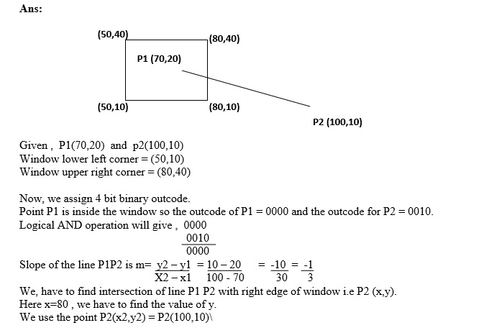

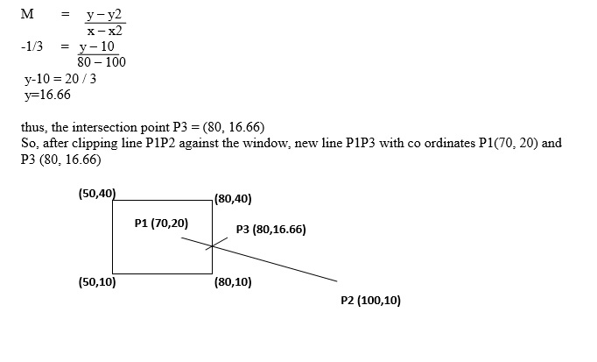

**Provide the Pseudo code of Bresenham’s midpoint line drawing algorithm:**

Step 1: Input the line endpoints and store the left endpoint in (X0, Y0) Step 2: Load (X0, Y0) in to the frame buffer

Step 3: Calculate constants ∆x, ∆y, 2 ∆y, -2 ∆x, and obtain the decision parameters as P0 = 2 ∆y – ∆x

Step 4 : At each Xk along the line, starting at k = 0, perform the following test If Pk< 0, the next point to plot is (Xk+1, Yk) and Pk+1 = Pk+2 ∆y Otherwise, the next point to plot is (Xk+1, Yk+1) and Pk+1 = Pk+2 ∆y - 2 ∆x

Step 5: Repeat step 4 ∆x times

**Circle Drawing Algorithms**  
**Explain Bresenham’s circle drawing algorithm**:

Step 1:Input radius r and circle center(Xc, Yc)and obtain the first point on the circumference of a circle centered on the origin as (X0, Y0) = (0, r)

Step 2: Calculate the initial values of the decision parameter as

P0 = 5/4 – r

Step 3: At each position starting at k perform the following test:

If Pk < 0, the next point to plot is (Xk+1, Yk) and

Pk+1 = Pk+2 Xk+1 + 1

Otherwise the next point is (Xk+1, Yk+1) and

Pk+1 = Pk+2 Xk+1 + 1- 2 Yk-1

Step 4: Determine symmetry points in the other seven octants

Step 5: Move each pixel position(X, Y) onto the circular path centred on (Xc, Yc) and plot the coordinate values as

X = X + Xc

Y = Y + Yc

Step 6: Repeat steps 3 through until X>=Y

Pk + 1= Pk + 2 ∆Y

Other wise, the next point is (Xk+1, Yk+1) and

Pk + 1= Pk + 2 ∆Y - 2 ∆X

Step 7: Repeat steps 4 ∆X times

**Bresenham’s algorithm can be extended to circles. Convince yourself of this statement by considering a circle centered at the origin. Which parts of the circle must be generated by an algorithm and which parts can be found by symmetry? Can you find a part of the circle such that if we know a point generated by a scan-conversion algorithm, we can reduce the number of candidates for the next pixel?**

**2D transformation**

**Show that the 2x2 matrix**

$$A= \left[\begin{matrix}\frac{1-t^{2}}{1+t^{2}} & \frac{2t}{1+t^{2}} \\ \frac{-2t}{1+t^{2}} & \frac{1-t^{2}}{1+t^{2}}\end{matrix}\right]$$

**Represents pure rotation.**

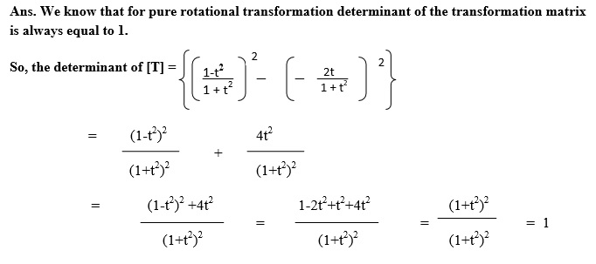

**Find a transformed point Q caused by rotating P (3, 5) about the origin through an angle of 60o.**

Solve it by yourself

**Prove that simultaneous shearing in both direction (X & y direction) is not equal to the composition of pure shear along x-axis followed by pure shear along y-axis.**

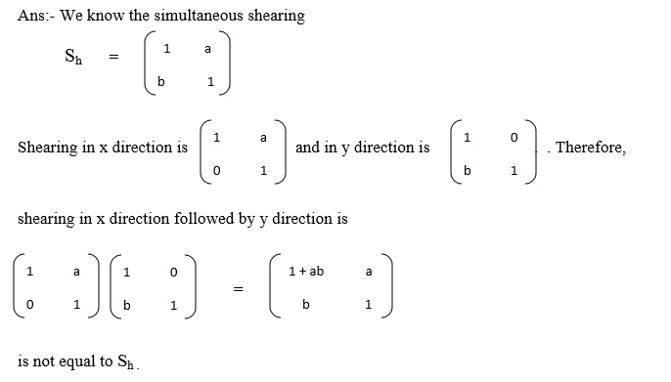

**Rotate the triangle given in figure (a) by 90 degrees about the origin.   
 Scale the triangle given in figure (a) using the scale factors Sx=1/3 and Sy=1/2 about the origin.   
A(3,2), B(6,2), C(6,6)**  
  
  
  
  
  
  
  
  
Solve it by yourself

**3D transformation**

**Write all the points which describe the rotation about arbitrary point other than the origin.**

TSRT

**Rotate P= (3, 1, 4) by 30 degrees along Y-axis.**

Solve it by yourself **Animation  
  
What are the steps involved in animation sequence?**

1. Storyboard layout
2. Object definition
3. Key frame specification
4. Generation of in-between frame

**What are the methods of motion specifications?**

1. Direct Motion specification
2. Goal-Directed system
3. Kinematics and dynamics
4. Inverse kinematics

**If a 280,000 pixel screen has 700 pixels in each horizontal row, how many pixels are in each vertical column?**

We know that resolution = width * height and width is given so,

700 * height = 280,000 pixels

Height = 280,000/700

Height = 400pixels.

**12 Stunning animation rules**

1. **Squash and stretch**
2. **Anticipation**
3. **Staging**
4. **Straight ahead & pose-to-pose**
5. **Follow-through & overlapping**
6. **Ease-in & ease-out**
7. **Arcs**
8. **Secondary action**
9. **Timing and spacing**
10. **Exaggeration**
11. **Solid drawing**
12. **Appeal**

**Lighting and Shading**

**Explain shadow masking:**

The **shadow mask** is one of the technologies used to manufacture cathode ray tube (CRT) televisions and computer displays that produce color images. All early color televisions and the majority of CRT computer monitors used shadow mask technology.

**Questions about diffusion , specular and ambient reflection.**  
  
**Polygon filling algorithm**

**Devise a test for whether a point is inside a convex polygon based on the idea that the polygon can be described by a set of intersecting lines in a single plane.|  
  
Projection  
Write two methods which are required to produce vanishing points in perspective transformation**

**Explain briefly oblique projection**

In oblique projections the parallel projection rays are not perpendicular to the viewing plane as with orthographic projection, but strike the projection plane at an angle other than ninety degrees.

**Explain Parallel projection**

Parallel projection is one in which z coordinates is discarded and parallel lines from each vertex on the object are extended until they intersect the view plane.

**Explain Perspective projection**

Perspective projection is one in which the lines of projection are not parallel. Instead, they all converge at a single point called the center of projection.

**Curves  
Derive an implicit equation for a torus whose center is at the origin. You can derive the equation by noting that a plane that cuts through the torus reveals two circles of the same radius.**

Consider two identical circles of radius r centered at (a,0) and (-a, 0).We can describe them through single implicit equation

((x-a)^2 + y^2 – r^2)(( x+a)^2 + y^2 – r^2)

By simply multiplying together their individual implicit equations. We can form the torus by rotating these circles about the y-axis which is equivalent to replacing x^2 by x^2 + z^2.

**Explain Ellipse in detail with diagrams**

Implicit:

+ = 1

This is only for the special case where the ellipse is centered at the

origin with the major and minor axes aligned with y= 0 and x= 0.

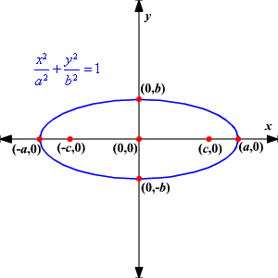

**Question about brazier curve. Numerical**

Best of luck.. If you have any questions or concerns. Mail me at aamermehmood@ciitlahore.edu.pk