Task 1:
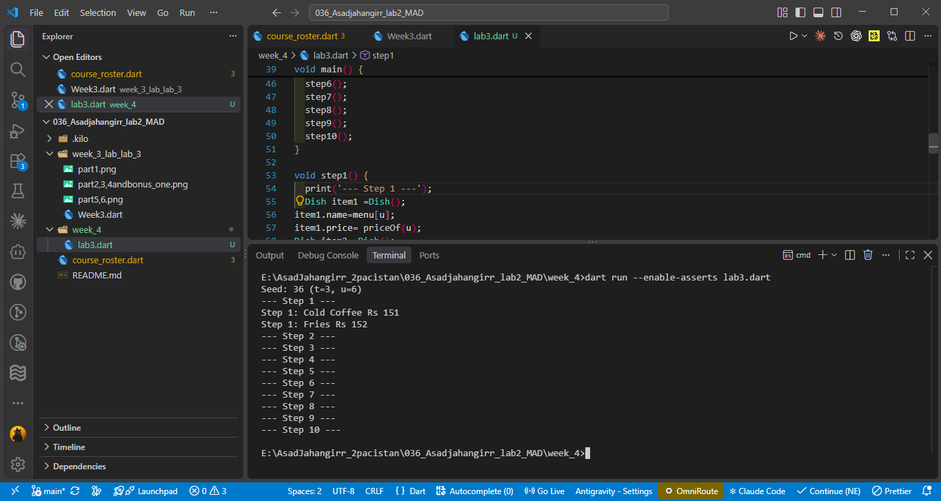
Task 2.1(verbose output)
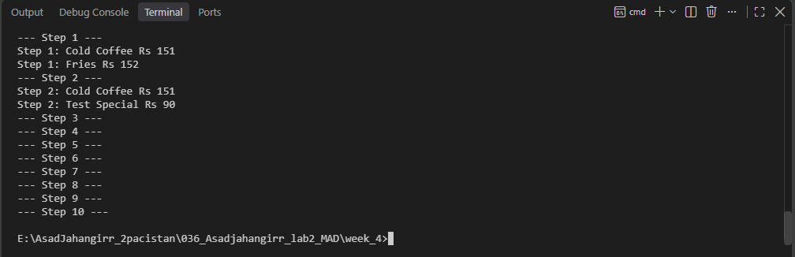
2.2(using if )
step 3
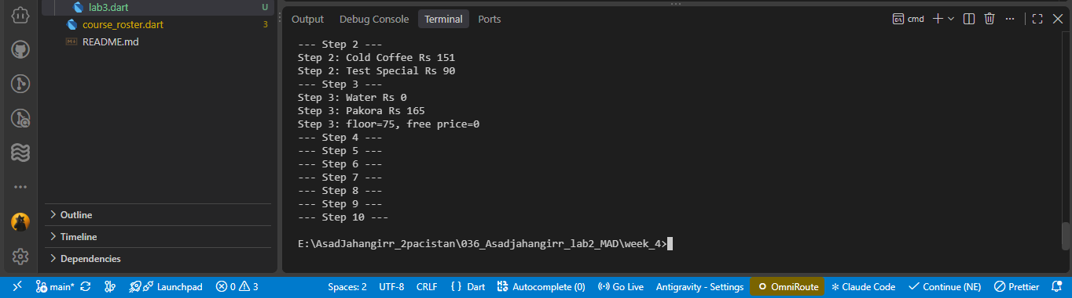
step 4
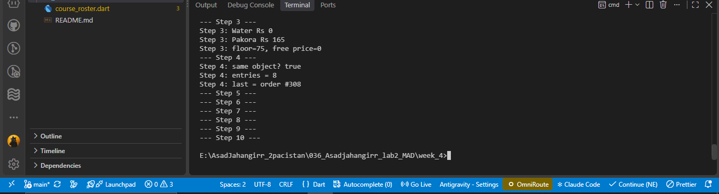
step 5
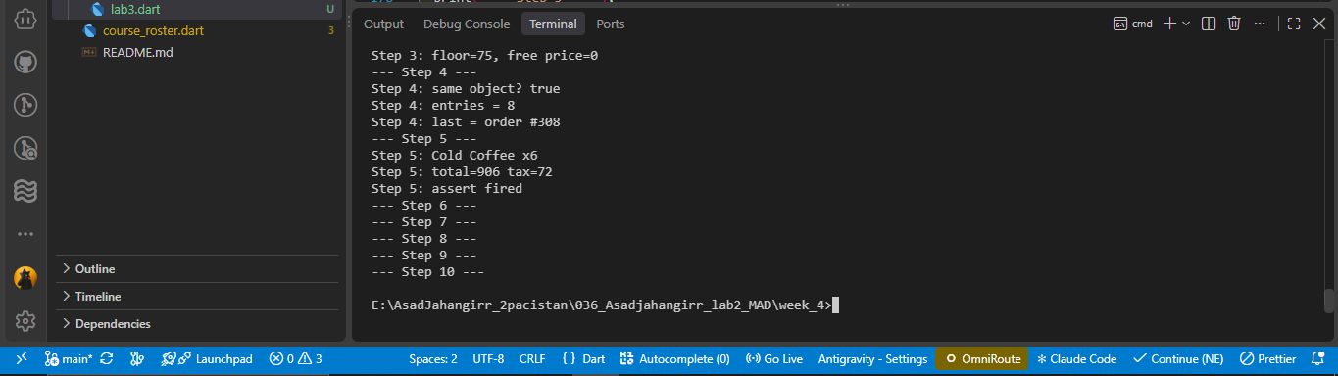
step 6
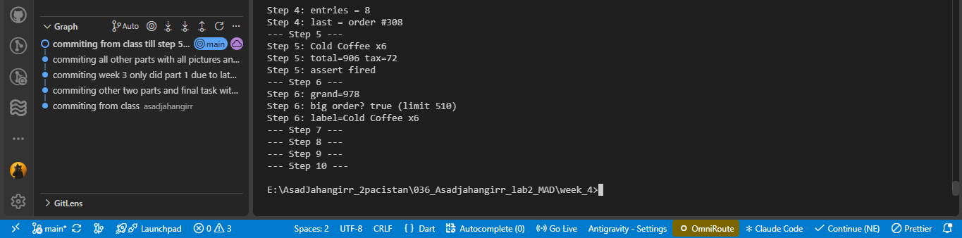
step 7
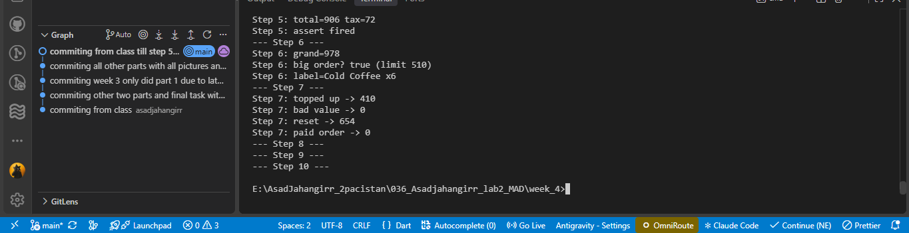
Step 8
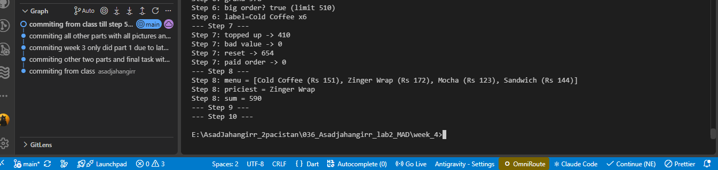
Step 9
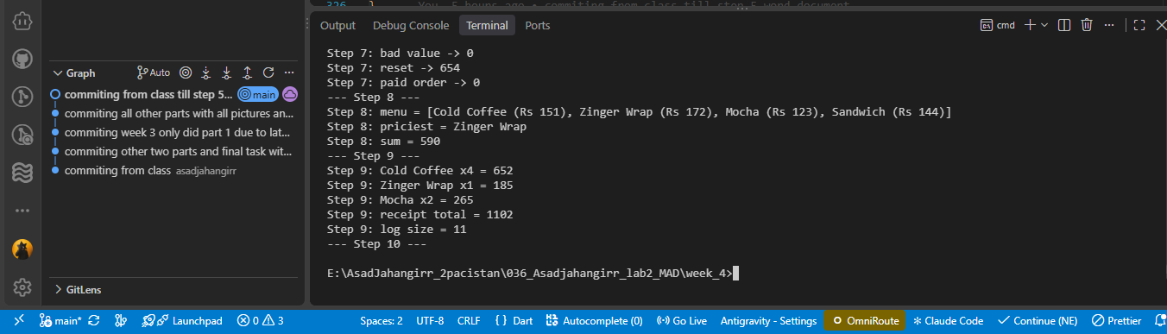
Step 10
