# Ubuntu Desktop 24.04 LTS Installation Guide

## Download Links

• [Ubuntu Desktop 24.04 LTS](https://ubuntu.com/download/desktop/thank-you?version=24.04&architecture=amd64&lts=true)

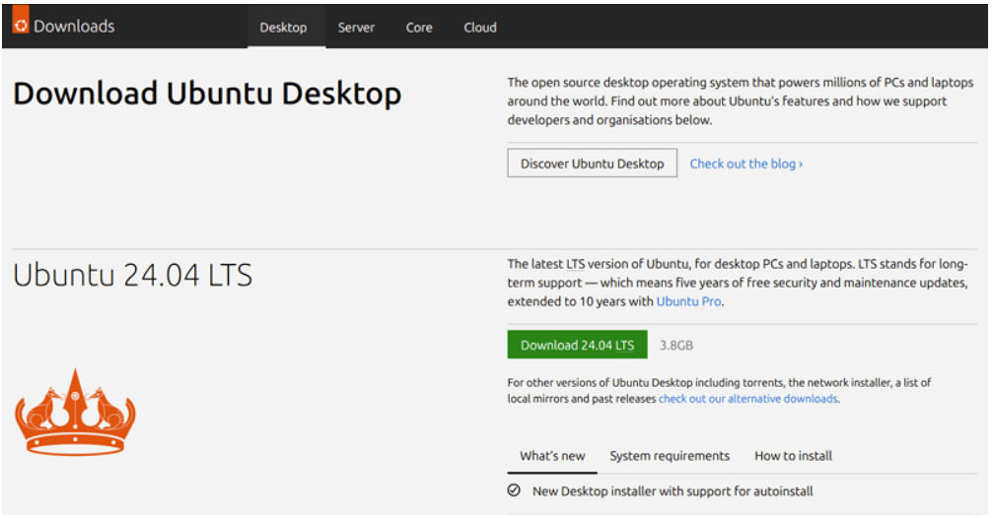

• [VirtualBox](https://www.virtualbox.org/wiki/Downloads)

## Prerequisites

1. Virtualization is enabled on your system.
2. Download [Ubuntu](https://ubuntu.com/download/desktop/thank-you?version=24.04&architecture=amd64&lts=true) ISO:  
    • https://ubuntu.com/download/desktop/thank-you?version=24.04&architecture=amd64&lts=true
3. Install [VirtualBox](https://www.virtualbox.org/wiki/Downloads) 7.0:  
    • https://www.virtualbox.org/wiki/Downloads

## Installation Steps

* Create a New VM:  
   • Use the media file selected for the ISO file downloaded in step 2.
* Launch Installation:  
   • When prompted, you can select the default installation settings.  
   • Ensure to check 'Install third-party software for graphics and Wi-Fi hardware and additional media formats' for a smoother experience.

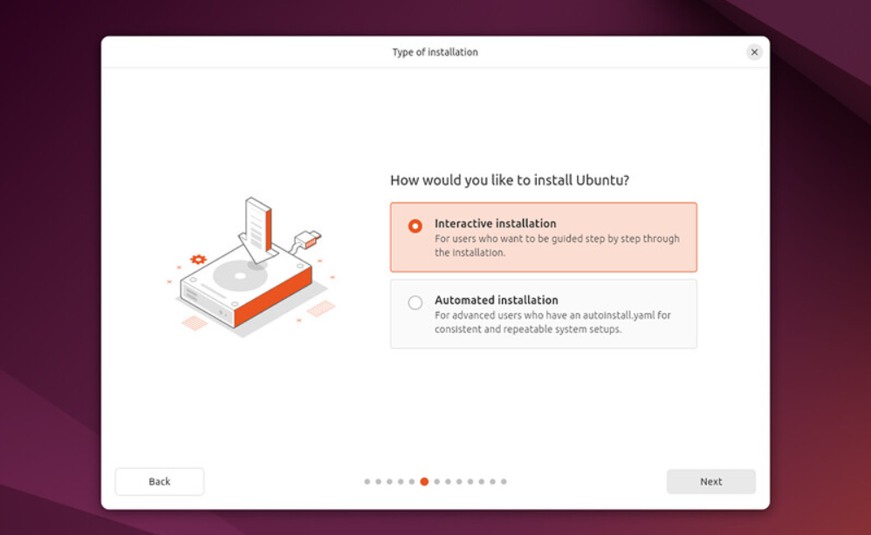

* Install Guest Additions:  
   • Go to VM devices -> Insert Guest Additions CD Image.  
   • From the CD icon, open it -> copy all files to a new folder (e.g., Kayani) in Documents.  
   •Copy this file to docs 
* Open Terminal and run the following commands:  
   chmod +x setup.sh  
   ./setup.sh  
   sudo reboot now

## Setting Up SSH Access

* Configure Windows Hosts File for Easy Access:  
   • Navigate to C:\Windows\System32\drivers\etc\hosts.  
   • Run ifconfig and copy ip address in following commands , Add an entry for your Ubuntu VM: e.g.   
   192.168.183.130 ubuntu ubuntu
* Update Ubuntu Hosts File:  
   • Type `sudo nano /etc/hosts` or `sudo vim /etc/hosts` and press Enter.  
   • Add the following line:  
   192.168.183.130 ubuntu ubuntu

## Resolving Memory Issues

If you encounter any memory issues with your VM, you can increase its size by running the following command:

VBoxManage modifymedium disk "path\ubuntu.vdi" --resize 32720