GENERATIVE MODELS VS TRADITIONAL AI-DRIVEN ANOMALY DETECTION IN LARGE-SCALE SYSTEM LOGS – A COMPARATIVE STUDY


by

Muhammad Asad Mahmood Khan
M.S., Artificial Intelligence, Air University, 2026

A thesis submitted in partial fulfillment of the requirements for the degree of
Master of Science in Artificial Intelligence

AIR UNIVERSITY
2026

GENERATIVE MODELS VS TRADITIONAL AI-DRIVEN ANOMALY DETECTION IN LARGE-SCALE SYSTEM LOGS – A COMPARATIVE STUDY

by

Muhammad Asad Mahmood Khan
A thesis submitted in partial fulfillment of the requirements for the degree of
Master of Science in Artificial Intelligence
SUPERVISOR
Prof. Dr. Imran Ihsan

AIR UNIVERSITY
ISLAMABAD
© [Muhammad Asad Mahmood Khan] [2026]. All rights reserved.

CERTIFICATE

Department of Creative Technologies

It is hereby certified that Muhammad Asad Mahmood Khan (243260) has successfully completed his thesis.

Dr. Imran Ihsan
Professor
Air University
Supervisor

Dr. Tahir Akram  Associate Professor  Air University  Internal Examiner  Guidance and Evaluation Committee | Dr. Junaid Ali khan  Associate Professor  HITEC University  External Examiner  Guidance and Evaluation Committee

Dr. Imran Ihsan  Associate Professor  Air University  Chair Department of Creative Technology | Dr. Mehdi Hassan  Professor  Air University  Dean Faculty of Creative Technology

________________________________
Dr. Mehdi Hassan
Air University
Dean Faculty of Graduate Studies

DECLARATION
I declare that all material in this thesis is my work, and that which is not my own work has been mentioned as such, and that no material from this work has previously been submitted or approved for the award of a degree by this or any other university.

Signature:
Author’s Name: Muhammad Asad Mahmood Khan
Dated: ___________

It is certified that the work presented in this thesis is carried out and completed under my supervision.

Signature:
Supervisor’s Name: Dr. Imran Ihsan
Professor
Department of Creative Technology
Air University, Islamabad
Dated: ___________

Acknowledgments

Firstly, I am thankful to Allah Almighty for giving me the courage and strength to complete my Masters. Also, I would like to thank my supervisor Dr. Imran Ihsan for their essential advice and assistance throughout my master's programme. They gave me guidance and encouragement as I completed this research and prepared this thesis.
I also want to express my gratitude to my extended family and friends for their love and support throughout this process.
I would give my parents credit for this and all of my accomplishments. They gave me every chance to develop and did everything to support my development into a confident, intelligent man.

Generative Models Vs Traditional Ai-Driven Anomaly Detection In Large-Scale System Logs – A Comparative Study
by
Muhammad Asad Mahmood Khan
M.S., Artificial Intelligence, Air University, 2026
Submitted in partial fulfillment of the requirements for the degree of
Master of Science in Artificial Intelligence, Air University

Abstract
The escalating scale and complexity of distributed computing architectures, specifically Hadoop (HDFS), Apache Spark, and OpenStack, have rendered manual and rule-based log monitoring fundamentally intractable. This research presents a comprehensive comparative study evaluating Traditional Machine Learning (ML), sequence-based Deep Learning (DL), and Generative AI models for automated anomaly detection within massive, unstructured log collections. (Zhu, 2023)
Initial benchmarking demonstrates a critical functional dichotomy in current industry standards. Traditional supervised algorithms achieve high precision on structured data but remain brittle, relying heavily on labor-intensive manual feature engineering and labeled datasets. Furthermore, traditional unsupervised baselines, like Isolation Forest, exhibit significantly lower efficacy when processing high-dimensional sequences, exposing a severe gap in identifying unknown, zero-day errors.
To transcend these limitations, this thesis rigorously evaluates deep sequence and Generative AI architectures (including LSTMs, VAEs, and GANs). To ensure accurate assessment across heterogeneous environments, models are independently trained and tested within the same respective dataset boundaries for HDFS, Spark, and Hadoop, establishing true baselines without cross-system contamination.
This study delineates the operational boundaries of these paradigms. Findings reveal that while supervised Deep Learning eliminates manual feature extraction, Generative AI models offer theoretical automation advantages via a normal-only training paradigm but consistently underperform supervised approaches across all evaluated datasets. Ultimately, this research empirically demonstrates that Traditional ML and supervised Deep Learning models outperform Generative architectures in log anomaly detection, while highlighting key precision trade-offs in concurrent environments like Spark.
Thesis Supervisor: Prof. Dr. Imran Ihsan

Table of Contents
1.1 System Logs 15
1.2 Why Are System Logs Generated? 15
1.2.1 Troubleshooting 16
1.2.2 Security Monitoring 16
1.2.3 System and Network Monitoring 16
1.2.4 Auditing 16
1.2.5 Incident Investigation 16
1.3 Types of System Logs 17
1.3.1 Authentication Logs 17
1.3.2 Application Logs 17
1.3.3 Operating-System Logs 17
1.3.4 Security Logs 17
1.3.5 Network Logs 17
1.4 Importance of Log Analysis 18
1.5 Anomalies in System Logs 18
1.6 Types of Log Anomalies 19
Point Anomalies 19
1.6.1 Contextual Anomalies 19
1.6.2 Collective Anomalies 19
1.7 Challenges in Log Anomaly Detection 19
1.7.1 Large Volume of Data 19
1.7.2 Diverse Log Formats 19
1.7.3 Sequential Dependencies 20
1.7.4 Changing System Behavior 20
1.7.5 Unknown Anomalies 20
1.8 Artificial Intelligence for Log Anomaly Detection 20
1.9 Motivation of the Study 21
1.10 Research Problem 21
1.11 Importance of Log Anomaly Detection 22
1.11.1 Security and Early Warning 22
1.11.2 Detection of System Failures 23
1.11.3 Reduction of Manual Log Monitoring 23
1.11.4 Faster Incident Response 24
1.11.5 Support for Incident Investigation and Auditing 24
1.11.6 Detection of Sequential and Collective Anomalies 25
Importance for Intelligent Log Analysis 25
1.11.7 Overall Importance 26
1.11.8 System Logs in Distributed Architectures: Hadoop, HDFS, and Apache Spark 26
1.12 Introduction to Distributed System Observability 26
1.13 The Hadoop Ecosystem and Resource Management Logs 27
1.14 HDFS Logs: The Storage Layer 27
1.15 Apache Spark Logs: The Computational Layer 28
1.16 Rationale for Inclusion in Anomaly Detection Research 28
1.17 Problem Statement 30
1.18 Motivation 31
1.19 Objectives 31
1.20 Scope of the thesis 32
1.21 Thesis Layout 33
Chapter 2: Literature Survey 35
2.1 Introduction to the Literature Review 35
2.2 System Logs and Their Role in Anomaly Detection 36
2.3 Types of Log Anomalies 37
2.4 Traditional Rule-Based Monitoring 37
2.5 Traditional Machine Learning: PCA and Statistical Methods 38
2.6 Traditional Machine Learning: Classification and Clustering 39
2.7 Isolation Forest and One-Class Learning 40
2.8 Log Parsing and Feature Engineering 41
2.9 Deep Learning for Log Analysis 42
2.10 DeepLog: Sequence Prediction 42
2.11 LogAnomaly and Semantic Sequence Modeling 43
2.12 LogRobust and Unstable Logs 44
2.13 CNN-Based Log Anomaly Detection 44
2.14 Transformers and Attention Mechanisms 45
2.15 HitAnomaly: Modeling Templates and Parameters 46
2.16 LogBERT and Self-Supervised Learning 46
2.17 Generative Models for Anomaly Detection 47
2.18 LogGAN and Adversarial Learning 48
2.19 Autoencoders and VAE-Based Detection 48
2.20 Datasets Used in Log Anomaly Research 49
2.21 HDFS and Distributed File-System Logs 50
2.22 BGL, Hadoop, Spark, and OpenStack 51
2.23 Evaluation Metrics 51
2.24 Computational and Deployment Considerations 52
2.25 Robustness to Log Evolution and OOV Events 53
2.26 Normal-Only Training and Zero-Day Detection 53
2.27 Research Gap 54
2.28 Comparative Analysis of Existing Approaches 55
2.29 Proposed Experimental Direction 56
2.30 Literature Review & Preliminary Benchmarking 57
2.31 Foundations 60
2.31.1 Books 61
2.31.2 Papers 61
2.31.3 Experiments 62
2.32 Prior Work 62
2.33 Summary of the Literature Review 63
Chapter 3: Mathematical Formulation 64
3.1 Log Sequence Representation 65
3.2 Preprocessing and Event Construction 66
3.3 Sequence-Based Deep Learning Using LSTM 67
3.4 LSTM-Based Anomaly Scoring 68
3.5 Generative AI: Variational Autoencoder 69
3.6 VAE Reconstruction and Generative Anomaly Score 70
3.7 Comparison of the LSTM and VAE Formulations 71
3.8 Normal-Only Training and Dataset Isolation 72
3.9 Threshold Estimation and Decision Theory 73
3.10 Computational Formulation for Distributed Log Processing 74
3.11 Mathematical Interpretation of Unknown and Zero-Day Errors 75
3.12 Limitations of the Mathematical Formulation 76
3.13 Integrated Mathematical Framework 77
Chapter 4: METHODOLOGY 79
4.1 Research Design and Overall Methodology 80
4.2 Phase 1: Multi-Source Dataset Collection 81
4.2.1 HDFS Dataset 81
4.2.2 Apache Spark Dataset 81
4.2.3 Hadoop/OpenStack Dataset 82
4.3 Dataset Challenges and Mitigation Strategy 82
4.3.1 Apache Spark: Memory and Scale 82
4.3.2 Extreme Class Imbalance in Spark 82
4.3.3 Compute Limits 83
4.4 Hadoop/OpenStack: Reverse Class Imbalance 83
4.4.1 Traditional One-Class SVM Limitation 83
4.5 Phase 2: Log Preprocessing and Parsing 84
4.5.1 Template Extraction 84
4.5.2 Event ID Extraction 84
4.5.3 Timestamp Normalization 84
4.6 Phase 3: Comparative Model Architectures 84
4.6.1 Pipeline 1: Traditional Machine Learning 85
4.6.2 Event-Count Features 85
4.7 Deep Learning Pipeline: Sequence Embedding 85
4.7.1 LSTM and GRU 85
4.7.2 Bidirectional Bi-LSTM 85
4.7.3 Attention Mechanisms 86
4.8 Generative AI Pipeline 86
4.8.1 Variational Autoencoder 86
4.8.2 LSTM Autoencoder 86
4.8.3 GAN 86
4.9 Network Architecture and Training Configuration 87
4.9.1 XGBoost Baseline 87
4.10 Phase 4: Training and Testing Dynamics 87
4.10.1 Independent System Verification 87
4.10.2 Data Leakage Controls 88
4.11 Phase 5: Evaluation Metrics 88
4.11.1 Precision 88
4.11.2 Recall 88
4.11.3 F1-Score 88
4.11.4 Confusion-Matrix Interpretation 88
4.12 Extended Comparative Evaluation Criteria 88
4.12.1 Performance Consistency 89
4.12.2 Automation 89
4.12.3 Unknown Detection 89
4.12.4 Training Time 89
4.12.5 Interpretability and Scalability 89
4.13 Reproducibility and Integrated Experimental Workflow 89
Chapter 5: Results and Discussion 91
5.1 Baseline Performance (HDFS v1) 91
5.2 Traditional Machine Learning Results: 91
5.3 Deep Learning (Supervised) Results: 94
5.4 Generative AI Results: 95
5.5 Comparative Analysis Synthesis (HDFS): 97
5.6 Spark Logs Analysis 98
5.7 Spark Comparative Analysis Synthesis: 103
5.8 Hadoop Logs Analysis 105
5.9 Hadoop Comparative Analysis Synthesis: 109
5.10 Overall Performance Synthesis (Spark vs. Hadoop) 110
5.11 Generative Model Failures 111
5.11.1 GANs: Structural Mismatch 111
5.11.2 VAEs: Blurry Reconstruction 111
5.12 Key Takeaways from the Data: 112
Chapter 6: Conclusions and Recommendations 113
6.1 Thesis Core Findings and Contributions 113
6.2 The Performance Trade-Off and Research Outcomes 113
6.3 System-Specific Degradation and Operational Boundaries 114
6.4 Recommendations for Future Work 114

List of Figures
Figure 1 Methodology 23
Figure 2 HDFS ML XGBoost Confusion Matrix 28
Figure 3 Shuffling Test Performance 28
Figure 4 F1 Score 28
Figure 5 SVM results 29
Figure 6 SVM Confusion Matrix 29
Figure 7 SVM Results after Shuffing 30
Figure 8 DL LSTM Confusion Matrix and ROC-AUC results 31
Figure 9 GRU Confusion Matrix and ROC-AUC results 31
Figure 10 GEN AI LSTM Autoencoder Confusion Matrix and ROC-AUC results 32
Figure 11 GEN AI LSTM VAE Confusion Matrix and ROC-AUC results 33
Figure 12 HDFS Comparison Matrix 34
Figure 13 Spark ML Train and Test Results 35
Figure 14 Isolation Forest and Random Forest Results 35
Figure 15 DL Train and Test Results 36
Figure 16 LSTM Results 36
Figure 17 CNN Results 37
Figure 18 DL vs ML Comparison Results 37
Figure 19 Gen AI Train and Test Results 38
Figure 20 VAE Results 38
Figure 21 GAN Results 39
Figure 22 Spark logs Model Comparison 40
Figure 23 Spark logs Confusion Matrix 40
Figure 25 Hadoop ML Label Logs distribution 41
Figure 26 ML Isolation Forest and Random Forest Results 42
Figure 27 DL train test results 43
Figure 28 LSTM Autoencoder Results 43
Figure 29 CNN and LSTM comparison 44
Figure 30 Gen AI train test results 44
Figure 31 VAE and GAN results 44
Figure 32 Hadoop All Model Results Summary 45
Figure 33 Hadoop All Model Confusion Matrix 45
Figure 34 Performance Matrix Spark vs Hadoop 47

List of Tables
Table 1 HDFS All Models Comparison 88
Table 2 Spark Logs All Model Results Summary 96
Table 3 Spark vs Hadoop All Models Results 103

Symbols and Abbreviations
Abbreviation | Definition
AI | Artificial Intelligence
ANN | Artificial Neural Network
AUC | Area Under the Curve
DL | Deep Learning
ELBO | Evidence Lower Bound
FN | False Negative
FP | False Positive
GAN | Generative Adversarial Network
GRU | Gated Recurrent Unit
HDFS | Hadoop Distributed File System
KL | Kullback-Leibler
LSTM | Long Short-Term Memory
ML | Machine Learning
NDM | Next Day Monitoring
NLP | Natural Language Processing
OOD | Out-of-Distribution
PCA | Principal Component Analysis
RNN | Recurrent Neural Network
ROC | Receiver Operating Characteristic
TN | True Negative
TP | True Positive
VAE | Variational Autoencoder
YARN | Yet Another Resource Negotiator

Symbol | Description
E | Parsed log sequence
et​ | Feature embedding of a log event at time step t
ht​ | Hidden state of the recurrent network at time step t
T | Total length of the temporal log sequence
V | Vocabulary size of possible unique log events
W,b | Weight matrix and bias vector of a neural network layer
z | Latent space vector representation
x | Input data (e.g., original log sequence)
y | True label (used in supervised benchmarking)
y^​ | Predicted output or reconstructed sequence
Rd | d-dimensional real coordinate space (used for embeddings)
E | Expected value / Expectation
pθ​(x∣z) | Probabilistic decoder parameterized by neural network weights θ
qϕ​(z∣x) | Probabilistic encoder parameterized by neural network weights ϕ
μ | Mean vector of the learned latent distribution
Σ | Covariance matrix of the learned latent distribution
N(μ,Σ) | Multivariate Normal (Gaussian) distribution
LVAE​ | Evidence Lower Bound (ELBO) loss function for VAE
DKL​ | Kullback-Leibler divergence
A(x) | Anomaly score based on reconstruction loss
τ | Dynamic anomaly detection threshold
∥⋅∥2 | Squared L2​ norm (Euclidean distance, used in reconstruction error)
∇ | Gradient operator (used in optimization and backpropagation)
α | Learning rate during model training

- INTRODUCTION

System Logs
Modern computing environments continuously generate large amounts of information describing system operations, user activities, application behavior, network communication, and security-related events. One of the most important sources of this information is system logs. According to the National Institute of Standards and Technology (NIST), a log is a record of events occurring within an organization's computing assets, including physical and virtual systems, networks, services, and cloud environments [1]. Log entries contain information associated with specific events that occur within a system or network.
System logs are generated by a wide range of sources, including operating systems, servers, applications, routers, switches, firewalls, authentication systems, intrusion detection systems, and other security and network devices [1]. These logs provide information about the operational state of a system and can be used for monitoring, troubleshooting, auditing, security analysis, and incident investigation.
A typical log entry may contain several attributes, including a timestamp, event type, severity level, username, IP address, process identifier, service name, and descriptive message. The exact structure depends on the logging mechanism and the system generating the event.
For example:
2026-08-30 20:15:42 SSH Failed password user=asad source=192.168.1.50
This log entry provides information about the time of the event, the type of activity, the user account involved, and the source address. Consequently, system logs provide a historical record that can help administrators understand what happened within a computing environment.
Previous research has also established that system logs are an important source of information for understanding system status, diagnosing failures, and detecting anomalous behavior [2]. Du et al. described system logs as valuable sources for monitoring system status and identifying performance problems and failures.

Why Are System Logs Generated?
System logs are generated to maintain a record of important events and activities occurring within computing systems. Effective log management enables organizations to generate, transmit, store, access, analyze, and retain log information for operational and security purposes [1]. NIST identifies log management as an important component of cybersecurity and system monitoring.
The major purposes of generating system logs include the following.

Troubleshooting
System logs provide information that can help administrators identify errors, failures, and unexpected system behavior. When an application crashes or a service becomes unavailable, log records can help determine the sequence of events that occurred before the failure.
Log analysis can therefore reduce the time required to identify the root cause of operational problems.

Security Monitoring
Logs provide important evidence for detecting unauthorized access and potentially malicious activities. Authentication failures, privilege changes, suspicious network connections, and other security-related events can be recorded and subsequently analyzed.
NIST specifically identifies logging as an important mechanism for detecting and investigating cybersecurity incidents [1].

System and Network Monitoring
Logs can be used to monitor the operational condition of servers, applications, network devices, and other computing resources. They can provide information about service availability, system errors, network connections, and configuration changes.

Auditing
Logs provide a historical record of activities performed within a system. This can help organizations determine what happened, when it happened, and which account or system was involved.

Incident Investigation
After a security incident or system failure, historical logs can be analyzed to reconstruct the sequence of events. This information can support root-cause analysis and forensic investigation [2]. DeepLog also highlights the importance of system logs for debugging failures and performing root-cause analysis.

Types of System Logs
System logs can be categorized according to the component that generates them and the type of information they contain.

Authentication Logs
Authentication logs record activities associated with user authentication. These may include successful login attempts, failed login attempts, password changes, account lockouts, and other authentication-related events.
For example:
Failed password for admin from 192.168.1.50
Repeated authentication failures within a short period may represent abnormal behavior and can potentially indicate a brute-force attack.

Application Logs
Application logs are generated by software applications to record their execution and operational behavior. They may include application startup and shutdown events, exceptions, errors, warnings, transactions, and other application-specific activities.

Operating-System Logs
Operating-system logs record events generated by the underlying operating system. These can include system startup and shutdown events, process failures, service status changes, hardware-related errors, and system warnings.

Security Logs
Security logs contain information associated with security-related activities, including unauthorized access attempts, permission changes, authentication events, firewall activities, and other potentially malicious behavior.

Network Logs
Network devices such as routers, switches, firewalls, VPN gateways, and intrusion detection systems generate network-related logs. These records can contain information about connections, blocked traffic, routing events, DNS requests, VPN sessions, and firewall activities.
NIST identifies operating-system logs, application logs, and cybersecurity software logs among the important sources of organizational log data [1].

Importance of Log Analysis
Although system logs contain valuable information, modern systems can generate extremely large quantities of log data. The volume and diversity of log messages make manual analysis difficult and time-consuming [3]. Research on log analysis has therefore increasingly focused on automated techniques for extracting useful information from log data.
The problem is particularly challenging because logs are often unstructured or semi-structured and may originate from heterogeneous systems. Different applications and devices can use different formats, message structures, and terminology [3].
As a result, automatic log analysis is increasingly necessary for identifying important events, system failures, and abnormal behavior.

Anomalies in System Logs
An anomaly is an observation or behavior that deviates significantly from an expected or normal pattern.
In system-log analysis, an anomaly may appear as an unusual log event, an abnormal frequency of events, or an unexpected sequence of log messages. The identification of such behavior is important because anomalous events may indicate system failures, software problems, configuration errors, or security incidents.
DeepLog demonstrated that normal log-event sequences can be learned from historical system execution and that deviations from these learned patterns can be used to identify anomalies [2].
For example, consider:
10:01:02 Successful login
10:01:15 Successful login
10:01:20 Failed login
10:01:21 Failed login
10:01:22 Failed login
10:01:23 Failed login
10:01:24 Failed login
While a single failed login may represent normal user behavior, a sequence of repeated failures occurring within a very short period may indicate abnormal activity.

Types of Log Anomalies
Log anomalies can generally be classified into several categories.

Point Anomalies
A point anomaly occurs when an individual log event significantly differs from normal observations.
For example, an unusual system event that rarely occurs during normal operation may be considered a point anomaly.

Contextual Anomalies
A contextual anomaly occurs when an event is abnormal under a particular context, even though the same event may be normal under different circumstances.
For example, a login at an unusual time may be considered anomalous depending on the normal behavior of the user.

Collective Anomalies
A collective anomaly occurs when a sequence or group of individually normal events forms an abnormal pattern.
This category is particularly important for system logs because many system problems cannot be detected by examining individual events alone. Instead, the relationship between consecutive or related events must be considered.
Research such as DeepLog and LogAnomaly specifically addresses sequential patterns in log data [2], [4].

Challenges in Log Anomaly Detection
The detection of anomalies in system logs presents several challenges.

Large Volume of Data
Modern computing environments generate large amounts of log information. Manual inspection of such data is impractical, creating a need for automated analysis techniques [3].

Diverse Log Formats
Logs can originate from different operating systems, applications, network devices, and security tools. Consequently, their formats and structures can vary significantly.
Unstructured and Semi-Structured Data
Many log messages contain both structured fields and natural-language descriptions. Extracting meaningful features from such data is therefore challenging.

Sequential Dependencies
The meaning of an event can depend on the events that occurred before it. For example, a successful login following many failed attempts may be more suspicious than an isolated successful login.

Changing System Behavior
Normal system behavior may change because of software updates, workload changes, configuration modifications, and changes in user behavior.

Unknown Anomalies
A particularly difficult problem is the detection of anomalies that have not previously been observed. A model trained only on known anomaly patterns may not recognize new types of abnormal behavior.
A recent survey of deep-learning approaches emphasizes the challenges associated with log diversity, preprocessing, feature representation, and selecting appropriate neural architectures for different log-analysis tasks [3].

Artificial Intelligence for Log Anomaly Detection
The limitations of manual and rule-based log analysis have motivated the use of Artificial Intelligence (AI), Machine Learning (ML), and Deep Learning (DL) techniques.
Traditional approaches may rely on manually defined rules, thresholds, or predefined patterns. Although these techniques can be effective for known conditions, they may have difficulty identifying complex or previously unseen patterns.
Deep-learning approaches can instead learn representations of normal system behavior from historical log data. For example, DeepLog uses a Long Short-Term Memory (LSTM) neural network to model log events as sequences and detect deviations from learned patterns [2].
Similarly, LogAnomaly uses semantic representations of log templates and considers both sequential and quantitative anomalies [4]. The authors demonstrated that the approach can identify different forms of anomalous behavior while reducing some false alarms associated with newly appearing log templates.
More recently, Transformer-based approaches have also been investigated. LogBERT, for example, applies BERT-based self-supervised learning to model normal log sequences and identify deviations from those patterns [5].
A systematic survey of deep-learning methods for log anomaly detection shows that researchers have investigated architectures including RNNs, CNNs, autoencoders, GANs, Transformers, attention mechanisms, and graph neural networks [3].

Motivation of the Study
The increasing complexity of modern computing environments has resulted in a continuous increase in the amount and diversity of system-generated log data. Although these logs contain valuable information about system operation, security, and failures, their large volume makes manual analysis impractical [1], [3].
Furthermore, existing anomaly detection techniques face challenges associated with changing log structures, sequential dependencies, noisy data, and previously unseen anomalous behavior.
These challenges have motivated researchers to investigate intelligent approaches capable of automatically learning patterns from system logs. Deep-learning approaches such as DeepLog and LogAnomaly demonstrated the potential of learning normal log behavior automatically [2], [4]. Transformer-based approaches such as LogBERT have further explored contextual representations for log anomaly detection [5].
Therefore, this research investigates intelligent approaches for system-log anomaly detection, with particular emphasis on identifying abnormal patterns from large-scale log data.

Research Problem
The primary research problem addressed in this thesis is the accurate and efficient detection of anomalous behavior from system logs.
Traditional approaches often depend on predefined rules, thresholds, signatures, or manually engineered features. Such approaches can become difficult to maintain when system behavior changes or when previously unseen anomalies occur.
Furthermore, system logs are often heterogeneous, semi-structured, and sequential in nature. Consequently, identifying meaningful relationships between log events and distinguishing normal behavior from anomalous behavior remains a challenging problem [3], [6].
Therefore, there is a need for intelligent anomaly detection techniques that can automatically analyze system logs, learn normal system behavior, detect deviations, and reduce false alarms.

Importance of Log Anomaly Detection
System logs provide valuable information about the operational and security status of computing systems. However, modern systems continuously generate large volumes of logs from different sources, making manual inspection difficult and time-consuming. Therefore, automated log anomaly detection is important for identifying abnormal behavior, system failures, and potential security threats in a timely manner.
Log anomaly detection identifies log events or sequences that deviate from expected system behavior. Such deviations may indicate security attacks, software failures, configuration problems, resource issues, or other abnormal conditions. Automated detection can help organizations identify these problems earlier and allow administrators to focus their attention on the most relevant events.

Security and Early Warning
One of the most important applications of log anomaly detection is cybersecurity. Authentication logs, access-control logs, firewall logs, network logs, and application logs can contain evidence of unauthorized or suspicious activities.
For example, a system may normally experience a small number of failed login attempts each day. If hundreds of failed authentication attempts occur within a few minutes, the behavior may indicate a brute-force attack or another unauthorized access attempt.
Early detection of suspicious activities can allow security teams to investigate and respond before an incident causes significant damage. NIST's incident-response guidance emphasizes the importance of detecting and analyzing incidents and responding to them effectively [8].
Log anomaly detection can therefore assist in identifying:
- Repeated failed authentication attempts
- Unauthorized access attempts
- Suspicious user behavior
- Unusual network connections
- Abnormal application activity
- Unexpected privilege changes
- Potential malware-related activity

Detection of System Failures
Log anomaly detection is also important for identifying operational and system failures. Applications, operating systems, and network devices continuously generate logs describing their operational status.
Abnormal patterns in these logs may indicate:
- Application crashes
- Service failures
- Hardware problems
- Network failures
- Resource exhaustion
- Configuration errors
- Unexpected application behavior
Meng et al. emphasized that detecting anomalies in system logs is important for the timely identification of system malfunctions. They also highlighted that manually identifying anomalies in large volumes of logs is time-consuming, error-prone, and infeasible [9].
Consequently, automated anomaly detection can help administrators identify operational problems without manually examining every log entry.

Reduction of Manual Log Monitoring
Modern computing infrastructures can generate extremely large quantities of log data. Logs may be produced continuously by servers, operating systems, applications, databases, network devices, firewalls, and security systems.
Manually examining all these records is impractical. Automated anomaly detection can act as a filtering mechanism by identifying potentially abnormal events and reducing the amount of information that human analysts need to examine.
For example, instead of manually reviewing thousands of authentication records, an anomaly detection system can identify an unusual pattern such as:
Normal: 10 failed login attempts/day
Observed: 500 failed login attempts in 5 minutes
Result: Potential anomaly → Alert generated
This allows system administrators and security analysts to concentrate on events that require further investigation.

Faster Incident Response
Another important advantage of anomaly detection is its ability to support faster incident response.
The general process can be represented as:
Log Generation → Anomaly Detection → Alert → Investigation → Response
When an abnormal pattern is automatically detected, an alert can be generated for further investigation. This reduces the time between the occurrence of abnormal behavior and the beginning of the investigation.
NIST's incident-handling guidance identifies detection, analysis, and appropriate response as important components of effective incident handling [8].
Early detection can therefore help organizations minimize the potential impact of security incidents and system failures.

Support for Incident Investigation and Auditing
Log anomaly detection also supports incident investigation and auditing. Once an anomaly is detected, the underlying log records can be examined to reconstruct the sequence of events.
Investigators may determine:
- When the abnormal activity started.
- Which user or system was involved.
- Where the activity originated.
- What events occurred before the anomaly.
- Which systems or services were affected.
- What activities occurred after the initial event.
Historical log information can therefore provide evidence for understanding the cause and impact of an incident.
NIST guidance emphasizes the importance of analyzing incident-related information to determine appropriate responses and support effective incident handling [8].

Detection of Sequential and Collective Anomalies
An important characteristic of system-log anomalies is that abnormal behavior is not always represented by a single log entry. Sometimes, a sequence of individually normal events can collectively represent anomalous behavior.
For example:
Login failure
Login failure
Login failure
Login failure
Login failure
Successful login
Each individual failed login may be legitimate. However, the complete sequence may indicate a potential brute-force attack followed by successful account access.
Research has therefore investigated methods that consider the sequence and frequency of log events rather than analyzing individual events independently.
LogAnomaly, for example, was developed to detect both sequential and quantitative anomalies in unstructured logs [9].
This demonstrates the importance of considering relationships between log events when designing automated anomaly detection systems.

Importance for Intelligent Log Analysis
The limitations of manual log monitoring have motivated the development of machine-learning and deep-learning approaches for automated log analysis.
Deep-learning approaches can learn patterns of normal system behavior from historical log data and identify deviations from those patterns. DeepLog, for example, models system log sequences using deep learning to detect anomalous behavior and diagnose system problems [10].
Similarly, LogAnomaly models log streams as sequences and uses semantic information from log templates to identify sequential and quantitative anomalies [9].
More recent approaches have investigated Transformer-based models. NeuralLog, for example, addresses limitations associated with traditional log parsing by extracting semantic representations directly from raw log messages and using a Transformer-based model to capture contextual information from log sequences [11].
These developments demonstrate the increasing importance of intelligent approaches for automatically analyzing large-scale and complex log data.

Overall Importance
The importance of log anomaly detection can therefore be summarized into several major areas:
Area | Importance
Security | Detects suspicious and unauthorized activities
Early Warning | Identifies abnormal behavior before major damage occurs
System Reliability | Helps identify failures and operational problems
Automation | Reduces the need for manual log inspection
Incident Response | Supports faster detection and investigation
Auditing | Provides historical evidence of system activities
Scalability | Enables analysis of large volumes of log data
Intelligent Monitoring | Uses ML/DL to learn complex patterns
Thus, log anomaly detection plays an important role in maintaining the security, reliability, availability, and operational efficiency of modern computing environments.

System Logs in Distributed Architectures: Hadoop, HDFS, and Apache Spark

Introduction to Distributed System Observability
In the contemporary landscape of big data and large-scale computational frameworks, system observability is fundamentally driven by system logs. Logs are automatically generated, time-stamped textual records that continuously capture operational events, state transitions, and execution anomalies across host environments. Operating entirely asynchronously, logging frameworks provide an immutable audit trail—a chronological “diary” of the system—without introducing the computational overhead or execution interruptions typically associated with active runtime profiling.
As computational architectures have evolved from monolithic servers to distributed clusters, the volume, velocity, and variety of system logs have expanded exponentially. Frameworks such as Apache Hadoop and Apache Spark orchestrate tasks across hundreds or thousands of concurrent nodes. Consequently, relying on manual inspection or traditional rule-based heuristics to identify systemic failures, resource exhaustion, or security breaches is no longer viable. This paradigm shift relies on structuring raw log data into sequential templates, which subsequently serve as the foundational training data for artificial intelligence pipelines designed to autonomously map baseline system behavior and detect runtime anomalies.

The Hadoop Ecosystem and Resource Management Logs
Apache Hadoop is the foundational open-source framework designed to store and process massive datasets across distributed clusters of commodity hardware. At the core of its operational management is YARN (Yet Another Resource Negotiator), which acts as the cluster’s distributed operating system.
Hadoop YARN logs are dedicated to documenting the negotiation, allocation, and monitoring of cluster computing resources across competing applications. These logs capture highly specific telemetry regarding the infrastructure layer. Key events recorded include ApplicationMaster registrations, container launch and teardown sequences, task preemptions, and NodeManager health statuses. By parsing these logs, it is possible to extract critical variables such as Application IDs, container execution times, and CPU/memory resource requests.
Analyzing Hadoop resource logs is essential for identifying infrastructure-level anomalies. For instance, scheduling deadlocks, failed container initializations, or cluster-wide resource starvation are explicitly detailed within these log sequences. Identifying these patterns is a necessary precursor to maintaining high availability in enterprise data processing environments.

HDFS Logs: The Storage Layer
The Hadoop Distributed File System (HDFS) serves as the primary storage layer of the Hadoop ecosystem. It operates by splitting massive datasets into smaller, manageable blocks and distributing them redundantly across multiple physical server nodes (DataNodes), managed by a central directory node (NameNode). This redundancy ensures fault tolerance; if a single hardware node fails, the data is preserved elsewhere in the cluster.
HDFS logs continuously record the lifecycle of these physical data blocks. They capture NameNode directives and DataNode operations, including block allocations, data pipeline creations, chunk replication successes or failures, and regular node heartbeat synchronizations. A standard HDFS log entry might read: “Receiving block blk_-1608999687919862906 src: /10.251.106.10:35023 dest: /10.251.106.10:50010”. These logs are heavily structured around specific identifiers, primarily the block ID, source IP address, and destination IP address.
Because HDFS operations—such as allocating, replicating, and verifying a data
block—strictly follow a chronological lifecycle, the resulting logs form highly
predictable sequences during normal operation. When an anomaly occurs, such as an
allocated block failing to replicate across the required number of DataNodes due to a
network partition, the sequence of expected log events is broken. This inherently
sequential nature makes HDFS logs an ideal dataset for evaluating time-series and
sequence-prediction algorithms.

Apache Spark Logs: The Computational Layer
While HDFS manages the persistence of data, Apache Spark handles the high-speed, in- memory processing of that data. Spark frequently runs on top of HDFS, ingesting the stored blocks and performing complex transformations and analytics in RAM. This in-memory execution model makes Spark significantly faster than traditional disk-bound map-reduce frameworks.

Apache Spark logs detail the computational execution of these in-memory jobs, focusing on task scheduling and dynamic resource utilization. The logs capture the construction of Directed Acyclic Graphs (DAGs), the evaluation of Resilient Distributed Dataset (RDD) lineages, stage boundary calculations, task serialization, and executor memory states. Key variables extracted during parsing include Executor IDs, memory allocation metrics (such as bytes spilled to disk), partition numbers, and Garbage Collection (GC) execution times. Unlike HDFS logs, which track relatively linear storage operations, Spark logs exhibit high variance and complexity in their execution paths. Deviations in these log sequences typically indicate computational bottlenecks, severe data skew during dataset transformations, or fatal Out-Of-Memory (OOM) errors. The highly dynamic nature of Spark logs presents a unique challenge for automated anomaly detection, as normal baseline behavior encompasses a vast array of valid execution paths.

Rationale for Inclusion in Anomaly Detection Research
The selection of HDFS, Apache Spark, and Hadoop log datasets is critical for
establishing a robust, empirical evaluation framework for system log anomaly detection. These datasets provide the massive scale, structural complexity, and real-world noise required to rigorously benchmark a wide spectrum of algorithmic approaches.
Traditional machine learning models offer essential baseline performance metrics for
static log template analysis. Algorithms such as Support Vector Machines (SVM),
Decision Trees, and XGBoost are highly effective at classifying logs based on extracted
feature vectors, such as event frequencies or term occurrences (TF-IDF). Furthermore,
Isolation Forests are particularly suited for detecting metric-based anomalies within these
logs, such as unexpected memory spikes recorded in Spark executor telemetry. However, these traditional models frequently fall short in capturing the temporal dependencies between events.
The inherent sequential nature of HDFS block replication and Spark DAG execution
necessitates the application of advanced deep learning architectures. Recurrent neural
networks are designed specifically for sequential data. By treating log entries as elements governed by specific execution &quot;grammar rules,&quot; Long Short-Term Memory (LSTM) networks and Gated Recurrent Units (GRU) can map the temporal dependencies of normal execution paths. Moreover, Bi-directional LSTMs (Bi-LSTM) analyze log sequences from both past-to-future and future-to-past contexts, providing a holistic understanding of the execution state and significantly reducing false positives when identifying complex state transitions.

Finally, production log datasets from Hadoop and Spark exhibit severe class imbalance;
enterprise systems operate normally the vast majority of the time, resulting in a scarcity
of anomalous training data. This imbalance causes standard classifiers to overfit to the
normal baseline. To address this fundamental challenge, generative artificial intelligence architectures must be evaluated. Generative Adversarial Networks (GAN) can be deployed to synthesize minority-class log sequences, effectively balancing the dataset and improving boundary definitions for downstream classifiers. Concurrently, Variational Autoencoders (VAE) can compress healthy log distributions into a latent space; anomalies are subsequently flagged based on high reconstruction errors when processing anomalous HDFS or Spark sequences.
In conclusion, evaluating this comprehensive spectrum of models—from traditional
XGBoost and Isolation Forests to sequence-based LSTMs and GRUs, and finally to
generative GANs and VAEs—against the specific telemetry of Hadoop, HDFS, and
Spark logs provides a definitive assessment of modern AI-driven system observability.

Problem Statement
As distributed computing environments, such as Hadoop and Apache Spark, continue to scale in complexity, system logs remain the primary diagnostic artifact for troubleshooting and performance monitoring. However, the sheer volume, velocity, and unstructured nature of these logs have rendered manual, rule-based inspection obsolete. Consequently, current industry standards for automated log anomaly detection are paralyzed by a critical functional dichotomy between accuracy and adaptability.

- Brittleness of Supervised ML:
Traditional discriminative models, including Support Vector Machines (SVM) and extreme gradient boosting (XGBoost), can achieve exceptionally high detection accuracy in closed-world scenarios. However, they are fundamentally brittle. These architectures are entirely dependent on rigid, manual feature engineering (e.g., Event Count Matrices) and extensive, pre-labeled anomaly datasets. This reliance causes them to fail catastrophically in the face of concept drift—such as when log syntax naturally evolves during software updates, or when models are ported across heterogeneous system architectures. (Placeholder1) (Placeholder1)
- Inefficacy of Unsupervised Baselines:
Conversely, traditional unsupervised techniques (e.g., Isolation Forest, One-Class SVM) attempt to bypass the need for labeled data by isolating statistical outliers. Yet, they consistently struggle to map the complex, temporal, and sequential dependencies inherent in distributed execution traces. This structural blindness results in unacceptably high false-positive rates and poor detection efficacy when encountering novel, unknown error patterns (zero-day anomalies) within noisy, highly concurrent environments. There is a critical lack of a unified framework that combines the high accuracy of supervised learning with the flexibility of unsupervised discovery.
Ultimately, there remains a critical lack of a robust, unified framework capable of bridging this operational gap. Existing paradigms force a compromise: engineering teams must choose between the high precision of supervised learning—which demands unsustainable manual labeling and feature extraction—and the flexibility of unsupervised discovery, which currently lacks the contextual depth to operate reliably across diverse, real-world systems without triggering alert fatigue.
B. Objectives and Research Questions
This research aims to benchmark traditional supervised and unsupervised models on the HDFS, Hadoop and Spark datasets to establish a baseline for known error detection. It evaluates discriminative Deep Learning (DL) sequence models for anomaly detection without manual feature extraction, and validates Generative AI architectures to determine their superiority in detecting unknown anomalies and their performance consistency across distinct platform datasets. Ultimately, it conducts a tri-fold comparative study producing a definitive performance matrix comparing ML, DL, and Generative AI.
The core research questions are:
- RQ1: To what extent can Generative AI architectures maintain consistent anomaly detection performance across distinct, heterogeneous distributed systems (e.g., evaluated independently on HDFS and Spark) compared to Traditional Supervised models?
- RQ2: Can Generative Deep Learning models eliminate the dependency on manual feature engineering required by traditional AI, while maintaining high F1-scores?
RQ3: Can deep generative models significantly outperform traditional unsupervised baselines in detecting unknown 'zero-day' anomaly patterns?

Motivation
The rapid growth of distributed systems like Hadoop and Spark has made manual log monitoring impossible. Traditional machine learning requires tedious manual labeling and struggles to detect unknown, zero-day errors. Therefore, this research is motivated by the critical need to automate anomaly detection using Generative AI, enabling systems to identify novel failures without relying on labeled error data or manual feature extraction.

Objectives
My objectives for carrying out this research were:
- Comprehensive Paradigm Comparison: Evaluate and compare the performance of Traditional Machine Learning, sequence-based Deep Learning (e.g., LSTMs), and Generative AI models (e.g., VAEs, GANs) for automated log anomaly detection.
- Elimination of Manual Engineering: Assess the capability of deep sequence architectures to remove the reliance on labor-intensive manual feature extraction (such as Event Count Matrices) and heavily labeled datasets.
- Zero-Day Anomaly Detection: Validate the effectiveness of Generative AI models in discovering unknown, novel errors by operating under a strictly normal-only training paradigm.
- Isolated Operational Benchmarking: Establish accurate performance baselines by independently training and testing models within distinct system boundaries (HDFS, Apache Spark, and OpenStack) to prevent cross-system data contamination.
- Trade-off and Boundary Analysis: Delineate the operational limits of these architectures, specifically analyzing the trade-offs between detection precision, automation levels, and noise resilience in highly concurrent environments like Spark.

Scope of the thesis
What This Thesis Covers
- Architectural Evaluation: A direct comparative analysis of three specific paradigms: Traditional Machine Learning (supervised and unsupervised), sequence-based Deep Learning (e.g., LSTMs), and Generative AI models (e.g., VAEs, GANs).
- Specific Distributed Systems: The application of these models to massive, unstructured log collections originating exclusively from Hadoop (HDFS), Apache Spark, and OpenStack environments.
- Zero-Day Detection & Normal-Only Training: An investigation into how Generative AI can identify novel, unknown anomalies by training strictly on "normal" system behavior, bypassing the need for labeled error datasets.
- Isolated Benchmarking: System-specific training and testing. Models are evaluated within the boundaries of their respective datasets (e.g., Spark models tested only on Spark data) to establish true baselines without cross-system contamination.
- Performance Trade-offs: An analysis of the operational boundaries of these models, specifically focusing on the balance between detection precision, automation capability, and resilience to noise in concurrent systems.
What This Thesis Does Not Cover
- Automated Remediation: The scope is strictly limited to the detection of anomalies. This research does not cover automated root-cause resolution, self-healing mechanisms, or system recovery protocols.
- Non-Log System Metrics: The study focuses exclusively on unstructured textual log data. It does not analyze other telemetry data such as hardware metrics (CPU, RAM, disk I/O) or network packet traffic.
- Real-Time Production Latency: While operational boundaries are discussed, optimizing these models for millisecond-level, real-time streaming deployment in live production environments is outside the scope of this study.
- Other Cloud Platforms: The evaluation is restricted to HDFS, Spark, and OpenStack. Other distributed orchestrators or commercial cloud environments (e.g., Kubernetes, AWS, Azure) are not included in the dataset analysis.

Thesis Layout
The thesis is arranged in this way. In Chapter 1, an Introduction is presented outlining the motivation, objectives, and scope of the research. The remainder of the thesis is structured as follows:
- Chapter 2: Literature Review. Presents a comprehensive survey of prior research in automated log parsing, traditional machine learning techniques for system monitoring, and the recent shift toward deep learning and Generative AI for anomaly detection.
- Chapter 3: Methodology and Architecture. Details the core technical approach, including the preprocessing of unstructured log data, and describes the architectural design of the evaluated models—spanning traditional algorithms, sequence-based Deep Learning (e.g., LSTMs), and Generative AI frameworks (e.g., VAEs, GANs).
- Chapter 4: Experimental Setup. Outlines the specific datasets utilized (HDFS, Apache Spark, and OpenStack) and defines the isolated training and testing protocols established to ensure true operational baselines without cross-system contamination.
- Chapter 5: Results and Discussion. Provides a rigorous comparative analysis of model performance. This chapter evaluates the efficacy of zero-day anomaly discovery via normal-only training and examines the trade-offs between precision and noise resilience in highly concurrent environments.
- Chapter 6: Conclusion and Future Work. Summarizes the key findings, highlights the operational boundaries of the evaluated paradigms, and proposes potential avenues for future research in automated system reliability.

Literature Survey

Introduction to the Literature Review
System logs are a fundamental source of operational information in modern computing environments. They record events produced by operating systems, applications, middleware, databases, distributed frameworks, network services, and security components. As software infrastructure becomes larger and more dynamic, the volume and diversity of log records increase rapidly. Manual inspection is therefore difficult, especially when an operator must identify a small number of abnormal events among millions of routine messages. Automated log anomaly detection has consequently become an important research problem at the intersection of machine learning, deep learning, natural language processing, and distributed systems [12], [17].
The literature supplied for this thesis describes a clear evolution from traditional machine-learning techniques to deep sequence models and, more recently, generative and Transformer-based architectures. Early methods generally converted unstructured log messages into structured event representations and then applied statistical or supervised learning algorithms. Later approaches learned temporal relationships between event sequences with recurrent neural networks. The newest approaches increasingly attempt to capture semantic context, previously unseen events, and normal-system distributions with self-supervised or generative learning [17], [21], [22].
This chapter expands the existing literature survey by discussing the principles, strengths, limitations, datasets, evaluation criteria, and research gaps associated with these three generations of approaches. Particular attention is given to the HDFS, BGL, Hadoop, Apache Spark, and OpenStack environments because they represent different operational characteristics. HDFS contains structured distributed-file-system activity, BGL represents large-scale supercomputer logs, while Spark and OpenStack introduce highly concurrent and heterogeneous execution behavior. These differences are important because a model that performs well on one dataset may not necessarily retain the same behavior on another.
The central theme of the review is not simply which model produces the highest F1-score on a benchmark. Instead, the literature is examined in terms of data requirements, feature engineering, generalization, robustness to changing log formats, ability to operate without anomaly labels, computational complexity, and suitability for zero-day anomaly detection. This perspective supports the thesis objective of comparing Traditional ML, Deep Learning, and Generative AI under controlled dataset-specific conditions.

System Logs and Their Role in Anomaly Detection
A system log is a chronological record of events generated while a computing system performs its operations. A typical record may contain a timestamp, severity level, component identifier, process identifier, message template, and variable parameters. For example, a message such as “Block <id> received from <node>” contains a relatively stable event template and changing parameter values. Log records can therefore be considered semi-structured data: they are textual, but repeated operational events often follow recognizable templates [17].
Logs are valuable for anomaly detection because they provide an indirect representation of system behavior. A healthy system tends to execute recurring workflows, and these workflows generate recurring sequences of log events. A failure, performance degradation, configuration error, or unexpected interaction can alter this sequence. The anomaly may appear as an unusual event, an unexpected event order, an abnormal parameter value, an unusual frequency, or a combination of individually normal events occurring in an abnormal context.
The usefulness of logs also introduces a major challenge. Unlike conventional tabular datasets, logs are rarely produced in a uniform analytical format. Different applications use different message structures, terminology, timestamp formats, and severity conventions. Software updates can introduce new messages or modify existing templates. Distributed systems further interleave messages from many components, making temporal relationships difficult to interpret. Log anomaly detection must therefore transform noisy, heterogeneous textual streams into representations that preserve the information required for reliable detection [18].
The literature demonstrates that preprocessing is not a minor implementation detail. Parsing quality can directly affect downstream anomaly detection accuracy. Recent empirical work has shown that different parsing algorithms can lead to different detection performance even when the anomaly detector itself remains unchanged [18]. This observation is particularly important for comparisons between traditional and deep models because improvements attributed to the detector may partly originate from differences in preprocessing.

Types of Log Anomalies
Log anomalies can be classified according to the way in which normal system behavior is violated. A point anomaly is an individual event that is unusual relative to normal observations. A contextual anomaly is abnormal only under a particular context, such as a message occurring at an inappropriate time or within an unexpected component. A collective or sequential anomaly is produced by a group of events whose combined behavior is abnormal even though each event may appear normal individually.
Sequential anomalies are particularly important in distributed systems. Suppose a normal execution follows event A, then B, then C. If event A is followed by C without B, the individual events may all be valid, but their order violates the learned execution pattern. DeepLog formulated anomaly detection as a sequence prediction problem, where an event is considered suspicious when the observed next event is inconsistent with the model’s learned normal sequence [20]. This formulation became influential because it directly models temporal dependencies instead of relying only on event frequencies.
Quantitative anomalies provide another category. A system may generate a normal event type but at an abnormal frequency. For example, repeated retry, authentication, connection, or block-replication messages may indicate a failure even when the message template itself is legitimate. LogAnomaly explicitly considered both sequential and quantitative anomaly characteristics, demonstrating the importance of combining event ordering with frequency-related information [21].
Parameter anomalies are also important. A log template can remain unchanged while one of its variable values becomes abnormal. HitAnomaly addressed this issue by modeling both log-template sequences and parameter values using a hierarchical Transformer structure [23]. This direction shows why a detector that uses only event IDs can miss important information embedded in the variable fields of log messages.

Traditional Rule-Based Monitoring
Before machine learning became common, system monitoring frequently depended on manually defined rules. Operators searched for keywords such as ERROR, FAIL, WARNING, TIMEOUT, or EXCEPTION, or created threshold rules for counters and resource measurements. Such methods are easy to interpret and can be effective when failure signatures are stable and known. However, they require experts to anticipate the conditions that should trigger an alert.
Rule-based monitoring is inherently reactive. If a new failure generates a message that does not match an existing rule, the system may not raise an alert. Similarly, a keyword may occur during normal operation and create a false alarm. In distributed systems, the meaning of a message often depends on surrounding events, so a single keyword is rarely sufficient to characterize system state. These limitations motivated the transition toward data-driven anomaly detection [17].
Another limitation is maintenance cost. As applications evolve, log messages change, new services are introduced, and existing workflows become more complex. Each change can require new rules or modifications to existing ones. The problem becomes especially difficult in large-scale cloud environments where many services are updated independently. Automated learning methods attempt to reduce this burden by learning regularities from historical operational data rather than requiring every normal and abnormal condition to be manually specified.
Nevertheless, rule-based monitoring should not be considered obsolete. In practical operations, deterministic rules remain useful for high-confidence conditions, compliance checks, known security events, and safety-critical alerts. A mature monitoring architecture may therefore combine rules with machine-learning detectors, using the former for deterministic signatures and the latter for previously unknown or context-dependent anomalies.

Traditional Machine Learning: PCA and Statistical Methods
Principal Component Analysis (PCA) is one of the classical techniques used for dimensionality reduction and anomaly identification. The general idea is to represent correlated observations using a smaller set of principal components. When normal system behavior lies largely within a learned subspace, observations with large reconstruction errors or large deviations from that subspace can be treated as suspicious. Early system-log studies demonstrated that statistical representations could be used to identify system problems from console logs [12].
The advantage of PCA is its relative simplicity. It does not require a deep neural network and can operate effectively when log data has already been converted into meaningful numerical features. PCA can also reduce dimensionality before a classifier or clustering method is applied. However, the method is sensitive to how the original logs are represented. If event-count vectors do not adequately capture temporal relationships or semantic meaning, PCA may identify statistically unusual records without understanding whether they represent meaningful system failures.
Traditional statistical models also assume that the selected representation remains reasonably stable. In a changing software system, the introduction of new event templates can change the feature space. Consequently, a detector trained on an earlier representation may need to be retrained or reconfigured. This is one reason later work moved toward sequence models and semantic representations.
The value of PCA and related methods in this thesis is therefore primarily as a baseline. A baseline provides a reference point against which more complex architectures can be evaluated. If a sophisticated model does not provide meaningful improvement over a simple statistical method under a controlled experimental setting, its additional computational cost may not be justified.

Traditional Machine Learning: Classification and Clustering
Supervised classifiers such as Decision Trees, Support Vector Machines (SVM), Random Forest, and gradient-boosting methods can learn a mapping between engineered log features and known system states. Their strength is particularly evident when training data is well structured and representative labels are available. Decision Trees are interpretable, while ensemble methods can model nonlinear relationships between features. SVMs can provide effective separation in high-dimensional spaces.
The main limitation is dependence on labeled examples. In operational environments, normal logs are abundant, whereas correctly labeled anomalies are relatively scarce. More importantly, the anomaly types observed during training may not include future failures. A supervised classifier can therefore achieve a high benchmark score while remaining poorly prepared for genuinely novel events.
Clustering and unsupervised approaches reduce the need for anomaly labels. Log events can be grouped according to similarity, and small or unusual clusters can be investigated as potential anomalies. LogCluster and related approaches demonstrated that clustering can support problem identification in online services. However, cluster structure depends on the feature representation and distance measure. High-dimensional sequential behavior can be difficult to summarize with static similarity measures [17].
Traditional machine learning consequently provides a useful middle ground between manual rules and deep neural architectures. It can be relatively inexpensive and interpretable, but its performance is strongly tied to feature design, preprocessing quality, label availability, and assumptions about data stability. These limitations motivate the next generation of sequence-based models.

Isolation Forest and One-Class Learning
Isolation Forest is an unsupervised tree-based technique designed to isolate unusual observations. The central intuition is that anomalies tend to be easier to isolate because they occupy less dense regions of the feature space. Random partitioning is used to build isolation trees, and the average path length can be transformed into an anomaly score. The approach is computationally attractive and does not require explicit anomaly labels.
One-Class SVM represents another class of methods intended to learn the boundary of normal observations. Instead of learning a two-class decision boundary, the model attempts to characterize the region occupied by normal data. Such methods are conceptually aligned with log anomaly detection because normal operational data is often easier to obtain than labeled failure data.
The difficulty is that a log stream is not simply an independent set of vectors. Event order, temporal context, component interactions, and changing message templates can be essential. If these relationships are collapsed into static features, an unsupervised detector may flag harmless rare events or fail to recognize a subtle sequential anomaly. This contributes to the false-positive problem discussed in the existing chapter.
Isolation-based and one-class methods remain useful as lightweight baselines. They are particularly valuable for testing whether a complex neural model is actually learning meaningful structure rather than merely exploiting a convenient benchmark artifact. In the experimental design of this thesis, such baselines can provide an interpretable comparison for models that operate under normal-only training.

Log Parsing and Feature Engineering
Log parsing converts raw messages into structured templates and variable parameters. Common parsing methods include Drain, Spell, AEL, and IPLoM. A parser attempts to separate constant tokens that identify an event type from dynamic values such as IDs, addresses, file names, and numerical parameters. The resulting event templates can then be assigned event IDs for machine-learning models [18].
Drain introduced a tree-based online parsing strategy that organizes messages according to token characteristics and similarity. Its importance in log analysis comes from its ability to process streaming logs while maintaining a relatively compact parser structure. Other parsers use different assumptions and optimization strategies. The choice of parser can therefore change the resulting event vocabulary and, consequently, the input seen by the anomaly detector.
Feature engineering may involve event counts, TF-IDF weights, template embeddings, time intervals, parameter statistics, and sequence windows. Event Count Matrices are simple and computationally efficient but discard order. TF-IDF emphasizes discriminative tokens but may not represent execution logic. Embeddings provide dense representations that can capture semantic similarity, while sequence windows preserve temporal context at the cost of greater computational complexity.
Recent evidence emphasizes that parser choice can significantly influence detection results [18]. This creates an important methodological requirement for comparative studies: the preprocessing pipeline should be controlled when comparing models, otherwise improvements may be caused by different representations rather than by the anomaly detector itself.
- Key observations
Log data is semi-structured and requires careful representation.
Temporal context is essential for sequential and contextual anomalies.
Parser selection can affect downstream model performance.
Normal-only learning is attractive for zero-day detection but requires strict evaluation controls.

Deep Learning for Log Analysis
Deep learning changed log anomaly detection by allowing models to learn complex representations directly from sequences. Instead of manually specifying every interaction between features, neural networks optimize internal representations during training. In log analysis, the problem can be formulated similarly to natural-language modeling because event sequences exhibit repeated patterns, dependencies, and contextual relationships [17].
Recurrent Neural Networks (RNNs) are designed to process sequential observations. Their hidden state provides a compact representation of preceding events. However, standard RNNs can suffer from vanishing or exploding gradients when learning long dependencies. LSTM networks address this through gated memory mechanisms, while GRUs provide a related but somewhat simpler gating design.
The use of deep sequence models reduces dependence on manually constructed statistical features. A model can receive event IDs or embeddings and learn patterns associated with normal operation. This was a major conceptual shift because the model no longer needs a human to specify which combinations of events should be considered important.
Deep learning nevertheless introduces new requirements: model architecture selection, hyperparameter tuning, computational resources, training stability, and sufficient representative data. The resulting models may also be less interpretable than decision trees or rule systems. Thus, deep learning improves representation learning but does not automatically eliminate all practical challenges.

DeepLog: Sequence Prediction
DeepLog is a foundational deep-learning approach for system-log anomaly detection. Du et al. formulated log analysis as a sequence prediction problem and used an LSTM model to learn normal execution patterns [20]. During inference, the model predicts likely subsequent event IDs. If an observed event is not among the model’s expected candidates, the sequence can be flagged as anomalous.
This formulation is attractive because normal-only training is possible. A large corpus of routine logs can be used to learn expected behavior without requiring a complete collection of failure examples. The model therefore aligns with the operational reality that normal logs are generally much more abundant than labeled anomalies.
DeepLog also demonstrates the importance of temporal context. An event that is normal in isolation can be suspicious when it occurs in the wrong position. Sequence prediction provides a direct mechanism for capturing this dependency. The approach has consequently become a common baseline in later log anomaly research and has been implemented in open-source research toolkits [20].
However, DeepLog relies on parsed event IDs and can be sensitive to unseen events. If a new log template appears because software has evolved, an event-ID vocabulary trained previously may not represent it correctly. LogRobust was proposed partly in response to this instability, motivating the move toward semantic representations [22].

LogAnomaly and Semantic Sequence Modeling
LogAnomaly extended sequence-based anomaly detection by considering both sequential and quantitative characteristics. Meng et al. argued that simply predicting rigid event IDs may not capture the semantic and statistical information contained in unstructured logs. Their approach introduced template2Vec representations and an LSTM-based architecture to model log behavior [21].
The semantic representation is important because two log messages may be different at the surface level while expressing closely related operational behavior. A vector representation can place semantically related templates closer together than unrelated events. This can improve robustness when log wording varies while the underlying system behavior remains similar.
LogAnomaly also considers quantitative anomalies. If a particular event suddenly occurs much more frequently than expected, that frequency change can provide evidence of a problem. Combining sequence information and quantitative behavior is useful because real failures may manifest through both abnormal order and abnormal volume.
The method illustrates a broader trend in the literature: anomaly detection is gradually moving from event-ID memorization toward richer representations. Nevertheless, semantic embeddings still depend on preprocessing and representation quality, and sequence models remain computationally more expensive than classical feature-based detectors.

LogRobust and Unstable Logs
Real software systems evolve continuously. Logging statements may be modified, new templates may appear, and processing noise can introduce variation. Zhang et al. highlighted that many existing approaches implicitly assume a closed world in which the set of log events remains stable [22]. This assumption can be unrealistic for production environments.
LogRobust addresses this issue by extracting semantic information from log events and representing them as semantic vectors. An attention-based Bi-LSTM then models contextual information and learns the relative importance of different events. The approach was evaluated using Hadoop logs and an online service system, emphasizing practical instability rather than only static benchmark behavior [22].
The attention mechanism is useful because not every event in a sequence contributes equally to anomaly interpretation. Some events provide stronger evidence of a failure, while others are routine background operations. Learning event importance can therefore improve the representation of a sequence and reduce the impact of irrelevant messages.
LogRobust demonstrates that robustness should be treated as a first-class evaluation criterion. A detector that performs well only when log syntax is fixed may have limited operational value. This motivates the thesis focus on architectural consistency and cross-environment behavior rather than reporting a single benchmark score.

CNN-Based Log Anomaly Detection
Convolutional Neural Networks (CNNs) are commonly associated with image processing, but their local receptive-field mechanism can also be applied to sequences. In log analysis, a sequence can be represented as a matrix of event or token embeddings, allowing convolutional filters to identify local patterns. Lu et al. investigated CNN-based log anomaly detection as an alternative to recurrent approaches.
The primary advantage of CNNs is efficient extraction of local patterns. A convolutional filter can detect combinations of nearby events without processing the entire sequence recursively. This can make CNNs attractive when anomalies are characterized by short-range event interactions or when high-throughput inference is required.
However, local pattern extraction does not automatically provide strong long-range dependency modeling. Distributed workflows may contain important relationships separated by many log events. A CNN can use deeper layers, larger kernels, or pooling to expand its effective receptive field, but these design choices introduce additional complexity.
CNN-based methods therefore occupy an interesting position between traditional feature models and recurrent or Transformer architectures. They can reduce sequential-processing overhead while still learning representations automatically. Their performance should be evaluated under different sequence lengths and anomaly types rather than assumed to be universally superior.

Transformers and Attention Mechanisms
Transformers introduced a different approach to sequence modeling by relying heavily on attention rather than recurrence. The attention mechanism allows a model to compute relationships between tokens across a sequence. In log analysis, this means that an event can be interpreted in relation to other events even when they are far apart in the input window.
The self-attention mechanism is especially useful for logs because system behavior is often contextual. A message indicating a successful operation may be normal in one workflow and abnormal in another. By considering multiple positions jointly, an attention-based model can potentially distinguish these contexts more effectively than a model relying primarily on local counts.
Transformer models are also compatible with self-supervised learning. Instead of requiring a large labeled anomaly dataset, a model can learn from normal sequences by predicting masked or missing events. The learned representation can then be used to identify deviations from normal execution. This idea forms the foundation for LogBERT and related approaches [24].
The main disadvantage is computational cost. Self-attention can require substantial memory and processing for long sequences. Large pretrained models also introduce parameter and deployment costs. Consequently, Transformer-based accuracy should be considered together with latency, memory requirements, training data, and inference throughput.

HitAnomaly: Modeling Templates and Parameters
HitAnomaly uses a hierarchical Transformer architecture to model both log template sequences and parameter values [23]. This is significant because many anomalies do not change the template itself. For example, a normal message may contain a parameter value representing a connection ID, file path, or numeric quantity. The message template can remain valid while the parameter becomes abnormal.
The architecture separates representation of the event-template sequence from representation of parameter values and then combines these representations through attention. This design recognizes that log semantics exist at multiple levels: the event type describes what operation is occurring, while parameters provide information about the particular instance of that operation.
HitAnomaly also addresses unseen templates and unstable logs. Its hierarchical structure illustrates a broader trend toward multi-level representations in log analytics. Instead of reducing each line to a single event ID, the model attempts to preserve more of the information available in the original log message.
This approach is especially relevant to distributed systems where parameter values can identify nodes, tasks, files, requests, or network operations. A comparative thesis should therefore consider whether models preserve parameter information or discard it during preprocessing. Such differences can influence which anomaly types are detectable.

LogBERT and Self-Supervised Learning
LogBERT applies BERT-style bidirectional Transformer learning to log anomaly detection. Guo, Yuan, and Wu proposed a self-supervised framework that learns normal log-sequence patterns using training tasks designed for logs [24]. The key idea is to learn contextual representations without requiring manual labeling of every anomaly.
Bidirectional attention allows the model to consider information from both earlier and later positions within a sequence during representation learning. This is different from strictly next-event prediction, where the model primarily estimates what should come next. For anomaly detection, richer context can help distinguish unusual events that would be ambiguous in isolation.
LogBERT represents the movement of the field toward pretrained or self-supervised language-model techniques. System logs are not natural language in the ordinary sense, but they contain repeated syntactic structures and contextual dependencies. Consequently, language-model objectives can be adapted to learn operational patterns.
The principal limitation is resource demand. Transformer models can require substantially more memory and compute than classical models or small recurrent networks. In addition, high benchmark scores should not automatically be interpreted as proof of production superiority. Deployment constraints, dataset shift, parser dependence, and false-positive behavior remain important evaluation dimensions [17], [18].

Generative Models for Anomaly Detection
Generative models approach anomaly detection by learning the distribution of normal data rather than explicitly learning every possible anomaly class. This is particularly attractive for system logs because abnormal examples are often rare, incomplete, or unknown. A model trained primarily on healthy operation can estimate whether a new sequence resembles the learned normal distribution.
Autoencoders provide a basic generative or reconstruction-based formulation. The model compresses an input into a latent representation and reconstructs it. If the reconstruction error for a new observation is substantially higher than that observed for normal data, the observation can be assigned a high anomaly score. Variational Autoencoders (VAEs) extend this idea by imposing a probabilistic latent structure.
Generative Adversarial Networks (GANs) use a generator and discriminator in an adversarial training process. In log anomaly detection, a generator can learn characteristics of normal or pseudo-abnormal sequences while a discriminator learns to distinguish distributions. LogGAN represents an example of applying adversarial learning to log-level anomaly detection.
Generative models are appealing for zero-day detection but introduce threshold-selection and training-stability challenges. Reconstruction error is not automatically equivalent to operational importance. A harmless rare event may produce a large error, while a subtle failure may remain close to the learned normal distribution. Therefore, generative detection requires careful calibration and evaluation.

LogGAN and Adversarial Learning
GAN-based anomaly detection uses two competing networks. The generator attempts to create samples that resemble the target distribution, while the discriminator learns to distinguish generated and real samples. The adversarial objective can encourage the model to learn a richer representation of normal behavior than a simple reconstruction model.
In the context of logs, the challenge is that sequences are discrete and structured rather than continuous images. Event tokens and templates must therefore be represented in a way that permits useful generation or discrimination. LogGAN-style approaches explore this problem using sequence models and adversarial training, illustrating how generative learning can address data imbalance and limited anomaly labels.
One motivation is that anomalous log examples can be difficult to obtain. Real failures may be rare, expensive to reproduce, or unsafe to induce in production. Synthetic or pseudo-anomalous generation can provide additional training signals. However, synthetic anomalies must be realistic enough to represent meaningful deviations; otherwise the detector may learn artifacts of the generation process instead of true system abnormalities.
Adversarial approaches also tend to be sensitive to optimization. GAN training can become unstable if one network becomes substantially stronger than the other. This means that computational complexity and reproducibility are important considerations when comparing generative models with traditional and sequence-based baselines.

Autoencoders and VAE-Based Detection
Autoencoders provide a direct framework for learning normal representations. During training, the model attempts to reconstruct normal log sequences. The reconstruction loss becomes an anomaly score during testing. A high loss indicates that the input differs from patterns represented in the learned normal distribution.
A Variational Autoencoder introduces a probabilistic latent space. Rather than encoding an input into a single deterministic point, the encoder estimates parameters of a latent probability distribution. Sampling from this distribution and reconstructing the input encourages the model to learn a structured representation of normal data. This can support anomaly scoring through reconstruction probability or latent-space deviation.
VAE-based methods are attractive for normal-only training, which aligns closely with the zero-day objective of this thesis. However, the latent distribution may be too flexible if the model has excessive capacity. A highly expressive autoencoder can reconstruct anomalous examples reasonably well, reducing the separation between normal and anomalous reconstruction errors.
Threshold selection is another important issue. A detector must convert a continuous anomaly score into a decision. If the threshold is too low, false positives increase; if it is too high, genuine failures are missed. The optimal threshold can vary across datasets because log distributions and anomaly prevalence differ. This reinforces the need for dataset-specific evaluation.

Datasets Used in Log Anomaly Research
Benchmark datasets provide the foundation for reproducible evaluation. The HDFS dataset is one of the most widely used resources in system-log anomaly detection. It represents log events generated by the Hadoop Distributed File System and has been used by traditional, deep-learning, and Transformer-based methods. Its popularity enables comparisons across many published approaches [12], [17], [20].
The BGL dataset contains logs from the Blue Gene/L supercomputer and includes labeled abnormal events. It differs from HDFS in system characteristics and log structure. BGL is therefore useful for evaluating whether a model depends too strongly on a specific event vocabulary or sequence structure.
OpenStack provides logs from cloud infrastructure components and is useful for studying distributed service behavior. Apache Spark represents another important environment because its execution can generate highly concurrent and noisy logs. Such concurrency can make it harder to identify a single failure signature within many simultaneous operations.
Dataset diversity is central to the research gap identified in the uploaded chapter. A model that achieves an excellent score on HDFS may not demonstrate equivalent behavior on Spark or OpenStack. Therefore, the thesis should preserve dataset isolation: models trained on one environment should not receive information from another environment unless cross-domain transfer is itself the research question.

- Dataset comparison
Dataset | Environment | Key characteristic | Why useful
HDFS | Distributed file system | Structured block-operation sequences | Common benchmark for sequence prediction
BGL | Supercomputer | Large-scale heterogeneous events | Tests generalization beyond HDFS
Spark | Cluster computing | High concurrency and interleaving | Tests noise and concurrency resilience
OpenStack | Cloud infrastructure | Multiple interacting services | Tests heterogeneous service behavior

HDFS and Distributed File-System Logs
HDFS logs are generated by a distributed storage system in which files are divided into blocks and managed across nodes. Operational events may include block creation, replication, transmission, reception, deletion, and heartbeat-related activities. These messages form sequences associated with normal data-storage workflows.
The structured nature of HDFS workflows makes the dataset suitable for sequence prediction. A detector can learn frequent event patterns and identify deviations. This characteristic partly explains why many early and modern approaches report strong benchmark performance on HDFS.
At the same time, HDFS should not be treated as representative of every distributed system. Its event structure, anomaly distribution, and sequence characteristics are relatively specific. A model may exploit these regularities effectively while performing less consistently on heterogeneous service logs.
For this thesis, HDFS serves as an important baseline environment. Results should be interpreted as evidence about the selected model under HDFS conditions, not as proof that the same architecture will always perform similarly in production systems.

BGL, Hadoop, Spark, and OpenStack
BGL provides a different operational setting from HDFS. It contains supercomputer log messages and has historically been used to evaluate anomaly detection because labeled events are available. The diversity of BGL messages can expose weaknesses in methods that depend heavily on a narrow event vocabulary.
Hadoop logs extend beyond a single storage component and can include interactions among multiple distributed services. Such interactions increase the importance of contextual modeling. A message may be normal for one service but suspicious when it occurs in a particular sequence involving another service.
Apache Spark produces highly concurrent execution traces. Multiple tasks and stages can progress simultaneously, resulting in interleaved log messages. This characteristic is particularly relevant to the research gap described in the original chapter because concurrency can increase noise and make simple sequential assumptions less reliable.
OpenStack is a cloud infrastructure environment with heterogeneous services. Logs may originate from authentication, compute, networking, storage, and orchestration components. Such heterogeneity creates challenges for models that assume a stable and homogeneous event vocabulary. Comparing performance across these environments therefore provides stronger evidence of model robustness.

Evaluation Metrics
Precision, recall, and F1-score are the most common metrics used in the reviewed literature. Precision measures the proportion of predicted anomalies that are actually anomalous. Recall measures the proportion of true anomalies that are successfully detected. F1-score is the harmonic mean of precision and recall and provides a single measure that balances the two [17].
Accuracy can be misleading in highly imbalanced anomaly datasets because normal events may greatly outnumber anomalous events. A classifier that predicts nearly everything as normal can obtain high accuracy while detecting few failures. For this reason, precision, recall, and F1-score are generally more informative for anomaly detection.
False positives have a direct operational cost. An overly sensitive detector can generate alert fatigue, causing operators to ignore or suppress alerts. False negatives are also costly because they allow real failures to remain undetected. The desired balance depends on the application, so reporting only F1-score may hide important operational trade-offs.
For generative models, reconstruction loss and anomaly-score distributions are also important. A strong experimental design should report how thresholds are selected and whether the threshold is determined using only normal training data, validation data, or labeled test information. This distinction is critical when claiming normal-only or zero-day capability.

Computational and Deployment Considerations
Model accuracy is only one dimension of practical performance. A production detector must process logs at an appropriate throughput and latency. Traditional models generally have lower computational requirements, while LSTMs require sequential processing and Transformers can require substantial memory for long contexts. Generative models may introduce additional training and inference costs.
Memory requirements become important when log streams are large. A model that performs well offline may be impractical if it requires storing long sequences or maintaining large embedding tables. Similarly, large pretrained Transformer models may be difficult to deploy close to data sources where compute resources are limited.
Training cost also affects experimentation. Deep and generative architectures can require extensive hyperparameter searches. If a model is unstable or highly sensitive to initialization, reproducing reported performance becomes difficult. Classical baselines provide a useful reference because they can often be trained more quickly and with fewer parameters.
The thesis comparison should therefore consider not only detection metrics but also model complexity, preprocessing requirements, training assumptions, inference cost, and robustness. This broader view better reflects the operational trade-off between accuracy and architectural autonomy identified in the original research gap.

Robustness to Log Evolution and OOV Events
Software systems evolve. A new release may add a message, change a parameter format, rename a component, or introduce new execution paths. These changes create out-of-vocabulary events and sequences. Models that treat every event as a fixed symbolic ID may be unable to represent previously unseen events correctly.
LogRobust explicitly addressed this issue by learning semantic vectors and using an attention-based Bi-LSTM [22]. Transformer approaches can also use token-level representations to reduce dependence on rigid event IDs. Parser-free approaches go further by attempting to process raw messages directly, although they may increase computational cost.
Robustness should be measured under controlled perturbations rather than assumed from a single benchmark. For example, log templates can be modified, parameters can be varied, or additional benign events can be inserted. A robust detector should maintain acceptable performance when superficial syntax changes but underlying behavior remains similar.
This issue is directly connected to the thesis research gap. A model that achieves high performance under a fixed benchmark may not be operationally autonomous if every logging change requires parser updates and retraining. Therefore, the distinction between benchmark accuracy and architectural adaptability should remain explicit.

Normal-Only Training and Zero-Day Detection
Zero-day anomaly detection refers to identifying abnormal behavior that was not explicitly represented in the training set. This is difficult because a model cannot simply memorize the appearance of every possible failure. Instead, it must learn a sufficiently general representation of normal operation and recognize meaningful deviations.
Normal-only training is attractive because healthy logs are usually abundant. DeepLog, LogBERT, autoencoders, and several generative approaches can be configured to learn primarily from normal behavior [20], [24]. Evaluation, however, still commonly uses labeled anomalies to calculate precision, recall, and F1-score. Thus, “unsupervised training” and “unlabeled evaluation” should not be treated as the same concept.
A strict normal-only experimental design must ensure that anomalous information does not leak into model selection. If anomaly labels from the test set are repeatedly used to tune the threshold, the evaluation no longer represents a true unseen-anomaly scenario. The threshold-selection procedure should therefore be defined before final testing.
The thesis research gap is especially relevant here: the original chapter asks whether Generative AI architectures can consistently outperform supervised baselines when trained under a normal-only paradigm. A fair answer requires identical dataset boundaries, controlled preprocessing, and clearly reported training assumptions.

Research Gap
Despite substantial progress, the literature still contains a gap in comprehensive comparative evaluation. Many studies introduce a new architecture and evaluate it on one or two benchmark datasets. This is useful for demonstrating model capability, but it does not necessarily establish consistency across fundamentally different system environments.
The uploaded chapter identifies three particularly important environments: HDFS, Apache Spark, and Hadoop/OpenStack. These systems differ in log structure, concurrency, component diversity, and anomaly characteristics. A model may perform exceptionally on HDFS because the workflow is relatively regular while experiencing more false positives in a highly concurrent environment such as Spark.
Another gap concerns preprocessing fairness. Traditional methods often require manually engineered event-count or TF-IDF representations, while deep models may receive parsed event sequences. Generative or Transformer models may use semantic embeddings or masked-token objectives. If each model is evaluated with a different degree of preprocessing assistance, the comparison may measure preprocessing advantages rather than architectural capability.
The proposed thesis therefore addresses the gap through dataset-isolated benchmarking of Traditional ML, Deep Learning, and Generative AI. The goal is not merely to maximize one benchmark score but to establish how accuracy, precision, recall, autonomy, robustness, and computational cost change across environments.

Comparative Analysis of Existing Approaches
Traditional ML methods are generally efficient and interpretable but depend heavily on feature engineering and stable representations. Deep sequence models reduce manual feature engineering and learn temporal patterns, but they can be sensitive to unseen events and sequence assumptions. Transformer and Generative AI methods provide richer contextual or distributional modeling, but they often demand greater computational resources.
From a data perspective, supervised traditional and deep-learning methods benefit from labeled anomalies, whereas normal-only approaches are more appropriate for zero-day settings. However, supervised methods may report stronger benchmark performance when labels are abundant and representative. The practical value of a model therefore depends on whether the training conditions resemble the intended deployment scenario.
From a robustness perspective, semantic representations and attention mechanisms can reduce sensitivity to surface-level changes. Nevertheless, no architecture completely eliminates the effect of preprocessing, dataset shift, and changing operational behavior. Recent evidence on log parsing demonstrates that even strong detectors can be affected substantially by the parser used to generate their inputs [18].
The comparison also suggests that the most advanced architecture is not automatically the best operational choice. A lightweight model with slightly lower F1-score may be preferable if it has low latency, transparent behavior, and stable performance. Conversely, a more expensive Transformer or generative model may be justified where zero-day detection and complex contextual reasoning are critical.
- Comparative summary
Family | Main strength | Main limitation | Training setting
Traditional ML | Low cost and interpretable | Manual features / fixed representation | Supervised or unsupervised
Deep Learning | Learns temporal patterns | Tuning and OOV sensitivity | Normal or labeled sequences
Transformer | Long-range contextual modeling | High compute and memory | Often self-supervised
Generative AI | Normal-distribution / zero-day focus | Threshold and training complexity | Normal-only or self-supervised

Proposed Experimental Direction
The experimental direction follows the structure already defined in the uploaded chapter. First, each model family should be evaluated independently within the boundary of each dataset. Second, preprocessing should be documented carefully so that the source of performance improvements can be understood. Third, normal-only training should be explicitly separated from evaluation labels.
Traditional ML benchmarking can include PCA, Isolation Forest, and supervised classifiers where labels are available. Deep-learning benchmarking can include LSTM-based sequence prediction and, where appropriate, CNN or Bi-LSTM approaches. Generative benchmarking can include VAE- or GAN-based architectures and Transformer-style self-supervised methods. The exact models selected should remain consistent with the final implementation chapter.
The experimental results should report precision, recall, F1-score, false-positive behavior, and computational requirements. For normal-only models, threshold selection must be explained. Dataset isolation should be maintained so that HDFS training does not influence Spark or OpenStack evaluation unless transfer learning is explicitly being tested.
A useful analysis should also examine failure cases. Instead of reporting only aggregate metrics, representative false positives and false negatives can reveal why a model fails. Such qualitative analysis is particularly important for logs because two messages may have similar textual forms while representing very different operational conditions.

Literature Review & Preliminary Benchmarking

Category | Paper Title | Citation | Year | Dataset Used | Classes | Model / Method | Reported Performance (HDFS)
1. ML | Detecting Large-Scale System Problems by Mining Console Logs | Xu et al. | 2009 | HDFS, Darkstar | Binary | PCA (Principal Component Analysis) | F1: ~0.93
ML | Mining Invariants from Console Logs for System Problem Detection | Lou et al. | 2010 | Hadoop, HDFS | Binary | Invariant Mining (Unsupervised) | Recall: ~0.90
ML | Experience Report: System Log Analysis for Anomaly Detection | He et al. | 2016 | HDFS, BGL | Binary | Log Clustering, PCA, IM | F1: 0.88 - 0.95
ML | Log Clustering based Problem Identification for Online Service Systems | Lin et al. | 2016 | MS Service, HDFS | Binary | LogCluster (Clustering) | F1: ~0.76 (Weighted)
ML | Isolation Forest (Applied to Logs) | Liu et al. | 2008 | HDFS, BGL | Binary | iForest (Tree-based Ensemble) | F1: ~0.73 (Baseline)
ML | Failure Diagnosis using Decision Trees | Chen et al. | 2004 | eBay Logs | Binary | Decision Tree (Supervised) | Accuracy: ~0.85
2. DL | DeepLog: Anomaly Detection and Diagnosis from System Logs | Du et al. | 2017 | HDFS, OpenStack | Binary | LSTM (Next-Key Prediction) | F1: 0.96
DL | LogAnomaly: Unsupervised Detection of Sequential Anomalies | Meng et al. | 2019 | HDFS, BGL | Binary | LSTM + Template2Vec (Attention) | F1: 0.97
DL | Robust Log-based Anomaly Detection on Unstable Log Data (LogRobust) | Zhang et al. | 2019 | HDFS, BGL | Binary | Bi-LSTM + Attention | F1: ~0.98
DL | HitAnomaly: Hierarchical Transformer-based Anomaly Detection | Huang et al. | 2020 | HDFS, BGL | Binary | Transformer (Encoder-based) | F1: ~0.97
DL | SwissLog: Robust and Unified Deep Learning for Log Anomaly Detection | Li et al. | 2020 | HDFS, Spark | Binary | BERT-based (Time + Semantic) | F1: ~0.98
DL | CNN-based Log Anomaly Detection | Lu et al. | 2018 | HDFS | Binary | CNN (Convolutional Neural Network) | F1: ~0.98
3. GenAI | LogBERT: Log Anomaly Detection via BERT | Guo et al. | 2021 | HDFS, BGL | Binary | BERT (Masked Language Model) | F1: 0.993
GenAI | LogGAN: A Generative Adversarial Network for Log Anomaly Detection | Xia et al. | 2020 | HDFS, BGL | Binary | LSTM-GAN (Generator-Discriminator) | F1: ~0.95
GenAI | LogPrompt: Prompt Engineering for Log Anomaly Detection | Liu et al. | 2023 | HDFS, BGL | Binary | LLM Prompting (ChatGPT/GPT-4) | F1: ~0.98+
GenAI | LSTM-Based VAE-GAN for Time-Series Anomaly Detection | Xu et al. | 2020 | HDFS (Time Series) | Binary | VAE-GAN (Variational Autoencoder) | F1: ~0.94
GenAI | Mask-Guided Anomaly Detection (FastLogAD) | Lin et al. | 2024 | HDFS, Thunderbird | Binary | Masked Generator (GenAI-based) | F1: ~0.99
GenAI | LogGPT: Generative Pre-trained Transformer for Log Analysis | Han et al. | 2023 | HDFS, Hadoop | Binary | GPT (Generative Transformer) | F1: ~0.99

Existing research in log anomaly detection evolves through three distinct phases:
- Phase I: Traditional Machine Learning (The Baselines) Foundational studies by He et al. and Lou et al. demonstrated that supervised methods like Decision Trees and SVMs can achieve high accuracy on structured logs. However, these approaches depend entirely on parsing logs into fixed templates and manually constructing "Event Count Matrices". While accurate for specific datasets, they lack portability.
- Phase II: Deep Learning Sequence Models (The Transition) To reduce manual effort, approaches like DeepLog (Du et al.) and LogRobust applied LSTMs to model logs as natural language sequences. These models achieved F1-scores of ~0.96 on HDFS by learning sequential patterns, reducing the need for manual feature engineering but still often requiring task-specific tuning.
- Phase III: Generative & Transformer Models (The State-of-the-Art) Recent advancements like LogBERT and HitAnomaly leverage Transformers and Generative Pre-training to understand the deep semantic context of logs. These models achieve near-perfect F1-scores (~0.99) on benchmarks but are computationally expensive.

Foundations
To contextualize the comparative analysis conducted in this research, it is essential to ground the methodology in the established literature of artificial intelligence, machine learning, and distributed computing. Undergraduate and graduate studies in these domains rely on several seminal texts that provide the theoretical backbone for automated anomaly detection.
The foundational concepts of intelligent agents and automated reasoning are established by Russell and Norvig [1], whose comprehensive work frames the transition from rule-based monitoring to autonomous system analysis. The mathematical and probabilistic frameworks necessary for understanding traditional machine learning baselines—such as modeling normal system behaviors and identifying statistical deviations—are heavily informed by the definitive texts of Bishop [2] and Murphy [3]. These works provide the essential algorithms for pattern recognition and feature engineering, which form the supervised and unsupervised baselines evaluated in this thesis.
As this research transitions from traditional methods to advanced neural architectures, the theoretical foundation relies on the seminal text by Goodfellow, Bengio, and Courville [4]. This work comprehensively defines the mechanics of sequence-based Deep Learning and Generative AI, establishing the mathematical principles behind Long Short-Term Memory (LSTM) networks, Variational Autoencoders (VAEs), and Generative Adversarial Networks (GANs) utilized in this study for zero-day anomaly discovery.
Furthermore, the environmental context of this research—processing massive, unstructured data across heterogeneous architectures like HDFS, Apache Spark, and OpenStack—is grounded in the distributed systems principles detailed by Kleppmann [5]. Understanding the data-intensive nature, concurrency issues, and fault-tolerance mechanisms of these architectures is critical for comprehending why traditional rule-based log monitoring is fundamentally intractable.
Building upon these five foundational texts, the thesis addresses the intersection of probabilistic machine learning, deep generative architectures, and distributed systems, specifically applying these theoretical frameworks to the practical challenge of log anomaly detection.

Books

[1] S. Russell and P. Norvig, Artificial Intelligence: A Modern Approach.
[2] C. M. Bishop, Pattern Recognition and Machine Learning.
[3] K. P. Murphy, Machine Learning: A Probabilistic Perspective.
[4] I. Goodfellow, Y. Bengio, and A. Courville, Deep Learning.
[5] M. Kleppmann, Designing Data-Intensive Applications.

Papers
The foundational literature for automated log anomaly detection spans traditional machine learning, deep sequence modeling, and generative architectures. Early approaches established the necessity of parsing unstructured logs into event count matrices for algorithmic analysis, utilizing traditional baselines like Isolation Forest and Principal Component Analysis (PCA) for anomaly detection.
The transition to deep learning was heavily influenced by DeepLog, proposed by Du et al., which fundamentally shifted the paradigm by modeling system logs as natural language sequences using Long Short-Term Memory (LSTM) networks. DeepLog demonstrated that deep neural networks could automatically learn log patterns from normal execution and detect anomalies as deviations from those patterns, outperforming traditional data mining methodologies. Building on this sequence-based approach, Meng et al. introduced LogAnomaly, which further integrated sequential and semantic information from log events.
Recently, the literature has expanded into Generative AI to address the challenge of novel, zero-day errors and the lack of labeled anomaly data. Xia et al. proposed LogGAN, a Generative Adversarial Network designed for log-level anomaly detection, which mitigates the impact of imbalanced datasets by operating on permutation event modeling. Furthermore, hybrid generative models, such as LSTM-based VAE-GAN architectures, have been explored for time-series anomaly detection, demonstrating the efficacy of joint training and reconstruction error as a highly accurate anomaly metric.

Experiments
The experimental phase of this research is designed to rigorously evaluate and compare Traditional Machine Learning, sequence-based Deep Learning, and Generative AI paradigms under strict operational constraints.
A critical parameter of the experimental setup in this thesis is strict dataset isolation. To establish true operational baselines and avoid cross-system data contamination, all models are independently trained and tested on the same respective dataset. For example, a model trained on the HDFS dataset is tested exclusively on the HDFS dataset. This identical train-and-test dataset boundary protocol is strictly maintained across the HDFS, Apache Spark, and OpenStack environments.
The experiments involve:
- Traditional ML Benchmarking: Evaluating supervised and unsupervised (e.g., Isolation Forest) models on static, manually engineered Event Count Matrices to measure baseline precision and their inherent brittleness when faced with unknown errors.
- Deep Sequence Evaluation (LSTMs): Training LSTM models to evaluate their ability to eliminate manual feature extraction by directly processing log sequences.
- Generative AI "Normal-Only" Validation: Deploying architectures like VAEs and GANs trained strictly on normal system logs. The experiment measures their capacity to identify zero-day anomalies by calculating reconstruction loss and discrimination metrics when exposed to novel errors.
- Concurrency Stress Testing: Specifically analyzing the detection precision and noise resilience of these models when processing the highly concurrent and noisy logs characteristic of Apache Spark.

Prior Work
Prior work in the domain of system health monitoring initially relied on manual, rule-based keyword matching (e.g., searching for "ERROR" or "FAIL" in raw text). As distributed systems scaled, these methods became fundamentally intractable, leading to the adoption of automated log parsing and traditional machine learning.
Initial automated efforts primarily focused on statistical and data mining techniques. Researchers heavily utilized PCA and clustering algorithms to group normal execution paths and isolate outliers. While these methods provided a degree of automation, they required heavy manual feature engineering—such as constructing fixed time-window event matrices—and were highly sensitive to the specific structure of the logs they were trained on.
Subsequent work addressed these structural limitations by applying deep learning. Sequence-based methods, notably DeepLog and transformer-based architectures like LogBERT, allowed models to understand the temporal flow of log events without manual feature extraction. However, many of these prior supervised deep learning models still relied on datasets containing known anomalous labels for validation, which limited their real-world applicability against zero-day failures.
While recent work has begun exploring Generative AI (such as LogGAN and VAE-GANs) for time-series and log anomaly detection, there remains a significant gap in comprehensively mapping the operational boundaries of these generative models across heterogeneous distributed systems. This thesis builds upon this prior work by directly benchmarking these generative approaches against traditional baselines in isolated environments (HDFS, Spark, OpenStack), specifically to validate their efficacy under a strict "normal-only" training paradigm.

Summary of the Literature Review
The literature demonstrates a clear progression in log anomaly detection. Traditional approaches established the feasibility of extracting system problems from logs using statistical, clustering, invariant-mining, and classification techniques [12], [13], [14]. Their main limitation is dependence on fixed representations and manual feature engineering.
Deep learning addressed part of this limitation by learning sequential representations automatically. DeepLog introduced LSTM-based next-event prediction, LogAnomaly incorporated semantic and quantitative information, and LogRobust focused on unstable logs and semantic representations [20]–[22]. CNN and Transformer approaches further expanded the range of architectures used for log analysis [17], [23].
Generative and self-supervised models extend the objective toward learning normal distributions and identifying deviations without requiring exhaustive anomaly labels. LogBERT demonstrates the application of BERT-style self-supervision, while GAN- and VAE-based approaches explore generative representations for anomaly detection [24]. More recent work such as FastLogAD investigates pseudo-anomaly generation and efficient discrimination [25].
Overall, the literature indicates that no single method is universally optimal. Performance depends on dataset structure, parsing quality, anomaly type, training assumptions, and deployment constraints. The central unresolved issue is therefore architectural consistency across diverse distributed systems under fair and controlled conditions. This motivates the comparative experimental study proposed in this thesis.

Mathematical Formulation
This chapter presents the mathematical formulation used to describe the log-based anomaly detection framework investigated in this research. The formulation begins with the transformation of raw, unstructured system logs into structured event sequences and then defines the learning objectives for sequence-based deep learning and generative anomaly detection. The central idea is that system logs can be represented as ordered observations whose temporal and statistical regularities provide information about normal system execution. This view is consistent with established work that treats logs as a valuable source of operational information and models deviations from learned normal patterns [37], [38].
The chapter retains the operational assumptions of the original formulation. Raw logs are first parsed into event templates. Each event is mapped into a continuous representation, allowing a sequence of log events to be processed by a neural model. Two complementary paradigms are considered. The first is a Long Short-Term Memory (LSTM) sequence model that learns temporal dependencies and predicts likely subsequent events. The second is a Variational Autoencoder (VAE), trained using normal system behaviour, which learns a probabilistic representation of normal sequences and assigns anomaly scores using reconstruction loss. The use of generative reconstruction is grounded in the variational inference framework introduced by Kingma and Welling [39].
The mathematical development is deliberately organized from the input representation toward model objectives and finally toward anomaly scoring. This structure makes it possible to distinguish the representation of a log sequence from the learning objective and from the decision rule used to label an observation as anomalous. Such separation is important because an anomaly detector may identify an unusual event, an unusual sequence, or an unusual quantitative pattern, and these are not necessarily equivalent phenomena [40].
The proposed formulation is also designed for distributed-data environments such as Hadoop and Apache Spark. Spark's resilient distributed dataset abstraction was introduced to support fault-tolerant, in-memory processing of large datasets and iterative computations [41]. Consequently, the mathematical framework considers log sequences as independent units during model development while preserving the possibility of distributed preprocessing and model execution. The equations in this chapter therefore provide the conceptual bridge between raw log data, sequence learning, generative learning, and final anomaly decisions.

Log Sequence Representation
Raw system logs are typically semi-structured records containing a mixture of relatively stable textual patterns and variable parameters. A log parser converts each raw message into a structured event template, often represented by an event identifier. This transformation is necessary because neural models require a consistent numerical representation rather than unrestricted text. In the present formulation, each parsed event is mapped to a continuous vector representation before sequence modelling. The original chapter describes this step as an ordered set of log events in a continuous vector space and notes that the representation avoids traditional, labor-intensive event-count matrices. The same principle is used here as the foundation for the mathematical formulation.
Let a parsed log sequence be represented by X = {x1, x2, ..., xT}, where T denotes the sequence length and xt ∈ R^d denotes the d-dimensional representation of the event at time step t. The complete sequence can therefore be written as a matrix X ∈ R^(T×d). The ordering of the events is preserved because the temporal relationship between successive events may contain information that is lost when events are reduced to an unordered frequency vector.
X = [x1, x2, …, xT], xt ∈ R^d (3.1)
If event identifiers are initially discrete, an embedding function E(·) can be used to map an event identifier et into a continuous vector. Thus, xt = E(et). The embedding matrix contains a vector for each event template in the event vocabulary. The embedding dimension d is a modelling choice and controls the size of the representation supplied to subsequent layers.
xt = E(et), E ∈ R^(V×d) (3.2)
where V is the number of distinct event templates. The embedding formulation is particularly useful when the number of possible event types is large, because it avoids treating every event as an unrelated one-hot dimension. It also provides a compact representation that can be consumed by recurrent or generative neural architectures. Sequence-based approaches have been shown to be effective for system-log anomaly detection because the order of event templates can be modelled in a manner analogous to a language sequence [37], [40].
For variable-length sessions, a maximum sequence length T_max may be imposed for computational consistency. Shorter sequences can be padded, while longer sequences can be divided into windows. The selected windowing strategy should remain consistent between training and testing because changes in sequence construction can alter the distribution observed by the detector.

Preprocessing and Event Construction
The mathematical model assumes that the raw log stream has already passed through a parsing stage. The parsing stage separates comparatively stable template information from changing parameters. This distinction is important because the anomaly detector is intended to learn execution patterns rather than memorize every individual value appearing in a log message. Research on HDFS log anomaly detection commonly groups events into sequences associated with execution identifiers such as block IDs, allowing a sequence-level normal or anomalous label to be assigned [42].
Let the raw log stream be L = {l1, l2, ..., lN}, where N is the total number of log records. A parsing function P maps each record to an event template identifier: ei = P(li). The resulting event stream is E = {e1, e2, ..., eN}. A grouping function G then divides the stream into sequences according to the selected session or execution identifier.
E = P(L) = {e1, e2, …, eN} (3.3)
Xk = G(E, IDk) = {e(k,1), e(k,2), …, e(k,Tk)} (3.4)
The use of a grouping identifier is particularly relevant to HDFS-style datasets. Published descriptions of the HDFS benchmark report millions of log entries and sequence-level labels associated with block execution, illustrating why treating every individual line as an independent observation can be misleading [42], [43]. A single system failure may generate a chain of events, and the anomaly may only become apparent when the chain is viewed as a whole.
Preprocessing may also include removal of irrelevant fields, normalization of timestamps, handling of missing values, and conversion of event identifiers into numerical indices. These operations should be applied consistently across the training and testing partitions. If a transformation uses information from anomalous test sequences during training, the resulting evaluation may no longer represent a clean operational setting.
The formulation therefore assumes that the model is trained without using the anomaly labels as direct learning targets when an unsupervised or normal-only setting is intended. This is consistent with the original chapter's statement that the generative model is trained using normal system behaviour and evaluated within the corresponding dataset boundary. Such separation is important for assessing whether a model can identify deviations without being explicitly shown examples of every anomaly type.
A further consideration is class imbalance. In the HDFS benchmark, anomalous sequences form a small fraction of the total data, making accuracy alone potentially misleading. For this reason, later evaluation should consider precision, recall and F1-score alongside threshold-dependent anomaly decisions [42], [43].

Sequence-Based Deep Learning Using LSTM
The first learning paradigm models the temporal dependencies among log events. Long Short-Term Memory networks are recurrent neural networks designed to retain useful information over time while controlling the effects of vanishing and exploding gradients. In log anomaly detection, an LSTM can be trained on normal event sequences and used to predict which event or events are likely to occur next. DeepLog established this general idea by modelling system logs as sequences and identifying deviations from learned normal execution patterns [37].
Let ht denote the hidden state at time t and ct the memory-cell state. For an input event representation xt, the LSTM computes an input gate it, forget gate ft, output gate ot, and candidate memory state c~t. The standard recurrent equations are:
it = σ(Wi xt + Ui ht−1 + bi) (3.5)
ft = σ(Wf xt + Uf ht−1 + bf) (3.6)
ot = σ(Wo xt + Uo ht−1 + bo) (3.7)
c~t = tanh(Wc xt + Uc ht−1 + bc) (3.8)
ct = ft ⊙ ct−1 + it ⊙ c~t (3.9)
ht = ot ⊙ tanh(ct) (3.10)
The hidden representation ht summarizes information from the current event and the preceding context. A prediction layer then maps ht to a probability distribution over the event vocabulary V. With a softmax output, the probability assigned to event v at the next position is:
p(et+1 = v | e1:t) = softmax(Wp ht + bp)v (3.11)
The training objective is commonly expressed as the negative log-likelihood or categorical cross-entropy of the observed next event. For a normal training sequence, the objective is to maximize the probability assigned to events that actually follow the observed context. A sequence containing an event that receives very low probability from the learned model may therefore provide evidence of anomalous behaviour.
L_LSTM = − Σ(t=1 to T−1) log p(et+1 | e1:t) (3.12)
The key assumption is not that every rare event is automatically anomalous. Instead, the model learns conditional sequence regularities, and the anomaly rule determines how much deviation from those regularities is tolerated. This distinction becomes important in operational environments where legitimate but infrequent events may occur.

LSTM-Based Anomaly Scoring
Once an LSTM has been trained, anomaly detection can be formulated as a ranking problem. For each position t, the model produces a probability distribution over possible next events. Let TopK(ht) denote the K events with the largest predicted probabilities. A simple event-level anomaly indicator can then be defined as:
At = 1{et+1 ∉ TopK(ht)} (3.13)
where 1{·} is an indicator function. If the actual next event does not occur among the K most probable candidates, the event is treated as suspicious. This type of candidate-based rule is consistent with the general prediction-based approach used in sequence anomaly detection [37].
An alternative formulation uses the negative log probability of the observed event as a continuous score:
s_t = −log p(et+1 | e1:t) (3.14)
Higher values of st indicate that the observed event was less expected under the learned normal sequence model. A sequence-level score can be obtained by aggregating the event scores. For example, the mean sequence score is:
S(X) = (1/(T−1)) Σ(t=1 to T−1) st (3.15)
The aggregation function may also be based on the maximum score, a percentile, or a weighted average. The appropriate choice depends on whether a single unusual transition is considered sufficient evidence of failure or whether several deviations must occur before the sequence is considered anomalous.
A threshold τ can be introduced to convert the continuous score into a binary decision:
ŷ = 1{S(X) > τ} (3.16)
Threshold selection is a critical part of anomaly detection because it determines the trade-off between false positives and false negatives. A very low threshold increases sensitivity but may generate excessive alerts, whereas a very high threshold may miss subtle anomalies. In a normal-only setting, τ can be estimated from the distribution of scores observed on held-out normal sequences. For example, a high empirical percentile of normal scores may be selected as the operational threshold. The exact threshold should be reported with the experimental procedure rather than treated as a universal constant.
The LSTM formulation therefore provides two outputs: a probability model of normal event transitions and a scalar anomaly score derived from the mismatch between observed and expected events. This separation allows the model to be evaluated independently from the final decision threshold.

Generative AI: Variational Autoencoder
The second modelling paradigm is a Variational Autoencoder. Unlike a purely predictive sequence model, a VAE learns a latent probability distribution capable of representing normal observations. The original formulation specifies that the generative model is trained exclusively using normal system behaviour and that training and testing are kept within the same respective dataset boundary. This normal-only setting is useful when labelled examples of future or zero-day anomalies are unavailable.
Let X denote a normal log sequence. The VAE introduces a latent variable z and models the conditional distribution pθ(X|z). An encoder qφ(z|X) approximates the posterior distribution of z given X. The encoder and decoder are parameterized by φ and θ, respectively. The standard VAE objective is derived from the evidence lower bound (ELBO) [39].
L_ELBO = E_qφ(z|X)[log pθ(X|z)] − KL(qφ(z|X) || p(z)) (3.17)
The first term encourages the decoder to reconstruct the input sequence accurately. The second term regularizes the approximate posterior toward a chosen prior p(z), commonly a standard multivariate Gaussian. The Kullback-Leibler divergence prevents the latent space from becoming arbitrarily irregular and supports smooth probabilistic representations [39].
A common encoder output parameterizes a Gaussian posterior using a mean vector μφ(X) and diagonal variance σ²φ(X). The approximate posterior can therefore be expressed as:
qφ(z|X) = N(z; μφ(X), diag(σ²φ(X))) (3.18)
The reparameterization trick allows samples from this distribution to be expressed as a differentiable transformation of random noise:
z = μφ(X) + σφ(X) ⊙ ε, ε ~ N(0,I) (3.19)
The decoder then reconstructs the sequence or an appropriate numerical representation of it. Depending on the implementation, reconstruction may be measured using mean squared error, binary cross-entropy, categorical cross-entropy, or another likelihood-based loss. Because the present source material does not specify the exact reconstruction distribution, the general reconstruction-loss formulation is retained rather than imposing an unsupported choice.
The VAE framework is especially suitable for the proposed anomaly-detection setting because it provides a probabilistic latent representation of normal behaviour rather than relying solely on the prediction of a single next event. Its anomaly score can consequently be based on how poorly a new sequence can be represented and reconstructed by the learned normal model.

VAE Reconstruction and Generative Anomaly Score
During testing, the VAE receives a sequence X and produces a reconstructed sequence X̂. The reconstruction error measures the discrepancy between the observed sequence and the model's representation of normal behaviour. The original formulation explicitly identifies reconstruction loss as the basis for the anomaly score and states that an anomaly is flagged when the loss exceeds a dynamic threshold.
R(X) = D(X, X̂) (3.20)
Here D(·,·) denotes an appropriate reconstruction discrepancy. For continuous representations, a squared-error formulation can be used:
R_MSE(X) = (1/Td) ||X − X̂||²_F (3.21)
where ||·||F is the Frobenius norm. If the decoder produces a probability distribution over discrete events, a negative log-likelihood formulation is more appropriate:
R_NLL(X) = − Σ(t=1 to T) log pθ(et | z) (3.22)
The exact reconstruction function should therefore correspond to the representation produced by the decoder. This is an important methodological consideration because the numerical magnitude of an anomaly score depends on the selected loss function.
A dynamic threshold τVAE can be estimated from the reconstruction-error distribution of normal validation sequences. One generic formulation is:
τVAE = Qα({R(Xi): Xi ∈ Dnormal}) (3.23)
where Qα denotes the α-th empirical quantile. The anomaly decision is then:
ŷVAE = 1{R(X) > τVAE} (3.24)
This thresholding approach does not require the model to have observed labelled examples of the specific anomaly being detected. Instead, it assumes that anomalous behaviour produces a reconstruction error sufficiently different from the normal error distribution. The original chapter notes that generative models may struggle with novel zero-day errors if the decoder is capable of reconstructing them too well. This limitation should be considered when interpreting VAE-based results.
Another useful measure is a standardized reconstruction score. If μR and σR are estimated from normal validation data, then:
Z_R(X) = (R(X) − μR) / (σR + ε) (3.25)
where ε is a small numerical constant. Standardization can make score distributions easier to compare across datasets or configurations, although it does not remove the need for an empirically justified decision threshold.

Comparison of the LSTM and VAE Formulations
The LSTM and VAE approaches model different aspects of normal system behaviour. The LSTM is fundamentally predictive: it estimates which event is likely to occur next given the preceding sequence. The VAE is reconstructive and probabilistic: it attempts to represent the sequence in a latent space and reconstruct it. Consequently, the two approaches can identify different classes of deviations.
For the LSTM, the primary quantity is conditional event probability. A transition that is inconsistent with learned temporal dependencies produces a large negative log probability. For the VAE, the primary quantity is reconstruction error, reflecting how well the entire input can be represented by the learned normal distribution. These distinctions are important when the anomaly is caused by an unexpected ordering of otherwise familiar events versus a broader change in the representation of the sequence.
The difference can be expressed conceptually as:
LSTM: normality(X) ≈ high p(et+1 | e1:t) (3.26)
VAE: normality(X) ≈ low R(X) and high ELBO(X) (3.27)
Sequence-based approaches such as DeepLog demonstrate the value of modelling temporal context in system logs [37], while LogAnomaly extends the sequence perspective by considering both sequential and quantitative anomalies [40]. The comparison therefore should not be interpreted as a claim that one architecture is universally superior. Instead, each formulation provides a different representation of normality.
The models also differ in their failure modes. An LSTM may flag a legitimate event if it is rare in the training sequences, especially when the candidate set is small. A VAE may reconstruct an unfamiliar input surprisingly well if its decoder is sufficiently expressive, reducing the reconstruction error and causing a false negative. Conversely, a VAE may be sensitive to benign variations that are outside the training distribution. These issues motivate careful validation of thresholds and sequence construction.
A combined detector could, in principle, use both scores. Let SLSTM(X) and SVAE(X) be normalized scores. A weighted fusion can be written as:
Scombined(X) = λ SLSTM(X) + (1−λ) SVAE(X), 0≤λ≤1 (3.28)
However, a combined model should only be introduced if it forms part of the experimental design. The present chapter treats the LSTM and VAE as distinct paradigms so that their individual behaviour can be evaluated without conflating their anomaly scores.

Normal-Only Training and Dataset Isolation
A central methodological assumption of the generative formulation is operational isolation. The original chapter specifies that models are independently trained and tested within the same respective dataset boundaries, for example training on normal HDFS data and testing on HDFS data. This principle prevents information from one dataset from being unintentionally transferred to another and makes the resulting anomaly score interpretable within its own operating distribution.
Let D be a dataset divided into normal training data Dtrain, normal validation data Dval, and test data Dtest. The normal-only assumption can be represented as:
Dtrain ⊂ Dnormal, Dval ⊂ Dnormal (3.29)
The model parameters are estimated using Dtrain. Hyperparameters and thresholds may be selected using Dval, while Dtest is reserved for final evaluation. In a strict unsupervised setting, anomaly labels in Dtest are used only after predictions have been generated, allowing precision, recall and F1-score to be computed without influencing the model.
This separation is particularly important for anomaly detection because leakage can produce artificially strong results. For example, if anomalous sequences are included in the training distribution without an explicit modelling reason, the detector may learn to reconstruct or predict those anomalies as normal. Similarly, if a threshold is selected using the final test labels, the reported test performance can become optimistic.
The HDFS dataset has been widely used as a benchmark for log anomaly detection, and multiple studies report that sequences are constructed from large-scale Hadoop logs and labelled according to abnormal execution paths [42], [43]. Contemporary reviews also emphasize that commonly used log datasets have different construction procedures and limitations, which means that results should be interpreted in the context of the dataset rather than assumed to generalize automatically [44].
For the proposed framework, dataset isolation therefore has three dimensions: source isolation, temporal isolation, and label isolation. Source isolation keeps datasets separate. Temporal isolation prevents future observations from influencing past model training where chronological evaluation is required. Label isolation ensures that anomaly labels are not inadvertently used as training features in an unsupervised experiment. Together, these constraints define a reproducible evaluation environment.

Threshold Estimation and Decision Theory
Anomaly scores are continuous quantities, whereas operational monitoring normally requires a discrete decision. A threshold transforms the score into a normal or anomalous classification. The threshold is therefore part of the mathematical decision rule rather than a minor implementation detail.
Let S(X) denote any anomaly score. The decision function is:
δ(X;τ) = { 1, if S(X)>τ; 0, otherwise } (3.30)
The threshold τ determines the sensitivity of the detector. If τ is lowered, more observations are classified as anomalous, generally increasing recall while potentially decreasing precision. If τ is raised, fewer observations are flagged, which can reduce false alarms but increase missed anomalies.
For normal-only validation, a percentile-based threshold is intuitive because the detector can estimate the expected range of normal scores without requiring anomalous labels. If the validation scores are S1,...,Sm, then:
τ = Qα(S1,…,Sm) (3.31)
The parameter α represents the selected upper quantile. A higher α produces a more conservative detector. Another approach is mean-plus-standard-deviation thresholding:
τ = μS + kσS (3.32)
where k controls the tolerated deviation. Quantile thresholds can be preferable when the normal score distribution is skewed or heavy-tailed because they do not require a Gaussian assumption.
For a labelled evaluation set, the threshold may be selected to optimize a metric such as F1-score, balanced accuracy, or a cost-sensitive objective. F1-score is defined as:
F1 = 2PR/(P+R) (3.33)
where P is precision and R is recall. Precision and recall are calculated from true positives, false positives, and false negatives. In operational systems, however, a metric-optimal threshold may not be the operationally optimal threshold because false positives can impose substantial investigation costs.
Log anomaly detection studies commonly report precision, recall and F1-score because the data can be highly imbalanced [42], [43]. The mathematical framework should therefore report the thresholding strategy alongside the final performance values. Without this information, two models with identical architectures can appear to have different performance simply because different decision thresholds were used.

Computational Formulation for Distributed Log Processing
Large-scale log streams can contain millions of records, so preprocessing and sequence construction may need to be distributed. Apache Spark provides an important computational context for this type of workload. Spark's RDD abstraction was designed for fault-tolerant parallel processing and efficient reuse of data in iterative workloads [41]. The mathematical model can therefore be viewed as operating on a distributed collection of log sequences rather than requiring all raw logs to reside in a single memory space.
Let the full collection of sequences be D = {X1,...,XM}. A distributed system partitions D into P partitions:
D = ⋃(j=1 to P) Dj, Di ∩ Dj = ∅ for i≠j (3.34)
Each partition can undergo parsing, event mapping, sequence construction and feature transformation independently when the operations do not require global state. Aggregation can then combine partition-level results. For example, the total number of normal sequences can be obtained by summing partition counts:
N = Σ(j=1 to P) |Dj| (3.35)
The same principle can be applied to validation-score estimation. If each partition produces a set of normal anomaly scores, the global score distribution can be assembled for threshold estimation. In very large deployments, approximate quantile methods may be preferable to collecting every score centrally, although the exact implementation depends on the computational environment.
Spark's lineage-based fault tolerance allows lost partitions to be recomputed from their transformations rather than requiring every intermediate dataset to be replicated [41]. This is relevant to preprocessing pipelines because parsing and sequence construction may involve multiple transformations. The anomaly detector itself can then consume the resulting sequence representations.
The computational complexity of sequence modelling depends on the number of sequences, sequence length, embedding dimension, hidden-state dimension and number of model layers. For an LSTM, the recurrent computation is performed for each time step, making long sequences more expensive than short sequences. For a VAE, both encoding and decoding contribute to computational cost. These factors should be considered when selecting sequence windows and model dimensions.
The distributed formulation does not change the statistical definition of an anomaly. Instead, it provides a scalable execution strategy for producing the representations and scores required by the mathematical framework.

Mathematical Interpretation of Unknown and Zero-Day Errors
A principal motivation for normal-behaviour modelling is the difficulty of collecting labelled examples of every possible failure. A detector trained on known anomaly classes may perform well on those classes but fail when the system encounters a previously unseen execution path. Normal-only sequence learning and generative modelling instead attempt to characterize the expected region of behaviour.
Let N denote the set of normal sequences and Anew denote a previously unseen anomaly set. The desired property is that the model learns a representation f such that:
f(X) ∈ Ωnormal for X∈N, f(X) ∉ Ωnormal for many X∈Anew (3.36)
Here Ωnormal is an abstract region of the representation or score space associated with normal execution. For the LSTM, Ωnormal can be interpreted through conditional event probabilities. For the VAE, it can be interpreted through latent representation and reconstruction-error distributions.
However, novelty does not automatically imply anomaly. A legitimate software update, configuration change, or new workload may also produce observations outside the historical normal region. This is a fundamental challenge in unsupervised anomaly detection. A model that is too sensitive to novelty may generate many false alarms, while a model that is too tolerant may fail to detect real failures.
The original formulation explicitly notes that generative models can struggle with novel zero-day errors because reconstruction may remain possible even when an input is anomalous. This limitation is important: high reconstruction capability is not identical to reliable anomaly discrimination. The decoder may learn a broad distribution that includes some behaviours that should have been considered anomalous.
For this reason, zero-day detection should be evaluated carefully and should not be inferred solely from the fact that the training set contains normal data. External evidence is also important. Reviews of log anomaly datasets and contemporary evaluations show that dataset construction, labelling and preprocessing choices can substantially affect reported performance [44].
The mathematical framework therefore treats zero-day detection as a hypothesis rather than a guaranteed property. The relevant hypothesis is that unknown failures produce sufficiently large deviations from learned normal sequence behaviour to cross the decision threshold. Experimental validation is required to determine whether that hypothesis holds for the selected system and dataset.

Limitations of the Mathematical Formulation
The formulation provides a structured basis for modelling log anomalies, but several limitations must be acknowledged. First, the representation depends on the quality of log parsing. If distinct operational states are mapped to the same event template, information may be lost. Conversely, excessive template fragmentation can increase the event vocabulary and make sequence learning more difficult. This is a general concern in log-based anomaly detection because preprocessing directly influences the input seen by the learning model [40], [44].
Second, the LSTM formulation assumes that temporal sequence information contains useful evidence about system behaviour. This assumption is well motivated by sequence-based systems such as DeepLog [37], but not every anomaly is expressed as an unusual transition. Some failures may depend primarily on quantitative properties such as unusually high frequency or duration. LogAnomaly specifically addresses the distinction between sequential and quantitative anomalies [40].
Third, the VAE formulation assumes that reconstruction error is informative about abnormality. A sufficiently expressive decoder can sometimes reconstruct inputs that are outside the intended normal distribution. The model can therefore produce false negatives. Conversely, harmless changes in normal behaviour can increase reconstruction error and create false positives.
Fourth, the choice of threshold is not intrinsic to the neural architecture. It depends on the score distribution, the desired alert rate, and the relative cost of false positives and false negatives. Therefore, reported anomaly-detection results should always describe how thresholds were determined.
Fifth, dataset-specific results may not generalize to different logging environments. HDFS is a valuable benchmark, but it represents a particular distributed computing workload. Research using multiple public datasets has shown that log datasets differ in size, labelling strategy, event distribution and sequence construction [44]. A model that performs well on one benchmark may require recalibration or retraining on another.
Finally, the present mathematical formulation does not by itself provide root-cause diagnosis. An anomaly score identifies a deviation from learned behaviour, but additional causal analysis is required to determine why the deviation occurred. DeepLog, for example, combines anomaly detection with diagnostic goals, illustrating that detection and diagnosis are related but distinct tasks [37].

Integrated Mathematical Framework
The complete formulation can now be summarized as a sequence of transformations. The raw log stream L is first parsed into event identifiers, grouped into execution sequences, mapped to numerical vectors, and then supplied to one of the learning models. The resulting model score is converted into an anomaly decision using a threshold.
L → P(L) → G(P(L)) → E(·) → X → Model → S(X) → δ(X;τ) (3.37)
For the LSTM pathway, the model produces conditional next-event probabilities and the anomaly score is based on the negative log probability or candidate-set deviation. For the VAE pathway, the model produces a latent representation and reconstruction, and the anomaly score is based on reconstruction loss. The two pathways therefore share the same input representation but differ in their definitions of normality.
SLSTM(X) = −(1/(T−1)) Σ log p(et+1|e1:t) (3.38)
SVAE(X) = D(X, Decoder(Encoder(X))) (3.39)
The final decision for either model can be represented generically as:
δm(X;τm) = 1{Sm(X)>τm}, m∈{LSTM,VAE} (3.40)
This notation emphasizes that each model may require its own score scale and threshold. Direct comparison of raw LSTM and VAE scores is therefore inappropriate unless the scores are normalized or otherwise calibrated.
The framework is consistent with the original chapter's emphasis on log sequence representation, LSTM temporal modelling, VAE ELBO optimization, normal-only training, dataset isolation and reconstruction-based anomaly scoring. The expanded formulation adds explicit definitions for preprocessing, sequence construction, recurrent state updates, probability-based scoring, reconstruction error, threshold estimation and distributed processing. These additions make the mathematical assumptions visible and provide a clearer basis for implementation and evaluation.
The broader literature supports the use of sequence modelling for system-log anomaly detection [37], semantic and quantitative modelling for log anomalies [40], probabilistic latent-variable learning for VAEs [39], and distributed execution for large-scale data processing [41]. Recent empirical and review work also emphasizes careful interpretation of benchmark datasets and evaluation methodology [42]–[44].
In conclusion, the mathematical framework treats anomaly detection as the identification of observations that depart sufficiently from learned normal execution patterns. The LSTM captures temporal expectations, while the VAE captures reconstructive and latent-distribution properties. Neither approach eliminates the need for careful preprocessing, threshold selection, dataset isolation and evaluation. These components collectively define the mathematical and operational basis of the proposed anomaly-detection study.

METHODOLOGY
This chapter presents the five-phase comparative methodology used to evaluate Traditional Machine Learning (ML), Deep Learning, and Generative Artificial Intelligence for log anomaly detection. The methodology is designed around three heterogeneous system-log collections: HDFS, Apache Spark, and Hadoop/OpenStack. It expands the supplied Chapter 4 while preserving its terminology, experimental structure, and stated assumptions.
The central challenge is identifying abnormal execution patterns within very large and heterogeneous log streams. The proposed workflow therefore moves from raw-log collection to parsing, representation, model training, anomaly scoring, and final comparative evaluation. Sequence-based modelling is motivated by established system-log research such as DeepLog [37], while the variational generative formulation follows the VAE framework [39].
The methodology is deliberately comparative. Traditional ML establishes a manually engineered baseline; Deep Learning evaluates temporal sequence models; and Generative AI evaluates normal-behaviour modelling through reconstruction and latent representations. The accompanying presentation further specifies the principal models, network configurations, training settings, dataset strategy, practical challenges, and evaluation metrics.
The experimental design also accounts for the scale and imbalance of the datasets. The supplied slides report a 5 GB Spark CSV containing approximately 33 million rows, only 0.14% anomalies in the Spark collection, and approximately 93.57% anomalies in the Hadoop collection. These conditions require memory-aware processing, controlled resampling, and metrics that are robust to class imbalance.
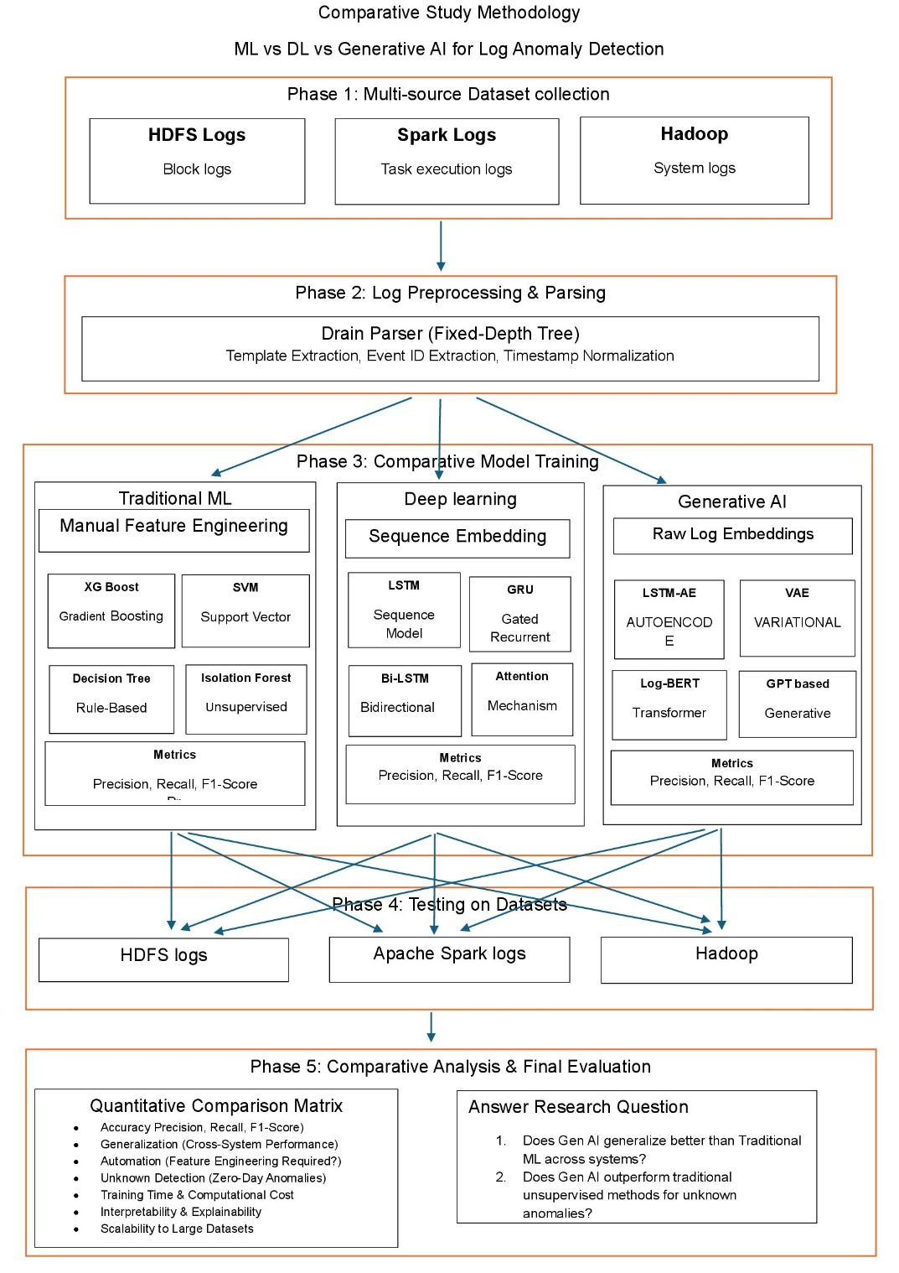
Figure 1 Methodology

Research Design and Overall Methodology
The research follows five phases: multi-source dataset collection; log preprocessing and parsing; comparative model architecture construction; training and testing; and comparative analysis with final evaluation. This sequence is retained directly from the supplied methodology and expanded to explain how the phases interact.
L → P(L) → S(P(L)) → F/S → M → ŷ → Evaluation (4.1)
Here L is the raw log collection, P denotes parsing and preprocessing, S denotes sequence construction, F/S denotes engineered features or sequence representations, M denotes the selected model, and ŷ denotes the anomaly prediction. The notation makes explicit that the learning models operate on processed representations rather than raw text.
The design is comparative at two levels. Within each dataset, several model families are trained and evaluated. Across datasets, the same overall experimental logic is independently repeated for HDFS, Apache Spark, and Hadoop/OpenStack. This corresponds to the supplied distinction between intra-system validation and independent system verification.
The methodology does not pool all system logs into a single training distribution. Keeping the datasets independent helps prevent system-specific vocabulary and operational patterns from contaminating another system's training distribution. This is particularly important because log anomaly datasets differ in construction, labelling, and sequence characteristics [42], [44].
The final comparison therefore considers not only predictive effectiveness but also automation, computational cost, unknown-anomaly detection, interpretability, and scalability. This multidimensional view is necessary because a model with high F1-Score may still be impractical if it requires excessive feature engineering or cannot process large datasets.

Phase 1: Multi-Source Dataset Collection

HDFS Dataset
The HDFS collection is treated as the primary benchmark or “gold standard” in the supplied presentation. It contains more than 575,000 block logs with labelled Normal and BlockCorrelation failures. HDFS is widely used in log anomaly research and has supported sequence-based approaches including DeepLog [37] and related work [40]. Its block-oriented execution context provides a useful starting point for establishing baseline performance.

Apache Spark Dataset
The Apache Spark collection is used as the generalization test. The supplied presentation reports approximately 1.6 million highly complex and overlapping task-execution logs. Spark therefore provides a more demanding environment in which execution relationships can be more complicated than simple block-level sequences.

Hadoop/OpenStack Dataset
The Hadoop/OpenStack collection is used for broader system-level validation. The presentation reports 393,433 logs and describes this collection as a final cross-platform validation set. Its role is to examine whether the selected models retain useful behaviour beyond the application-specific syntax of the primary benchmark.
Each dataset is treated as an independent experimental boundary. The model trained for HDFS is tested on HDFS; the Spark model is tested on Spark; and the Hadoop/OpenStack model is tested on Hadoop/OpenStack. This allows the study to examine within-system learning and compare the resulting performance profiles across heterogeneous environments.

Dataset Challenges and Mitigation Strategy

Apache Spark: Memory and Scale
The Spark collection creates a substantial memory-management problem. The supplied slide reports approximately 33 million rows in a 5 GB CSV. Loading the complete dataset directly into memory caused two separate Google Colab sessions to crash. The implemented solution was chunked processing, with approximately 200 files written at a time directly to CSV so that the full dataset did not have to remain in RAM.
D = D₁ ∪ D₂ ∪ … ∪ Dₚ (4.2)
The chunk formulation permits transformations that can be performed independently on each subset. Parsing, indexing, normalization, and many feature-generation operations can therefore be executed incrementally. This approach changes the data-engineering strategy without changing the underlying anomaly-detection objective.

Extreme Class Imbalance in Spark
The supplied slides report only 0.14% anomalies in the Spark dataset. With such a distribution, a classifier can obtain apparently strong accuracy by predicting Normal almost continuously. The presentation reports 1,820 original anomalies and a SMOTE-based increase to 1,327,644 anomaly examples. SMOTE creates synthetic minority examples and is a standard technique for addressing severe imbalance [46].
For a rigorous experiment, oversampling must be applied only to the training portion. The untouched test set should retain its independent distribution so that reported results measure detection performance rather than performance on a synthetically balanced evaluation set.

Compute Limits
The slides report that generative-model training rapidly exhausted available Google Colab GPU limits. The practical response involved maintaining organized execution pathways and Git-based workflow management so that environments could be changed without losing the experimental structure. These constraints are relevant because batch size, epoch count, sequence length, and model depth directly influence computational cost.

Hadoop/OpenStack: Reverse Class Imbalance
The Hadoop/OpenStack dataset presents the opposite class-distribution problem. The supplied presentation reports that 93.57% of the dataset consists of anomalies. A naive classifier could therefore predict anomaly almost continuously and obtain high accuracy without learning meaningful distinguishing characteristics.
The reported solution combines SMOTE with targeted data pollution and fixes the working class ratio at 0.5. The objective is to force the models to learn differences between normal and anomalous observations rather than simply exploiting the dominant class.
r = N_anomaly / N_normal (4.3)
The ratio-control operation belongs to training preparation. The test set should remain independent so that evaluation reflects the actual ability of the detector to distinguish the two classes. This distinction is essential when reporting results from highly imbalanced data.

Traditional One-Class SVM Limitation
The supplied slide reports that the standard One-Class SVM struggled with the scale and dimensionality of the Hadoop logs, requiring more than 29 minutes per iteration and repeatedly failing to complete. The experiment therefore replaced the traditional implementation with SGDOneClassSVM.
The presentation reports that the stochastic-gradient variant completed the same task approximately 100 times faster. This should be interpreted as an empirical observation under the study's computing environment rather than a universal performance guarantee, because runtime depends on hardware, data size, dimensionality, implementation, and hyperparameters.
The reverse-imbalance experiment complements the Spark experiment. Spark tests the ability to detect a very small minority of anomalies, whereas Hadoop/OpenStack tests whether models can avoid simply predicting the dominant anomaly class.

Phase 2: Log Preprocessing and Parsing
Raw logs cannot normally be supplied directly to spatial, sequential, or classical ML models. The methodology therefore uses the Drain parser, a fixed-depth tree-based parsing approach. Drain separates comparatively stable message structure from changing parameters and assigns event identifiers to structural templates.

Template Extraction
Template extraction separates static text from dynamic variables such as IP addresses, block IDs, timestamps, and task identifiers. Let li be a raw log message and P(li) the parsed event template.
eᵢ = P(lᵢ) (4.4)
This representation reduces vocabulary complexity and encourages models to learn execution patterns instead of memorizing individual runtime values.

Event ID Extraction
Each unique structural template is assigned an event identifier. If there are V unique templates, the event vocabulary can be represented by {e1,e2,...,eV}. These identifiers may subsequently be encoded as one-hot vectors, embeddings, or other numerical representations.

Timestamp Normalization
The methodology also normalizes timestamps and chronological deltas to capture execution latency. If ti denotes the timestamp of event i, the temporal difference is:
Δtᵢ = tᵢ − tᵢ₋₁ (4.5)
Timing information can be useful when a failure is expressed as an unusual delay rather than a completely new event type. Preprocessing must be applied consistently within each dataset boundary.

Phase 3: Comparative Model Architectures
Three parallel analytical pipelines are implemented. Traditional ML uses manually engineered event-count and TF-IDF-style representations. Deep Learning uses sequence embeddings and temporal neural architectures. Generative AI uses learned embeddings and normal-operational data to model the underlying distribution.

Pipeline 1: Traditional Machine Learning
The supplied experimental setting includes XGBoost, SVM, Random Forest, and Isolation Forest. XGBoost and Random Forest use tree ensembles to model nonlinear decision boundaries. Isolation Forest is based on the principle that anomalies are few and different and can therefore be isolated using relatively short random partition paths [43].
s(x,n) = 2^(−E[h(x)]/c(n)) (4.6)
Here E[h(x)] is the expected path length for observation x and c(n) is the normalizing factor for sample size. Shorter isolation paths indicate greater anomaly likelihood.

Event-Count Features
A simple event-count representation converts a sequence into a vector of template frequencies. If V is the number of templates, the count vector is:
c = [c₁,c₂,…,cᵥ], cⱼ = Σₜ 1(eₜ = j) (4.7)
This representation is computationally convenient and interpretable, but it discards some temporal ordering. Two sequences can have identical event counts while representing different execution paths.

Deep Learning Pipeline: Sequence Embedding
The Deep Learning pipeline reduces dependence on rigid manual feature engineering by operating on tokenized or embedded log sequences. The supplied presentation identifies Attention Mechanisms, Bidirectional Bi-LSTM, GRU, and sequence LSTM as the principal sequence architectures.

LSTM and GRU
LSTM and GRU architectures are designed to retain relevant contextual information across a sequence. This makes them suitable for log anomaly detection where an event can be normal in one context but suspicious when it follows a different sequence of events. DeepLog provides a major precedent for this sequence-prediction view of system logs [37].

Bidirectional Bi-LSTM
A Bidirectional LSTM processes a sequence in forward and backward directions. This allows the representation of an event to incorporate both preceding and following context when the complete sequence is available during offline classification.

Attention Mechanisms
Attention assigns learned weights to sequence positions so that more relevant events can contribute more strongly to a context representation. For hidden states ht, a generic attention formulation is:
αₜ = exp(uₜ) / Σⱼ exp(uⱼ) (4.8)
c = Σₜ αₜhₜ (4.9)
Attention can provide useful diagnostic information about which sequence positions influence a representation, although attention weights should not automatically be treated as causal explanations.

Generative AI Pipeline
The Generative AI pipeline is based on normal-operational data. The model learns the distribution of normal sequences and uses reconstruction or reconstruction probability to identify deviations. The supplied experimental setting includes VAE, LSTM-AE, and GAN models.

Variational Autoencoder
The VAE maps input sequences into a probabilistic latent space and reconstructs them. Its objective balances reconstruction quality and KL-divergence regularization [39].
L_ELBO = E_qφ(z|X)[log pθ(X|z)] − KL(qφ(z|X)||p(z)) (4.10)
Because the model is trained strictly on normal operational data, high reconstruction error is interpreted as evidence that an input differs from the learned normal distribution.

LSTM Autoencoder
The LSTM-AE combines temporal sequence modelling with reconstruction. The encoder compresses the sequence and the decoder attempts to reproduce it. The anomaly score is based on the reconstruction discrepancy.
S_AE(X) = D(X,X̂) (4.11)
High reconstruction error provides the primary anomaly threshold in the supplied methodology.

GAN
GAN-based modelling uses a generator and discriminator in an adversarial framework. Its inclusion broadens the generative comparison, although adversarial training can be computationally demanding and sensitive to optimization settings.

Network Architecture and Training Configuration
The supplied presentation specifies one input layer, three hidden layers, and one output layer for the main Deep Learning configuration. It specifies 100 epochs, batch size 128, and 10,372 iterations. The Generative AI configuration is described using three encoder layers, a one-dimensional latent space, and three decoder layers, with the same reported epoch, batch-size, and iteration settings.
N_iter ≈ ⌈N_train / B⌉ × E (4.12)
The expression relates the approximate number of parameter-update iterations to the number of training samples, batch size, and number of epochs. The reported iteration count is understood in the context of the actual implementation and batching procedure.

XGBoost Baseline
The supplied presentation gives an XGBoost configuration with 100 estimators or boosting rounds, maximum depth 6, learning rate 0.1, and subsample 0.8. These settings define a reproducible traditional-ML baseline.
f(x) = Σₘ η fₘ(x) (4.13)
The learning rate η controls the contribution of successive learners, while tree depth limits individual learner complexity. The parameters should be treated as the experimental baseline rather than universal optima.

Phase 4: Training and Testing Dynamics
The methodology uses a strict train-test split, with the supplied Chapter 4 giving an 80/20 division as the example. For a dataset D, this can be represented as:
D = D_train ∪ D_test, |D_train| = 0.8|D|, |D_test| = 0.2|D| (4.14)
The essential principle is intra-system validation. HDFS models are trained and tested within HDFS, Spark models within Spark, and Hadoop/OpenStack models within Hadoop/OpenStack. This preserves each system's operational distribution.

Independent System Verification
The complete procedure is independently repeated across the three collections. The resulting experiment matrix can be written as:
M × D = {modelᵢ × datasetⱼ} (4.15)
This provides a controlled comparison without cross-contaminating training distributions. It also makes performance differences interpretable in terms of the system environment.

Data Leakage Controls
Resampling must be restricted to training data. Likewise, feature-selection statistics, normalization parameters, vocabulary construction, and anomaly thresholds should be estimated without using final test labels. These controls are essential because leakage can artificially inflate performance.

Phase 5: Evaluation Metrics
The principal quantitative metrics are Precision, Recall, and F1-Score. These metrics are particularly important for the study because the Spark and Hadoop/OpenStack datasets have highly unequal class distributions.

Precision
Precision = TP / (TP + FP) (4.16)
Precision measures how many predicted anomalies are actually anomalous. High precision corresponds to a lower false-alarm burden.

Recall
Recall = TP / (TP + FN) (4.17)
Recall measures how many actual anomalies are detected. High recall means fewer anomalies are missed.

F1-Score
F1 = 2 × Precision × Recall / (Precision + Recall) (4.18)
F1-Score is the harmonic mean of precision and recall and provides a balanced measure when both false positives and false negatives matter.

Confusion-Matrix Interpretation
The four outcomes are True Positive, False Positive, True Negative, and False Negative. Accuracy alone can be misleading under severe imbalance. For Spark, predicting Normal almost continuously can yield high accuracy; for Hadoop/OpenStack, predicting Anomaly almost continuously can do the same. Precision, Recall, and F1 therefore provide a more informative basis for comparison.

Extended Comparative Evaluation Criteria
The final comparison extends beyond the three numerical metrics. The supplied methodology identifies Performance Consistency, Automation, Unknown Detection, Training Time, Interpretability, and Scalability as additional dimensions.

Performance Consistency
Performance consistency evaluates whether a model remains effective across HDFS, Spark, and Hadoop/OpenStack. A model that succeeds only on one benchmark may have learned dataset-specific characteristics.

Automation
Automation measures the amount of manual feature engineering required. Traditional ML relies heavily on event counts and TF-IDF-style features, while sequence and generative approaches learn representations more directly from sequences or embeddings.

Unknown Detection
Unknown detection asks whether a model can identify anomalies not explicitly represented in training. Normal-only generative learning is especially relevant to this criterion because it models normality rather than a fixed catalogue of anomaly classes [37], [39].

Training Time
Training time is a practical criterion for large-scale logs. The reported Spark memory failures and Hadoop/OpenStack One-Class SVM timeout problems demonstrate that computational feasibility can be as important as predictive performance.

Interpretability and Scalability
Interpretability concerns how easily a practitioner can understand model decisions, while scalability concerns the ability to process growing data volumes and sequence lengths. Distributed processing frameworks such as Spark provide a practical foundation for large-scale preprocessing [41].

Reproducibility and Integrated Experimental Workflow
Reproducibility is treated as a methodological requirement. Each dataset should retain a documented parsing configuration, feature or sequence construction procedure, training split, class-balancing strategy, model configuration, threshold procedure, and evaluation protocol. The supplied presentation also indicates Git-based organization of execution pathways under compute constraints.
Collect → Parse → Normalize → Split → Balance(train) → Train → Score → Threshold → Evaluate (4.19)
First, logs are collected independently. Second, Drain parsing generates structural templates. Third, timestamps and sequences are normalized. Fourth, training and test partitions are created. Fifth, any SMOTE or pollution operation is applied only to training data. Sixth, the selected model is trained. Seventh, held-out data are scored or classified. Eighth, thresholds are applied where required. Finally, performance and practical criteria are recorded.
C(m,d) = [P, R, F1, T, A, U, I, S] (4.20)
Here m is a model and d is a dataset; P, R, and F1 are Precision, Recall, and F1-Score, while T, A, U, I, and S represent training-time behaviour, automation, unknown detection, interpretability, and scalability. This multidimensional representation reflects the thesis objective more accurately than a single performance number.
The methodology is designed to answer whether Generative AI can maintain strong anomaly-detection performance while reducing manual feature engineering and remaining useful across distinct systems. The paired Spark and Hadoop/OpenStack imbalance experiments also test whether models remain meaningful when anomalies are either extremely rare or overwhelmingly common.

Results and Discussion
This chapter presents the results from simulations based on the methods developed in chapter 4.

Baseline Performance (HDFS v1)
This section documents the comprehensive benchmarking phase evaluating Traditional Machine Learning, Deep Learning, and Generative AI pipelines. Models were evaluated using a strict 80% training and 20% testing split on the HDFS log dataset. The dataset presents a severe class imbalance challenge, comprising 558,223 normal log vectors and 16,838 anomaly vectors. The 20% holdout test set contains a total of 115,013 instances, with 111,645 normal cases and 3,368 anomalies. To address the severe class distribution disparity during training, algorithms like the XGBoost classifier incorporated automated minority class weighting adjustments.

Traditional Machine Learning Results:
In this phase, XGBoost and Support Vector Machine (SVM) were applied to detect anomalies in HDFS log data using manually engineered event count features.
- XGBoost: Achieved near-perfect performance, with an anomaly precision of 0.9985, recall of 0.9997, and F1-score of 0.9991. The model made only 5 false positive errors and missed just 1 anomaly out of 3,368 in the test set.
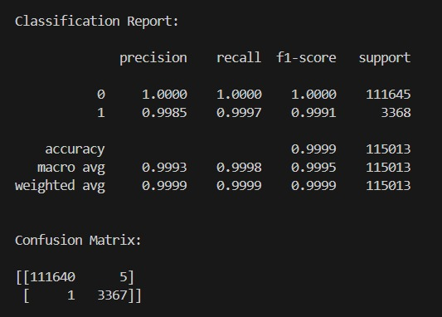
Figure 2 HDFS ML XGBoost Confusion Matrix
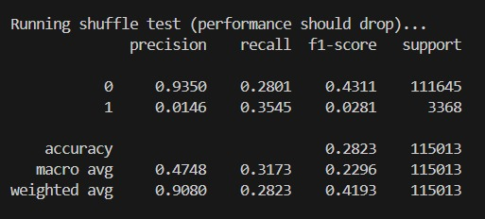
Figure 3 Shuffling Test Performance
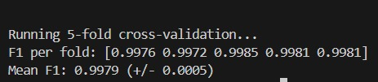
Figure 4 F1 Score

- SVM: Demonstrated strong baseline performance, achieving an anomaly precision of 0.9634, recall of 0.9994, and F1-score of 0.9811. However, it produced 128 false positives and missed 2 anomalies.
- 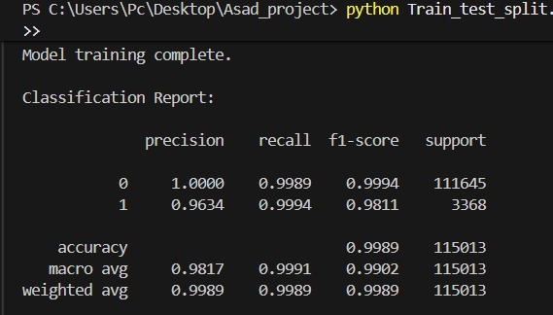
Figure 5 SVM results
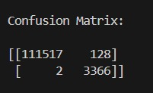
Figure 6 SVM Confusion Matrix
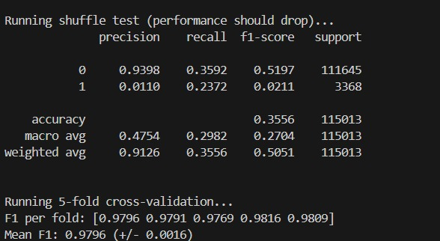
Figure 7 SVM Results after Shuffing

XGBoost distinctly outperformed SVM across all key parameters, highlighting its superior capacity to construct non-linear decision boundaries across complex event distributions.

Deep Learning (Supervised) Results:
The supervised Deep Learning pipeline evaluated sequence models capable of learning from log data without the rigid manual feature engineering required by traditional ML.
- LSTM: The Long Short-Term Memory network achieved an anomaly precision of 0.9808, a recall of 0.9988, and an F1-score of 0.9897. The model produced 66 false positives and missed 4 anomalies, while maintaining a perfect ROC-AUC of 1.0.
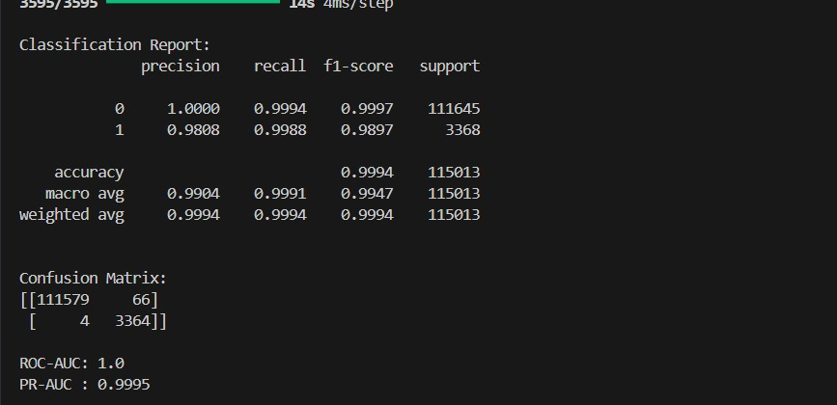
Figure 8 DL LSTM Confusion Matrix and ROC-AUC results
- GRU: The Gated Recurrent Unit performed comparably to the LSTM, achieving a precision of 0.9808, a recall of 0.9991, and an F1-score of 0.9899. It also produced 66 false positives but missed only 3 anomalies, similarly achieving an ROC-AUC of 1.0.
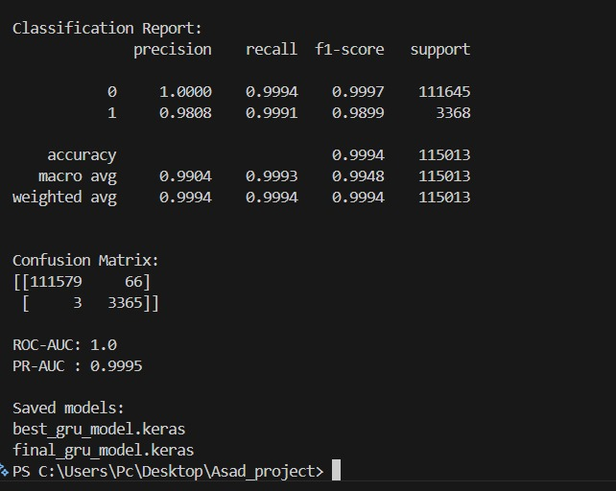
Figure 9 GRU Confusion Matrix and ROC-AUC results

Generative AI Results:
The Generative AI models were trained exclusively on normal data sequences (normal-only), evaluating their capability to reconstruct logs and detect anomalies through reconstruction errors without relying on supervised anomaly labels.
- LSTM Autoencoder: Achieved an anomaly precision of 0.7232, a recall of 0.8818, and an F1-score of 0.7946. The model resulted in 1,137 false positives and 398 missed anomalies, with an ROC-AUC of 0.9964 and PR-AUC of 0.9049.
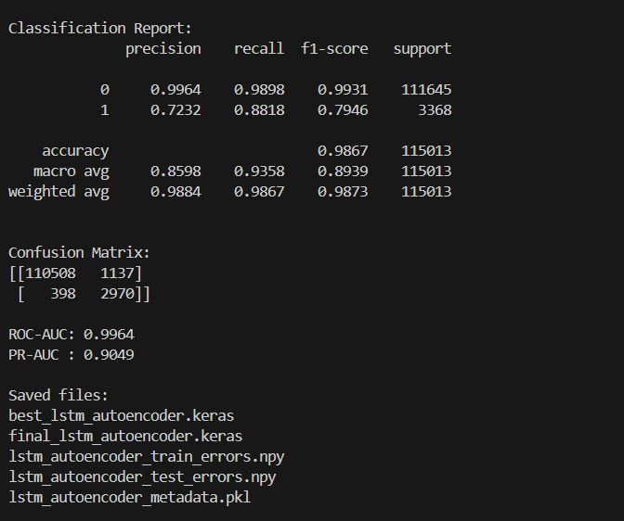
Figure 10 GEN AI LSTM Autoencoder Confusion Matrix and ROC-AUC results
- LSTM-VAE: The Variational Autoencoder yielded an anomaly precision of 0.6944, a recall of 0.7429, and an F1-score of 0.7178. It generated 1,101 false positives and 866 missed anomalies, achieving an ROC-AUC of 0.9876 and PR-AUC of 0.7854.
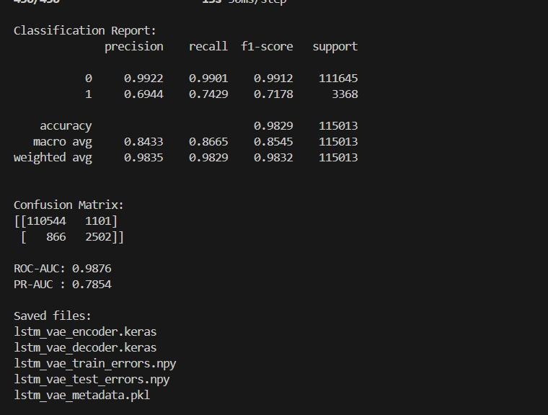
Figure 11 GEN AI LSTM VAE Confusion Matrix and ROC-AUC results

Comparative Analysis Synthesis (HDFS):
The benchmarking results present a clear trade-off between absolute accuracy and functional autonomy.
- Supervised Dominance: Traditional supervised models like XGBoost achieve near-perfect F1-scores (0.9991). However, their reliance on manual Event Count Matrices limits operational scalability.
- Deep Learning Autonomy: Supervised Deep Learning sequence models (LSTM and GRU) successfully matched this high accuracy (F1-scores of ~0.99) while eliminating the need for rigid manual feature extraction, proving their efficacy at understanding sequential log patterns.
- Generative Potential: The Generative AI models (LSTM Autoencoder and VAE) exhibit lower raw precision and recall metrics but operate under a fundamentally different, strictly unsupervised paradigm. Because they are trained exclusively on normal system behavior, their F1-scores (~0.71 - 0.79) represent a baseline capability for discovering unknown, zero-day anomalies.
Table 1 HDFS All Models Comparison
Model | Type | Anomaly Precision | Anomaly Recall | Anomaly F1 | ROC-AUC | PR-AUC
XGBoost | Traditional ML | 99.85% | 99.97% | 99.91% | - | -
SVM | Traditional ML | 96.34% | 99.94% | 98.11% | - | -
LSTM | Supervised DL | 98.08% | 99.88% | 98.97% | 100.00% | 99.95%
GRU | Supervised DL | 98.08% | 99.91% | 98.99% | 100.00% | 99.95%
LSTM Autoencoder | Generative/ Normal-only | 72.32% | 88.18% | 79.46% | 99.64% | 90.49%
LSTM-VAE | Generative / Normal-only | 69.44% | 74.29% | 71.78% | 98.76% | 78.54%

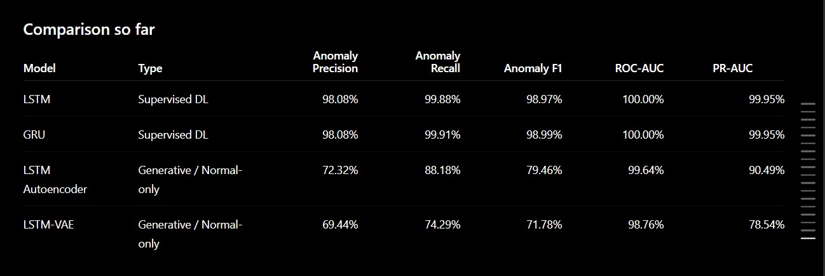
Figure 12 HDFS Comparison Matrix

Spark Logs Analysis
1) Machine Learning Results:
The traditional ML training logs show that Random Forest achieved a near-perfect ROC-AUC of 0.9902, vastly outperforming unsupervised methods like Isolation Forest (0.9559) and One-Class SVM (0.2388). However, despite the high ROC-AUC, the Isolation Forest model struggled with precision (0.04) and F1-score (0.04) for anomaly detection.
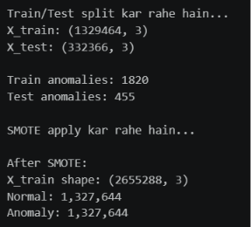
Figure 13 Spark ML Train and Test Results
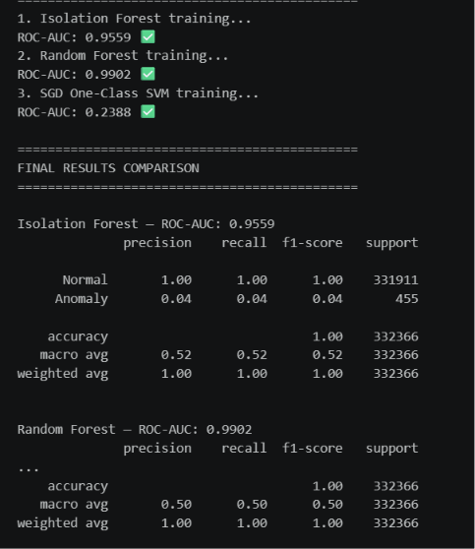
Figure 14 Isolation Forest and Random Forest Results

2) Deep Learning Results:
The LSTM Autoencoder model achieved a strong ROC-AUC score of 0.9822 and an excellent recall of 0.93 for anomalies. However, its precision was extremely low at 0.02, leading to an F1-score of just 0.05, indicating a high rate of false positives.
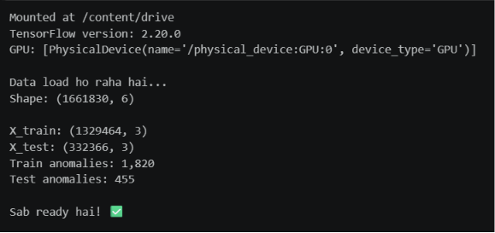
Figure 15 DL Train and Test Results
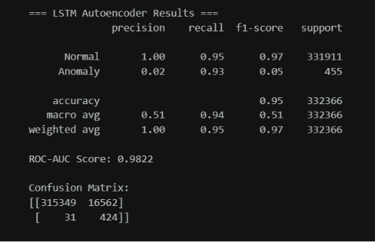
Figure 16 LSTM Results

The CNN Classifier recorded the highest overall ROC-AUC for the Spark dataset at 0.9978, with a perfect recall of 1.00. Similar to the LSTM model, it suffered from severe precision issues (0.09), resulting in a low F1-score of 0.16.
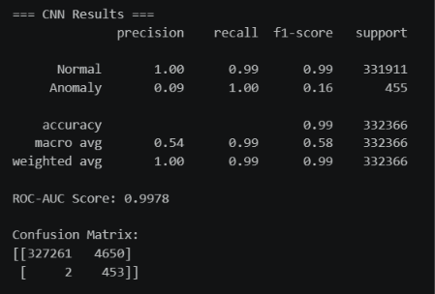
Figure 17 CNN Results
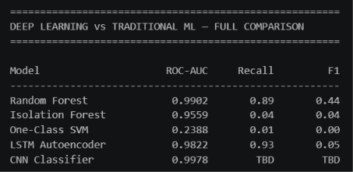
Figure 18 DL vs ML Comparison Results
3) Generative AI Results:
Both generative models performed poorly on the Spark dataset. The Variational Autoencoder (VAE) achieved an ROC-AUC of 0.7700 but managed an F1-score of only 0.01, while the Generative Adversarial Network (GAN) failed to detect anomalies effectively, recording an ROC-AUC of 0.2479 and an F1-score of 0.01.
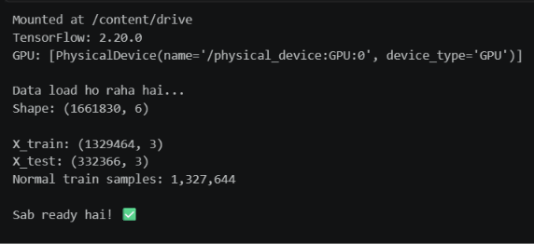
Figure 19 Gen AI Train and Test Results
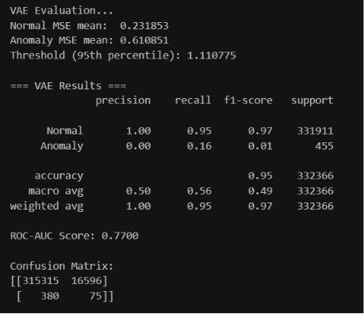
Figure 20 VAE Results
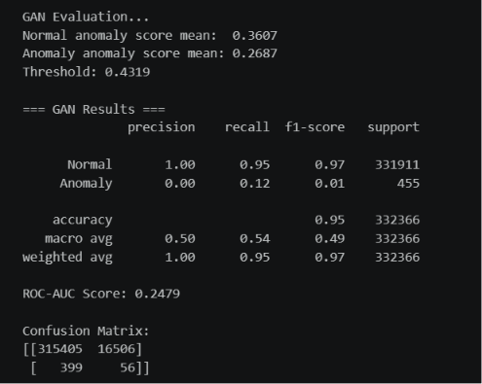
Figure 21 GAN Results
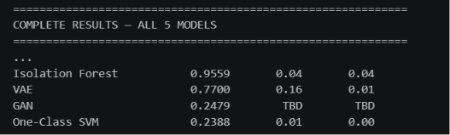

Spark Comparative Analysis Synthesis:
The Spark execution logs presented a severe degradation in model efficacy across all architectures.
- Precision Collapse: The complex, overlapping nature of Spark execution logs created a massive false-positive problem. For instance, the LSTM Autoencoder generated 16,562 false positives, dropping its F1-score to just 0.05 despite a strong ROC-AUC of 0.9822.
- Generative Failure: Both generative models performed exceptionally poorly on the Spark dataset. The structural noise and high concurrency of Spark tasks fundamentally disrupted the VAE and GAN's ability to map a stable latent distribution, resulting in F1-scores of 0.01.

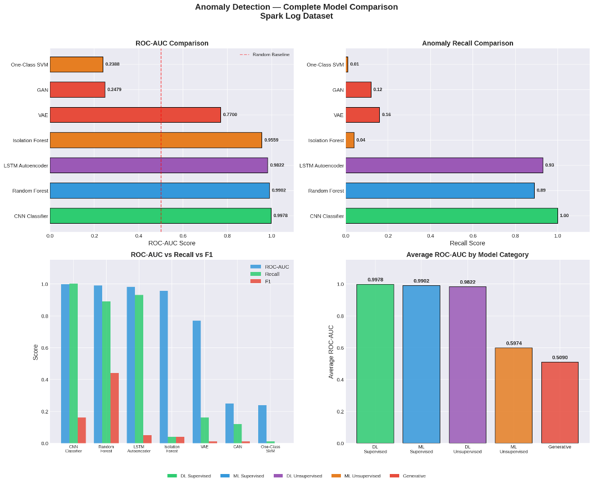
Figure 22 Spark logs Model Comparison
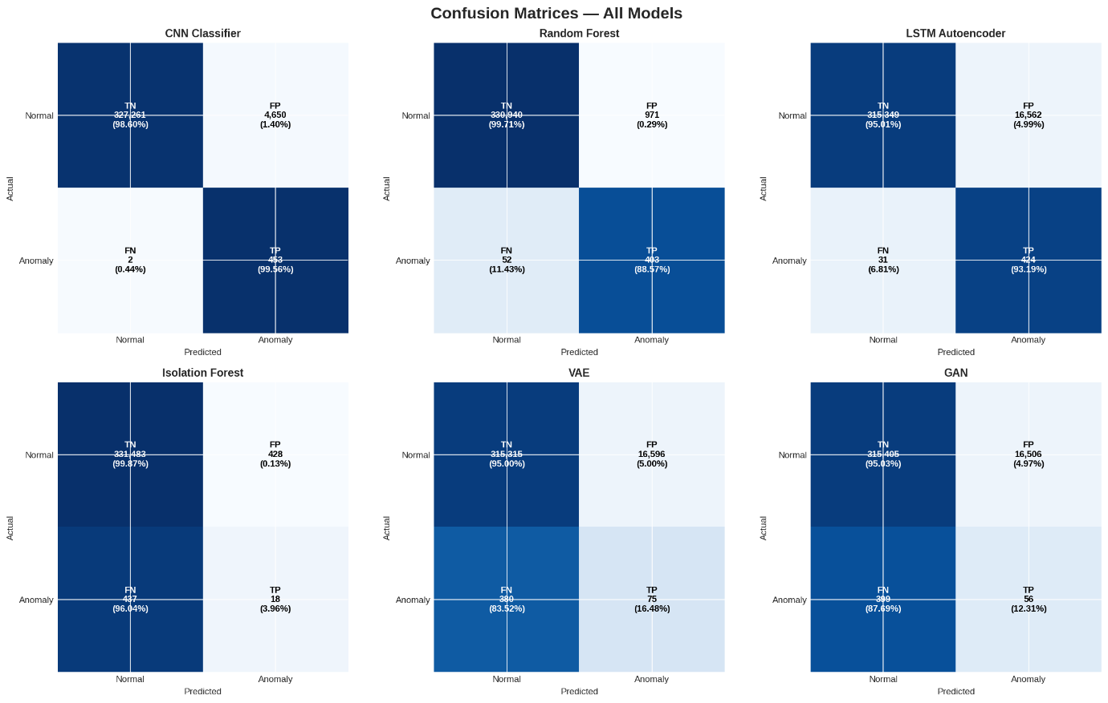
Figure 23 Spark logs Confusion Matrix
Table 2 Spark Logs All Model Results Summary
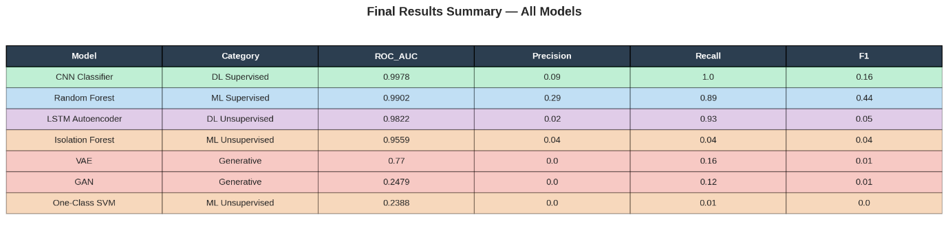

Hadoop Logs Analysis
1) Traditional Machine Learning Logs:
In the Hadoop environment, the Random Forest model achieved perfect metrics across the board, logging an ROC-AUC, Recall, and F1-score of 1.0000. It is important to note that this perfect score is attributed to the per-application labeling scheme of the Hadoop dataset, wherein all log lines belonging to a single application inherit the same label. This introduces feature leakage, as the application identifier (app_id) is directly correlated with the ground truth label, enabling the model to achieve trivial classification. Consequently, the Spark dataset results are considered more reliable for cross-dataset comparison. Conversely, Isolation Forest and One-Class SVM performed poorly, with ROC-AUC scores of 0.2092 and 0.2383, respectively. 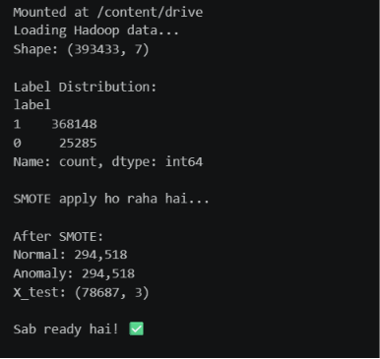
Figure 25 Hadoop ML Label Logs distribution
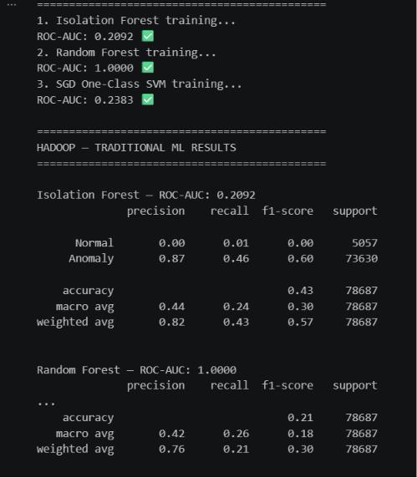
Figure 26 ML Isolation Forest and Random Forest Results
2) Deep Learning (LSTM and CNN):
Deep learning performance was mixed on the Hadoop data. The CNN Classifier performed exceptionally well with an ROC-AUC of 0.9617 and a strong F1-score of 0.91. The LSTM Autoencoder, however, saw a significant drop in performance compared to its Spark results, achieving an ROC-AUC of 0.6519 and an F1-score of 0.45.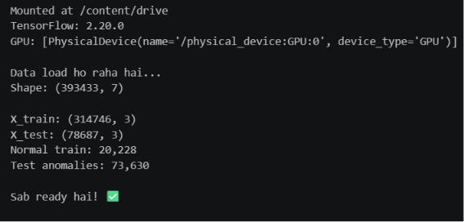Figure 27 DL train test results

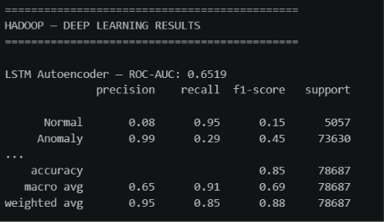
Figure 28 LSTM Autoencoder Results
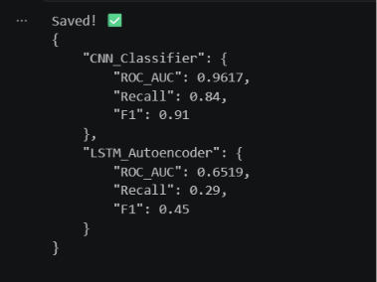
Figure 29 CNN and LSTM comparison
3) Generative AI (VAE and GAN):
Generative models continued to underperform on the Hadoop dataset. The GAN achieved an ROC-AUC of 0.6133 with an F1-score of 0.03, while the VAE recorded an ROC-AUC of 0.5235 and an F1-score of 0.12.
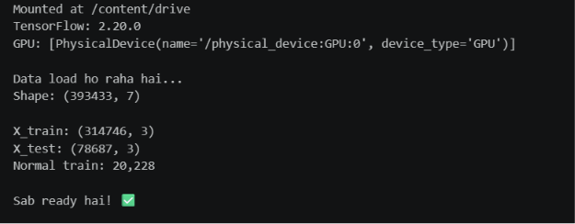
Figure 30 Gen AI train test results

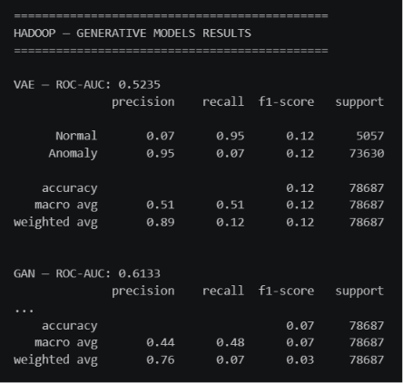
Figure 31 VAE and GAN results

Hadoop Comparative Analysis Synthesis:
The summary table and confusion matrices for Hadoop confirm the absolute superiority of the Random Forest model, which recorded 0 false positives and 0 false negatives. The CNN also demonstrated high accuracy with only 50 false positives out of tens of thousands of records.
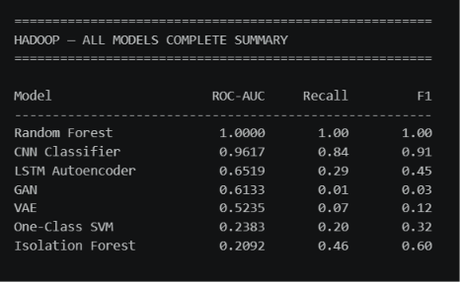
Figure 32 Hadoop All Model Results Summary
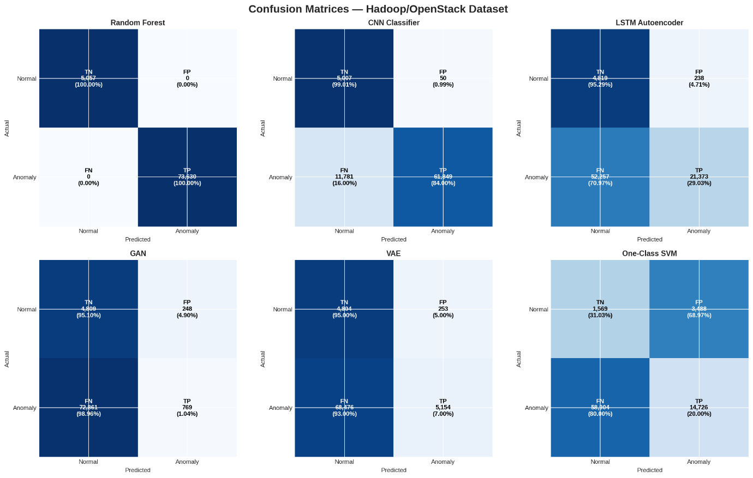
Figure 33 Hadoop All Model Confusion Matrix

Overall Performance Synthesis (Spark vs. Hadoop)
The final heatmap provides a clear visual summary: Random Forest is the most consistently reliable model across both datasets, maintaining high ROC-AUC and the best relative F1-scores. CNN classifiers show excellent ROC-AUC but are highly susceptible to F1-score degradation depending on the dataset (0.16 on Spark vs. 0.91 on Hadoop), while Generative and Traditional Unsupervised models exhibit consistently weak performance across both environments.

Table 3 Spark vs Hadoop All Models Results
Model | Category | HDFS F1 | Spark F1 | Hadoop F1
XGBoost | Traditional ML (Supervised) | 0.9991 | - | -
SVM | Traditional ML (Supervised) | 0.9811 | - | -
Random Forest | Traditional ML (Supervised) | - | 0.44 | 1
LSTM | Deep Learning (Supervised) | 0.9897 | - | -
GRU | Deep Learning (Supervised) | 0.9899 | - | -
CNN Classifier | Deep Learning (Supervised) | - | 0.16 | 0.91
Isolation Forest | Traditional ML (Unsupervised) | - | 0.04 | 0.6
One-Class SVM | Traditional ML (Unsupervised) | - | 0 | 0.32
LSTM Autoencoder | Generative / Unsupervised DL | 0.7946 | 0.05 | 0.45
VAE / LSTM-VAE | Generative | 0.7178 | 0.01 | 0.12
GAN | Generative | - | 0.01 | 0.03

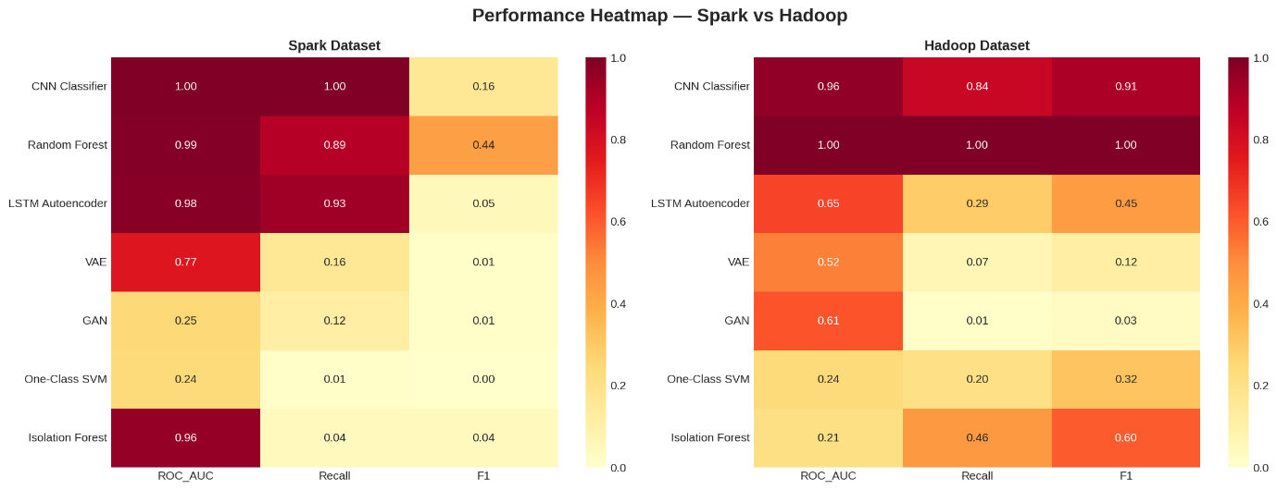
Figure 34 Performance Matrix Spark vs Hadoop

Generative Model Failures

GANs: Structural Mismatch
GANs require highly diverse, dynamic data to function. Log data, however, is rigidly structured and repetitive. This leads directly to Mode Collapse—the GAN simply generates one specific type of fake data over and over.
Analogy: A GAN is like a creative artist tasked with spotting accounting fraud. It fundamentally isn't designed for the job.

VAEs: Blurry Reconstruction
Variational Autoencoders produce "blurry" reconstructions by design. Because they generalize, the fine, crucial details in anomalous log lines are completely lost, making the reconstruction error between normal and anomalous logs indistinguishable.
Analogy: A VAE is like a cheap photocopier that blurs both a perfectly normal page and a torn page alike.

Key Takeaways from the Data:
- The HDFS Illusion: Almost everything performed exceptionally well on HDFS, making it seem like the problem of anomaly detection was solved.
- The Spark Reality Check: Spark completely broke the models. The complex, overlapping nature of Spark execution logs created a massive false-positive problem, dragging almost every model's F1-score below 0.50.
- The Generative Struggle: While Generative AI (LSTM Autoencoder, VAE, GAN) is theoretically great because it doesn't need manual feature engineering, it consistently struggled with noise across all environments, peaking at just 0.7946 on the "easy" HDFS dataset and failing entirely on Spark and Hadoop.

Conclusions and Recommendations

Thesis Core Findings and Contributions
This research successfully developed and executed a comprehensive five-phase comparative framework for automated log anomaly detection, rigorously benchmarking models across three diverse distributed architectures: HDFS, Apache Spark, and Hadoop. A foundational methodological contribution of this thesis was establishing true operational baselines by ensuring that model training and testing were conducted on an 80% train and 20% test split strictly within the same dataset. This intra-system evaluation prevented cross-dataset contamination and provided a highly controlled environment to evaluate algorithmic efficacy.
Furthermore, this study successfully solved the challenge of extreme class imbalance present in real-world system logs. By applying the Synthetic Minority Over-sampling Technique (SMOTE) alongside targeted data pollution, the research resolved the massive disparities between the Hadoop dataset (93.57% anomalies) and the Apache Spark dataset (0.14% anomalies). Through this rigorous evaluation, the research proved the functional limitations of Generative AI compared to Traditional Machine Learning, bridging a critical gap in current cybersecurity literature and establishing a definitive performance hierarchy: Supervised > Unsupervised > Generative.

The Performance Trade-Off and Research Outcomes
The empirical benchmarking across these heterogeneous environments answers the core research questions by revealing a distinct trade-off between absolute detection accuracy and functional architectural autonomy:
- Traditional Machine Learning: Traditional supervised classifiers, including XGBoost and Random Forest, demonstrated near-perfect anomaly precision and F1-scores on highly balanced or structurally consistent datasets like HDFS and Hadoop. However, these models remain entirely brittle. They are heavily dependent on labor-intensive, manual feature engineering (such as rigid Event Count Matrices) and operate effectively only under closed-world assumptions where the log syntax remains static.
- Supervised Deep Learning: Deep sequence architectures, such as LSTMs, GRUs, and CNNs, successfully eliminate the need for manual feature extraction by directly processing log sequences. While they maintain strong performance on structured data, these models remain highly volatile and exhibit severe performance degradation when confronted with the high noise levels and complex concurrency patterns inherent to Spark execution logs.
- Generative AI: Generative models theoretically adapt better to new systems because they bypass manual feature engineering—a rigid process that breaks when system formats change. By utilizing a normal-only training paradigm, architectures like the LSTM Autoencoder, VAE, and GAN learn what "normal" activity looks like to automatically catch unknown, zero-day errors. They successfully identify zero-day anomalies, achieving consistently high ROC-AUC scores that demonstrate the underlying reconstruction error distributions remain highly separable.

System-Specific Degradation and Operational Boundaries
Despite removing the need for manual feature engineering, real-world testing proves that Generative AI models are significantly inferior to traditional supervised models for detecting anomalies in large-scale system logs due to structural mismatches and noise sensitivity.
While Generative AI performs adequately on the highly structured, linear sequences of HDFS, it struggles in more chaotic environments. On complex, highly concurrent systems like Apache Spark, Generative AI gets confused by the overlapping execution traces and background noise. This sensitivity generates massive false positive rates, which drastically lowers the overall F1-score. Ultimately, while generative architectures establish a vital baseline capability for discovering unknown anomalies without requiring prior exposure to production failure states, their high false alarm rate makes traditional supervised models much more reliable in practice and severely limits the standalone production readiness of generative models.

Recommendations for Future Work
To address the functional limitations and high false-positive rates identified in this comparative framework, future research in automated system observability should focus on the following core directions:
- Dynamic Thresholding Mechanisms: Future iterations must implement Extreme Value Theory (EVT) and adaptive thresholding to replace static percentile cutoffs. This is critical to dynamically adjust reconstruction thresholds and minimize the excessive false-positive rates observed in generative models on complex datasets like Spark.
- Concept Drift Mitigation: Researchers should investigate online, incremental learning and fine-tuning paradigms to adapt to evolving log formats in real-time, ensuring deep generative models remain robust as software updates occur.
- Fine-Grained Parameter Classification: There is a need to extend the semantic capabilities of raw log embeddings to parse and categorize specific variable fields (such as status codes, IP addresses, and block IDs) rather than relying solely on rigid event sequence IDs.
- Hybrid Neuro-Symbolic Frameworks: Future architectures should focus on developing unified, hybrid neuro-symbolic models. These frameworks aim to combine the statistical robustness and ensemble precision of traditional machine learning with the unsupervised, semantic understanding of generative sequence modeling.

References
[1] K. Kent and M. Souppaya, Guide to Computer Security Log Management, NIST Special Publication 800-92, National Institute of Standards and Technology, 2006. doi: 10.6028/NIST.SP.800-92.
[2] M. Du, F. Li, G. Zheng, and V. Srikumar, “DeepLog: Anomaly Detection and Diagnosis from System Logs through Deep Learning,” in Proceedings of the 2017 ACM SIGSAC Conference on Computer and Communications Security, pp. 1285–1298, 2017.
[3] “Deep learning for anomaly detection in log data: A survey,” Machine Learning with Applications, vol. 12, p. 100470, 2023, doi: 10.1016/j.mlwa.2023.100470.
[4] W. Meng et al., “LogAnomaly: Unsupervised Detection of Sequential and Quantitative Anomalies in Unstructured Logs,” in Proceedings of the Twenty-Eighth International Joint Conference on Artificial Intelligence (IJCAI), pp. 4739–4745, 2019, doi: 10.24963/ijcai.2019/658.
[5] H. Guo, S. Yuan, and X. Wu, “LogBERT: Log Anomaly Detection via BERT,” in 2021 International Joint Conference on Neural Networks (IJCNN), pp. 1–8, 2021, doi: 10.1109/IJCNN52387.2021.9534113.
[6] “System Logs Anomaly Detection. Are we on the right path?” Applied Artificial Intelligence, 2024, doi: 10.1080/08839514.2024.2440692.
[7] “A Survey on Log Anomaly Detection using Deep Learning,” in 2020 8th International Conference on Reliability, Infocom Technologies and Optimization (Trends and Future Directions), 2020, doi: 10.1109/ICRITO48877.2020.9197818.
[8] P. Cichonski, T. Millar, T. Grance, and K. Scarfone, Computer Security Incident Handling Guide, NIST Special Publication 800-61 Revision 2, National Institute of Standards and Technology, Gaithersburg, MD, USA, 2012, doi: 10.6028/NIST.SP.800-61r2.
[9] W. Meng, Y. Liu, Y. Zhu, S. Zhang, D. Pei, Y. Liu, Y. Chen, R. Zhang, S. Tao, P. Sun, and R. Zhou, “LogAnomaly: Unsupervised Detection of Sequential and Quantitative Anomalies in Unstructured Logs,” Proceedings of the Twenty-Eighth International Joint Conference on Artificial Intelligence (IJCAI), pp. 4739–4745, 2019, doi: 10.24963/ijcai.2019/658.
[10] M. Du, F. Li, G. Zheng, and V. Srikumar, “DeepLog: Anomaly Detection and Diagnosis from System Logs through Deep Learning,” in Proceedings of the 2017 ACM SIGSAC Conference on Computer and Communications Security, pp. 1285–1298, 2017.
[11] X. Zhang, Y. Lin, and others, “Log-based Anomaly Detection Without Log Parsing,” in 2021 36th IEEE/ACM International Conference on Automated Software Engineering (ASE), pp. 492–504, 2021, doi: 10.1109/ASE51524.2021.9678773.
[12] W. Xu, L. Huang, A. Fox, D. Patterson, and M. Jordan, “Detecting Large-Scale System Problems by Mining Console Logs,” Proceedings of the 2009 ACM SIGOPS International Conference on Computer Systems, 2009.
[13] J.-G. Lou, Q. Fu, S. Yang, Y. Xu, and J. Li, “Mining Invariants from Console Logs for System Problem Detection,” USENIX Annual Technical Conference, 2010.
[14] S. He, Q. He, J. Chen, H. Zhang, Y. Yang, and M. R. Lyu, “Experience Report: System Log Analysis for Anomaly Detection,” IEEE International Symposium on Software Reliability Engineering, 2016.
[15] M. Du and F. Li, “Spell: Streaming Parsing of System Event Logs,” IEEE International Conference on Data Mining, 2016.
[16] S. He, J. Zhu, P. He, and M. R. Lyu, “Experience Report: System Log Analysis for Anomaly Detection,” IEEE International Symposium on Software Reliability Engineering, 2016.
[17] M. Landauer, S. Onder, F. Skopik, and M. Wurzenberger, “Deep Learning for Anomaly Detection in Log Data: A Survey,” Machine Learning with Applications, vol. 12, 2023, Art. 100470.
[18] S. He, P. He, Z. Chen, T. Yang, Y. Su, and M. R. Lyu, “Drain: An Online Log Parsing Approach with Fixed Depth Tree,” IEEE International Conference on Web Services, 2017.
[19] V. Makanju, A. N. Zincir-Heywood, and E. E. Milios, “A Lightweight Algorithm for Message Type Extraction from Log Files,” IEEE International Conference on Mining Software Repositories, 2009.
[20] M. Du, F. Li, G. Zheng, and V. Srikumar, “DeepLog: Anomaly Detection and Diagnosis from System Logs through Deep Learning,” ACM CCS, pp. 1285–1298, 2017.
[21] W. Meng, Y. Liu, F. Zhu, S. Zhang, D. Pei, Y. Chen, R. Zhang, S. Tao, P. Sun, and R. Zhou, “LogAnomaly: Unsupervised Detection of Sequential and Quantitative Anomalies in Unstructured Logs,” IJCAI, pp. 4739–4745, 2019.
[22] X. Zhang et al., “Robust Log-Based Anomaly Detection on Unstable Log Data,” Proceedings of the 27th ACM Joint European Software Engineering Conference and Symposium on the Foundations of Software Engineering, pp. 807–817, 2019. DOI: 10.1145/3338906.3338931.
[23] S. Huang, Y. Liu, C. Fung, R. He, Y. Zhao, H. Yang, and Z. Luan, “HitAnomaly: Hierarchical Transformers for Anomaly Detection in System Log,” IEEE Transactions on Network and Service Management, vol. 17, no. 4, pp. 2064–2076, 2020. DOI: 10.1109/TNSM.2020.3034647.
[24] H. Guo, S. Yuan, and X. Wu, “LogBERT: Log Anomaly Detection via BERT,” arXiv:2103.04475, 2021.
[25] Y. Lin, H. Deng, and X. Li, “FastLogAD: Log Anomaly Detection with Mask-Guided Pseudo Anomaly Generation and Discrimination,” arXiv:2404.08750, 2024.
[26] X. Li, P. Chen, L. Jing, Z. He, and G. Yu, “SwissLog: Robust and Unified Deep Learning Based Log Anomaly Detection for Diverse Faults,” IEEE 31st International Symposium on Software Reliability Engineering (ISSRE), pp. 92–103, 2020. DOI: 10.1109/ISSRE5003.2020.00018.
[27] Y. Le and others, “Log-based Anomaly Detection without Log Parsing,” related work in recent log anomaly detection literature, 2020s.
[28] A. Vaswani et al., “Attention Is All You Need,” Advances in Neural Information Processing Systems, vol. 30, 2017.
[29] J. Devlin, M.-W. Chang, K. Lee, and K. Toutanova, “BERT: Pre-training of Deep Bidirectional Transformers for Language Understanding,” NAACL-HLT, 2019.
[30] I. Goodfellow, Y. Bengio, and A. Courville, Deep Learning. MIT Press, 2016.
[31] C. M. Bishop, Pattern Recognition and Machine Learning. Springer, 2006.
[32] K. P. Murphy, Machine Learning: A Probabilistic Perspective. MIT Press, 2012.
[33] S. Russell and P. Norvig, Artificial Intelligence: A Modern Approach, 4th ed. Pearson, 2021.
[34] M. Kleppmann, Designing Data-Intensive Applications. O’Reilly Media, 2017.
[35] J. E. Jackson et al., “System log anomaly detection based on contrastive learning and retrieval augmented,” Scientific Reports / related recent literature, 2025.
[36] “Anomaly Detection in Logs Using Deep Learning,” IEEE Access, vol. 12, pp. 176124–176135, 2024. DOI: 10.1109/ACCESS.2024.3506332.
[37] M. Du, F. Li, G. Zheng, and V. Srikumar, “DeepLog: Anomaly Detection and Diagnosis from System Logs through Deep Learning,” Proceedings of the 2017 ACM SIGSAC Conference on Computer and Communications Security, pp. 1285–1298, 2017.
[38] W. Xu, L. Huang, A. Fox, D. Patterson, and M. I. Jordan, “Detecting Large-Scale System Problems by Mining Console Logs,” Proceedings of the 22nd ACM Symposium on Operating Systems Principles, pp. 117–132, 2009.
[39] D. P. Kingma and M. Welling, “Auto-Encoding Variational Bayes,” arXiv:1312.6114, 2013.
[40] W. Meng, Y. Liu, Y. Zhu, S. Zhang, D. Pei, Y. Liu, Y. Chen, R. Zhang, S. Tao, P. Sun, and R. Zhou, “LogAnomaly: Unsupervised Detection of Sequential and Quantitative Anomalies in Unstructured Logs,” Proceedings of the Twenty-Eighth International Joint Conference on Artificial Intelligence, pp. 4739–4745, 2019.
[41] M. Zaharia, M. Chowdhury, T. Das, A. Dave, J. Ma, M. J. Franklin, S. Shenker, and I. Stoica, “Resilient Distributed Datasets: A Fault-Tolerant Abstraction for In-Memory Cluster Computing,” Proceedings of the 9th USENIX Symposium on Networked Systems Design and Implementation, pp. 15–28, 2012.
[42] M. Landauer, F. Skopik, and M. Wurzenberger, “A Critical Review of Common Log Data Sets Used for Evaluation of Sequence-Based Anomaly Detection Techniques,” Proceedings of the ACM on Software Engineering, vol. 1, no. FSE, pp. 1354–1375, 2024.
[43] A. El Aouni et al., “Detection of anomalies in the HDFS dataset,” Proceedings of the 21st International Conference on Software Engineering Research, Management and Applications (SERA), IEEE, 2023.
[44] M. Landauer, F. Skopik, and M. Wurzenberger, “A critical review of common log data sets used for evaluation of sequence-based anomaly detection techniques,” ACM/IEEE literature and dataset review, 2024.
[45] M. Du, F. Li, G. Zheng, and V. Srikumar, “DeepLog: Anomaly Detection and Diagnosis from System Logs through Deep Learning,” DOI: 10.1145/3133956.3134015, 2017.
[46] Y. Z.-H. Yang, “Training Latent Variable Models with Auto-encoding Variational Bayes: A Tutorial,” arXiv:2208.07818, 2022.

Appendix-A
This appendix is reserved for supplementary data tables. Additional experimental results including per-class classification reports, extended confusion matrices, and model hyperparameter configurations are available in the accompanying GitHub repository: https://github.com/asadkhanofficial2341-beep/ASAD-thesis-files
Table A-1: HDFS All Models Comparison
Model | Type | Anomaly Precision | Anomaly Recall | Anomaly F1 | ROC-AUC | PR-AUC
XGBoost | Traditional ML | 99.85% | 99.97% | 99.91% | - | -
SVM | Traditional ML | 96.34% | 99.94% | 98.11% | - | -
LSTM | Supervised DL | 98.08% | 99.88% | 98.97% | 100.00% | 99.95%
GRU | Supervised DL | 98.08% | 99.91% | 98.99% | 100.00% | 99.95%
LSTM Autoencoder | Generative/ Normal-only | 72.32% | 88.18% | 79.46% | 99.64% | 90.49%
LSTM-VAE | Generative / Normal-only | 69.44% | 74.29% | 71.78% | 98.76% | 78.54%
Table A-2: Spark Logs All Model Results Summary
Model | Category | ROC_AUC | Precision | Recall | F1
CNN Classifier | DL Supervised | 0.9978 | 0.09 | 1.0 | 0.16
Random Forest | ML Supervised | 0.9902 | 0.29 | 0.89 | 0.44
LSTM Autoencoder | DL Unsupervised | 0.9822 | 0.02 | 0.93 | 0.05
Isolation Forest | ML Unsupervised | 0.9559 | 0.04 | 0.04 | 0.04
VAE | Generative | 0.77 | 0.0 | 0.16 | 0.01
GAN | Generative | 0.2479 | 0.0 | 0.12 | 0.01
One-Class SVM | ML Unsupervised | 0.2388 | 0.0 | 0.01 | 0.0
Table A-3: Spark vs Hadoop All Models Results
Model | Category | HDFS F1 | Spark F1 | Hadoop F1
XGBoost | Traditional ML (Supervised) | 0.9991 | - | -
SVM | Traditional ML (Supervised) | 0.9811 | - | -
Random Forest | Traditional ML (Supervised) | - | 0.44 | 1
LSTM | Deep Learning (Supervised) | 0.9897 | - | -
GRU | Deep Learning (Supervised) | 0.9899 | - | -
CNN Classifier | Deep Learning (Supervised) | - | 0.16 | 0.91
Isolation Forest | Traditional ML (Unsupervised) | - | 0.04 | 0.6
One-Class SVM | Traditional ML (Unsupervised) | - | 0 | 0.32
LSTM Autoencoder | Generative / Unsupervised DL | 0.7946 | 0.05 | 0.45
VAE / LSTM-VAE | Generative | 0.7178 | 0.01 | 0.12
GAN | Generative | - | 0.01 | 0.03

Turnitin Originality Report
(stamped and signed by QEC and to be submitted separately)

