Appointment Booking System
Sidebar Structure, Section Details & Complete Process Explanation
Web-Based System • Admin • Provider/Staff • Customer
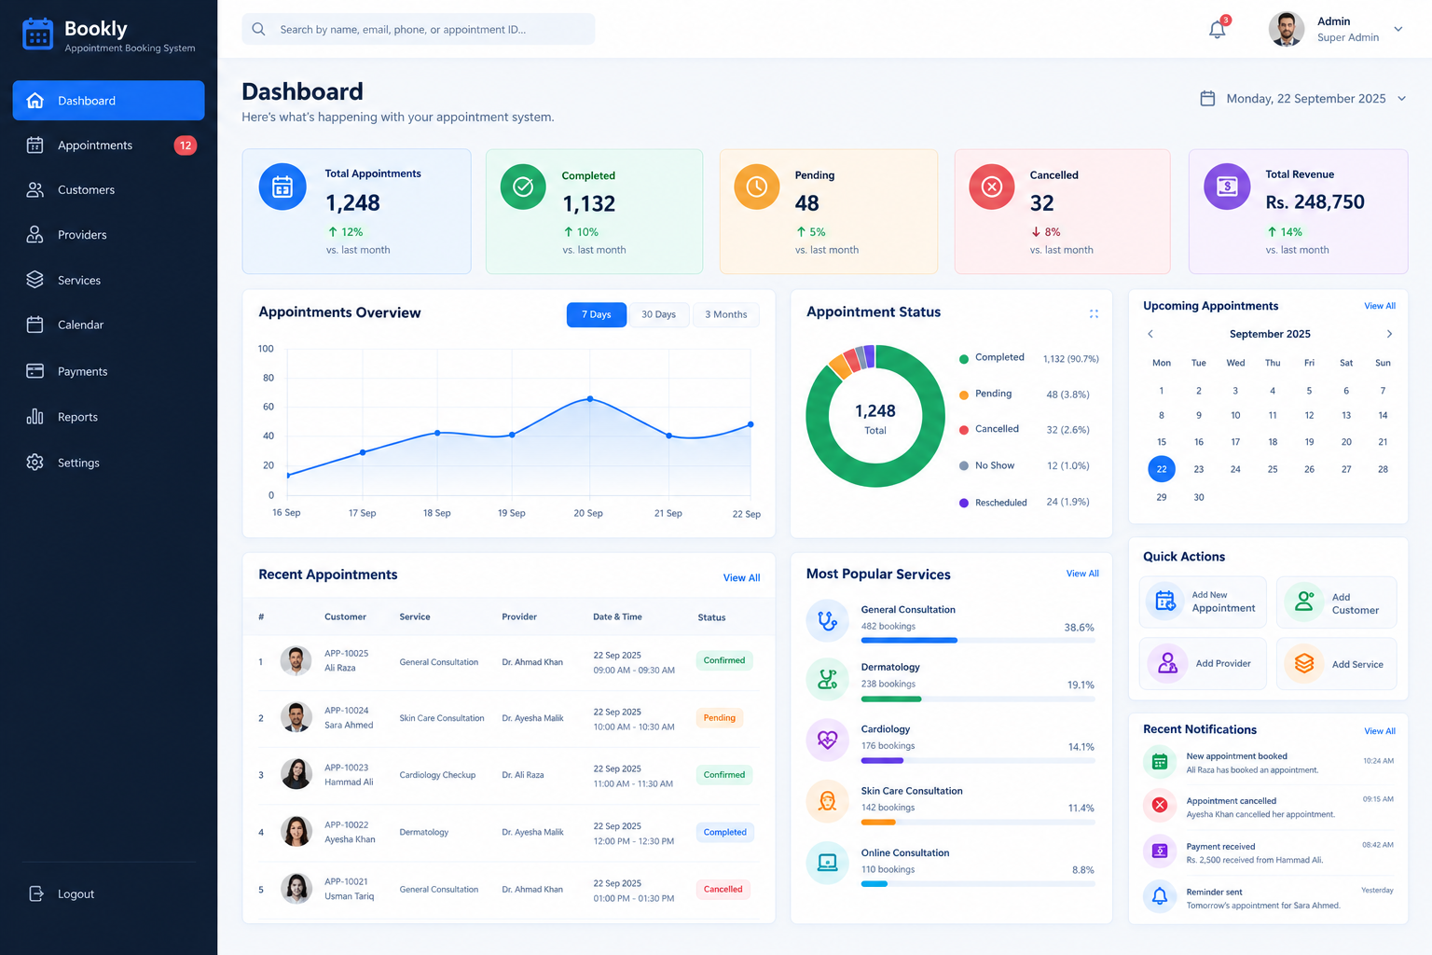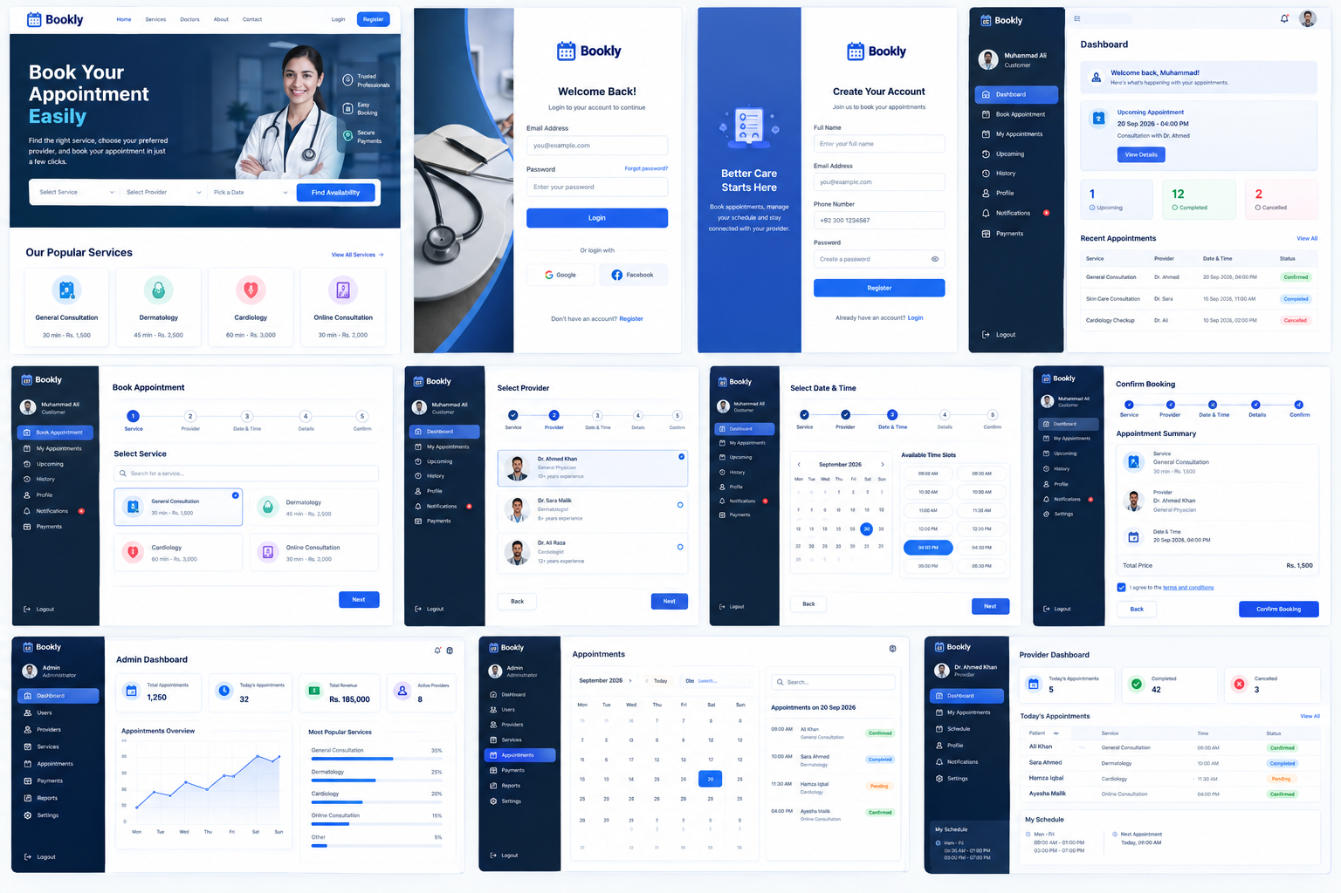

1. System Overview
The Appointment Booking System is a web-based platform where customers can book appointments with providers/staff for specific services and time slots. Administrators manage the complete business operation, while providers manage their schedules and appointments.

Recommended User Roles
Role | Main Responsibility
Admin | Complete system management, users, providers, services, appointments, payments, reports and settings.
Provider / Staff | Manage own appointments, availability, schedule, profile and appointment notes.
Customer | Register, browse services, select provider/date/time, book, pay, reschedule and view appointment history.

2. Admin Sidebar → Every Section
Recommended Admin Sidebar:
- Dashboard
- Appointments
- Customers
- Providers / Staff
- Services
- Calendar
- Payments
- Reports
- Notifications
- Settings
- Admin Profile
- Logout

3. Dashboard
The dashboard is the main overview screen for the administrator. It should show the current health of the appointment business at a glance.
Features:
- Total appointments
- Today's appointments
- Completed appointments
- Pending appointments
- Cancelled / No-show appointments
- Total revenue
- Active providers
- Appointment trend chart (7 days / 30 days / 3 months)
- Appointment status chart
- Upcoming appointments
- Recent appointments
- Most popular services
- Recent notifications
- Quick actions: Add Appointment, Add Customer, Add Provider, Add Service

4. Appointments
This is the central operational section. Admin can view, search, filter, create and manage every appointment.
Features:
- All Appointments: complete appointment list
- Pending: appointments waiting for confirmation
- Confirmed: approved appointments
- Completed: appointments already served
- Cancelled: cancelled appointments
- Rescheduled: appointments moved to another slot
- No Show: customer did not attend
- View appointment details
- Create appointment manually from admin panel
- Edit/reschedule appointment
- Cancel appointment
- Change appointment status
- Add internal/provider notes
- Search by appointment ID, customer, provider or phone
- Filter by date, service, provider, status and payment status
- Export appointment data

5. Customers
Customer management contains the complete customer database and customer activity history.
Features:
- Customer list
- Add customer
- Edit customer
- View customer profile
- Customer contact information
- Appointment history
- Upcoming appointments
- Payment history
- Notes
- Search and filters
- Activate/deactivate customer account

6. Providers / Staff
Providers are the people who deliver the selected service. This can represent doctors, consultants, trainers, teachers, lawyers, salon staff or other professionals.
Features:
- Provider list
- Add provider
- Provider profile
- Specialization / designation
- Qualification and experience
- Profile image
- Services assigned to provider
- Working days and hours
- Break times
- Leave / unavailable dates
- Appointment duration rules
- Provider appointment history
- Activate/deactivate provider

7. Services
Services define what customers can book. Every service can have its own duration, price and assigned providers.
Features:
- All services
- Add service
- Edit service
- Delete/deactivate service
- Service name and description
- Category
- Duration
- Price
- Image/icon
- Assigned providers
- Online/offline service type
- Active/inactive status
- Service-specific booking rules

8. Calendar
The calendar gives administrators and providers a visual view of appointments by day, week or month.
Features:
- Monthly calendar
- Weekly calendar
- Daily schedule
- Appointment blocks
- Provider filter
- Service filter
- Status filter
- Click appointment to open details
- Drag-and-drop rescheduling (optional advanced feature)
- Color/status indicators
- Today shortcut

9. Payments
The payment section tracks money collected against appointments and provides a financial history.
Features:
- All payments
- Paid payments
- Pending payments
- Failed payments
- Refunded payments
- Payment method
- Transaction/reference ID
- Appointment link
- Customer link
- Amount
- Payment date
- Refund management
- Revenue totals and filters

10. Reports
Reports help the business owner understand appointment performance, revenue and provider activity.
Features:
- Appointment report
- Revenue report
- Provider performance report
- Customer report
- Service popularity report
- Cancellation/no-show report
- Daily/weekly/monthly/yearly filters
- Custom date range
- Charts and summaries
- Export to Excel/CSV
- PDF report generation

11. Notifications
Notifications keep customers and providers informed about booking events.
Features:
- New booking notification
- Booking confirmation
- Booking rejection
- Appointment reminder
- Cancellation notification
- Rescheduling notification
- Payment confirmation
- In-app notification center
- Read/unread status
- Email notifications
- SMS/WhatsApp integration as an advanced feature

12. Settings
Settings control the general behavior and business rules of the system.
Features:
- General settings: business name, logo, contact information
- Business settings: address, timezone, currency
- Appointment settings: minimum notice, cancellation window, slot duration rules
- Working hours
- Booking rules
- Payment settings
- Email/SMTP settings
- Notification templates
- Role and permission settings
- Security settings
- System maintenance settings

13. Admin Profile
The logged-in administrator can manage their own account.
Features:
- View profile
- Update name
- Update email
- Update phone
- Change password
- Profile picture
- Login/security information

14. Logout
Ends the current authenticated session and redirects the user to the login page.
Features:
- Secure session logout
- Redirect to login page
- Prevent access to protected pages after logout

15. Provider / Staff Sidebar
- Dashboard
- My Appointments
- Calendar
- My Schedule
- Availability / Time Off
- Notifications
- Profile
- Logout

16. Provider / Staff Section Details

Dashboard
- Today's appointments
- Upcoming appointments
- Completed count
- Pending count
- Quick view of schedule

My Appointments
- View assigned appointments
- Accept/reject where allowed
- Mark completed
- Mark no-show
- Add notes
- View customer details

Calendar
- Day/week/month view
- Provider-only appointment view
- Filter by status
- Open appointment details

My Schedule
- Set working days
- Set working hours
- Set breaks
- Set appointment duration

Availability / Time Off
- Block dates
- Add leave
- Add holidays
- Set special availability

Notifications
- New appointment
- Cancellation
- Rescheduling
- Reminder

Profile
- Update profile
- Specialization
- Bio
- Experience
- Password

17. Customer Sidebar
- Dashboard
- Book Appointment
- My Appointments
- Upcoming
- History
- Payments
- Notifications
- Profile
- Logout

18. Customer Booking Process
- Customer registers or logs in.
- Customer opens Book Appointment.
- Customer selects a service.
- System displays providers who offer that service.
- Customer selects a provider.
- Customer selects a date.
- System checks the provider's working schedule, breaks, holidays and existing bookings.
- System generates available time slots automatically.
- Customer selects an available time slot.
- Customer enters/confirm their details.
- Customer reviews appointment summary.
- Customer optionally completes payment.
- System creates the appointment and generates a unique appointment/booking ID.
- Customer receives confirmation.
- Provider receives the new appointment notification.
- System sends a reminder before the appointment.
- After the appointment, provider/admin marks it Completed, Cancelled or No Show.

19. Time Slot Generation Process
Time slots should be generated automatically from provider availability and service duration.
Input | Example
Provider | Dr. Ahmed
Service | General Consultation
Duration | 30 minutes
Working Hours | 09:00 AM – 01:00 PM
Break | 11:00 AM – 11:30 AM
Existing Booking | 10:00 AM – 10:30 AM
Possible slots after checking conflicts:
- 09:00 – 09:30 Available
- 09:30 – 10:00 Available
- 10:00 – 10:30 Booked
- 10:30 – 11:00 Available
- 11:00 – 11:30 Break
- 11:30 – 12:00 Available
- 12:00 – 12:30 Available
- 12:30 – 01:00 Available

20. Important Booking Rules
- Do not allow double booking of the same provider and time slot.
- Do not allow customers to book a time in the past.
- Only show slots inside provider working hours.
- Do not show slots during breaks, holidays or blocked time.
- Respect service duration when calculating end time.
- Allow configurable minimum booking notice.
- Allow configurable cancellation deadline.
- Use server-side validation for every booking.
- Use database transactions/locking where necessary to prevent simultaneous double bookings.
- Keep appointment status and payment status separate.
- Store a unique booking/appointment ID.

21. Suggested Database Tables
Table | Purpose
users | Authentication and basic account information
roles / permissions | Role-based access control
providers | Provider/staff profiles
services | Bookable services
service_categories | Service grouping
provider_services | Provider-to-service relationship
schedules | Regular provider working hours
breaks | Provider break periods
holidays / time_off | Blocked dates and leave
appointments | Core booking records
payments | Appointment payment records
notifications | In-app notification records
reviews | Customer feedback (optional)
coupons | Discounts (optional)
audit_logs | Admin/system activity history (advanced)

22. Recommended Laravel Development Process
- Create a fresh Laravel project.
- Configure MySQL database.
- Set up authentication.
- Create roles and permissions.
- Create migrations and models.
- Build Services CRUD.
- Build Providers CRUD.
- Build provider schedules and availability.
- Build Customers management.
- Build appointment/time-slot logic.
- Build booking form and validation.
- Build Admin dashboard.
- Build Provider dashboard.
- Build Customer dashboard.
- Add calendar.
- Add notifications.
- Add payments.
- Add reports and exports.
- Test booking conflicts and edge cases.
- Deploy and configure production environment.

23. Complete System Process
The following flow represents the recommended end-to-end process:
- Admin creates services.
- Admin creates providers/staff.
- Admin assigns services to providers.
- Provider/admin sets working hours, breaks and unavailable dates.
- Customer selects a service.
- System finds eligible providers.
- Customer selects provider and date.
- Backend checks schedule and existing appointments.
- System generates only available slots.
- Customer selects a slot and confirms details.
- System validates the slot again before saving.
- Appointment is created.
- Payment is recorded if payment is required.
- Customer and provider receive notifications.
- Appointment is completed, cancelled, rescheduled or marked no-show.
- Reports and dashboard statistics are updated.

24. Recommended MVP Version
For the first version, build these features before advanced integrations:
- Authentication and roles
- Admin dashboard
- Customer management
- Provider management
- Service management
- Provider schedules
- Availability and time-off
- Automatic time-slot generation
- Appointment booking
- Appointment status management
- Customer appointment history
- Provider appointment view
- Basic calendar
- Basic notifications

25. Advanced Features for Version 2
- Online payment gateways
- Email/SMS/WhatsApp notifications
- Automatic reminders
- Coupons and discounts
- Reviews and ratings
- Multiple branches/locations
- Online meeting links
- Recurring appointments
- Advanced analytics
- PDF/Excel exports
- Drag-and-drop calendar rescheduling
- Audit logs
- Mobile app/API

26. Final Recommended Sidebar
Keep the admin sidebar clean and use submenus where appropriate:
- Dashboard
- Appointments → All, Pending, Confirmed, Completed, Cancelled, Calendar
- Customers → All Customers, Add Customer
- Providers → All Providers, Add Provider, Schedules, Availability
- Services → All Services, Categories, Add Service
- Calendar
- Payments → All, Paid, Pending, Failed, Refunds
- Reports → Appointments, Revenue, Providers, Customers
- Notifications
- Settings → General, Business, Appointment, Payment, Email, Notifications, Roles
- Profile
- Logout

Document prepared as a functional blueprint for development.

