# Training:

Screenshots:

Started training at 7:47

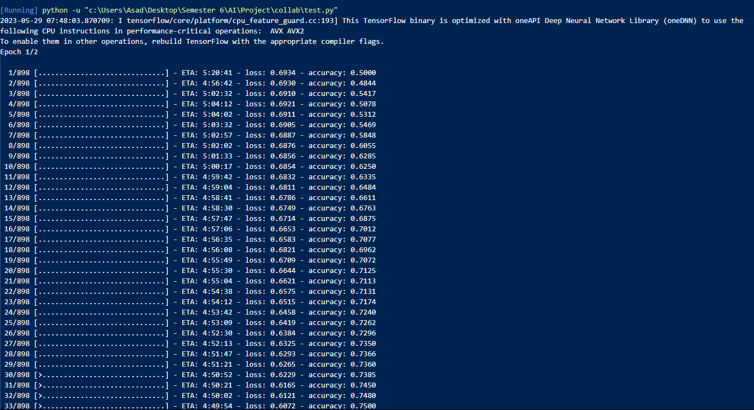

Loss slowly decreases and accuracy increases by the end of first Epoch. 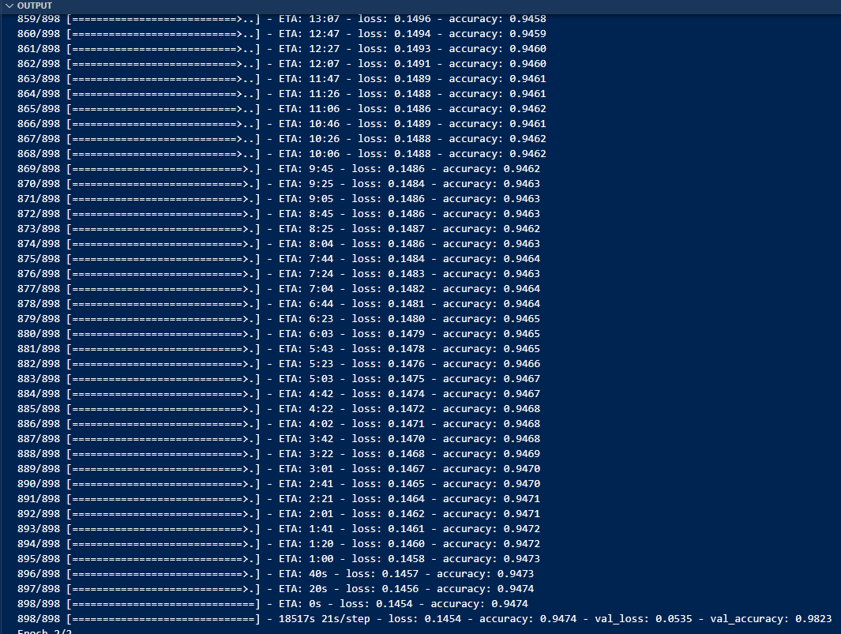

By the end of 2nd Epoch we see that the accuracy has increased a lot and loss is nearly minimized to the fullest but it shows signs of overfitting as total val_accuracy has decreased.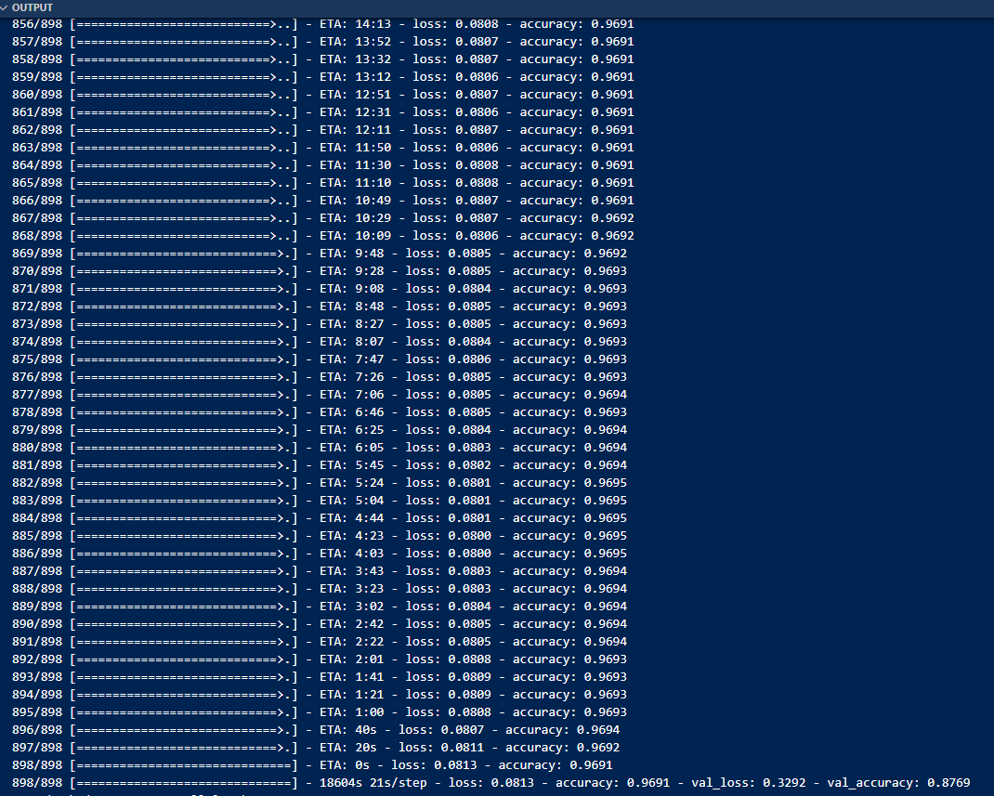

As the 2nd epoch was overfitting so we used our best performing model, which was saved on first epoch for further analysis.

The training process on a non CUDA system using AMD Ryzen 5 2600 CPU took 10 hours on two epochs.



# Testing:



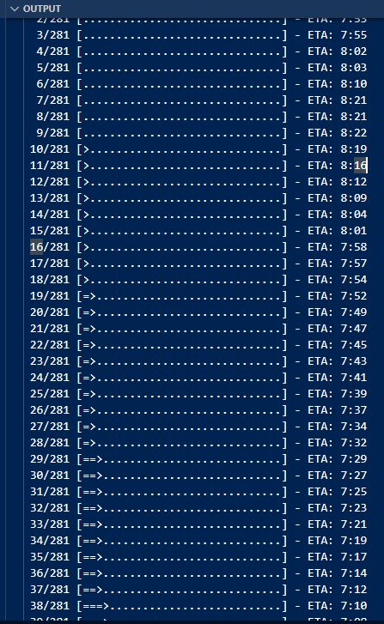

We got the following from testing the best performing model we trained:

|  |  |
| --- | --- |
| Accuracy | 0.9844 |
| Precision | 0.9888 |
| Recall | 0.9781 |
| F1 Score | 0.9834 |

# Implementation:

As we can see from our output, the model performs nicely on trained dataset, and being able to classify between fake and real news in real world scenario.

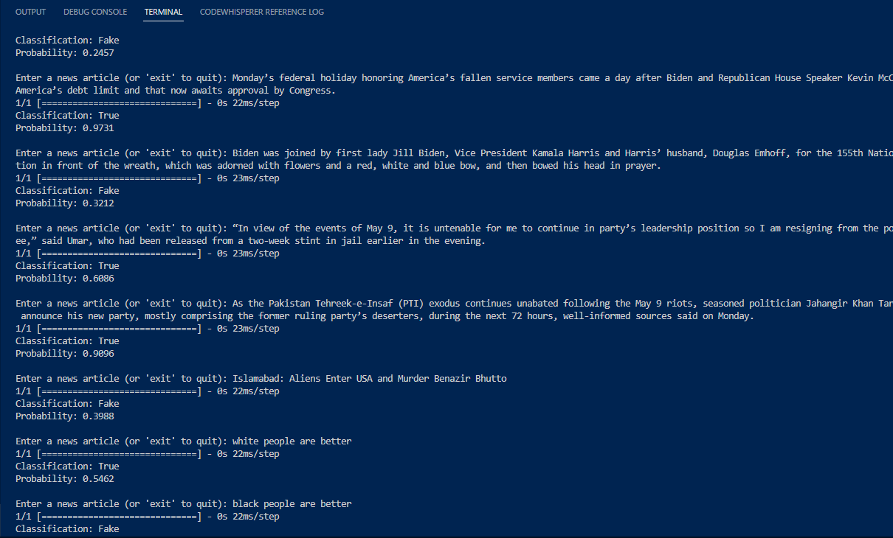

Endless examples can be implemented on this model. Note that the model shows hints of biasness due to the dataset it has been trained on. Some racist remarks can be seen while it does a good job of predicting the validity of general news articles.