Global Public Health (GPH) is the first cloud passed app that will be provided for free by Enhanced Informatics – (I believe you have the address but in any case, it is ttps://enhancedinformatics.com/).

A summary posted on 01/01/2020 (tomorrow) and the complete design by 01/15/2020.

Here is the diagram:

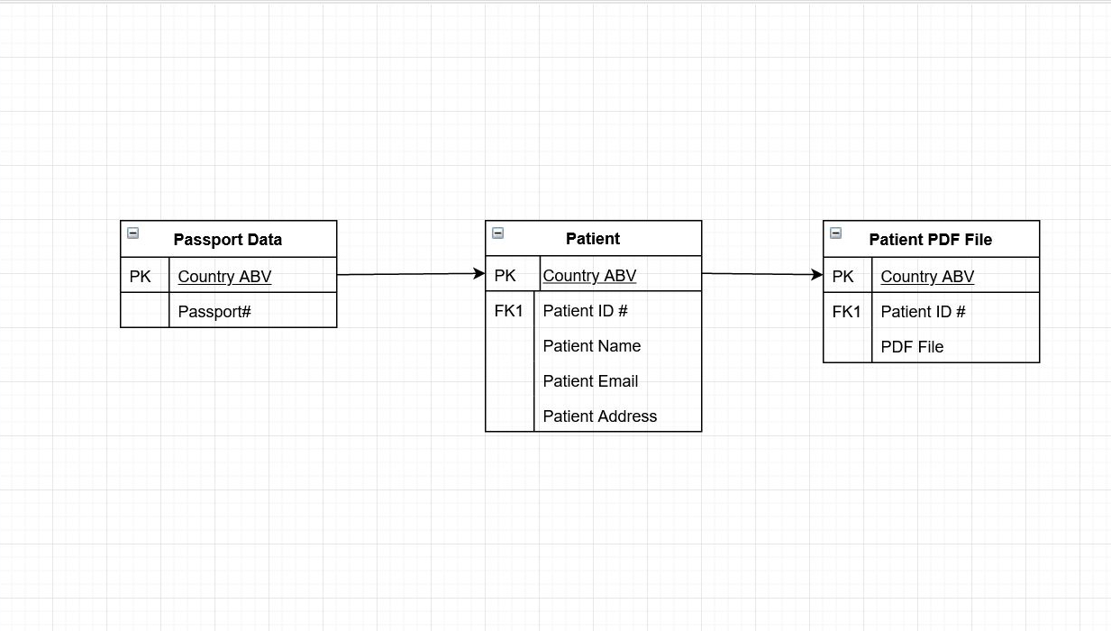

Its essential purpose is to depict a patient's medical history such as blood type, allergies and the medication he takes to make emergency help more practical in case of an emergency.

It would be accessible on mobile (while it is available, it is not proactive) but also accessible via the internet.

A patient has a wrist band bearing his ID# if needed.