Sentiment and Semantic Analysis of Azerbaijani YouTube Comments
Student: Kamran Asadov
Course: Advanced AI (SABAH Groups)
University: Azerbaijan State Oil and Industrial University

Abstract
This study presents a comprehensive sentiment and semantic analysis of Azerbaijani-language YouTube comments. Given the low-resource nature of Azerbaijani in natural language processing, special attention is paid to model selection and methodological transparency. The analysis combines language-specific sentiment models, emoji-based sentiment interpretation, confidence threshold experiments, and semantic structure analysis using sentence embeddings.

1. Data Collection and Pre-processing
A dataset of over 1,000 Azerbaijani YouTube comments was collected using the YouTube Data API. Each comment includes the raw comment text, the number of likes, the number of replies, and the emojis used in the comment. URLs were removed, spacing was normalized, and emojis were extracted into a separate column. A clean text channel without emojis was created for text-based analysis.

2. Sentiment Analysis Models
For text sentiment analysis, the LocalDoc Azerbaijani sentiment model (LocalDoc/sentiment_analysis_azerbaijani) was used. This model performs three-class sentiment classification (positive, negative, neutral) and is fine-tuned specifically on Azerbaijani data. Emoji-only sentiment was analyzed separately using a multilingual XLM-R-based sentiment model, as emoji representations are language-agnostic.

3. Parameter-Based Experiments

3.1 Confidence Threshold Analysis
Sentiment predictions were evaluated using confidence thresholds of 0.6 and 0.8. Increasing the threshold resulted in a modest increase in neutral classifications and slight decreases in positive and negative labels, indicating high overall confidence in the Azerbaijani-specific sentiment model.
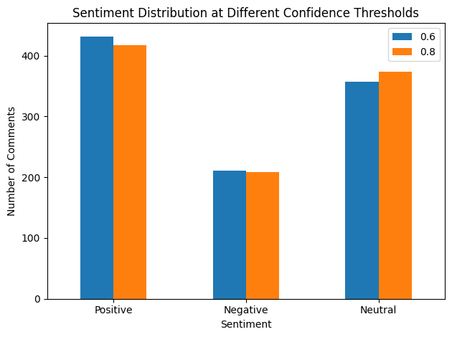

3.2 Comment Length Filtering
Comment length filtering was applied using minimum word counts of 3, 5, and 7 words. Longer comments exhibited greater sentiment stability across confidence thresholds, while shorter comments were more sensitive to stricter confidence requirements.
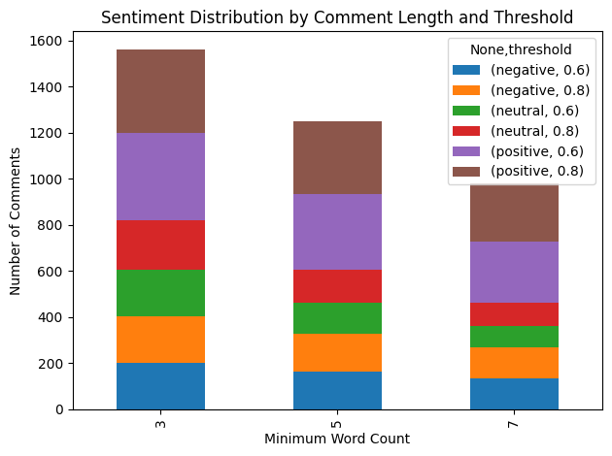

4. Analytical Tasks

4.1 Emoji–Text Inconsistency
Emoji–text inconsistency was identified by comparing emoji-only sentiment with text sentiment. Many comments expressed positive or neutral text sentiment alongside negative emojis, reflecting emotionally complex expressions common in music-related discussions.
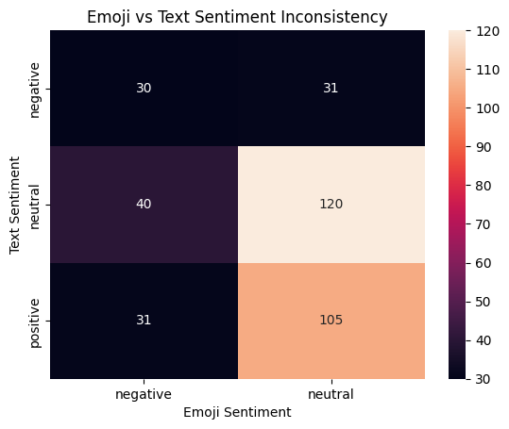

4.2 Semantic Similarity Analysis
Semantic similarity between comments was analyzed using sentence embeddings generated by the TEmA-small model (LocalDoc/TEmA-small), an Azerbaijani-specific embedding model. Cosine similarity was used to identify groups of highly similar comments, revealing repeated praise patterns and formulaic expressions.
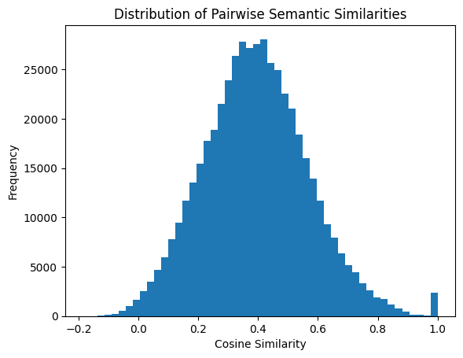
The histogram represents the distribution of pairwise cosine similarities between all unique comment pairs. Since the number of pairs grows quadratically with the number of comments, high frequencies on the y-axis are expected and reflect the dominance of semantically unrelated comment pairs.

4.3 Semantic Outliers
Semantic outliers were defined as comments with unusually low average cosine similarity to other comments. These outliers typically consisted of off-topic remarks, personal stories, or very short temporal references.

4.4 Popular Comment Analysis
Popular comments were identified using the top decile of like and reply counts. Lexical analysis of these comments revealed frequent use of praise expressions, culturally resonant phrases, and emotionally salient language.

5. Semantic Category-Based Sentiment Analysis
All comments were classified into five semantic categories using zero-shot classification with XLM-R large (XNLI): rational positive feedback, emotional reaction, criticism and dissatisfaction, direct address to the author, and troll or non-constructive comments.
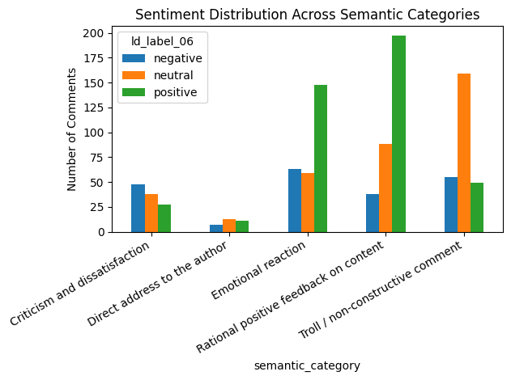

6. Discussion and Limitations
The results demonstrate that language-specific models significantly improve sentiment analysis for Azerbaijani text. Multilingual models remain suitable for higher-level semantic tasks such as similarity and categorization. Limitations include the absence of task-specific Azerbaijani models for some semantic tasks and the inherent ambiguity of emotionally complex expressions.

7. Conclusion
This work highlights the importance of task-aware model selection in low-resource language NLP. Combining Azerbaijani-specific sentiment models with multilingual and Azerbaijani-trained semantic models provides a robust framework for analyzing social media discourse.

