**Assignment 1: Visualisation**

Student Name: Asad Sattar

# Dataset Link:

The dataset I am using contains world population statistics information. This data can be accessed at the following link:

[World Population Dataset](https://www.kaggle.com/datasets/iamsouravbanerjee/world-population-dataset/data)

# Github Link:

[Github Repository Link](https://github.com/asadsattar77/Assignment_1_visualisation)

# Line Plot: Population Trends for Top 5 Ranked Countries

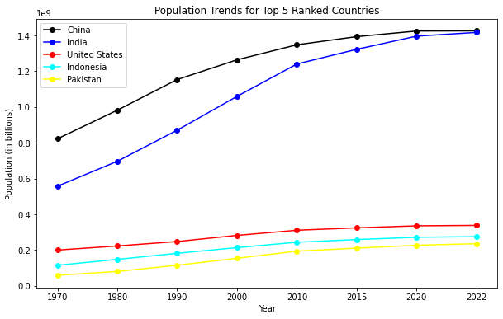

The line graph shows the population trends for the top 5 ranked countries (by population) from 1970 to 2022. The population of all five countries has increased over the past 52 years. We can see that, China and India have grown the fastest, while the US and Pakistan have grown more slowly. In the future, the population of these countries is expected to continue to grow, but at a slower rate.

# Bar Chart: Total Population by Continent in 2022

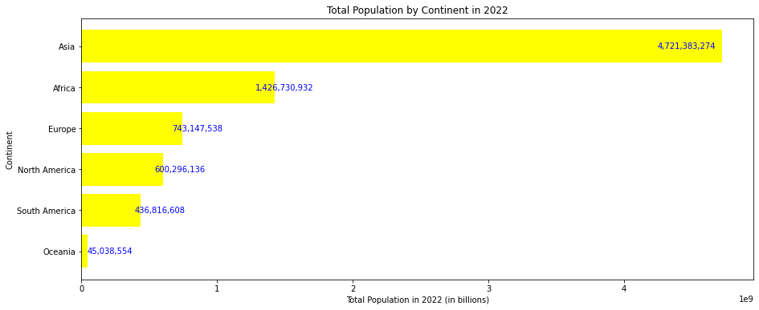

The graph shows the total population by continent in 2022. The graph shows that Asia has the largest population, followed by Africa, Europe, North America, South America, and Oceania. The trend of the graph is that the population of Asia is much larger than the population of any other continent. Africa is the second most populous continent, with a population of over 1.4 billion people. Europe is the third most populous continent, with a population of over 740 million people. Oceania is the least populous continent, with a population of just over 45 million people.

A bar graph is perfect for visualizing the total population by continent because it is a categorical variable. A categorical variable is a variable that can be divided into categories, such as continent, country, or age group.

# Pie Chart: World Population Percentage by Continent

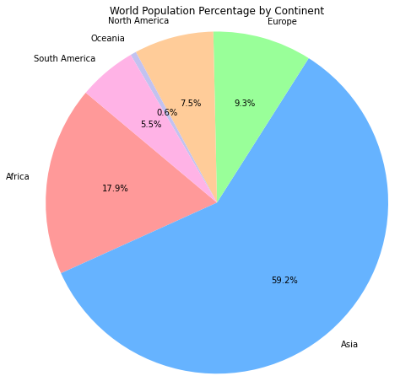

This pie chart is showing the percentage of the world's population by continent. The continents are North America, Europe, Asia, Africa, and South America. Asia has the highest percentage, with 59.2%. Africa is second, with 17.9%. Europe is third, with 9.3%. North America is fourth, with 7.5%. South America is fifth, with 5.5%. Oceania is the smallest continent, with 0.6% of the world's population.

Pie charts are good for this data because they show the percentage of the world's population in each region. The whole pie represents the world's population, and each slice represents a region. The bigger the slice, the bigger the population of that region.