Aureus ERP Guide & Functionality Manual
Operational guide for Accounting, HR, approvals, reporting, and deployment
Document version: 1.0
Date: 28 August 2026
Prepared for: Administrators, finance teams, HR teams, managers, operators, and implementation partners
System baseline: Aureus ERP — verified Accounting + HR integration with production Docker stack
This document contains no passwords, access tokens, private keys, customer files, or local machine paths.

Contents
Project overview
System architecture
Companies, roles, hierarchy, and permissions
Accounting workflow
Chart of Accounts and FS Tags
Configurable imports and validation
Bank statements, mapping, and reconciliation
Currencies and exchange rates
Customers, vendors, invoices, and analytics
Accounting reports and controls
HR employee master and hierarchy
Timesheets, attendance, and leave
Performance and recruitment
Employee requests and Accounting integration
HR analytics and audit trails
Configuration and daily operating procedures
Docker, backup, restore, and deployment
Troubleshooting
What changed from the original ERP
Functional status and known boundaries

Project overview
Aureus ERP is a modular, multi-company Laravel ERP. The completed baseline combines the existing operational modules with a reconciled Accounting platform, shared approvals, integrated HR workflows, and a production-oriented Docker stack. Accounting truth remains in posted journals and ledger lines; reports do not read values directly from uploaded spreadsheets.
- Accounting source of truth: master data and imports → validation → mapping → approval → journal → posting → General Ledger → Trial Balance → reports.
- HR source of truth: employee and organizational master data → workflow submission → hierarchy-based review → approval → operational or financial handoff.
- Company boundaries apply to accounts, imports, journals, mappings, employees, requests, reports, and permissions.
- Sensitive changes are auditable and routed through existing authorization and approval services where configured.
Audience | Use this manual for
Administrator | Plugin state, companies, permissions, reference data, import profiles, deployment operations
Finance | COA, FS Tags, imports, mapping, posting, reconciliation, rates, ledgers, financial reports
HR | Employee master, attendance, leave, performance, recruitment, requests, HR analytics
Manager/approver | Review queues, hierarchy-scoped decisions, comments, rejection/rework, audit history
Operator | Daily data entry, imports, review queues, issue resolution, reports

System architecture
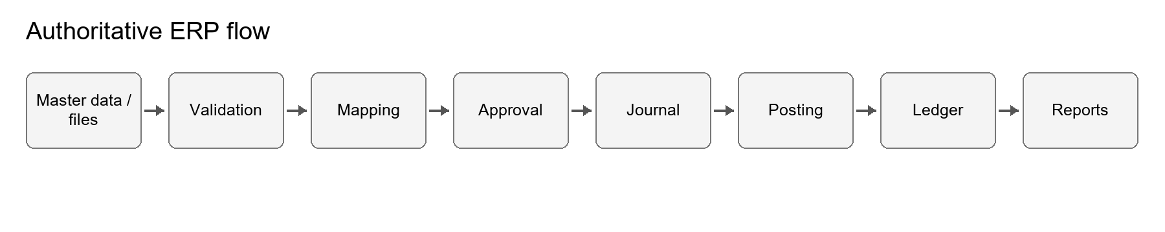
Figure 1. Accounting information moves through validation and posting before it reaches reports.
The browser UI is provided by Filament and Livewire. Laravel services enforce validation, company scope, approvals, journal generation, posting, and reporting. MySQL stores authoritative records; database-backed queues, cache, and sessions are the supported default. The production Docker layout separates Nginx, PHP-FPM, queue, scheduler, and MySQL services.
Layer | Responsibility
Filament/Livewire | Forms, lists, filters, dashboards, review actions, exports, and operator feedback
Domain services | Imports, mapping, matching, approvals, HR workflows, reconciliation, analytics
Eloquent models | Company-scoped records, relationships, lifecycle state, audit fields
MySQL | Durable accounting, HR, configuration, queue, cache, session, and audit data
Docker services | Nginx web edge, PHP-FPM application, worker, scheduler, persistent database and storage

Companies, roles, hierarchy, and permissions
A company is the primary business-data boundary. Users receive a default company and an allowed-company set. Resources and services must scope records to the active/authorized company; a visible menu is not a substitute for server-side authorization.
- Company switching changes the operational scope; verify the selected company before importing, posting, approving, or reporting.
- Roles and generated permissions control resource access and sensitive actions. The verified administrator had all 1,818 generated permissions.
- HR hierarchy supports Company → Department → Team → Manager → Employee and is reused for visibility and routing.
- The shared approval engine supports workflow, ordered steps, subject type, status, requester, approver decisions, timestamps, and reasons.
- Cross-company parents, GL accounts, FS Tags, rates, employees, and approval subjects are rejected rather than silently accepted.

Administrator setup
- Create or verify the company, base currency, users, allowed-company assignments, and administrator role.
- Run Accounting and HR permission synchronization after fresh deployment or after adding new protected resources.
- Configure approval workflows by subject/request type and company. Add ordered steps and approvers before enabling sensitive workflows.
- Test with a non-administrator account to confirm intended visibility and denial behavior.

Accounting workflow
Accounting begins with controlled master data and source documents. Imports generate preview and validation results before accepted records can be mapped, reviewed, journalized, and posted. Posted move lines feed the General Ledger, Trial Balance, Profit & Loss, Balance Sheet, Cash Flow, partner ledgers, and reconciliation views.
Stage | Operator action | Control
Prepare | Select company, import profile, file, and statement/account context | Company and profile ownership
Preview | Review header mapping, row counts, duplicates, and failures | No guessing when required structure is missing
Resolve | Correct or reject unresolved GL, FS Tag, currency, or data errors | Configured failure policy
Map | Confirm bank GL, offset GL, counterparty, tax/cash-flow metadata | Postable, active, correct-company accounts
Approve | Submit sensitive imports/mappings/journals to workflow | Ordered decisions and audit trail
Post | Create/post balanced journals | Debit/credit, company, currency, and state validation
Report | Run GL, TB, statements, aging, analytics, and reconciliation | Posted ledger only

Chart of Accounts and FS Tags

Chart of Accounts
The COA importer preserves supplied GL codes as canonical account codes and builds the account hierarchy from workbook classifications. Accounts use permanent database IDs internally, so authorized code/title changes do not rewrite historical journal relationships.
- Nature and classification columns define the hierarchy; group nodes are non-postable and leaf accounts are postable where valid.
- Opening-balance and transaction imports must resolve an existing canonical GL code. They do not silently create unknown ledger accounts.
- Company, currency, active/deprecated status, group/postable status, parent ownership, and uniqueness are validated.
- Bank GL creation accepts a manually entered GL code, title, bank name, account number, IBAN, and branch/reference; the selected parent must be a real same-company Asset/Cash/Bank group.
- If no suitable Bank GL parent exists, an authorized user can create a valid group/non-postable parent inline and the form selects it automatically.

FS Tags
FS Tags connect source transactions to configured financial-statement classification, linked GL accounts, cash-flow categories, and tax treatment. Match imported FS Tag codes against the configured code, not the display name. Unknown, inactive, or wrong-company tags follow the active import profile's failure policy.

Configurable imports and validation
Import profiles define accepted columns, aliases, required fields, transformations, validations, and failure behavior. Profiles support Chart of Accounts, FS Tag registry, opening balances, bank statements, non-bank journals, and partner/invoice data through the existing import platform.
Failure policy | Result
Needs Review | Retain the row and surface unresolved issues for controlled correction
Reject failed rows | Import valid rows; exclude failed rows; provide a rejected-row CSV with reasons
Reject entire file | Do not create accepted business records when any blocking validation fails
Warn and continue | Continue only for explicitly configured non-critical conditions

Preview and duplicate handling
- The preview summarizes total, valid, duplicate, missing-required, FS Tag, Offset GL, and other failure counts.
- Stable transaction fingerprints detect overlap across incremental files; filename and row number alone are not the identity.
- Duplicate removal requires confirmation before importing the remaining valid rows.
- Source rows preserve raw payload, normalized payload, validation errors, provenance, and outcome for auditability.
- Rows sharing a non-bank JE ID form one journal and must balance before posting.

Bank statements, mapping, and reconciliation
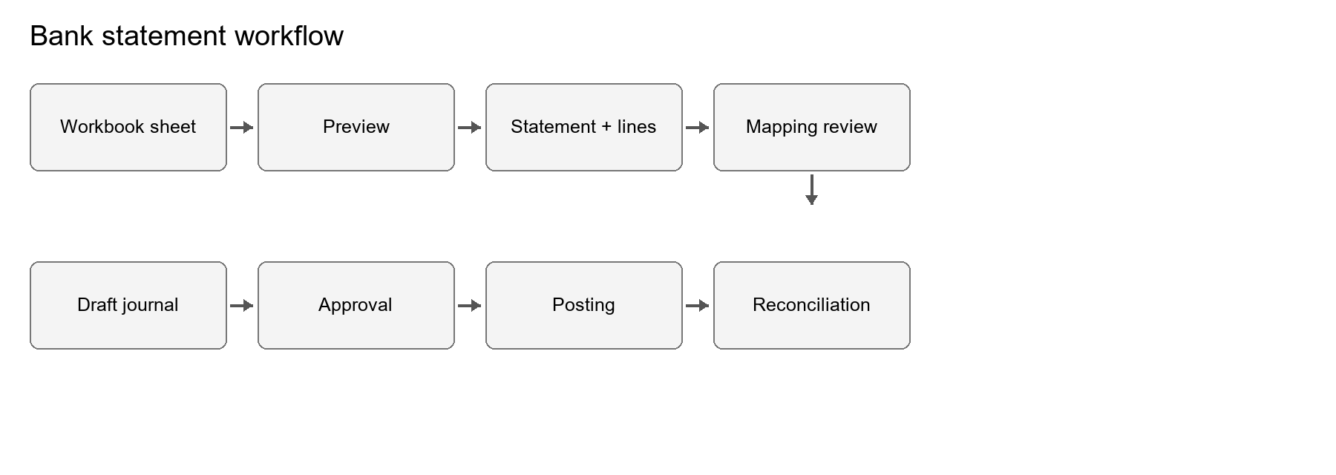
Figure 2. Bank source data remains traceable through mapping, posting, and reconciliation.

Importing a statement
- Choose the company and the configured bank import profile.
- Upload the workbook and select/confirm the statement sheet, Bank GL, original currency, and opening balance.
- Inspect the preview. Resolve blocking headers, dates, amounts, currency, duplicates, FS Tags, and Offset GL codes.
- Confirm duplicate handling and import only accepted rows.
- Open Transaction Mapping. Review source values, Bank GL, offset account, counterparty, cash-flow category, tax treatment, document/reference, confidence source, and status.
- Submit or approve according to the configured workflow; generate a balanced draft journal; post only after review.
- Run bank reconciliation and ledger reports to confirm the statement ending balance and postings.

Invoice/payment matching
The matching priority service can use invoice number, Booking ID, Consolidated Number, bank reference, partner, and amount. A reliable match links the mapping to the obligation and supports payment/reconciliation status updates. Ambiguous matches remain in review; they are not guessed.

Currencies and exchange rates
Imported transactions retain original currency and original amounts. Company currency is used for accounting/reporting conversion and must not overwrite the source currency. Moves and lines can reference original, company, and reporting currencies together with the applied exchange-rate record, rate, date, source, type, and conversion status.
- Enable currencies and maintain effective-dated rates in Currency Management.
- Use the historical rate applicable to the transaction/reporting date; do not replace historical rates with the latest rate.
- Exchange-rate changes can require approval and preserve rate history/auditability.
- Reports can present native and company/reporting amounts where the report supports those dimensions.
- Currency selection remains company-scoped and must match Bank GL/journal requirements.

Customers, vendors,
invoices, and analytics
Existing partner and invoice modules are reused. Customer and vendor identities, tax numbers, addresses, payment terms, currencies, company scope, and active state remain editable subject to permissions and approval controls.

Invoice lifecycle
- Posted customer invoices create accrual accounting for receivable, revenue, and applicable tax before cash is received.
- Payment matching settles receivable and supports partial/full payment status and reconciliation.
- Reference fields include invoice number/date, payment terms/due date, location, Booking ID, Consolidated Number, drop-off, products/services, quantities, rates, tax, and total value.
- Vendor/AP flows follow the same principle: recognize the payable and expense/asset first, then settle through payment.

Partner analytics
Partner Analytics and aging views provide company-scoped customer revenue, invoice counts/values, receivables, aging, overdue indicators, payment history, concentration, trends, vendor spend, payable balances, and volume. General Ledger and partner-ledger screens remain the source for transaction-level detail.

Accounting reports and controls
Report/control | Purpose
Journal Entries | Source, date, state, company, lines, and posting audit
General Ledger | Posted activity by account, date, company, partner, and currency dimensions
Trial Balance | Opening, period movement, adjustments, and closing totals from authoritative move lines
Profit & Loss | Income and expense performance from ledger classifications
Balance Sheet | Assets, liabilities, and equity at the reporting date
Cash Flow | Cash movement by configured cash-flow classification
Aging/partner ledger | Receivable/payable due-date and partner exposure
Bank reconciliation | Statement activity, mapping, accounting entries, and unresolved differences
Checks | Debit=credit, GL→TB, TB→statements, balance equation, and cash relationships

Verified workbook benchmark: Opening Dr/Cr 800,000 / 800,000; Movement Dr/Cr 685,000 / 685,000; Adjustments Dr/Cr 20,000 / 20,000; Closing Dr/Cr 1,170,000 / 1,170,000; difference 0. The current verified posted database aggregate was Dr 3,010,000 and Cr 3,010,000 across 42 lines, with zero unbalanced posted moves.

HR employee master and hierarchy
The employee master extends the existing Employees plugin with company, department, team, manager, location, employment details, dates, sensitive identity/bank information, status history, and authorized salary baseline fields. Sensitive fields and changes are permission-protected and auditable.
- Use one employee record per person and link it to the correct user only when application access is required.
- Assign company, department, team, manager, and location to enable scoped visibility and approvals.
- Record joining/leaving dates, employment type, status, and status-history reason consistently.
- Restrict identity, salary, and bank information to authorized HR/finance roles.
- Hierarchy traversal is centralized in HrHierarchyService rather than reimplemented in each screen.

Timesheets, attendance, and leave

Timesheets
Timesheets reuse the Projects/Timesheets models and add HR workflow state for submission, approval, rejection, rework, overtime, billability, project/task context, and manager review. TimesheetWorkflowService validates transitions and authorization.

Attendance
Attendance records capture employee, company, work date, check-in/out, worked hours, late/early indicators, status, source, and notes. Source is designed for extensibility; no biometric integration is claimed unless a real adapter and credentials are configured.

Leave
The existing Time Off plugin remains authoritative for leave types, balances/allocations, requests, mandatory days, accruals, calendars, and manager views. LeaveApprovalService connects leave decisions to the shared approval model while retaining Time Off policy checks and company/hierarchy scope.

Performance and recruitment

Performance
Performance cycles and reviews support date ranges, goals/KPIs, self/manager ratings, competencies, comments, status transitions, improvement plans, and promotion recommendations. PerformanceService validates cycle/review operations; visibility follows hierarchy and permission rules.

Recruitment
The Recruitments plugin manages jobs, candidates, applications, stages, interviewers, documents, and source metadata. The intended pipeline is Applied → Screening → Interview → Assessment → Offer → Hired/Rejected. ApplicantIntakeService normalizes manual/API imports, ApplicantSourceRegistry selects adapters, and CandidateConversionService creates an Employee without duplicate re-entry.
- Track source/channel such as company website, LinkedIn, Indeed, referral, recruiter, manual import, or another configured value.
- Manual and generic API adapter contracts are available; live third-party integrations are not represented as active without real credentials and implementation.
- Keep scorecards, interview notes, CV/documents, hiring owner, company, department, and location associated with the applicant/job.

Employee requests and Accounting integration
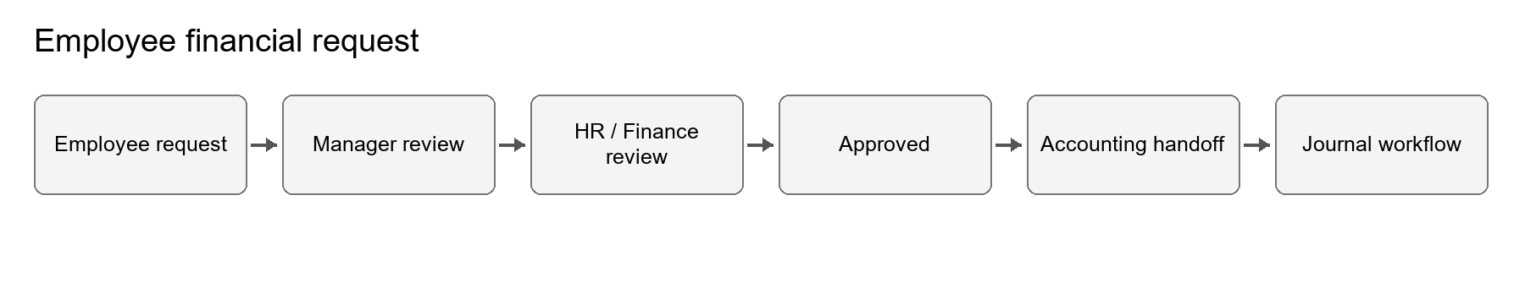
Figure 3. Approved financial HR requests hand off to Accounting instead of requiring duplicate entry.
Employee request types are configurable and can represent reimbursement, expense, travel, advance, loan, equipment, asset, document, letter, correction, leave-related, or custom requests. The type defines documents, financial behavior, workflow, and GL configuration where applicable.
- EmployeeRequestService submits requests, invokes the shared approval engine, records transitions, and synchronizes approved financial subjects.
- Approval routing can use company, request type, amount, role, department, hierarchy level, and ordered steps configured in the shared workflow.
- Approved financial requests create a controlled Accounting handoff; they do not directly bypass journal review/posting rules.
- A salary baseline exists in the employee master, but a full payroll engine was not created because the repository had no authoritative payroll architecture to extend.

HR analytics and audit trails
HR Analytics aggregates authorized, company-scoped indicators for headcount, department distribution, attendance/lateness, leave, overtime, timesheet compliance/utilization, performance distribution, recruitment funnel/source effectiveness, open requests, and reimbursement trends. Payroll-cost analytics are limited to the salary/financial data actually present; the UI does not invent unavailable payroll runs.
Auditability is distributed across record timestamps, status-history records, approval requests/steps/decisions, import source rows, source/accounting identifiers, matching provenance, rate references, posting state, and Analytics records. Preserve these links when correcting data; never delete posted accounting history to make a report agree.

Configuration and daily operating procedures
Frequency | Procedure
Daily | Review failed imports, unresolved mappings, approval queues, queue failures, attendance exceptions, and pending employee requests
Weekly | Review bank reconciliation, duplicate warnings, aged receivables/payables, missing timesheets, leave/attendance exceptions, and rate coverage
Monthly | Close journals, confirm GL/TB/statement reconciliation, lock/approve rates, review access, run backups, and inspect audit exceptions
Before deployment | Back up DB and storage, review migrations, build images/assets, run focused tests, apply forward-only migrations, sync permissions if changed

Reference/configuration setup order
- Company, currencies, users, allowed companies, roles, and permissions.
- Plugin states and required reference data; do not seed local companies or transactions into production.
- COA hierarchy, journals, bank accounts/Bank GLs, taxes, payment terms, and FS Tags.
- Import profiles, aliases, compulsory fields, validations, failure policy, and duplicate rules.
- Approval workflows and steps for Accounting and HR subjects.
- HR departments, teams, managers, employee/request types, leave and performance configuration.

Docker, backup, restore, and deployment
The root Compose stack builds immutable application and web images and runs Nginx, PHP-FPM, a queue worker, a scheduler, and MySQL 8.4. MySQL and Laravel storage use named volumes. Redis is intentionally absent because cache, queue, and sessions use the database by default.

First local start
powershell -ExecutionPolicy Bypass -File .\docker\setup-env.ps1
docker compose build
docker compose up -d
docker compose exec app php artisan migrate --force
docker compose exec app php artisan db:seed --force
docker compose exec app php artisan accounting:sync-permissions
docker compose exec app php artisan hr:sync-permissions
docker compose exec app php artisan erp:doctor
Migrations, seeders, plugin installation, and permission synchronization never run automatically at container startup. On a fresh empty database, the root seeder adds required security/support/reference/plugin-state/permission configuration only; it does not add local companies, journals, imported files, transactions, or demo business records. Do not seed after restoring an existing production database.

HTTP and HTTPS
- Local HTTP: APP_URL=http://localhost:8080, empty ASSET_URL, FORCE_HTTPS=false, SESSION_SECURE_COOKIE=false.
- HTTPS: use the real public HTTPS APP_URL, FORCE_HTTPS=true, SESSION_SECURE_COOKIE=true, and forward X-Forwarded-* headers from the load balancer/proxy.
- No domain or public IP is hardcoded. MySQL is bound to host loopback only by default.

Backup and restore
Back up both MySQL and the aureuserp-storage volume before upgrades. Keep backups outside Git, verify non-zero size, test restore to an isolated target, and retain the previous volume/database as a rollback checkpoint. Restore during controlled downtime and never add docker compose down --volumes to routine operations.

Troubleshooting
Symptom | Checks and safe response
App cannot connect to DB | Compare .env DB host/port/user/password with the actual server; in Compose use DB_HOST=mysql. Do not delete volumes.
Missing menus/resources | Confirm plugin installed/active state, user company, role/permissions; run permission sync and ERP Doctor.
Import rejected | Read preview counts and rejected-row reasons; verify headers/profile, required values, dates, numeric values, currency, FS Tag, and GL.
Duplicate transactions | Review fingerprints and source references; confirm whether to discard already imported rows. Never repost them.
Unbalanced journal | Correct source/mapping lines before posting. Do not force a balancing plug without an approved accounting basis.
Report discrepancy | Trace posted move lines → GL → TB → statements; confirm dates, company, state, currency, opening/adjustment classification.
Queue backlog | Inspect queue logs and failed jobs, correct the cause, then retry safely; keep the worker running.
Docker unhealthy | Check APP_KEY, DB credentials, migrations, writable storage, app/nginx/queue/scheduler/mysql logs, and /up health.

Local handover note: the Laragon MySQL root account accepted an empty password during final diagnostics while the existing local .env supplied a password. Align the local DB_PASSWORD with the actual local account before starting the non-Docker app; no repository secret should be used as a default.

What changed from the original ERP
Area | Delivered change
Accounting imports | Configurable preview/validation/failure controls, rejected-row handling, duplicate confirmation, common workbook parser, stronger transformations
Banking | Company/currency-safe Bank GL creation, mapping review, matching priority, transfer/invoice reconciliation links, source provenance
Currency | Original/company/reporting currency fields, effective rate metadata, approval-aware rate changes
Reporting | Reconciliation service fixes, partner analytics, aging/ledger improvements, workbook acceptance tests
Approvals | Shared configurable workflow, steps, requests, decisions, resources, and subject synchronization
HR master | Hierarchy, status history, sensitive-change service, attendance, requests, performance, analytics
HR workflows | Timesheet and leave approval services, recruitment source adapters, candidate-to-employee conversion, financial handoff
Fresh deployment | Plugin migration discovery, required default plugin states/permissions, safe reference-only seeding, configurable HTTP/HTTPS
Operations | Separated production Docker services, persistent volumes, health checks, explicit migrations/seeding, backup/AWS runbook

Functional status and known boundaries
Capability | Status
Accounting acceptance workbook | Passed; opening, movement, adjustment, closing, and difference totals reconcile
Posted accounting integrity | Passed; Dr=Cr 3,010,000, 42 posted lines, zero unbalanced posted moves
Configurable imports / bank / currency / reports | Implemented and covered by focused and module suites
HR hierarchy, requests, attendance, performance, recruitment, timesheets/leave | Implemented using existing plugins and shared services
Payroll | No complete payroll subsystem claimed; only supported salary baseline and approved financial-request handoff
External recruitment/biometric APIs | Extensible adapter/source design only; live integrations require real providers and credentials
Docker runtime | Compose/config/build inputs verified statically; real container start/persistence/browser checks blocked because Docker engine/Desktop was unavailable
Screenshots | Not embedded; runtime/browser verification was unavailable in the handover environment. UI behavior is covered by application tests.

