Assignment:5

**Practical:5.1**

**Aim:** **Build a JSP page to display “Hello World”Input:**

<html>

<head>

<title>Using JSP Comment Tag</title>

</head>

<body>

<%--The Code Display Welcome Message--%>

<%

out.println("Hello World?!");

%>

</body>

</html>

**Output:**

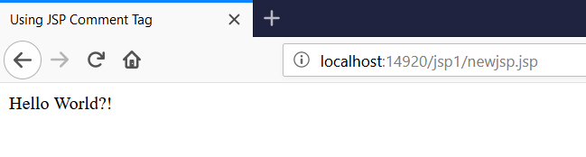

**Practical:5.2**

**Aim:** **Build a JSP page to count visitor of page and display visitor counter “**

**Input:**

<%@page contentType="text/html" pageEncoding="UTF-8"%>

<!DOCTYPE html>

<html>

<head>

<meta http-equiv="Content-Type" content="text/html; charset=UTF-8">

<title>JSP Page</title>

</head>

<body>

<%!

int visitor=0;

public void visitor()

{

visitor++;

}

%>

<h1>

<%

visitor();

out.println("visitor visit your page "+visitor+" time");

%>

</h1>

</body>

</html>

**Output:**

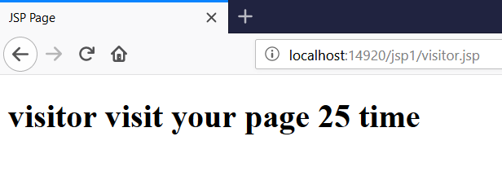

**Practical:5.3**

**Aim:** **Build Build a JSP page to fetch and display data from mysql database**

**Input:**

<%@page import="java.sql.*" %>

<% Class.forName("com.mysql.jdbc.Driver"); %>

<HTML>

<HEAD>

<TITLE>Fetching Data From a Database</TITLE>

</HEAD>

<BODY>

<%

try{

Connection connection = DriverManager.getConnection(

"jdbc:mysql://localhost/java", "root", "");

Statement statement = connection.createStatement();

ResultSet resultset =

statement.executeQuery("select * from student") ;

if(!resultset.next()) {

out.println("Sorry, could not find that publisher. " +

"Please <A HREF='tryAgain.html'>try again</A>.");

} else {

%>

<TABLE BORDER="1">

<TR>

<TH>eno</TH>

<TH>name</TH>

<TH>city</TH>

<% while(resultset.next())

{

%>

</TR>

<TR>

<TD> <%= resultset.getString(1) %> </TD>

<TD> <%= resultset.getString(2) %> </TD>

<TD> <%= resultset.getString(3) %> </TD>

</TR>

<%

}

%>

</TABLE>

<%

}

}

catch(Exception e)

{

e.printStackTrace();

}

%>

</BODY>

</HTML>

**Output:**

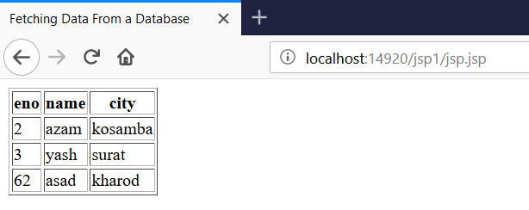

**Practical:5.4**

**Aim:** **Build registration form and insert data into mysql database using JSP.**

**Htmlform:**

<!DOCTYPE html>

<html>

<head>

<title>TODO supply a title</title>

<meta charset="UTF-8">

<meta name="viewport" content="width=device-width, initial-scale=1.0">

</head>

<body>

<form method="post" action="insert.jsp">

<table>

<tr>

<td><label>Enter Enrollment No:</label>

<td><input type="text" name="eno" placeholder="Enrollment No"></td>

</tr>

<tr>

<td><label>Enter Student Name:</label>

<td><input type="text" name="name" placeholder=" Name"></td>

</tr>

<tr>

<td><label>Enter Student city:</label>

<td><input type="text" name="city" placeholder="city"></td>

</tr>

<tr>

<td><input type="submit" value="submit"></td>

</tr>

</table>

</form>

</body>

</html>

**Jspfile:**

<%@page import="java.sql.*" %>

<!DOCTYPE html>

<html>

<head>

<meta http-equiv="Content-Type" content="text/html; charset=UTF-8">

<title>JSP Page</title>

</head>

<body>

<%

try{

%>

<%! int eno; String city,name; %>

<%

eno=Integer.parseInt(request.getParameter("eno"));

city=request.getParameter("city");

name=request.getParameter("name");

Connection connection = DriverManager.getConnection(

"jdbc:mysql://localhost/java", "root", "");

Statement statement = connection.createStatement();

String query1="insert into student values('"+eno+"','"+name+"','"+city+"')";

int r=statement.executeUpdate(query1);

if(r==1)

{

out.println("<h1>data inserted successfully</h1>");

}

ResultSet resultset =

statement.executeQuery("select * from student") ;

%>

<TABLE BORDER="1">

<TR>

<TH>eno</TH>

<TH>name</TH>

<TH>city</TH>

<% while(resultset.next())

{

%>

</TR>

<TR>

<TD> <%= resultset.getString(1) %> </TD>

<TD> <%= resultset.getString(2) %> </TD>

<TD> <%= resultset.getString(3) %> </TD>

</TR>

<%

}

%>

</TABLE>

<%

}

catch(Exception e)

{

e.printStackTrace();

}

%>

</body>

</html>

**Output:**

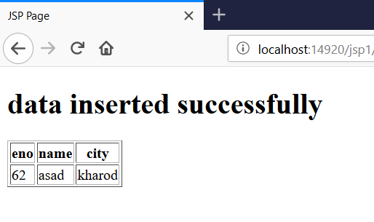

**Practical:5.5**

**Aim:** **Build Build HTML form to take student’s marks as input and count the grade of students and display it using JSP**

**htmlForm:**

<html>

<head>

<title>TODO supply a title</title>

<meta charset="UTF-8">

<meta name="viewport" content="width=device-width, initial-scale=1.0">

</head>

<body>

<form method="post" action="studentmarks.jsp" >

<h1>Calculate student grade</h1>

<input type="text" name="m1" placeholder="enter marks for advance java">

<input type="text" name="m2" placeholder="enter marks for nma">

<input type="text" name="m3" placeholder="enter marks for mcad">

<input type="submit" value="calculate">

</form>

</body>

</html>

**jspfile:**

Top of Form

<%@page contentType="text/html" pageEncoding="UTF-8"%>

<!DOCTYPE html>

<html>

<head>

<meta http-equiv="Content-Type" content="text/html; charset=UTF-8">

<title>JSP Page</title>

</head>

<body>

<%

try

{

%>

<%! Double m1,m2,m3; Double per,total; %>

<%

m1=Double.parseDouble(request.getParameter("m1"));

m2=Double.parseDouble(request.getParameter("m2"));

m3=Double.parseDouble(request.getParameter("m3"));

total=m1+m2+m3;

per=total/3; %>

<table>

<tr>

<td> <% out.println(" your marks in ad.java :"+m1); %></td>

</tr>

<tr>

<td> <% out.println(" your marks in nma :"+m2); %></td>

</tr>

<tr>

<td> <% out.println(" your marks in mcad :"+m3); %></td>

</tr>

</table>

<%

if(m1>=35 && m2>=35 && m3>=35)

{

if(per>=70)

{

out.println(" you are pass! you have got distinction");

}

else if(per>=60 && per<=69)

{

out.println(" you are pass! you have got first class");

}

else if(per>=50 && per<=59)

{

out.println(" you are pass!you have got second class");

}

else

{

out.println(" you are pass");

}

}

else

{

out.println("sorry you are fail");

}

}

catch(Exception e)

{

e.printStackTrace();

}

%>

</body>

</html>

**Output:**

