
Daffodil International University
Department of Computer Science and Engineering

Course Code: CSE 317
Course Title: Software project V

Submitted To
Fariha Jahan
Lecturer, Department Of CSE
Daffodil International University(DIU)

Submitted By
ID | Name | Email | Section
191-15-12966 | Razan Sarker Santa | razan15-12966@diu.edu.bd | M
191-15-12974 | Minjun Nahar Mim | minjun15-12974@diu.edu.bd | M
191-15-12981 | Asadullah Al Imran | asadullah15-12981@diu.edu.bd | M
191-15-12971 | Koushik Nag Shuvo | koushik15-12971@diu.edu.bd | M
191-15-12973 | Shama Saha | shama15-12973@diu.edu.bd | M

Customer Profile Data

Abstract—
This paper describes which constructs personal profiles based on customers' transactional histories. The system uses data mining techniques to discover a set of rules describing customers' behavior and supports human experts. They have 12 parts. In this project by the help of our group members we create some python code, graph and charts using by Jupyter Notebook .
Introduction:
MySQL: MySQL, the most popular Open Source SQL database management system, is developed, distributed, and supported by Oracle Corporation. There are some common features of MySQL. 1. MySQL is a database management system. 2. MySQL databases are relational. A relational database stores data in separate tables rather than putting all the data in one big storeroom. 3. MySQL software is Open Source. Open Source means that it is possible for anyone to use and modify the software. 4. The MySQL Database Server is very fast, reliable, scalable, and easy to use.

Jupyter Notebook : The Jupyter Notebook is an open source web application that you can use to create and share documents that contain live code, equations, visualizations, and text. Jupyter Notebook is maintained by the people at Jupyter Notebook. Jupyter Notebooks are a spin-off project from the IPython project, which used to have an IPython Notebook project itself. The name, Jupyter, comes from the core supported programming languages that it supports: Julia, Python, and R. Jupyter ships with the IPython kernel, which allows you to write your programs in Python, but there are currently over 100 other kernels that you can also use.

Result & Discussion :

- import pandas as pd
- csv read

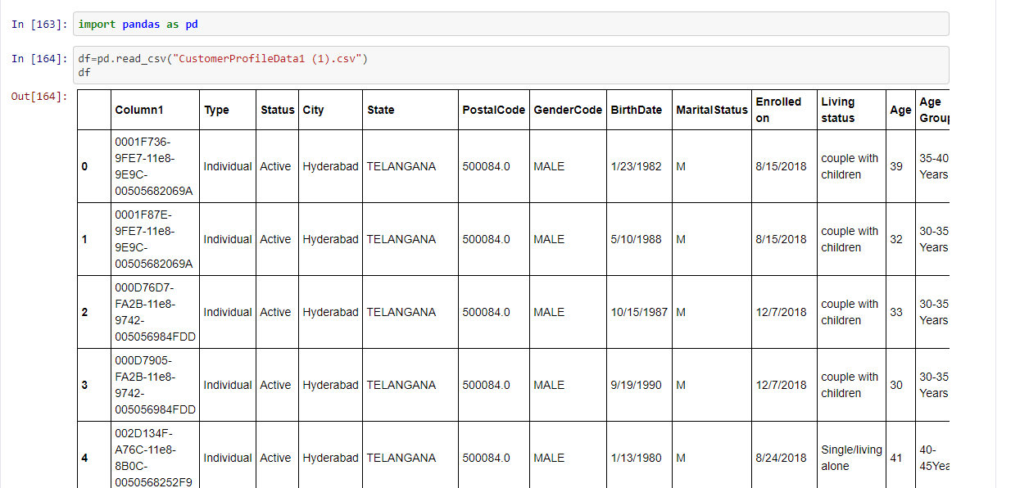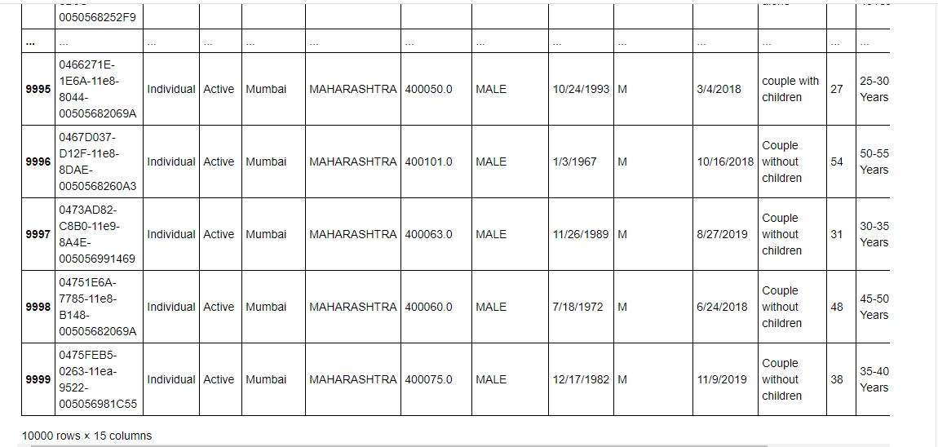

- Head show

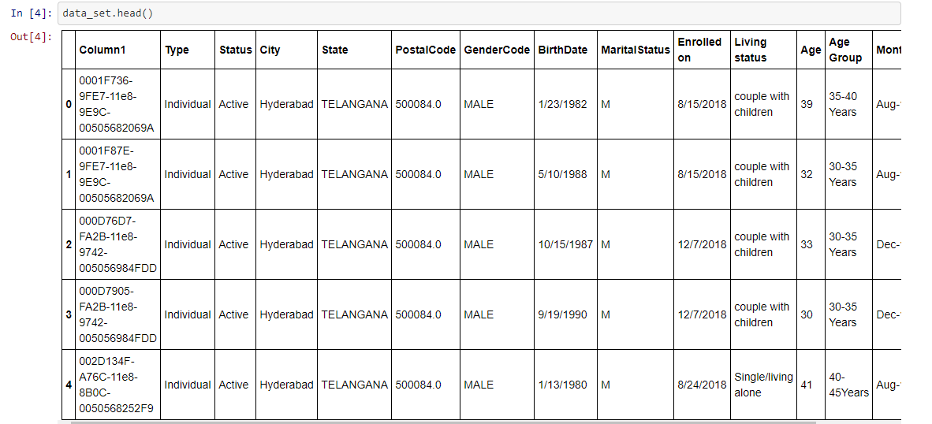

- Series is a 1-D array show
- Customer_name & Customer_country

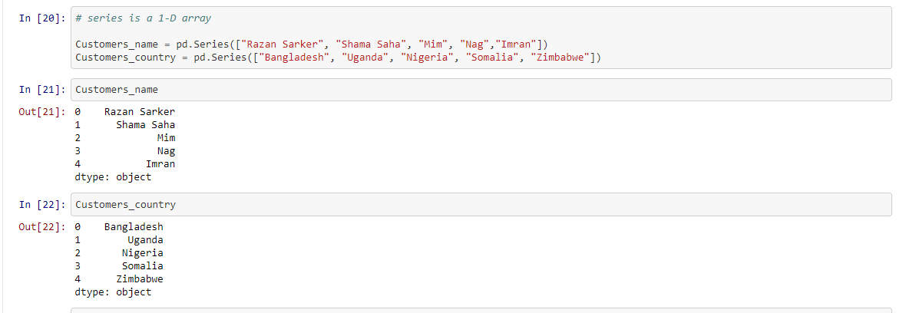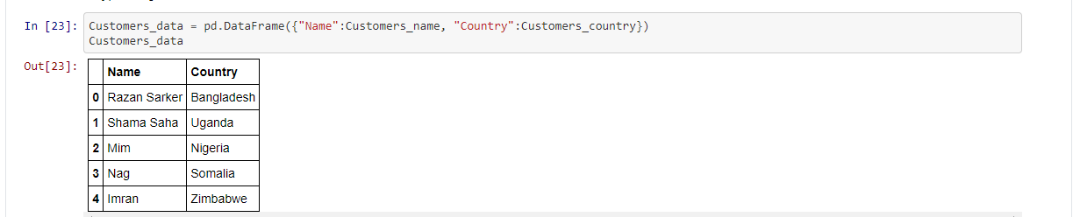

- Will show the type of each columns
- Will show the name of columns
- Will show the index range

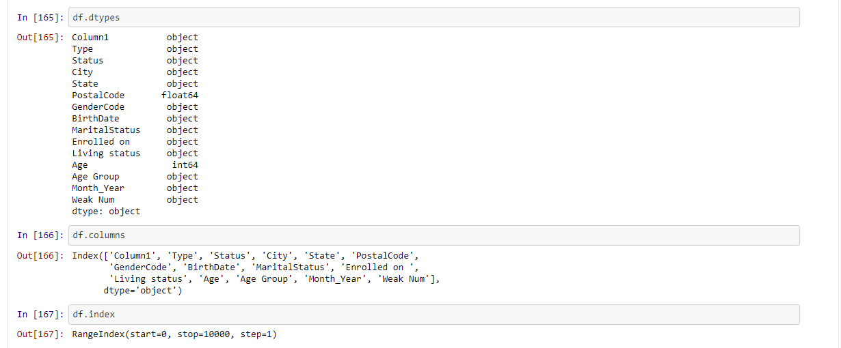

- It will show the statistic information and numeric analysis

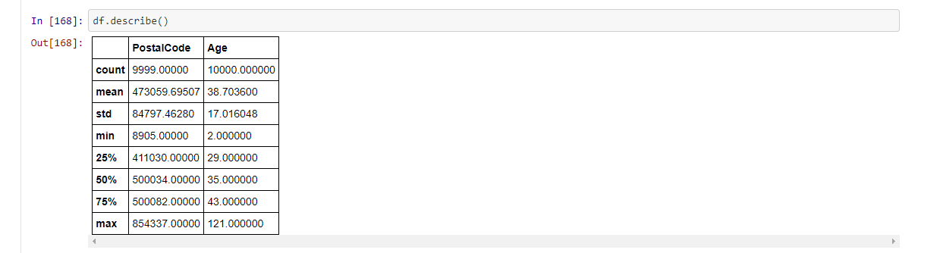

- Will show the info of each columns
- Will show give the average of numerical columns

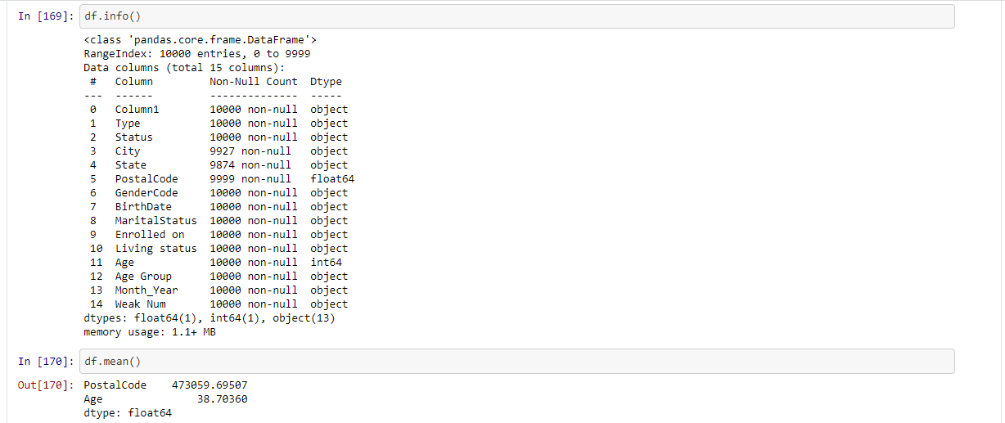

- Grouping data using group by
- Category show
- MaritalStatus sum
- Crosstab using by ‘GenderCode ‘and ‘MaritalStatus’

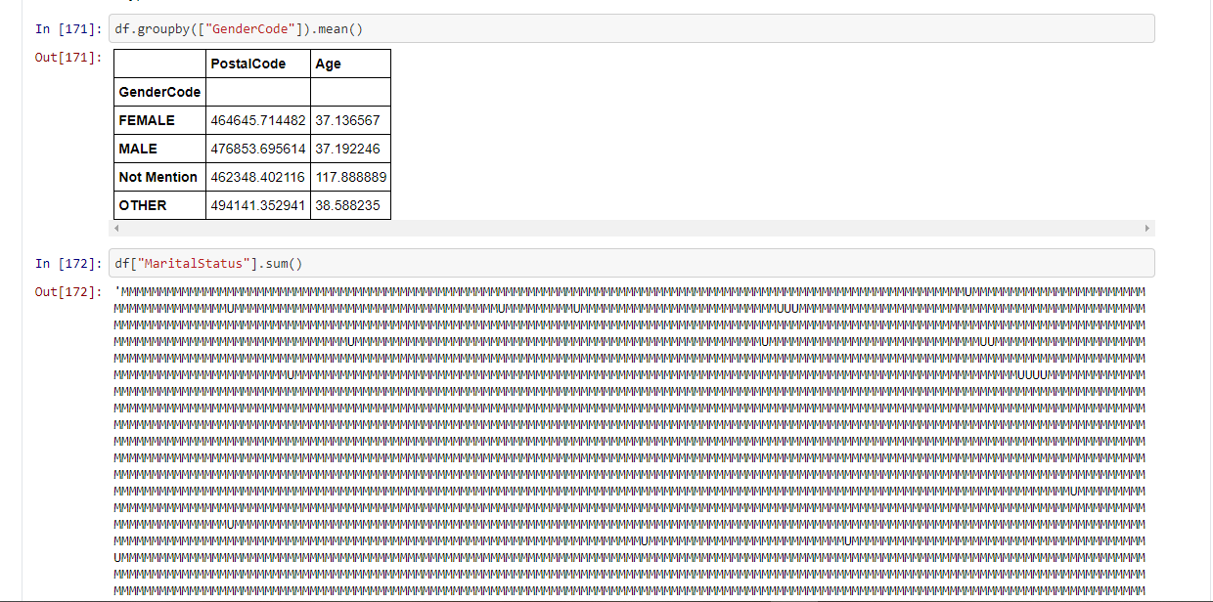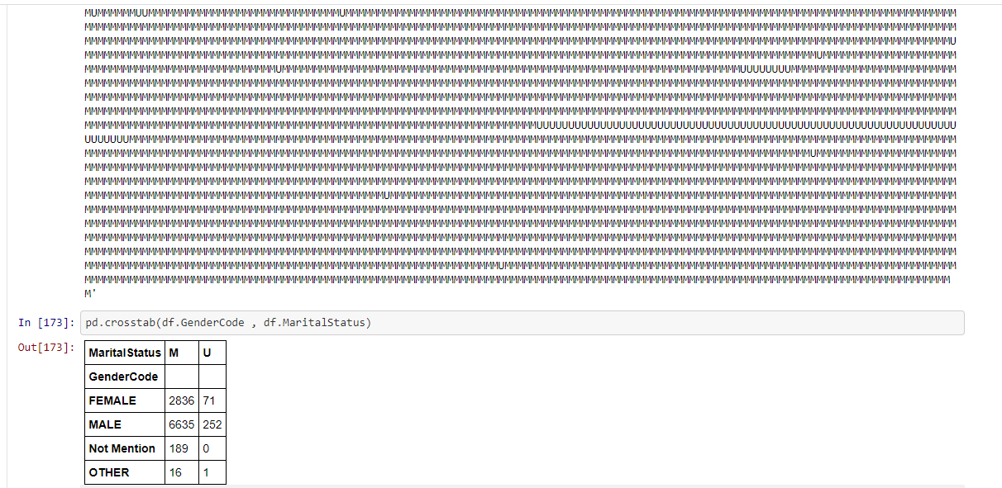

- Plotting data
- Group show

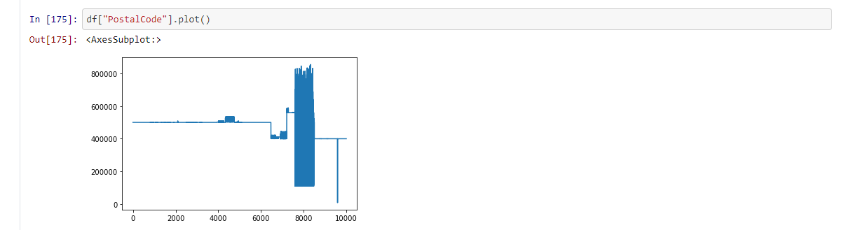

- Histogram
- Level show

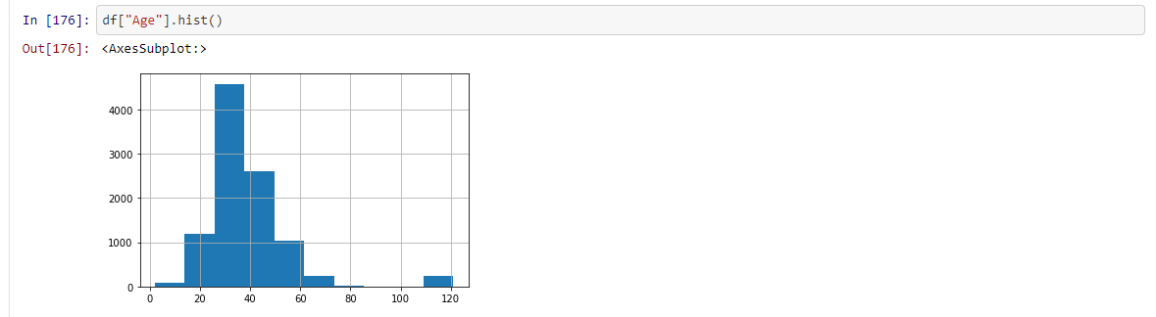

- Countplot using by ‘Age Group’

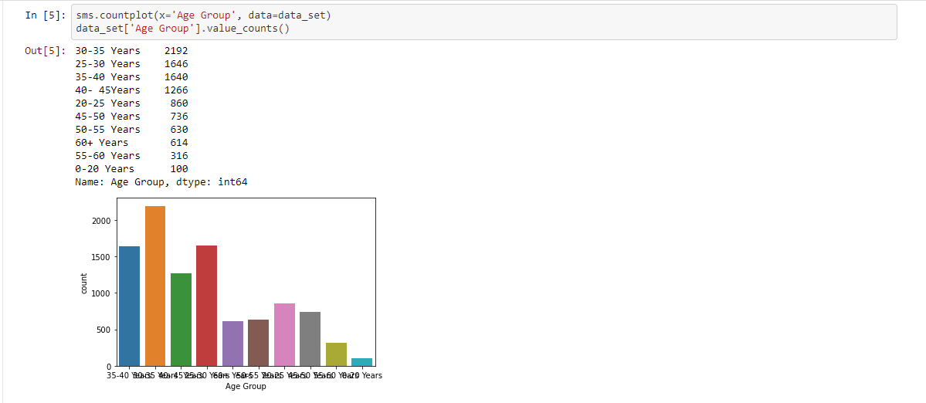

- Lower() Function using ‘Type’ Column
- Data Manipulating

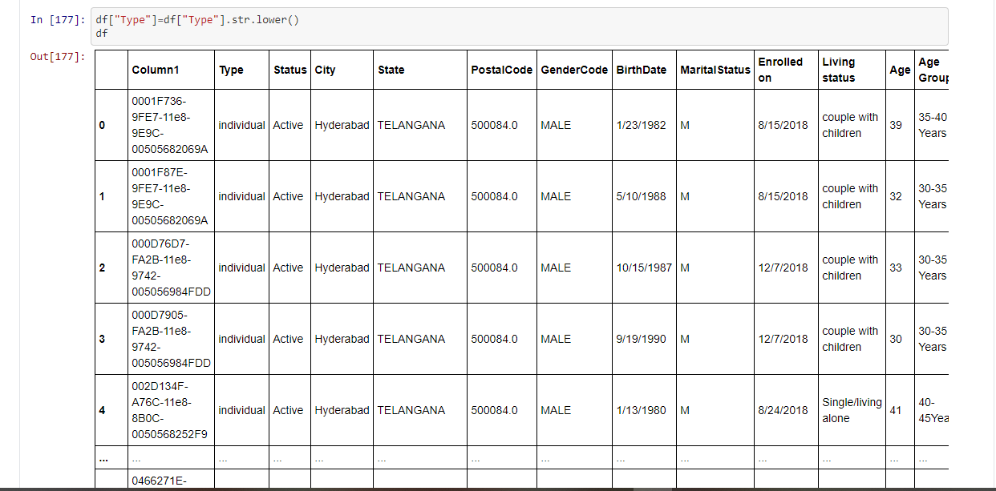

- Working with missing data
- Read missing value with csv

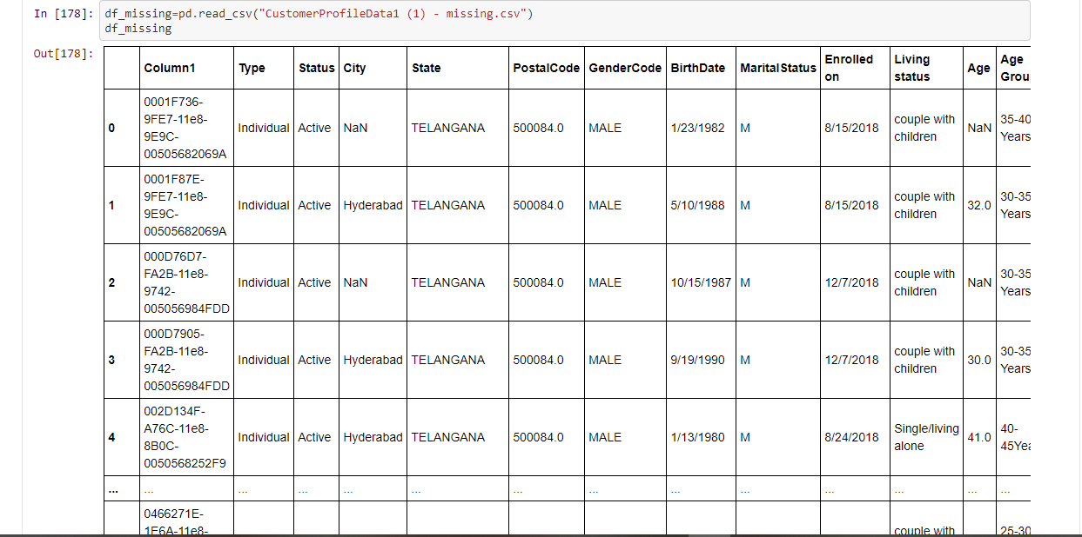

- Filling the missing data

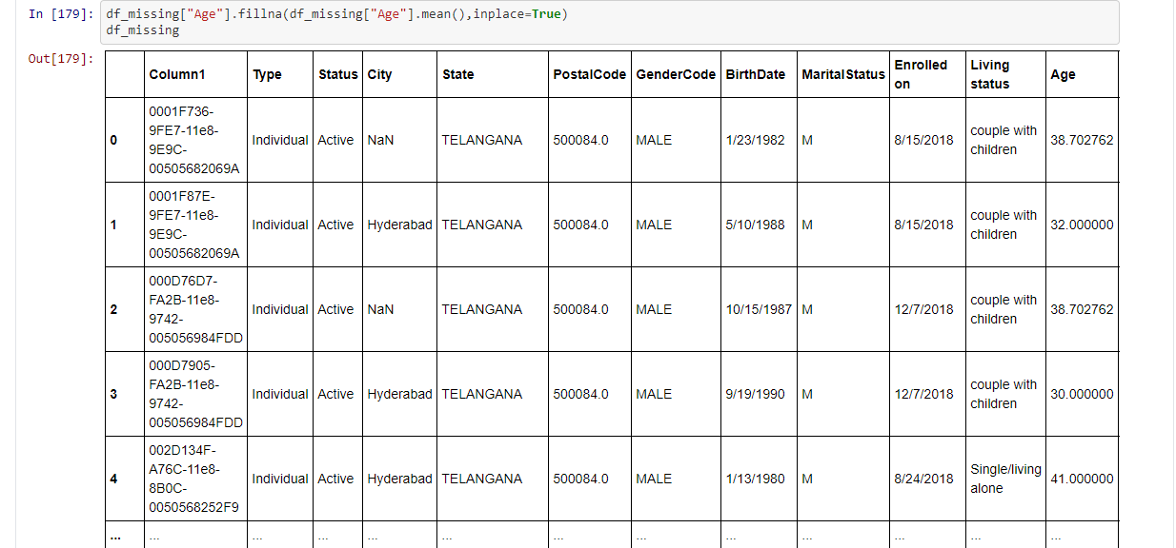

- Removing missing values
- Cleaning empty rows

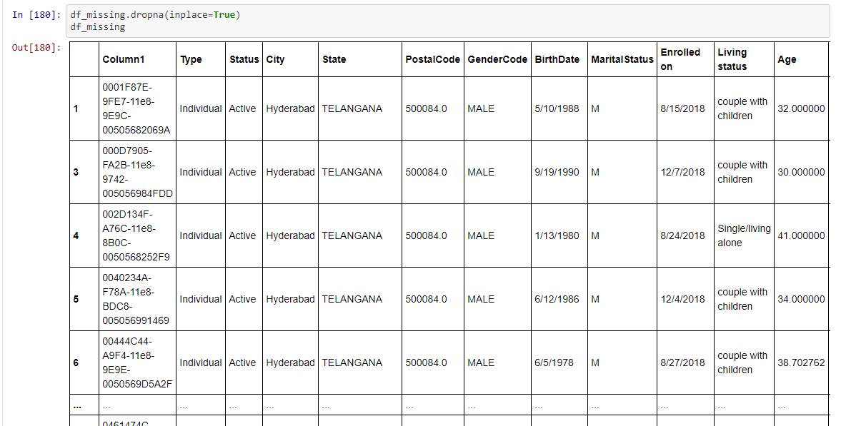

- Converting the data frame into csv file
- Creating a new column using the existing data

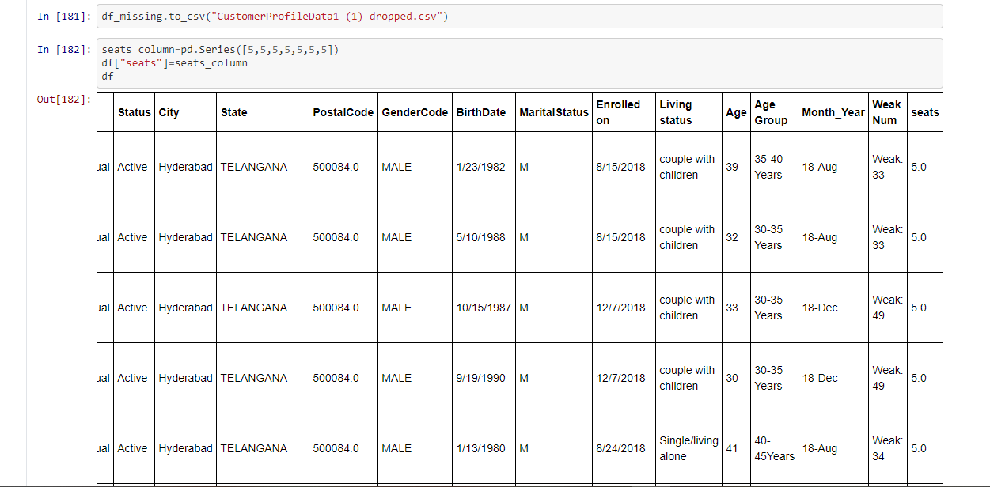
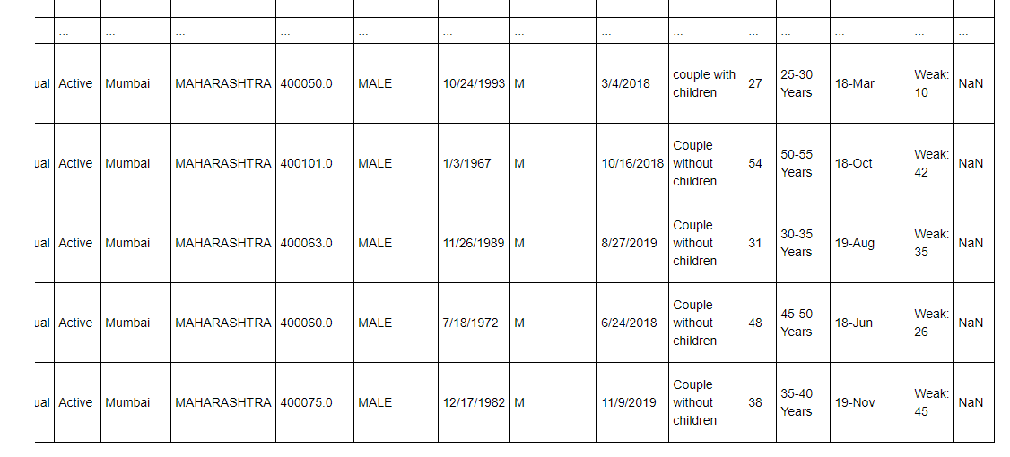

- Null_fillup

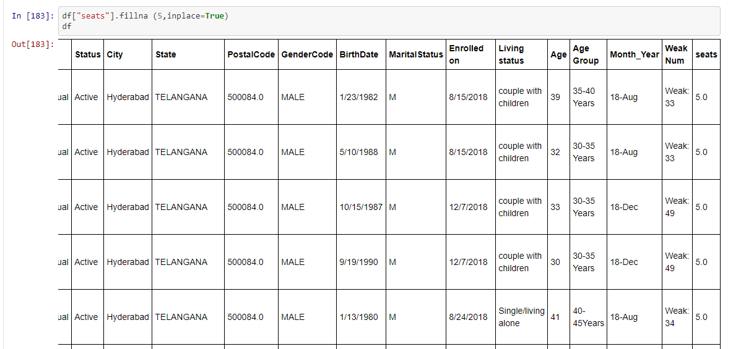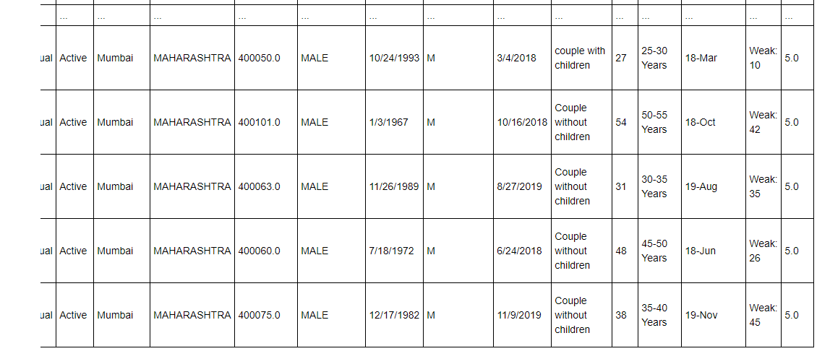

- Division : ‘Age’/’seats’

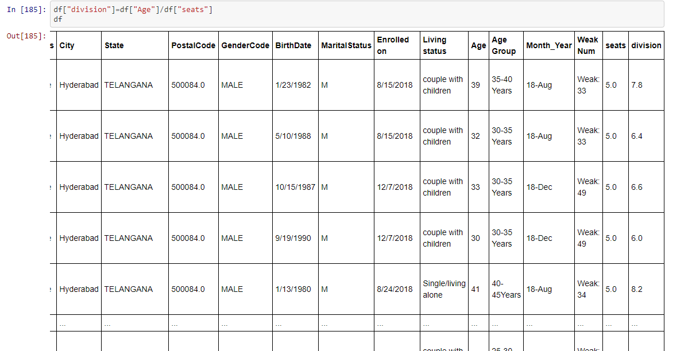

- Assign directly

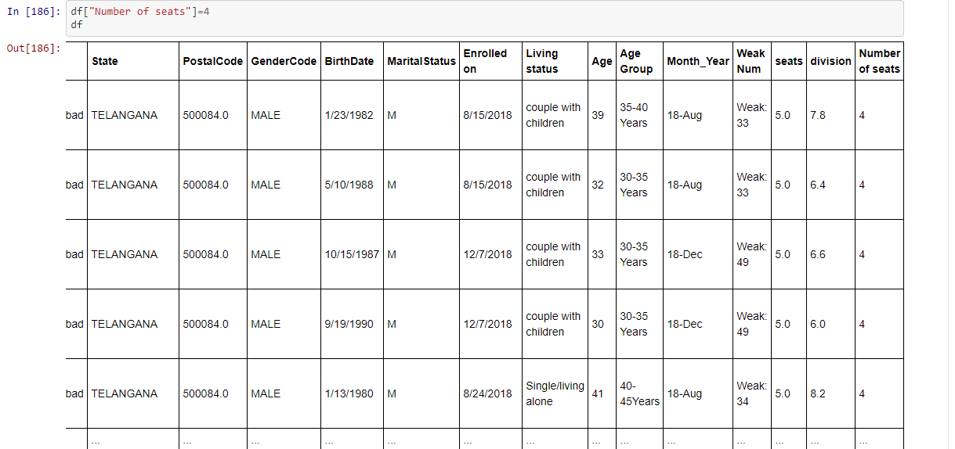

- Removing column

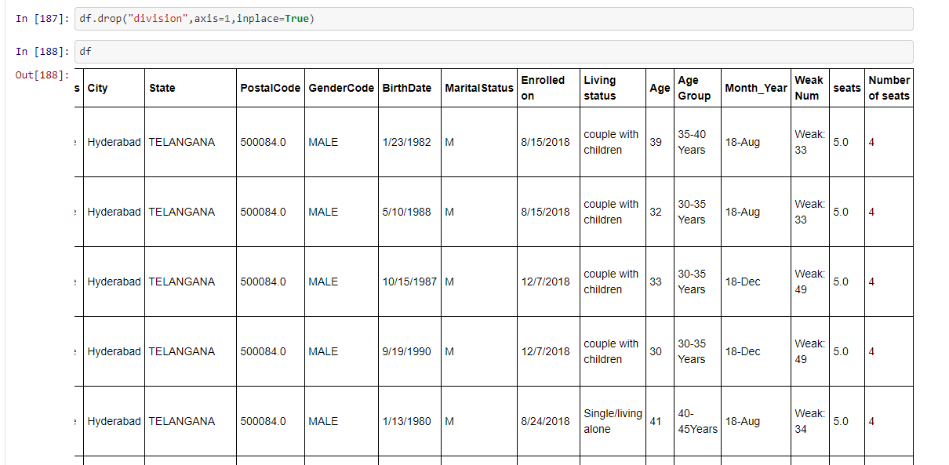

- Randomize/Sampling the data

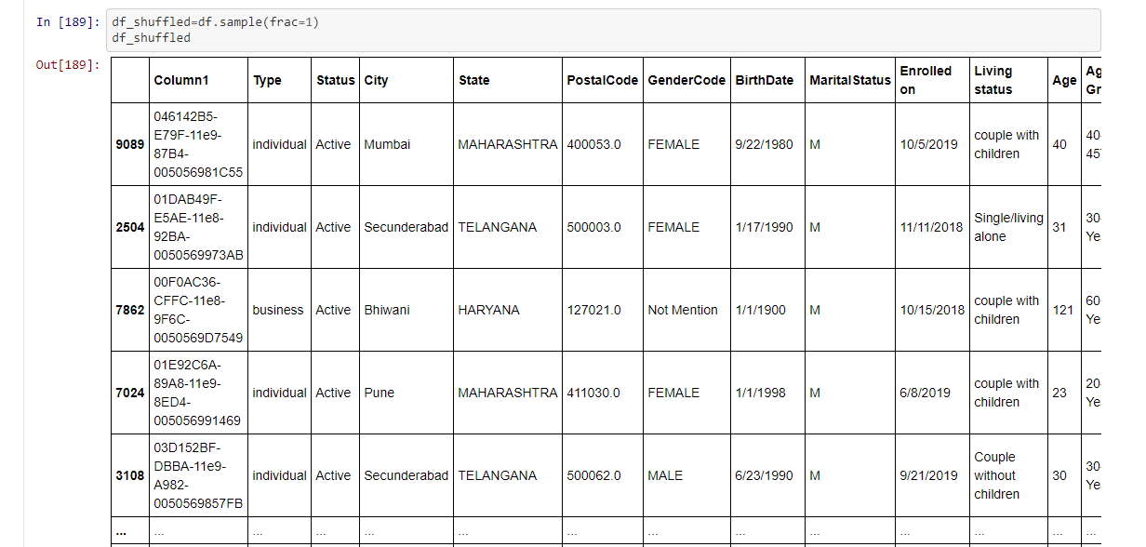

- Showing only 20% of data

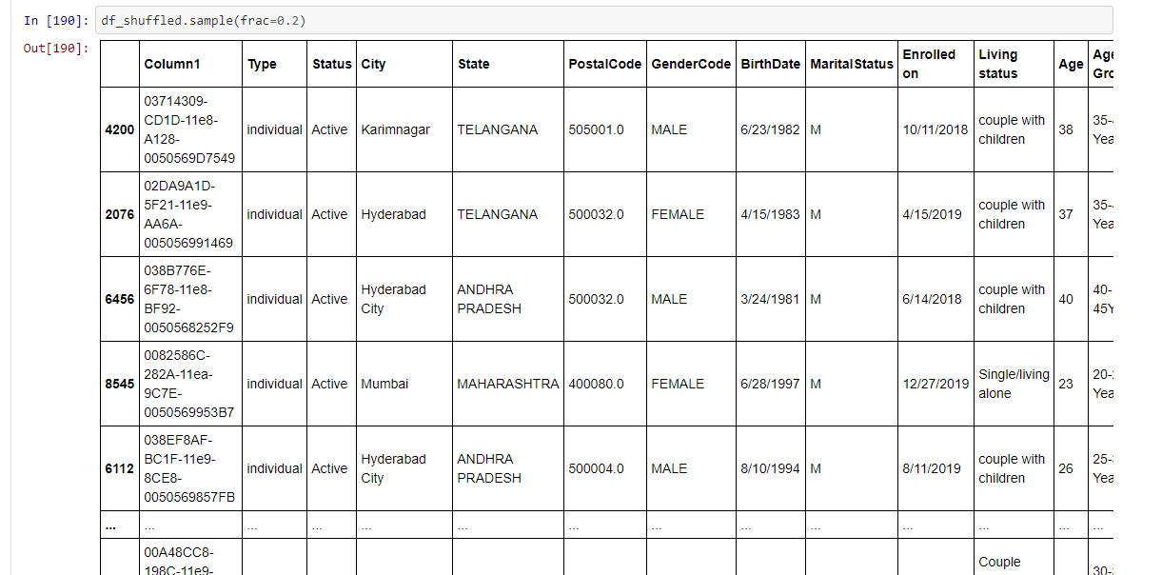

- Reset the shuffled index

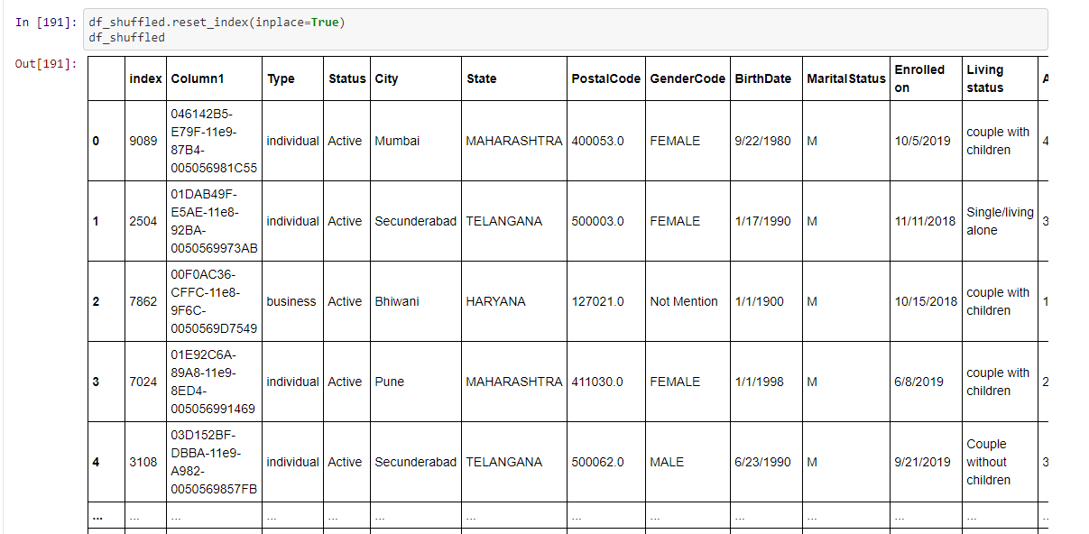

- Converting ‘seats’ to ‘seats’ using the lambda() function

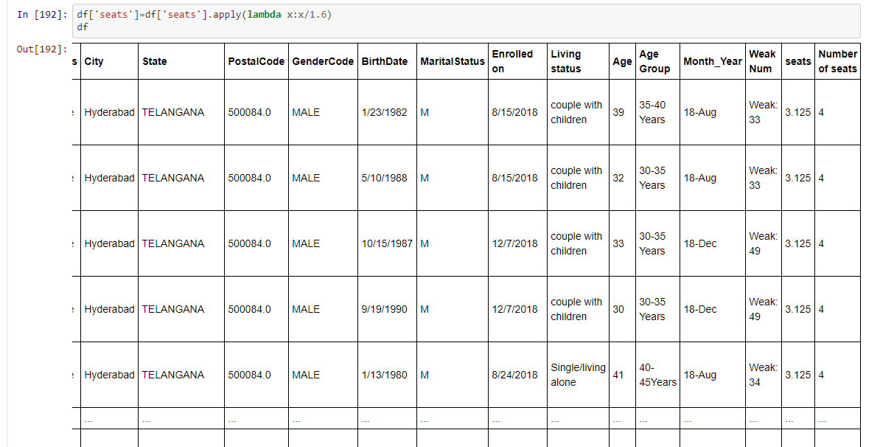

- Selecting Data frame row
- Showing the data of index=3

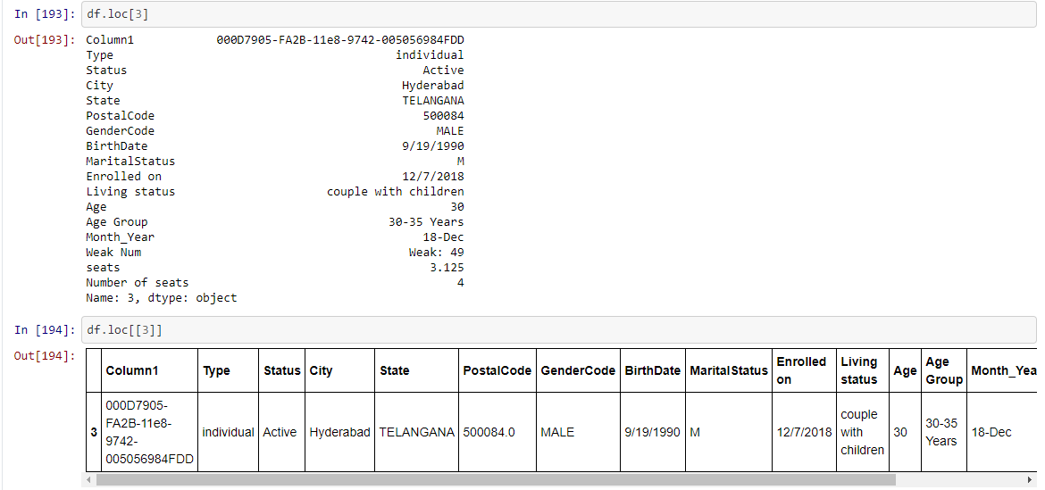

- Showing the data of 8,9 row wise

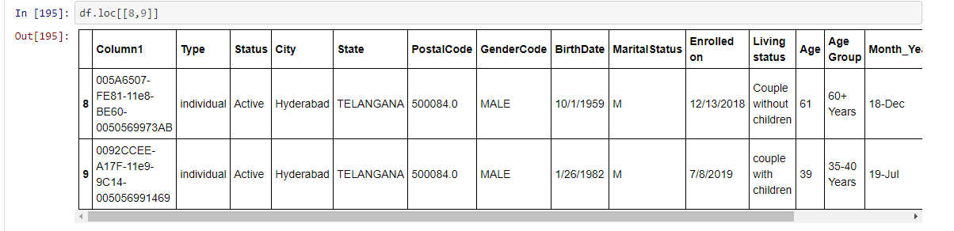

- 5-8 row showing

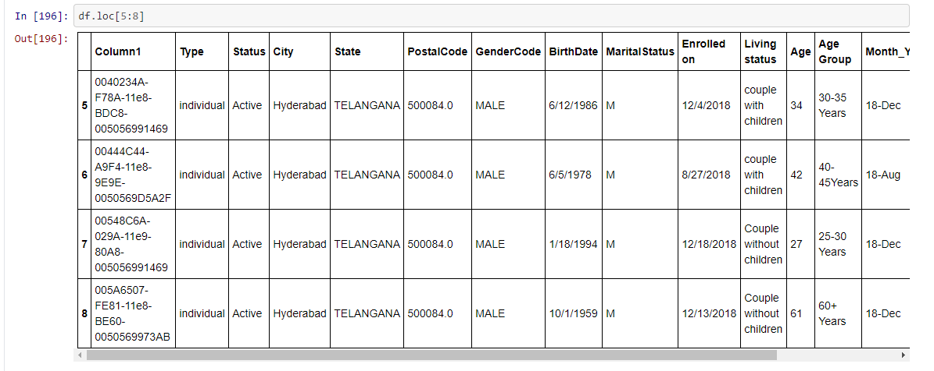

- Cleaning wrong data
- passing female to the GenderCode of index 4

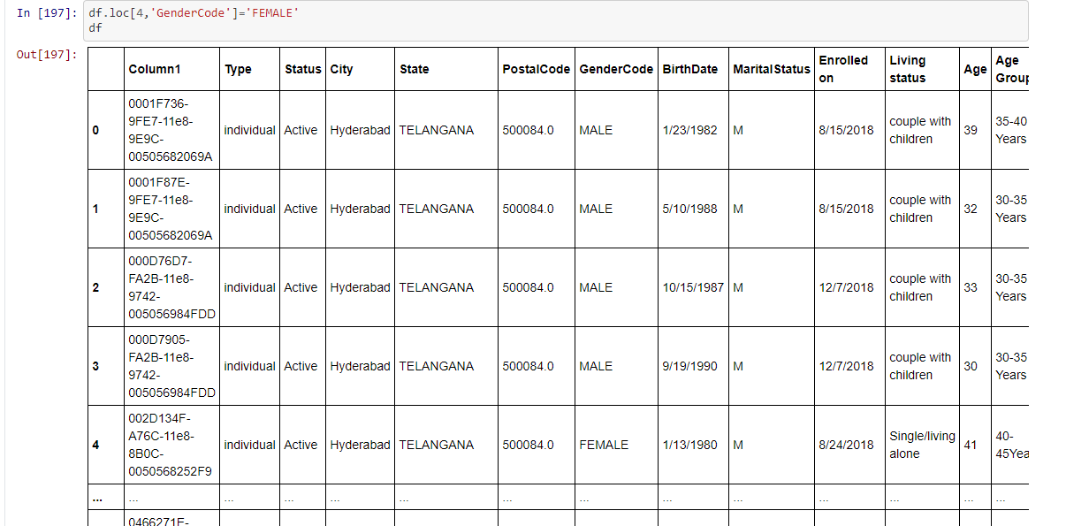

- 5 to 8 showing and distance 2
- 5 to 8 reverse show and distance -2

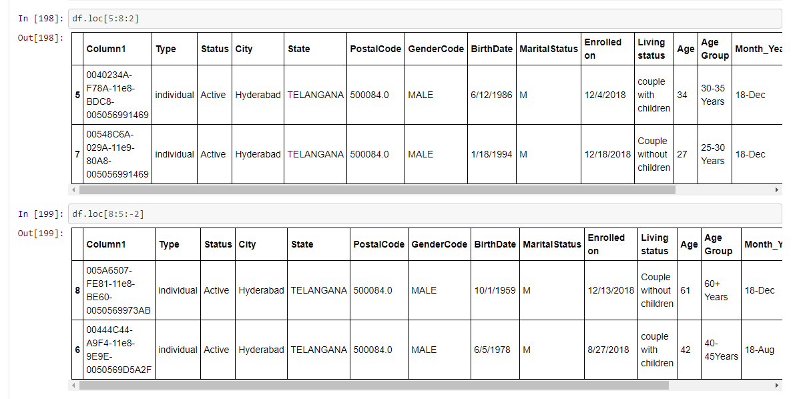

- Age 40 up show

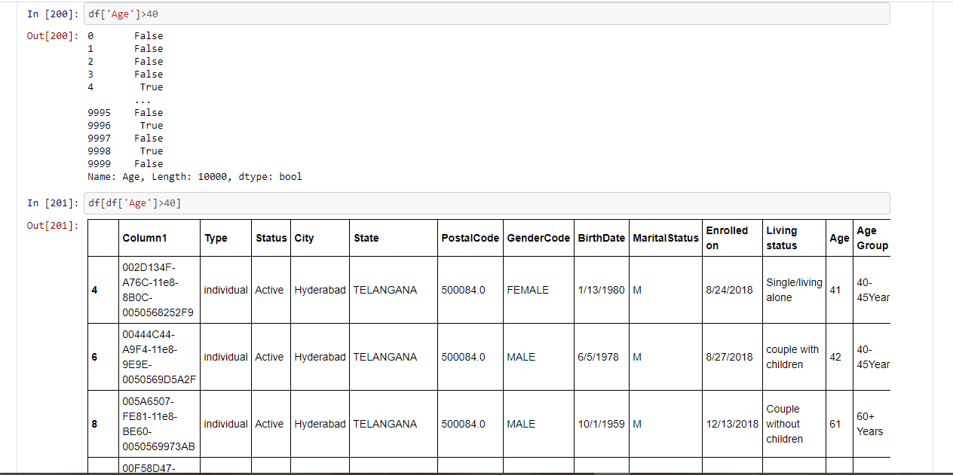

- column re-naming seats to seat_column

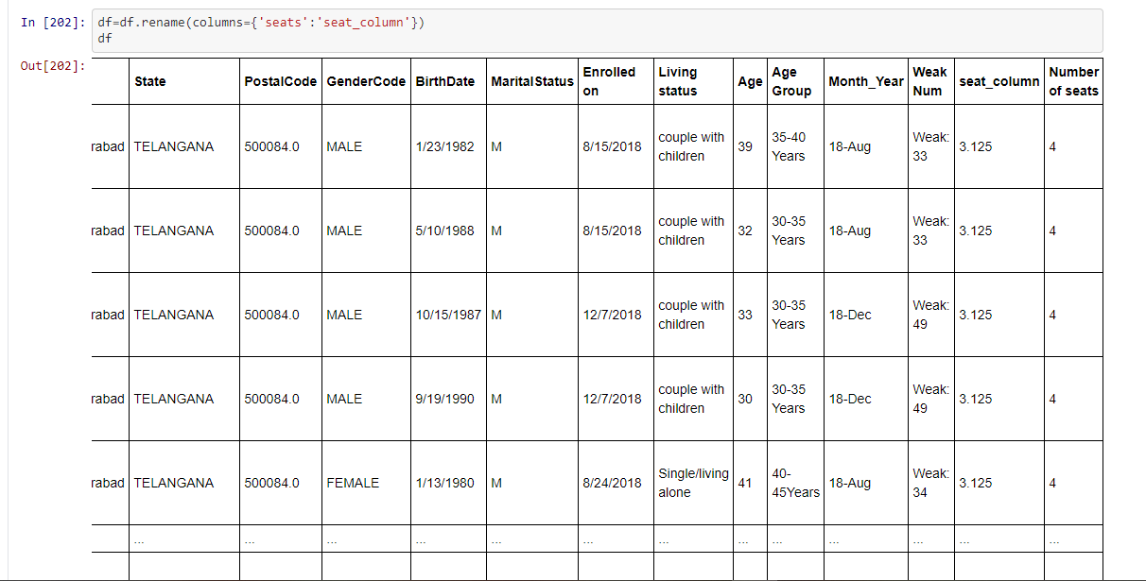

- Duplicate value
- Duplicate value removing

