 | NATIONAL  RADIO AND TELECOMMUNICATION  CORPORATION | 
Manufacturer of Military Electronic Equipment
NRTC/008/2025
Mar,2025
To,
Branch Manager
HBL
Subject: Request to Open a Bank Account for Company Employee
1. Please open at work account of Mubasher Hassan Shahbaz s/o Khalid Mehmood Shahbaz CNIC No. 13302-3173813-9. An employee of NRTC BO Lahore at Safe City Phase-II. Department and deputed at NRTC BO Lahore. Details are as under: -
- Address: NRTC 72 Block, Peco Mor, Kot Lakhpat, Railway Station Lahore
- Designation: Site Engineer
- Salary: 90k/-
2. Copy of CNIC is attached.
3. Kindly open at Work account to this employee with online bank facilities and ATM services as soon as possible.
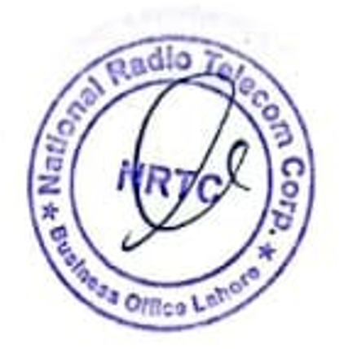 | Regard, | 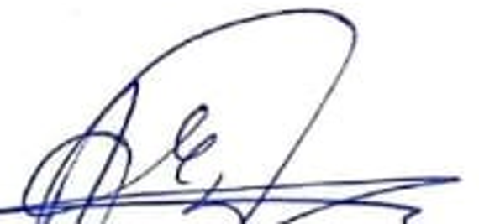  Muhammad Abdullah  Admin Officer  NRTC Business Office Lahore

Head Office  T&T Complex, Haripur,  Pakistan  Tel: +92 995 666311,666611  Fax:+92 995 610933 | Islamabad Office  ITP Office, Near  Islamabad Motorway  Toll Plaza,  ISLAMABAD  Tel: +92 51 2850135 | Lahore Office  72 Industrial State,  Kot Lakhpat  LAHORE  Tel: +92 42 35215700  Fax: +92 42 35117303 | Karachi Office  Army Log Area,  Near Regent Plaza,  KARACHI  Tel: +92 21 21906327  Fax: +92 21 21906328 | Peshawar Office  Bunglow No.23, F/7,  Khushal Road,  University Town,  PESHAWAR  Tel: +92 91 2601014  Tel: +92 315 2133564 | Quetta Office  Chiman Housing,  Scheme,  QUETTA  Tel: +92 332 7926421
eMail: marketing@nrtc.com.pk; Website: www.nrtc.com.pk

