London AQI Predictor
3-Day Air Quality Forecasting — End-to-End Serverless MLOps
City: London · Horizon: 72 hours · Feature store + registry: Hopsworks

1. Problem Statement
Forecast the Air Quality Index (AQI) for London over the next 72 hours through an automated, scalable, fully serverless pipeline with an interactive dashboard. AQI is a public-health signal; an accurate 3-day outlook lets sensitive groups plan exposure.

2. Data Sources
Source | Role | Access
AQICN (api.waqi.info) | Real-time AQI + pollutants (pm2.5, pm10, o3, no2, so2, co) | AQICN_API_TOKEN
OpenWeather | Weather (temp, humidity, pressure, wind) | OPENWEATHER_API_KEY
Synthetic generator | Offline / CI / backfill | physically-plausible hourly series
History APIs are paid, so backfill synthesises a plausible hourly series ending now; with live keys the same code path consumes real observations.

3. Exploratory Data Analysis
Analysis on a 90-day London series (notebooks/EDA.ipynb). Key findings:
- Strong daily seasonality — AQI peaks mid-afternoon, troughs pre-dawn (traffic + photochemistry).
- Weekly component — weekday levels exceed weekend.
- High autocorrelation at lags 1–24 h → lag/rolling features dominate predictive power.
- PM2.5 is the primary AQI driver — near-monotonic relationship (EPA breakpoints).
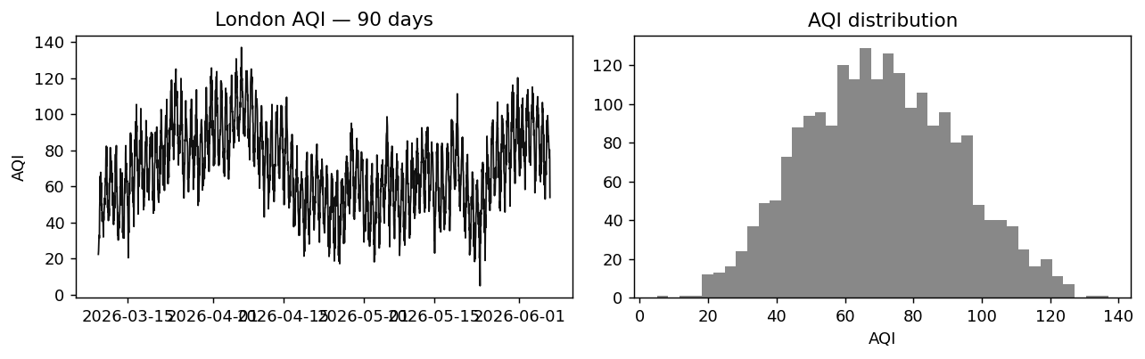
Figure 1 — London AQI over 90 days (left) and its distribution (right).
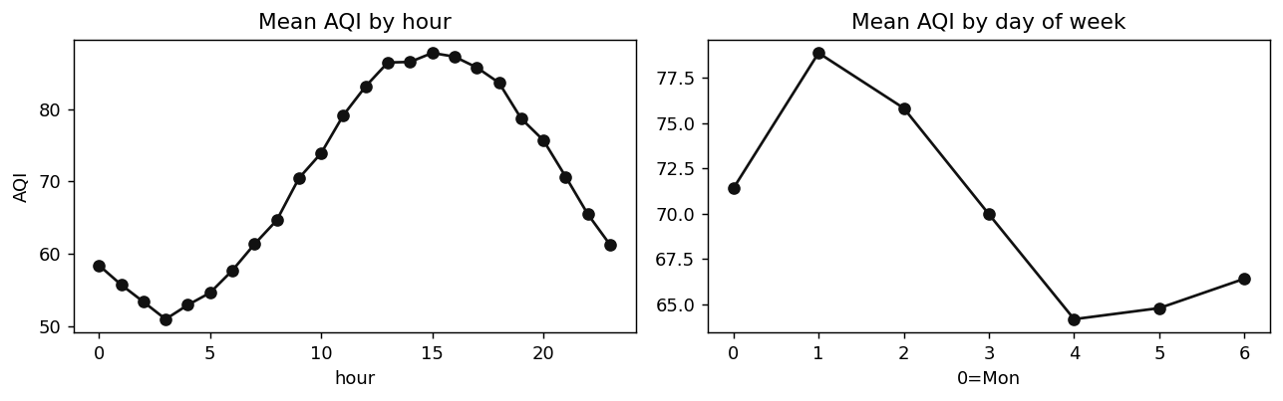
Figure 2 — Daily and weekly seasonality of mean AQI.
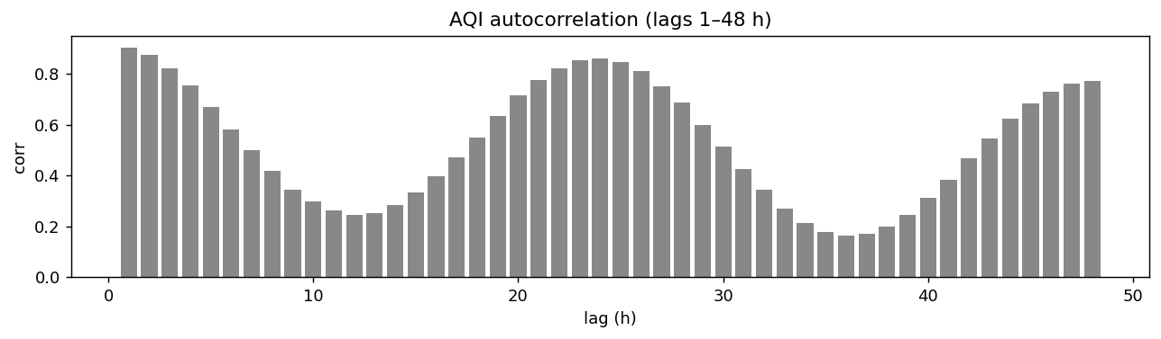
Figure 3 — Autocorrelation (lags 1–48 h): motivates lag and rolling features.
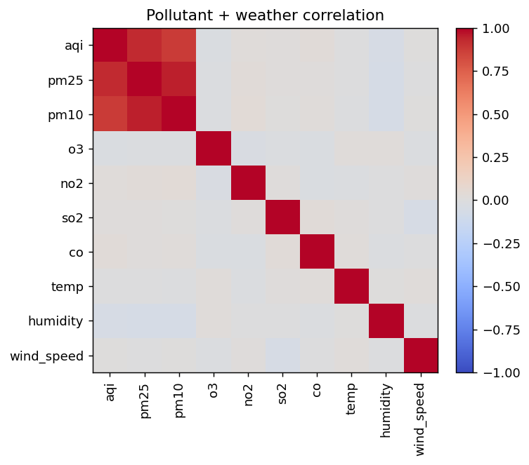
Figure 4 — Pollutant + weather correlation matrix.

4. Feature Engineering
Engineered features (src/feature_pipeline/feature_engineer.py) — 37 columns, all leak-free (past information only):
- Time: hour, day, month, dayofweek, is_weekend.
- Cyclical encodings: hour_sin/cos, month_sin/cos.
- Lags: aqi_lag_{1,3,6,12,24}.
- Rolling: mean/std over 6 & 24 h, max over 24 h (shifted 1).
- Derived: aqi_change_rate, aqi_trend_3h.
- Interactions: pm25_pm10_ratio, temp_humidity, wind_dispersion.
Targets: create_forecast_targets() builds aqi_t+1h … aqi_t+72h (AQI shifted −h). Models learn a direct multi-horizon mapping — one forward pass yields 72 distinct values, so the forecast genuinely varies (no flat nowcast, no autoregressive rollout).

5. Models & Experiments
Model | Type | Multi-output | Role
Ridge (scaled) | Statistical | wrapped | baseline
Random Forest (120 trees, depth 12) | Ensemble | native | workhorse / best
LSTM (Dense(72) head) | Deep learning | native | optional (needs TF)
Validation: 5-fold TimeSeriesSplit (no shuffle — respects time order). Metrics: RMSE, MAE, R². Best model auto-selected by lowest RMSE and tracked in the Hopsworks model registry.

Measured run (London, 90-day backfill, cloud-trained)
Model | RMSE | MAE | R²
Ridge | 20.00 | 15.83 | -0.489
Random Forest (best) | 17.72 | 14.79 | -0.265
LSTM | — | — | skipped (TF/protobuf conflict)
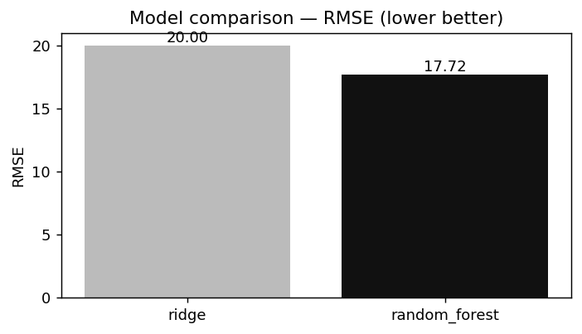
Figure 5 — Model RMSE comparison (lower is better).
R² is modest because the offline series is largely a seasonal random walk at a 72-h horizon; live data and longer history improve signal-to-noise. The forecast spread confirms a real, non-flat curve.

6. Live 72-Hour Forecast
Generated from the best cloud model (random_forest), served via the Hopsworks model registry. Forecast σ = 13.57 AQI over the 72-h curve (range 54–102).
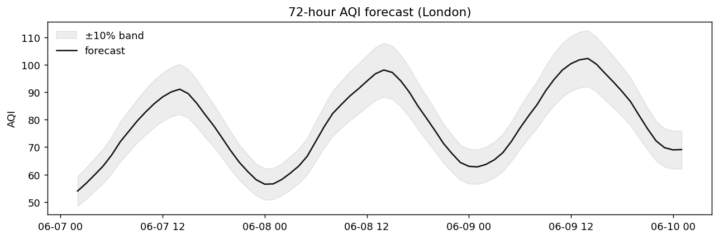
Figure 6 — 72-hour London AQI forecast with ±10% interval.

7. Architecture (Serverless)
AQICN + OpenWeather → Feature pipeline → Feature Store (Hopsworks) → Training pipeline → Model Registry (Hopsworks) → Inference (72 h) → Streamlit + Flask.
- Feature store + model registry: Hopsworks free tier (cloud source of truth); local SQLite/joblib dev fallback. No CSV ever written.
- Compute: GitHub Actions (no owned server).
- Dashboard: Streamlit (minimal white theme); Flask REST API alongside.

8. CI/CD Design
Workflow | Trigger | Purpose
ci.yml | push / PR | tests only, no secrets → always green
feature_pipeline.yml | hourly cron + dispatch | fetch → engineer → store
training_pipeline.yml | daily cron + dispatch | train → evaluate → registry
Scheduled jobs exit 0 on data gaps (warning, not failure); the cloud store persists data across runs so training never hits a cold cache.

9. Dashboard & API
Streamlit (app/streamlit_app.py): current AQI + health category, observed history, 72-h forecast with ±10% interval, 3-day min/mean/max summary, forecast table. Flask (app/flask_api.py) exposes GET endpoints: /health, /current, /predict, /history, /alerts, /models.

10. Explainability & Alerts
- SHAP (src/utils/shap_explainer.py) — top drivers: aqi_change_rate, aqi_roll_max_24, aqi_trend_3h, wind_dispersion.
- Alerts (src/utils/alerts.py) — EPA 6-level classification with health text; hazardous flag at AQI ≥ 150.

11. Limitations & Future Work
- Live history is synthetic without paid APIs; integrate a real archive (e.g. OpenAQ).
- LSTM disabled — TensorFlow (protobuf ≥6) conflicts with hopsworks (protobuf <5); isolate or containerise to enable.
- Per-horizon quantile models for calibrated intervals instead of a fixed ±10% band.
- Hyperparameter search (Optuna); data-drift / prediction-drift monitoring.

