Team11screenshots

**Part A: Hive**

1.



2.

3. select count(*) from metahumans where race = ‘american’; → 489



select count(*) from metahumans where race = ‘indian; → 498



select count(*) from metahumans where race = ‘asian; → 517



select count(*) from metahumans where race = ‘european; → 496



4.

select * from metahumans where superspeed > 80 and superhearing > 80 and supervision > 80;

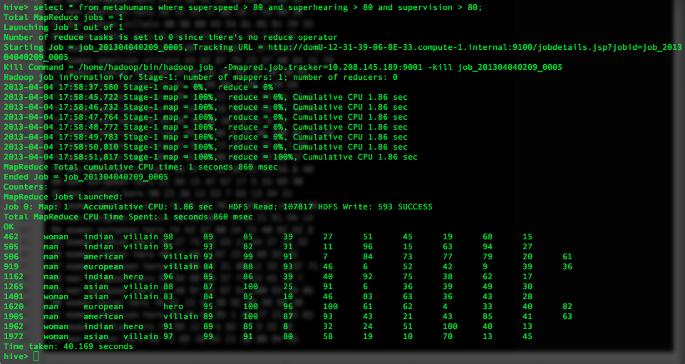

5. create table metahumanscombo (id INT, gender STRING, side STRING, weight INT, height INT);

INSERT OVERWRITE TABLE metahumanscombo SELECT metahumans.id, metahumans.gender, metahumans.side, bmi.weight, bmi.height FROM metahumans INNER JOIN bmi on metahumans.id = bmi.id;

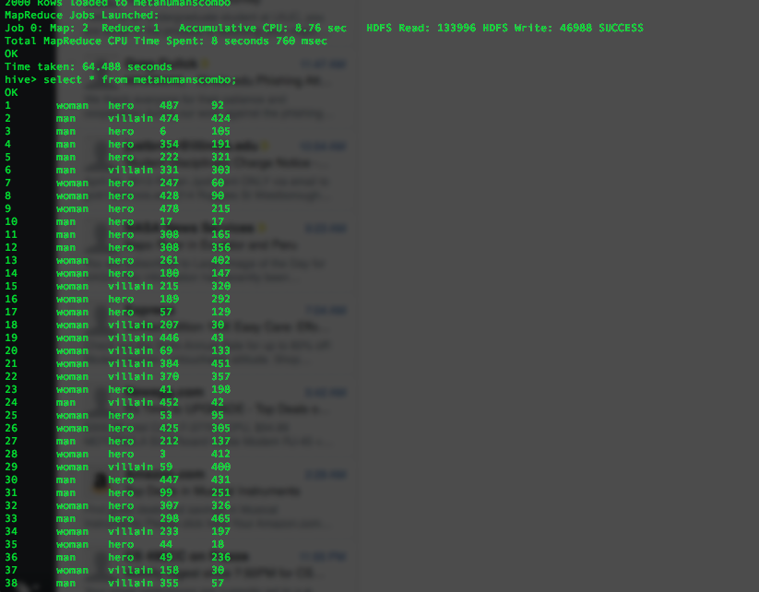

PART B

1. Number of rows

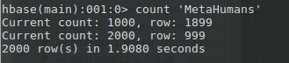

2. Contents of row 1050

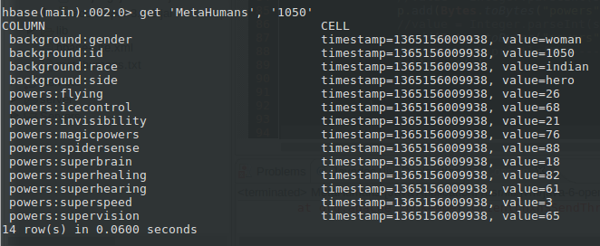

3. Row 1990-1993 scan of background:side

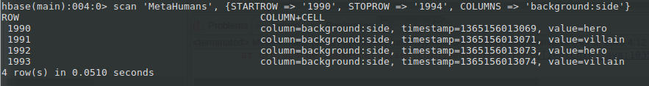

4. Status

