Asadullah Naeem
BSEF17A534
- We use whoami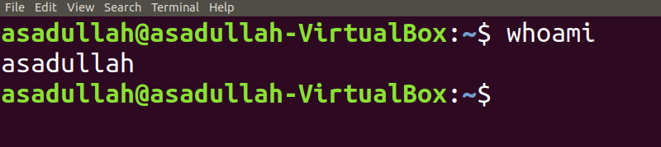
- 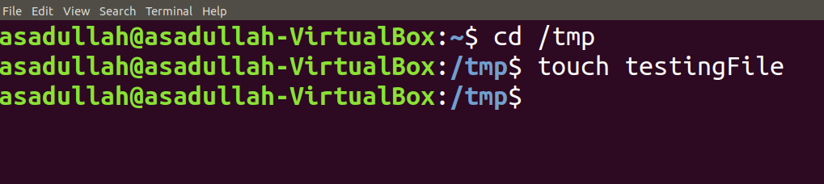
- We use ls –l in the beginning 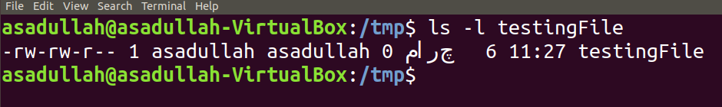
- rm is used to delete file and rmdir is used to delete directory.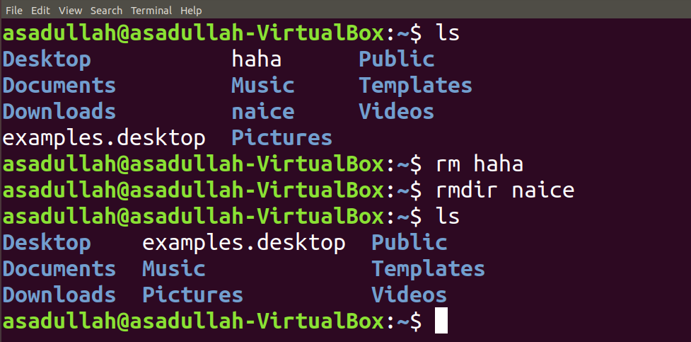
- 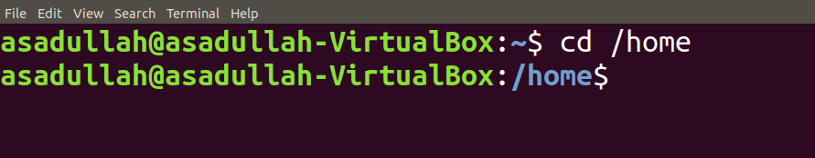
- We use mv “tryit&” “tryit_now”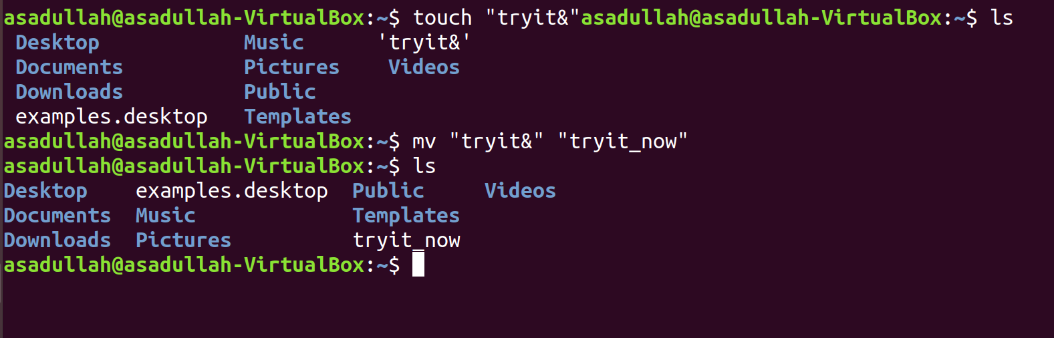
- 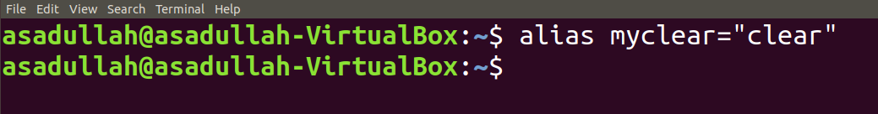
- A) First cls is alias of clear so it clears the screen then it becomes the alias of ls so it shows what is in the respective directory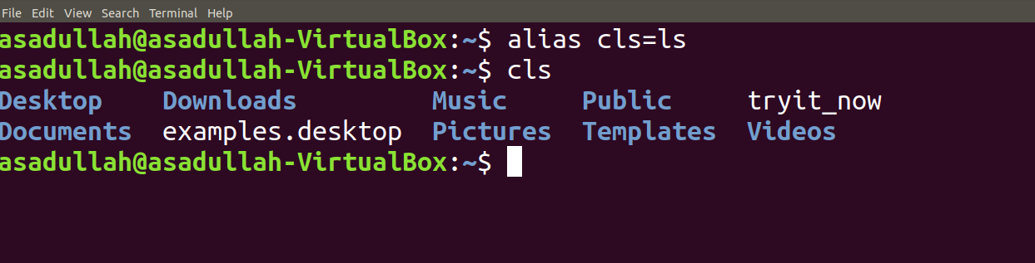
B) It cannot create another file because it already exists.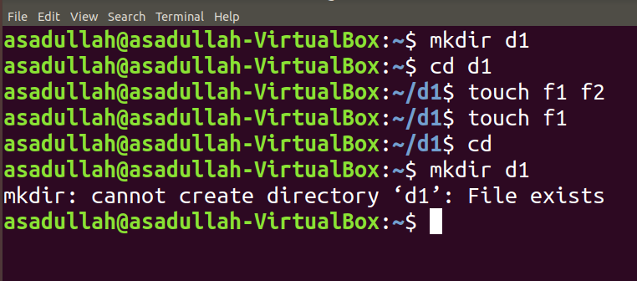

QUESTIONS:
- 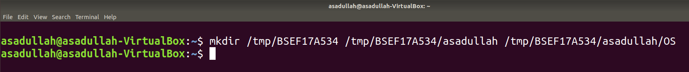
- 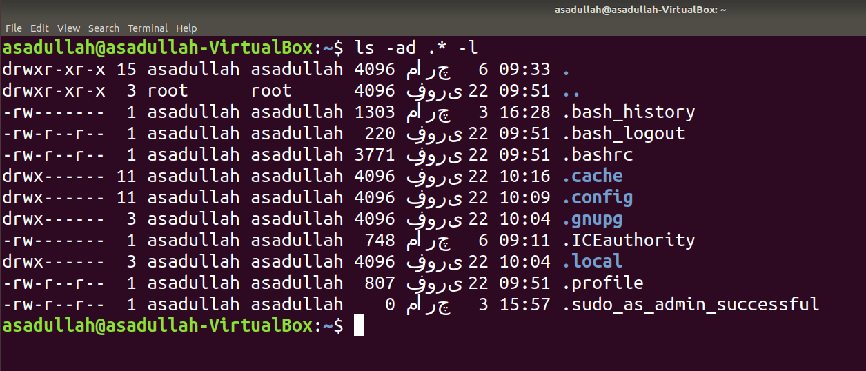
- We can use rm –r BSEF17A534 or rmdir /tmp/BSEF17A534/Asadullah/OS/ /tmp/BSEF17A534/Asadullah/ /tmp/BSEF17A534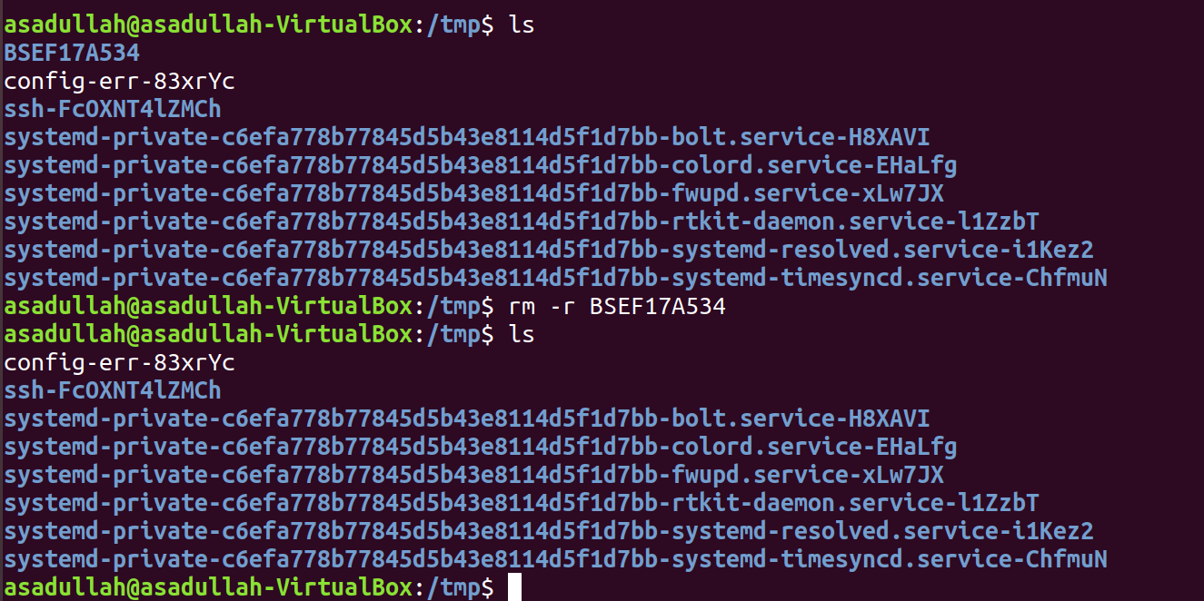
- 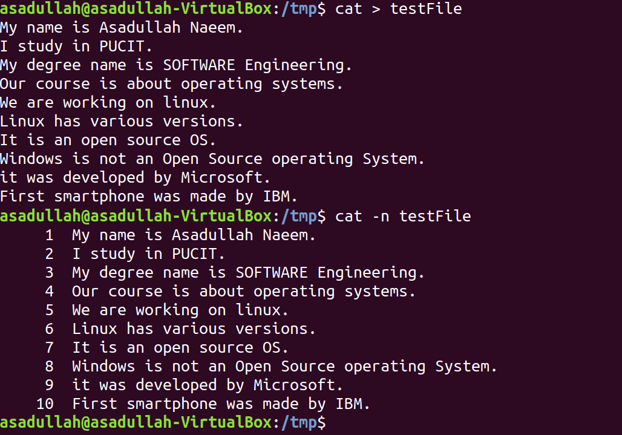
- 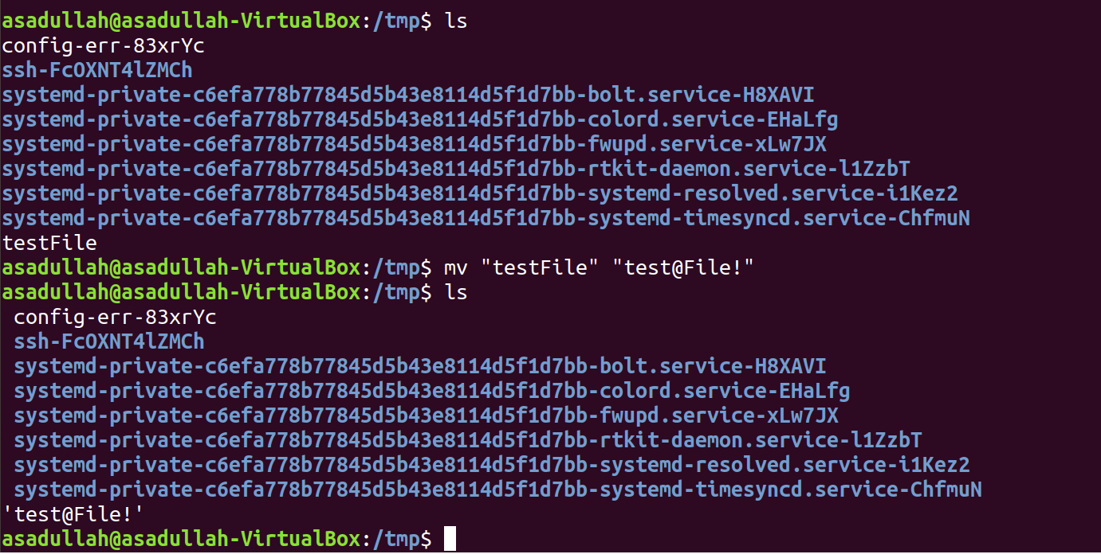
- 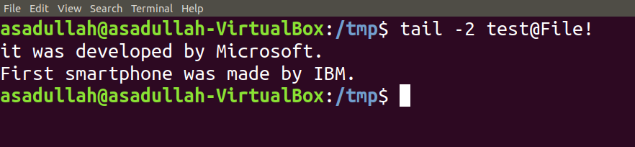
- 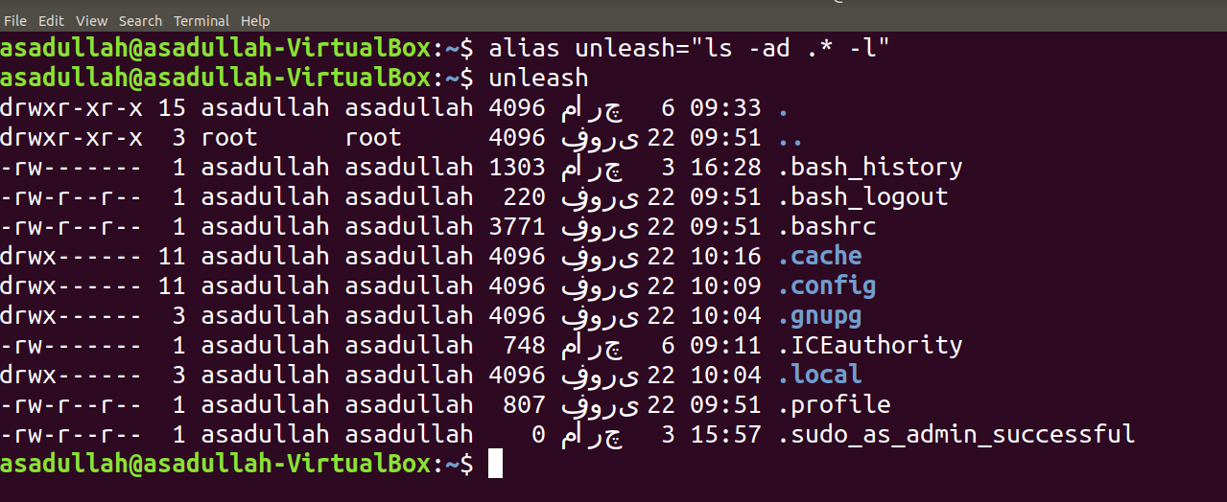
- We use man command-name
- type type is use to display type of a command. If it is builtin then it is an internal command.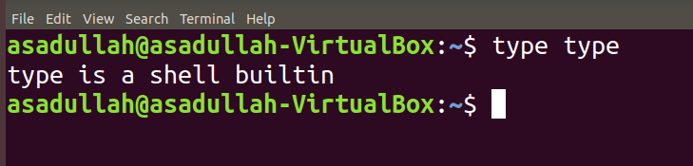
- 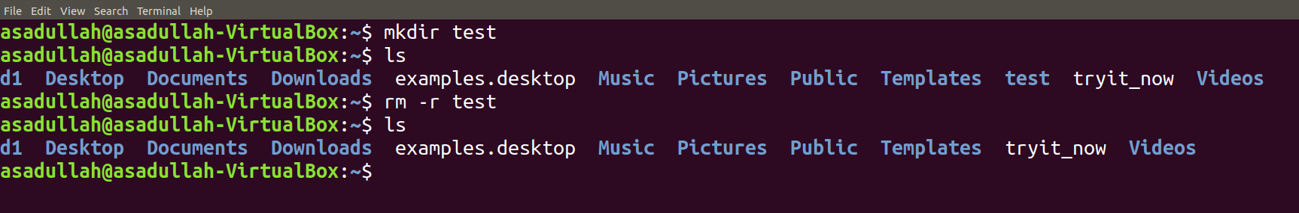

ABSOLUTE/RELATIVE PATH

- 
 