

MASTER OF DATA SCIENCE (SEMESTER 1 – 2024/2025)
FACULTY OF COMPUTER SCIENCE &
INFORMATION TECHNOLOGY
WQD7006 Machine Learning

Project
Identifying Crime High-Risk and Low-Risk Economic Zones in Malaysia​

Lecturer: Prof. Vimala Balakrishan
Date: 11th Jan 2025

Student Name | Matric No. | Role
Asadullah Qamar Bhatti | S2136569 | Leader
Lee Wei Jie | 23061366 | Member

Contents
1 Introduction 1
1.1 Problem Statement 1
1.2 Aim and Objectives: 1
1.3 Scope 1
1.4 Data Overview 1
2 Background & Literature Review 2
2.1 Insights from Related Studies 3
2.2 Research Gaps 3
2.3 Our Approach 3
3 Methodology 4
3.1 Data Preparation 5
3.2 Supervised Learning (Regression) 5
3.3 Unsupervised Learning (Clustering) 5
4 Results 6
4.1 Regression 6
4.2 Clustering 7
5 Discussion 8
5.1 Predictive Power of Economic Indicators 8
5.2 Economic Development and Crime Clusters 8
5.3 Policy Implications 8
5.4 Theoretical Implications and Model Interpretation 9
5.5 Limitations and Future Research 9
5.6 Methodological Contributions 9
6 Conclusion 10
References 11
Appendix 12

Introduction
Crime and economic activity are interconnected phenomena that significantly affect the society’s well-being. They also have a significant impact on the progress of the nation’s development. In Malaysia, the crime rates had continuously grown in 1990s but this trend had started to U-turn over the past decades. The crime rate has declined significantly in recent years. Various economic factors contribute to the prevalence of criminal activities and one of the factors is the Gross Domestic Product (GDP). GDP is the market value of goods and services produced within the country or selected area. According to Leamer (2009), this is an important measurement that explains the size and performance of the economics of a country. It is critical to know the relationship of economic zones and crime rates because it can help in design the policies and effective planning of resource use in Malaysia of each district. The economic health of a country often affects its ability to maintain safety and security. In contrast, high crime rates are unfavourable for the economy and even prevent investments. Our study focuses on addressing the challenges of identifying high-risk and low-risk economic zones by employing machine learning algorithms such as regression and clustering to analyse district-level crime and sectoral GDP data in Malaysia over the past 10 years from 2015 to 2024.

Problem Statement
Economic zones are often defined by their main sectors such as agriculture, manufacturing, service and others which contribution differently to the country GDP. These sectors influence the economic strength and job opportunities in a district that may affect the crime rates. At the same time, crime patterns are influenced by a mix of factors including economic conditions, population density, effectiveness of local law etc. Although there is data available but not much research has systematically explored deeply on how economic activities and crime patterns are related in Malaysia until district and sector level.
In addition, identify high-risk and low-risk district or zones is necessary for effective urban planning that focus on public safety. High-risk zones may not always correspond with poor economic conditions, but they are important and require immediate attention to ensure the safety of the district’s citizens. These areas often require additional resources, police activity and community programs to solve the underlying issues. On the other hand, the low risk-risk zones can be employed as a standard for effective management and become a good example for other high-risk zones.

Aim and Objectives:
- To optimize resource allocation by identifying high-risk and low-risk economic zones in Malaysia using crime and GDP data.
- To develop ML models that aid in the creation of economic policies that can lead to crime reduction in Malaysia.
- To create a reference guide for Malaysian to identify states or districts with strong economic growth and low crime rate.

Scope
The primary dataset utilized in this study is sourced from the Open DOSM database. According to Yeong (2023), OpenDOSM is a government-maintained open-source platform that provides reliable and detailed data that related to Malaysia’s socioeconomic indicators such as GDP, crime, population, and others. It allows public to have free access to its dataset to promote transparency. This research will include some preprocessing methods for example cleaning, normalization, and integration of datasets to match crime and economic activity on the district zone level to maintain the quality and compatibility of the data. Besides that, clustering and regression algorithms are used as machine learning techniques to detect the patterns and categorize the zones into classes of risk levels. Clustering methods will help group districts with similar crime and economic profiles. Apart from that, regression algorithms will predict risk levels based on predefined metrics. This approach ensures a comprehensive analysis that captures the nuances of crime and economic interdependencies. This study aims to discover actionable insights within economic activities and crime that contribute to the fields of data science, society safety and economic stability.

Data Overview
The dataset after preprocess consists of 1180 rows and 7 columns. The dataset covers data of the crimes and GDP from 2015 to 2024. The columns include:
- year: the year of observation.
- district: The district area of Malaysia.
- crimes: The number of recorded crimes.
- gdp_purchasers: GDP contribution from purchasers’ sector.
- gdp_agriculture: GDP contribution from agriculture sector.
- gdp_manufacturing: GDP contribution from manufacturing sector.
- gdp_services: GDP contribution from services sector.
.
The crime data is analysed at the district level while the GDP data is segmented by economic sectors and district which allowing for a granular understanding of the relationship between economic activities and crime. After preprocessing, the dataset is ready for machine learning to uncover patterns and actionable insights.

Background & Literature Review
The intersection of economic factors and crime analysis using machine learning techniques has been a popular research field in recent years. Researchers across the world have explored various methodologies to uncover patterns, forecast trends and identify risk zones. These studies and research have contributed significantly to the understanding of how economic indicators such as GDP influence crime. In addition, it provided valuable insights into the methodologies and frameworks of our research.
Table 1 below show the summary of the key studies that related to this field. It highlights the techniques and results of the related work.
No | Paper Title | Author/Year | Technique | Results
1 | Monitoring The Impact of Social Factors on Crime using Machine Learning | Khan et al. (2024) | Support Vector Regression (SVR),  Multilayer Perceptron (MLP),  K-Nearest Neighbour (KNN),  Gradient Boosting (GB) | In comparison, SVR had an MSE of 0.01 and an R² of 0.94, GB had an MSE of 0.011 and an R² of 0.95, and KNN had an MSE of 0.011 and an R² of 0.96. It was observed MLP had the lowest MSE and the highest R-squared value which suggests it is most effective in predicting the impact of economic factors on total crime rates.
2 | A Machine Learning Approach To Crime Analysis  And Forecasting For Prediction And Prevention | Bharath et al. (2024) | K-Nearest Neighbors (KNN), Logistic Regression, Linear Regression and Support Vector Machine | In crime location prediction model, the KNN model achieve an accuracy of 97%, precision of 95%, recall of 96% and F1-score of 93% in predicting the crime location. This indicates that the model can effectively classify locations as either high-risk or low risk based on the features provided in the dataset.
3 | Crime Prediction and Forecasting Using MLP & K-Means Clustering Algorithm | D et al. (2024) | Combination of K-mean clustering and Multi- Layer Percepton (MLP) | The combination of the model achieved an accuracy of 97.5%, precision of 97.82%, recall of 97.5% and F1 score of 97.55%. he results indicate that the proposed system, which combines K-means clustering and MLP, is effective for crime prediction, achieving high accuracy, precision, recall, and F1-score. The system demonstrates the potential for these techniques to aid law enforcement agencies and policymakers in their efforts to mitigate criminal activities.
4 | Mitigating Vulnerabilities through Forecasting and  Crime Trend Analysis | Orong et al. (2018) | K-mean clustering and Autoregressive Integrated Moving Average (ARIMA) | The K-mean clustering effectively grouped crime data into 2 district clusters with similar types of crimes. Besides that, The ARIMA (1,0,1) model was useful in predicting the trends of future crime occurrences which is helpful for authorities in designing preventative measures.
5 | Crime detection and criminal identification in India using data mining techniques | Tayal et al. (2014) | K-mean Clustering and K-Nearest Neighbors (KNN) | K-means clustering groups crime instances into two clusters based on similar attributes. This is done using the crime data. The accuracy of K-means clustering is verified using WEKA by achieving 93.62% accuracy for cluster 1 and 93.99% accuracy for cluster 2.
Table 1: Summary of Related Work to Our Study

Insights from Related Studies
Based on the reviewed studies, supervised learning techniques like regression and classification are excellent in predicting crime rates based on economic and social indicators. For instance, Khan et al. (2024) found that Multilayer Perceptron (MLP) outperformed other techniques in predicting the impact of economic factors on crime by achieving high accuracy and R-squared values. Similarly, Bharath et al. (2024) had demonstrated the potential of K-Nearest Neighbors (KNN) to classify crime locations effectively. The KNN regression model had identified the high risk and low risk zone with an excellent evaluation result.
Apart from that, unsupervised techniques such as clustering can reveal hidden patterns within crime data. The studies by Orong et al. (2018) and Tayal et al. (2014) had highlighted the ability of clustering in grouping crime data into meaningful categories. The application of these techniques has been demonstrated to improve decision-making processes in urban planning and resource allocation.
Furthermore, the combination of clustering and supervised learning has shown to be effective in predicting and forecasting the crime. D et al. (2024) successfully used K-means clustering alongside with MLP model to achieve high predictive performance. The combination of the model achieved an accuracy of 97.5%, precision of 97.82%, recall of 97.5% and F1 score of 97.55%. This excellent result had showed the advantages of integrating these techniques for comprehensive crime analysis.

Research Gaps
There are still significant gaps remain although much research had been done for these field across the world.
- Limited Exploration of Comparison of Methods: Most studies focus solely on either clustering or regression methods with limited exploration of their combined or comparison although D et al. (2024) has demonstrated the effectiveness of regression and combined clustering model. This lack of combined and comparison of methods restricts the depth of analysis that could be achieved in understanding the relationships between economic factors like GDP and crime.

- Geographical Context: Most studies such as Bharath et al. (2024) and Tayal et al. (2014) focus on global or region-specific on big country such as USA, India and other countries. There is lack of localise studies related to Malaysia’s economic and crime related issues. As a Malaysian, it is important for us to understand Malaysia’s economic and crime related topic because they are closely connected to us and significantly impact our lives.

- Sectoral and District-Level Analysis: The existing studies didn’t provide a deep analysis that reach until sectors and district level. Studies like Bharath et al. (2024) have demonstrated crime location analysis at a general level but didn’t provide deep until district-specific insights. Besides that, Khan et al. (2024) effectively analyse how the economic factor factors affect crime but not in detail of sector-specific economic contributions to crime. This lack of detailed analysis leaves critical insights uncover such as which sectors are most contribute to crime trends or how district-level economic affect crime rates. We need a specific approach to understand how the economic factors such as GDP of each sector and crime patterns in each district are related to enable policymakers and researchers to develop strategies that help to solve the unique challenges that faced by different sectors and districts.

Our Approach
Our study employed a comparative approach of clustering and regression. This methodology utilizes the strengths of both unsupervised and supervised learning to provide a framework for analysing the relationship between economic activities and crime patterns in Malaysia. This dual-model approach enables us to address the research gaps identified in previous studies by providing a granular analysis of GDP by sector and crime patterns by district in Malaysia. It is more holistic because it analyses the data from multiple angles.

Methodology
The project employed the CRISP-DM framework to ensure a structured and systematic approach towards completion of the ML model. The steps in CRISP-DM include Business Understanding, Data Understanding, Data Preparation, Modeling, Evaluation, and Deployment. Figure 3.1 summarises the steps in CRISP-DM.
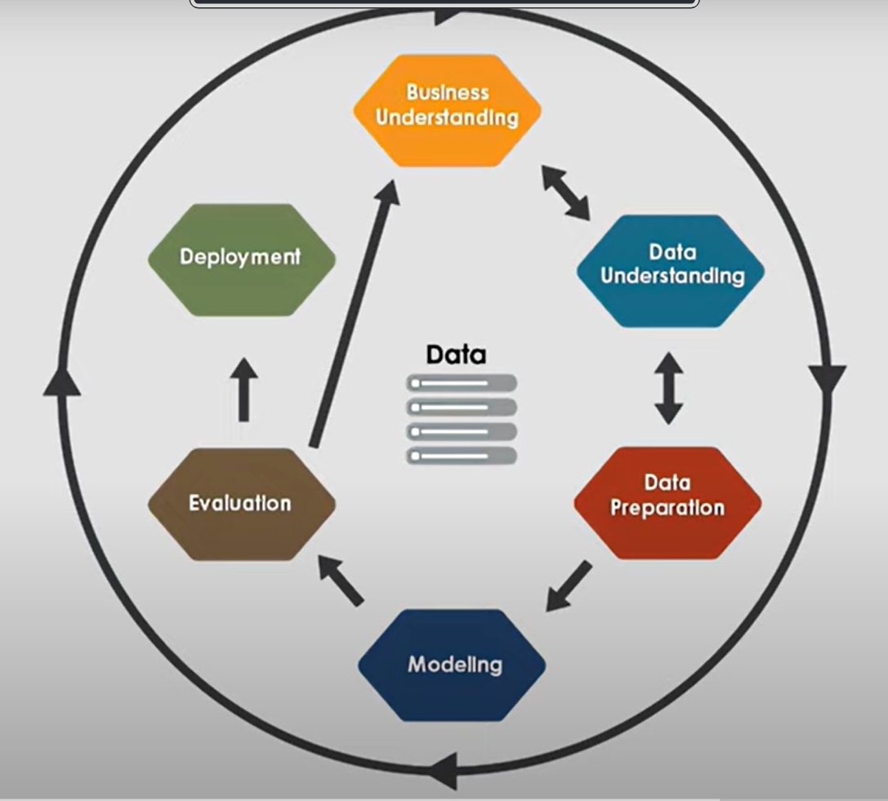
Figure 3.1: CRISP-DM Process Flow
During the business understanding phase, a literature review was conducted into Machine Learning in Crime and GDP. The literature review found that many have attempted to implement Machine Learning in this domain. Hence, the problem was zoomed into a sub-set of the problem that could be solved within a short project duration by 2 team members i.e. crime and GDP in Malaysia.
During the Data Understanding phase, OpenDOSM datasets were downloaded and interpreted. The primary dataset used was crime_district.csv. This dataset is supplemented by the secondary dataset gdp_district_real_supply.csv (Annual Real GDP by District & Economic Sector, 2025). Initial analysis based on the description found on OpenDOSM and based on domain knowledge study found that the data would not be easily compatible for analysis without proper data massaging procedures.
During this phase as well, we also used a Power BI dashboard to understand the trends and patterns in the data. Figure 3.2 shows the Power BI dashboard.
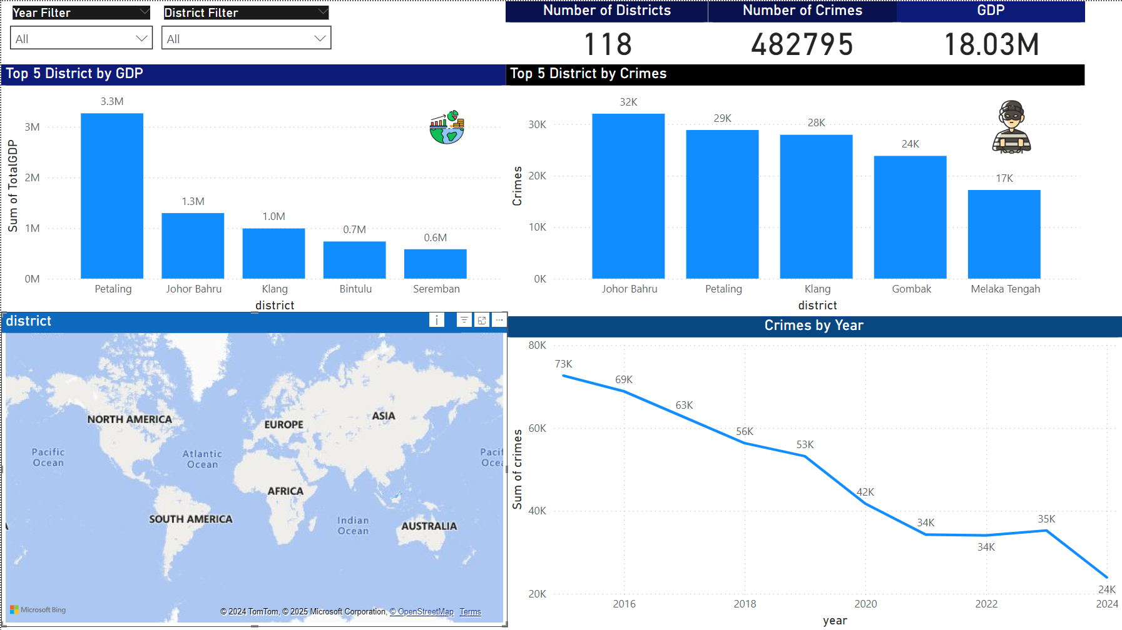
Figure 3.2: Power BI dashboard

Data Preparation
During this step, the data will be massaged and transformed into a format that would be compatible with each other for analysis. The crime and GDP data are in their raw format as per below:
crime_district.csv |  |  |  |  | gdp_district_real_supply.csv
district | year | state | crimes |  | series | state | district | date | sector | value
Alor Gajah | 2015 | Melaka | 424 |  | abs | Johor | Batu Pahat | 1/1/2015 | p0 | 11605.5
Alor Gajah | 2016 | Melaka | 436 |  | abs | Johor | Batu Pahat | 1/1/2015 | p1 | 2177.257
Alor Gajah | 2017 | Melaka | 376 |  | abs | Johor | Batu Pahat | 1/1/2015 | p2 | 13.0113
Table 3.1: Sample Data before Data Preparation
Seeing as this data is not formatted in a district-year-variable format, it needs to be massaged and transformed (on both sides) into this format before they can be merged. This requires data deduplication to remove crime categories from the crime data and data massaging to pivot rows to columns for the GDP data on the right.
The data will then be merged and transformed using some of the sample code attached in Appendix. The result of the transformation (pivoting, duplicate removal, missing value treatment, merging etc.). Once the datasets are merged, some final preparation is needed before it is ready for modelling. In the state it is in Table 3.2, the data would only be useful to predict the crimes of a district in the same year the GDP is made available. In terms of practical applications, this is not very helpful. Hence, the feature columns of the dataset need to be lagged by a year (shifted one row up) for each district. The code to do this is also included in the Appendix and the resulting dataset sample is shown in Table 3.2.
year | district | crimes | gdp_purchasers_l1 | gdp_agriculture_l1 | gdp_manufacturing_l1 | gdp_services_l1
2015 | Alor Gajah | 424 | 1477 | 726.8712 | 10.7435 | 729.7303
2015 | Bachok | 364 | 1395 | 434.7939 | 194.1093 | 719.3754
2015 | Baling | 376 | 600 | 265.7816 | 35.6816 | 286.8733
Table 3.2: Sample Data after Data Preparation

Supervised Learning (Regression)
The target variable is crime while the features are gdp_purchasers_l1, gdp_agriculture_l1, gdp_manufacturing_l1, and gdp_services_l1 which represent the respective GDP values of that district and in the year before. District and year are excluded from the machine learning model because there are insufficient examples of each district to allow the model to learn (district has a very high cardinality and cannot be encoded). The year is not deemed a relevant variable. The algorithms used include KNN regression, Random Forest, SVR, and ElasticNet.
First, correlation analysis will be done to find the variables that have a correlation to the target variable. Based on the correlation analysis, decisions can be made on the features that can be selected and excluded. Then, the regression models will be trained in separate experiments involving 4 models of different varieties. The best model that has a good trade-off performance without any serious concessions will be selected as the best model.

Unsupervised Learning (Clustering)
An unsupervised learning approach will also be used to identify clusters of crime and GDP. The same dataset prepared for regression will be used for clustering. All variables (both crime and GDP variables) will be used as features. The algorithms to be used are KMeans clustering, Agglomerative clustering, and DBScan.
The data will first need to be scaled for all features to be on the same range, and to ensure that they are all well-distributed throughout the scale. The code to perform scaling is included in the Appendix. Then, the Elbow method is used to determine the suitable number of clusters. For KMeans clustering, the Elbow method for inertia will be used. For Agglomerative clustering, the dendrogram will be used. Finally, for DBScan, the Elbow Method with Epsilon will be plotted. Then, the silhouette score will be evaluated and the best performing model with a meaningful number of clusters will be selected as the model to proceed with which can be interpreted for insights. Insights such as different blends and patterns of crime and GDP that are associated with one another could be determined, for example – which are the crime rate thresholds for varying levels of crime (very high, high, low, very low), and what are the associated GDP of these high crime districts.

Results

Regression
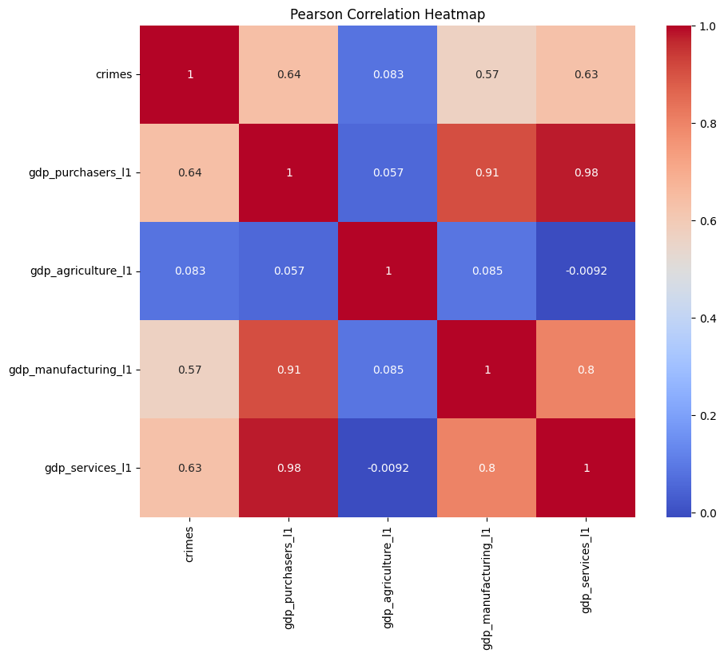
Figure 4.1: Correlation of crimes to gdp features
The correlation analysis in Figure 4.2 shows that there is a high correlation in the GDP values to crime for all GDP sectors except for gdp_agriculture. This intuitively makes sense because one would think that agriculture of a district doing good or bad does not have any bearing on crimes.
There is also a high correlation between the features. We found that this might cause a multicollinearity problem in the model but as we will see later, the model is performing well even with this multicollinearity (with an R2 of more than 80%) and hence, it is safe to assume that this is not a problem.
Based on these correlation analysis insights, we made the decision to implement 2 versions of models i.e. one version with all features, and one version with all features excluding agriculture. The table summarises the performance of the two versions of the model, for all 5 model types that were tried.
Version | Model | MSE | R2 | CV Score | Comments
All Features | KNN Regressor | 0.183590 | 0.811343 | 0.743294 | Best non-overfitted model
All Features | Random Forest Regressor | 0.130680 | 0.865713 | 0.732096 | Best R2, but overfitted
All Features | SVR | 0.151774 | 0.844037 | 0.664049 | Overfitted model
All Features | ElasticNet | 0.844439 | 0.132254 | 0.118033 | Worst model in every way
Without agriculture | KNN Regressor | 0.241139 | 0.752206 | 0.718310 | Best non-overfitted model
Without agriculture | Random Forest Regressor | 0.233957 | 0.759586 | 0.688725 | Best R2, but overfitted
Without agriculture | SVR | 0.307226 | 0.684294 | 0.639601 | Overfitted model
Without agriculture | ElasticNet | 0.844439 | 0.132254 | 0.118033 | Worst model in every way
Table 4.1: Summary of Regression Results
As shown in Table 4.4, the results were compared, and it was found that the performance of the model (measured by R2) does not significantly drop by removing agriculture beyond a confidence level of 95%. Considering the correlation analysis and the model results, we decided to remove agriculture from the final model. This is because despite the model performing slightly worse (but not significantly worse), the agriculture feature might be introducing noise to the model and not helping it learn the crimes.
KNN Regressor is the superior model for both versions hence, it is selected as the model to be used for future predictions. This model is ideal not just because it performs well but also because the size of the data is not that big i.e. only about 1000 rows. KNN Regressor struggles with data of large size and can be computationally expensive to run on large data. This is not a problem for our use case because the data is relatively small i.e. only 1000 rows, and this data will not grow much beyond this point because it’s size only increases by about 150 news for every year (there are only about 150 districts in Malaysia). This could be looked at again in the future when scaling to other countries is considered but for now, it is deemed fine to opt for KNN regression.

Clustering

First, the Elbow Method based on inertia measurement resulting from different algorithms yielded the following results:
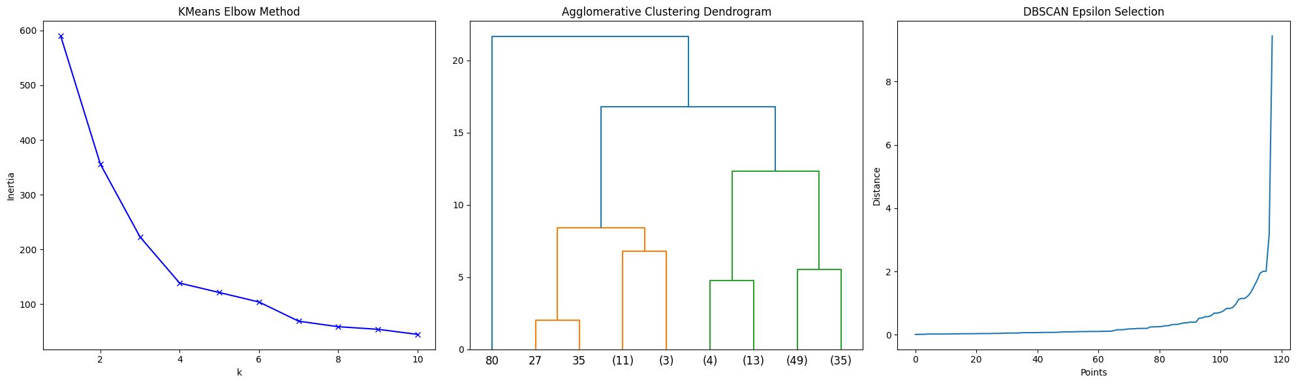
Figure 4.2: Ideal Number of Clusters for Unsupervised Learning
For KMeans clustering, the ideal cluster number is selected as 4, while for Agglomerative clustering, the ideal clusters found are 4 clusters as well. For DBScan, the ideal epsilon is about 2. After setting this hyperparameter for the models, the performance in terms of silhouette score was measured. It was found that Agglomerative clustering performed the best in terms of the clustering models.
Model | Silhouette Score | Comments
DBScan | 0.779413 | An epsilon of 2 means clusters of noise and not noise. Not meaningful.
Agglomerative | 0.546694 | The next best model. With 4 clusters, it is meaningful.
KMeans | 0.539633 | The worst model.
Table 4.2: Clustering Results Summary
As such, the agglomerative clustering model was then used to assign the clusters for each district and year and then the clusters were interpreted for descriptive statistics and similarities that could explain the clusters.
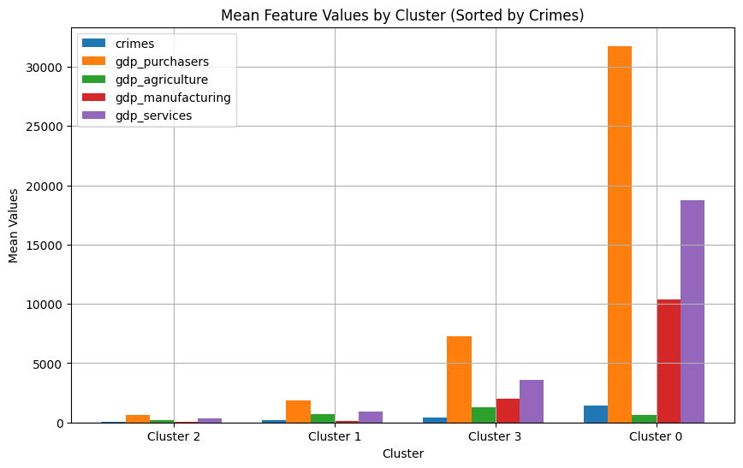
Figure 4.3: Clusters Interpretation for Agglomerative Clustering Model
Based on the insights, it was found that an average crime of 68.82, 170.61, 413.27, and 1396.02 are very low, low, high, and very high number of crimes for a district. These clusters of crime also show a trend of increasing gdp_purchasers which indicates that high crime clusters also have high gdp_purchasers. Hence, it might be better for the government of Malaysia to place crime fighting efforts in places with gdp_purchasers.

Discussion
The findings from both our regression and clustering analyses reveal several significant patterns in the relationship between GDP and crime rates across Malaysian districts. These results have important implications for both policymaking and our understanding of socioeconomic factors in crime prediction.

Predictive Power of Economic Indicators
The strong performance of our KNN regression model (R² ≈ 0.75) demonstrates that district-level GDP components serve as reliable predictors of crime rates. The exclusion of agricultural GDP without significant performance degradation suggests that crime patterns are more closely tied to urban and industrial economic activities. This aligns with classical criminological theories that link crime to urbanization and industrialization processes (Buhaug & Urdal, 2012). The high predictive power of manufacturing and services GDP particularly suggests that areas with concentrated economic activity may require proportionally increased security measures.
The superior performance of the KNN regressor over other models, including more complex ones like Random Forest, indicates that crime-GDP relationships may be fundamentally local in nature. This locality principle suggests that crime rates in a district are more similar to those in economically similar districts rather than following complex global patterns. This insight could be particularly valuable for police forces in newly industrializing areas, allowing them to learn from the experiences of economically similar districts.

Economic Development and Crime Clusters
Our clustering analysis revealed a striking pattern where higher crime clusters consistently corresponded with higher GDP levels. This finding challenges simplistic assumptions that economic development automatically leads to crime reduction. Instead, it suggests a more complex relationship where economic growth might create:
  - More criminal opportunities through increased commercial activity
  - Greater wealth disparities within districts
  - Higher population density and urbanization, which may facilitate certain types of crime
  - Increased reporting rates due to better institutional infrastructure
  - More complex social interactions and potential conflict points
The identification of four distinct crime-rate clusters (very low: ~69, low: ~171, high: ~413, very high: ~1,396) provides valuable benchmarks for policy makers to categorize and monitor district-level crime patterns. This clustering could help in resource allocation and in setting appropriate intervention thresholds. The substantial gap between the 'high' and 'very high' clusters (413 vs 1,396) suggests a possible tipping point in crime dynamics that warrants further investigation.

Policy Implications
Our findings suggest that economic development strategies should be accompanied by proportional investment in crime prevention. Districts experiencing rapid GDP growth, particularly in manufacturing and services sectors, may need preemptive strengthening of law enforcement resources. The strong predictive power of our model also suggests potential applications in:
- Early warning systems for crime rate changes based on economic indicators
- Resource allocation planning for law enforcement
- Development of targeted crime prevention strategies for high-GDP districts
- Integration of crime prevention into economic development planning
- Cross-district learning and best practice sharing based on economic similarities
The clear relationship between economic indicators and crime rates suggests that law enforcement agencies should establish stronger partnerships with economic planning bodies. This could involve:
1. Joint planning sessions for new industrial or commercial developments
2. Shared data systems for monitoring both economic and crime indicators
3. Collaborative risk assessment frameworks
4. Integrated response protocols for rapidly developing areas

Theoretical Implications and Model Interpretation
The success of our relatively simple KNN model in predicting crime rates has interesting theoretical implications. The fact that a distance-based algorithm performs well suggests that the relationship between economic factors and crime follows relatively stable patterns across similar districts. This challenges more complex theoretical models that posit highly nonlinear or chaotic relationships between economic development and crime.
The removal of agricultural GDP from the model without significant performance loss also provides interesting theoretical insights. This could indicate that:
1. Agricultural economic activity has fundamentally different social dynamics than manufacturing or services
2. The social organization of agricultural communities might provide natural crime prevention mechanisms
3. The relationship between economic activity and crime might be mediated by factors more prevalent in urban and industrial settings

Limitations and Future Research
Several limitations of our study should be acknowledged:
- The annual nature of our data may mask shorter-term fluctuations in both crime rates and GDP
- District-level aggregation might obscure more granular patterns at the neighborhood level
- The model doesn't account for specific types of crimes, which might have different relationships with economic indicators
- Potential reporting biases across districts with different economic development levels
- The absence of social and demographic control variables
- Limited ability to establish causal relationships despite strong correlations
Future research could address these limitations by:
- Incorporating more granular temporal and spatial data
- Disaggregating crime types to understand specific crime-economy relationships
- Including additional socioeconomic variables such as income inequality, unemployment rates, and demographic factors
- Expanding the analysis to include inter-district effects and spatial relationships
- Conducting comparative studies with other rapidly developing economies
- Investigating the mechanisms behind the agriculture-crime relationship
- Exploring the role of informal economies in crime patterns

Methodological Contributions
Our study demonstrates the effectiveness of combining supervised and unsupervised learning approaches in criminological research. The complementary insights from regression and clustering analyses provide a more nuanced understanding than either method alone could offer. The success of the KNN regressor, despite its known limitations with large datasets, suggests it may be particularly suitable for district-level analysis in countries with administrative divisions like Malaysia's.
The methodology developed in this study offers several innovations:
- Integration of economic sector-specific GDP data in crime prediction
- Development of a robust data preparation pipeline for combining crime and economic data
- Demonstration of effective feature selection through correlation analysis
- Validation of simple, interpretable models for complex socioeconomic phenomena

Conclusion
This project has successfully demonstrated the practical application of machine learning techniques to analyze and predict crime rates using GDP indicators across Malaysian districts. Through the implementation of both supervised and unsupervised learning approaches, we have developed effective tools for crime prediction and district classification.
The KNN regression model proved to be highly effective, achieving a strong predictive accuracy (R² ≈ 0.75) using district-level GDP components. A practical insight gained was that agricultural GDP could be excluded from the model without significant impact on performance, simplifying the data requirements for future implementations. The model's success suggests that districts with similar economic profiles tend to experience similar crime patterns, making it a valuable tool for law enforcement resource planning. This model could be implemented in years to come to predict the upcoming crime rate for next year when the GDP is reported for that district for this year, thereby enabling proactive preparation of crime fighting resources and interventions before the year starts.
Our clustering analysis successfully identified four distinct crime-rate categories:
- Very low: ~69 crimes
- Low: ~171 crimes
- High: ~413 crimes
- Very high: ~1,396 crimes
This classification system provides clear thresholds for categorizing districts and prioritizing interventions. The project revealed a consistent pattern where higher crime clusters corresponded with higher GDP levels, particularly in areas with high manufacturing and services activity.
Based on these findings, we recommend the following implementations:
- Deploy the KNN model as an early warning system to predict crime rate changes based on GDP indicators
- Use the clustering system to categorize districts and allocate resources appropriately
- Establish coordination between economic planning and law enforcement agencies
- Focus crime prevention efforts in areas with high GDP from manufacturing and services
- Implement district-to-district learning programs based on economic similarities
The project could be enhanced in future iterations by:
- Including more frequent data updates rather than annual data
- Adding neighbourhood-level analysis
- Incorporating different types of crimes
- Adding social and demographic variables to the model
- Expanding the analysis to include inter-district relationships
The methods developed in this project can be readily implemented in other districts or scaled to other regions with similar administrative structures. The success of our straightforward modelling approach shows that practical, effective crime prediction tools don't need to be overly complex to deliver valuable results.
This project provides law enforcement and economic planning agencies with concrete tools and insights for evidence-based decision-making in crime prevention and resource allocation. The findings can be immediately applied to improve public safety strategies while considering economic development patterns.

References

Annual Real GDP by District & Economic Sector. (2025, 1 9). Retrieved from OpenDOSM: https://open.dosm.gov.my/data-catalogue/gdp_district_real_supply
Crimes by District & Crime Type. (2025, 1 9). Retrieved from OpenDOSM: https://open.dosm.gov.my/data-catalogue/crime_district
Leamer, E. (2009). Gross Domestic Product. Macroeconomic Patterns and Stories, 19–38. https://doi.org/10.1007/978-3-540-46389-4_2
Yeong, A. (2023). Stats Dept launches open data portal OpenDOSM, aims to spur good policies. Malay Mail ; Malay Mail. https://www.malaymail.com/news/malaysia/2023/01/12/stats-dept-launches-open-data-portal-opendosm-aims-to-spur-good-policies/49836
Khan, Q. W., Department of Computer Engineering, Jeju National University, Jejusi 63243, Jeju Special Self-Governing Province, Republic of Korea, & Qazi Waqas Khan. (2024). Monitoring The Impact of Social Factors on Crime using Machine Learning. Journal of Electronics Science and Electrical Research, 01–09. https://www.mkscienceset.com
Bharath, R. R., H. Kaif Sulthan, R. Mohamed Mingaz, & S. Nirmal Kumaravengatesh. (2024). A MACHINE LEARNING APPROACH TO CRIME ANALYSIS AND FORECASTING FOR PREDICTION AND PREVENTION [Article]. Afr.J.Bio.Sc., 6–6(Si2), 1300–1313. https://www.afjbs.com/uploads/paper/f46fefba0bc11911f6e5dc4cbb359ba8.pdf
D, Y., P, B., M, H., P, M., & Velalar College of Engineering and Technology. (2024). Crime Prediction and Forecasting Using MLP & K-Means Clustering Algorithm [Research Article]. International Journal of Multidisciplinary Research in Science, Engineering and Technology, 7(5). https://doi.org/10.15680/IJMRSET.2024.0705050
Orong, M. Y., Sison, A. M., & Hernandez, A. A. (2018). Mitigating vulnerabilities through forecasting and crime trend analysis. 2022 7th International Conference on Business and Industrial Research (ICBIR), 57–62. https://doi.org/10.1109/icbir.2018.8391166
Tayal, D. K., Jain, A., Arora, S., Agarwal, S., Gupta, T., & Tyagi, N. (2014). Crime detection and criminal identification in India using data mining techniques. AI & Society, 30(1), 117–127. https://doi.org/10.1007/s00146-014-0539-6
Mittal, M., Goyal, L. M., Sethi, J. K., & Hemanth, D. J. (2018). Monitoring the Impact of Economic Crisis on Crime in India Using Machine Learning. Computational Economics, 53(4), 1467–1485. https://doi.org/10.1007/s10614-018-9821-x
Buhaug, H., & Urdal, H. (2012). An urbanization bomb? Population growth and social disorder in cities. Global Environmental Change, 23(1), 1–10. https://doi.org/10.1016/j.gloenvcha.2012.10.016

Appendix

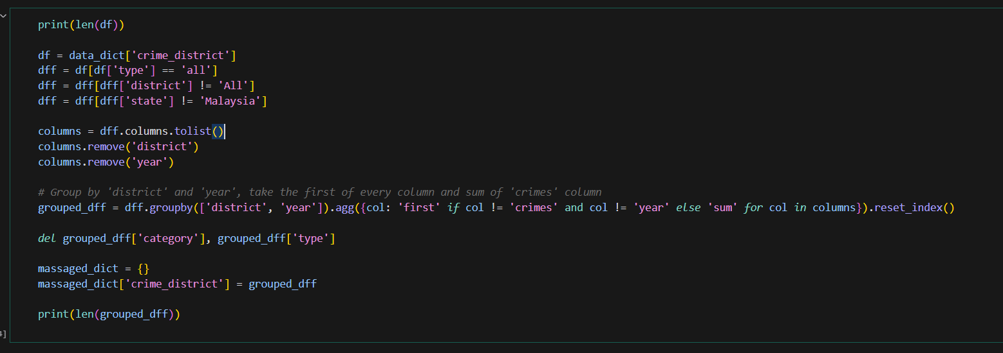
Python Code to Massage Crime Data

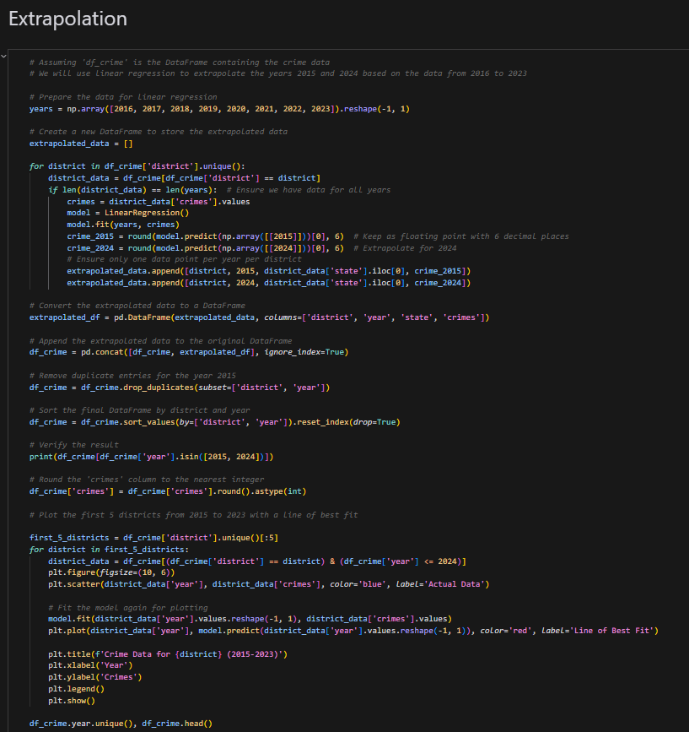
Python Code for Extrapolation for Missing Values in Crime Data
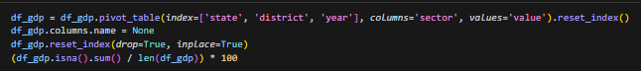
Python Code to Massage GDP Data

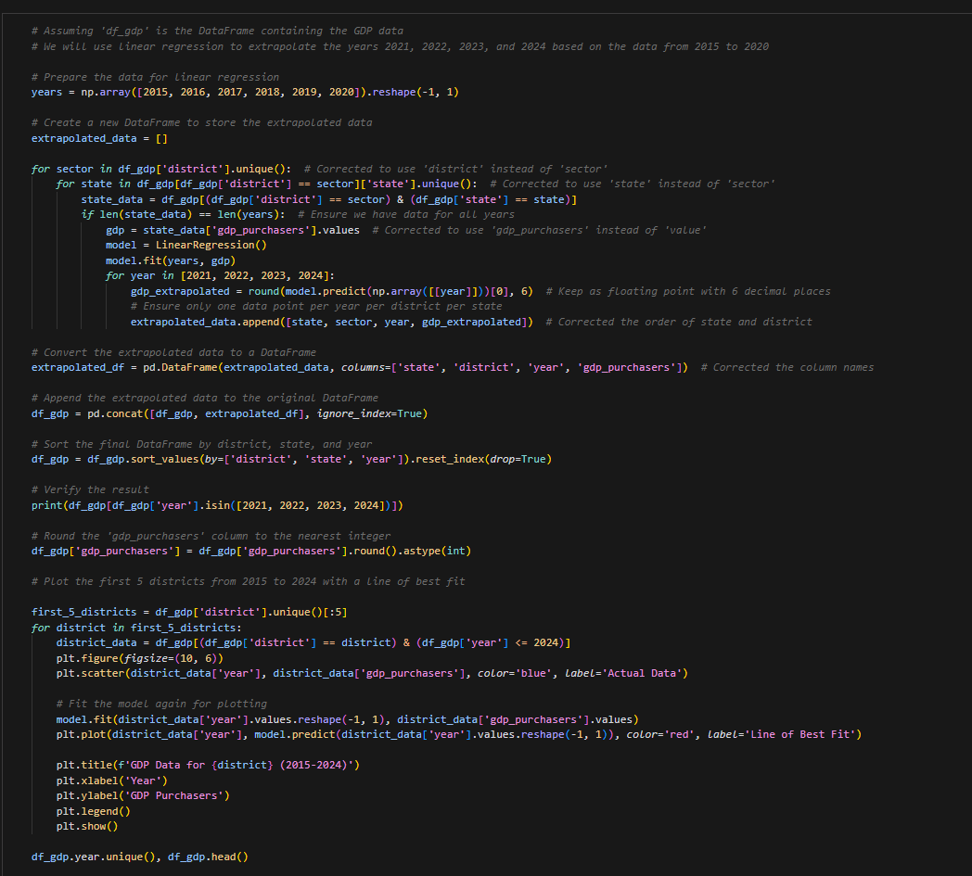
Python Code for Extrapolation of Missing Values in GDP Data

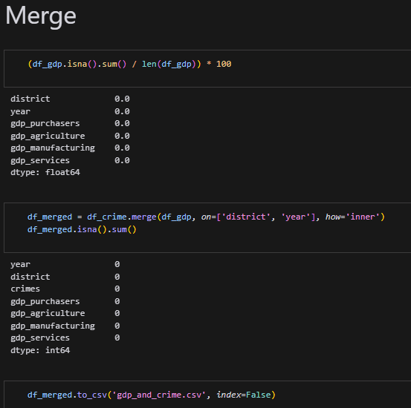
Python Code to Merge the Massaged Crime and GDP Data into a single Dataset

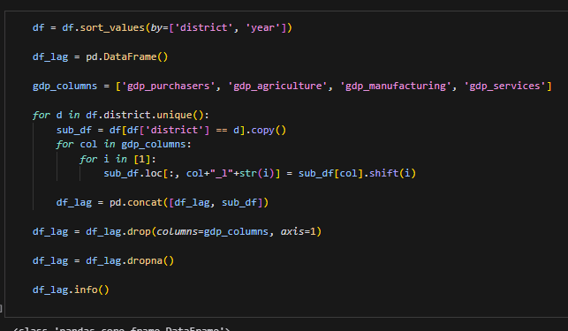
Python Code to Lag the Features by a Year for each District

