State-of-the-art analysis of the application of machine learning approaches in fire and safety Engineering.
Asad Yousaf Parhyar
Supervisor(s): Ruben Van Coile,

Abstract- In this thesis different machine learning applications have been explored and compared in the field of fire safety engineering. Initially basic machine learning techniques used in the literature are studied and the results for the subset of the datasets have been reproduced. Afterwards a comprehensive analysis of different classical machine learning techniques has been performed and comprehensive results have been reported. During the analysis it has been found that ensemble machine learning techniques have better performance and low variance for the case datasets and therefore the same can be used as an excellent candidate for the regression modelling of the datasets.
Keywords-fire and safety, machine learning, regression, surrogate

Introduction
We are leaving in an era of new industrial evolution, and therefore traditional techniques have been replaced with the AI-based advance techniques.
Just like all other fields fire and safety domain also have classical and advanced algorithms for the analysis and in time correction of the systems or architectures.
The advance method of ML encompasses new sets of computational techniques that heavily rely on machines to mimic human -like realization such as generalization, discovery, association, and abstraction. Such advance ability of ML methods able to solve problem in which there is a large amount of variable and there is unclear relationship between variables and expected outcome. This is a common problem in various branches of engineering. To find such relationship ML method use revolutionary algorithm to predict concealed patterns in a data set. Once a pattern is discovered, this pattern is further exploited to identify its governing parameters [1].
There are several papers published in the same domain and some of the relevant papers have been discussed in this report.
M.Z. Naser [2], published an article mechanistically informed machine learning and artificial intelligence in fire safety journal. This paper shows the current state of art machine learning methods used to solved FSE problems. This is the only paper available during this research which specify state of the art of machine learning approaches in fire safety engineering. However, there are number of articles published for a specific application of ML method to a specific problem of FSE such as detection of fire through image and video and fire resistance of structure.
The current-state-of-the-art technique such as fire dynamic simulator (FDS) is used in fire protection engineering to predict complex flow fields inside a compartment. The prediction of flow field has been used for designing a smoke and heat control system or to predict sprinkler activation time. FDS solves the conservation equation of mass, momentum, and energy. FDS model highly depended on true input properties of model variable which is hard to obtained. fire dynamics are highly nonlinear phenomena and the CFD technique is cost-prohibitive and often required a large time to predict flow filed in case of a large structure or parametric study. To remove such limitations of the CFD technique another advanced method has been introduced such as the machine learning technique which enabled scientists to develop a data-driven model to predict complex flow field [3] [4] [5][6].
Same researcher has published another study [7] for rapid high-fidelity prediction of fire to support fire hazard assessment. This study used another type of machine learning algorithm such as dimensionality reduction (reduce order model) and deep learning with neural network. The result of this study shows that machine learning can provide full field prediction 2 – 3 orders of magnitude faster than CFD simulation. likewise, another study has published [8] for prediction of velocity and temperature profile in a single compartment fire with improved neural network model.

Development of surrogate model
The literature review of machine learning application in fire safety engineering has been discussed in the previous section which highlights the potential and merit of adopting machine learning algorithms to solve the FSE problem. This section discusses the development of a regression-based surrogate modeling to solve structural fire engineering problems through probabilistic fire analysis of structure. Furthermore, a recently published study [9] has been recalculated and analyzed the result of the developed surrogate model. In addition to that a comparative analysis of different classical machine learning algorithms has been performed and reported.

Analysis of the already available surrogate models
The published work [55], shows a polynomial order of degree 2 has higher accuracy while this study shows the polynomial degree of 3 has higher accuracy. The difference of polynomial degree is occurred due to different testing sample has been used. However, there is no significant improvement for the surrogate model with higher-order m > 3 is observed during this study. Therefore, a 3rd-degree polynomial is adopted as the surrogate model hypothesis for the fire-exposed RC slab depicted in figure 1.

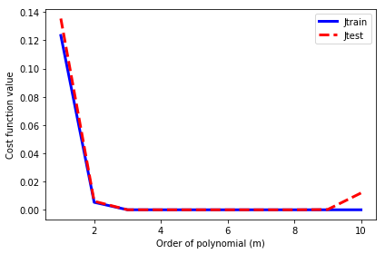
Figure 1: Order of polynomial vs cost function plot
The remaining hyperparameter such as the number of a training sample points, and regularization factor has been shown in Figures 2 and 3. This study shows that the optimum value of the number of required samples is 1600 which produces a converged value of cost function. Similarly, the optimum value of the regularization parameter is 0 where the minimum value of the cost function has been observed. further increase of the regularization parameter increases the value of the cost function. The analysis of the obtained result revealed that the regularization parameter does not influence the developed surrogate model and could be neglected, and furthermore linear regression model seem to be accurate to describe given data set.
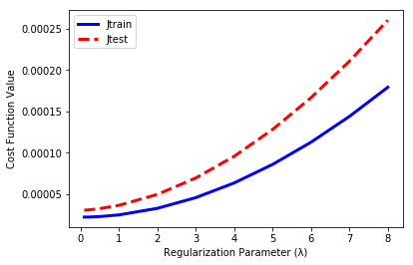
Figure 2: Regularization parameter vs cost function
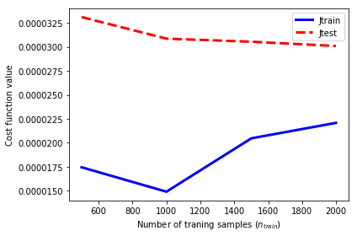
Figure 3: Number of training sample vs cost function value
The performance of the developed surrogate model is depicted in Figures 4 for the published and current study.

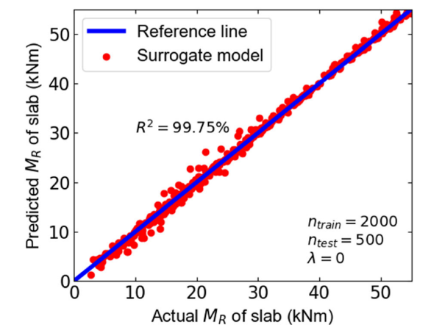
(a): Research paper results
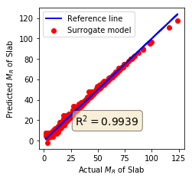
(b): Reproduced results
Figure 4: Correlation analysis for surrogate model

Comparative analysis of different regression algorithms
From the feature analysis it has been found that in spite to time there is no-linear relationship between any other feature and the prediction variable Y=Load. Therefore, a wide-range of regression has to be explored to get the optimal robust regression-model for the design and then the same can be optimized for the dataset.
The comparative analysis for the different algorithms is reported in Table 1. The best two values for each performance metrics are reported in bold. It can be noted from the analysis that ensemble learning method light gradient boosting has the best results in majority of the cases and so can be considered as an optimal candidate for the advanced non-linear fire and safety and load analysis problem.
It is pertinent to mention here that a detailed feature analysis for the problem has been performed using GAIN and split for LGBM and famous shap method after the analysis it has been found that time espckfc and nodeline-Y are the best features for the dataset.

Table 1: Comparative Analysis of Different Regression algorithm for advanced fire and safety dataset
Regression  Algorithm | RMSE | MAE |  | Spearman | Kindall
Multi-Linear | 1.036758 | 0.847117 | 0.801184 | 0.904038 | 0.904038
XGBOOST  Gradient-Boosting | 0.584425 | 0.450628 | 0.936824 | 0.971922 | 0.855835
Random  Forest | 0.692961 | 0.548095 | 0.911179 | 0.955167 | 0.812871
MLP | 0.38071 | 0.249973 | 0.973191 | 0.973191 | 0.9169
Linear-SVR | 1.011218 | 0.827174 | 0.810858 | 0.909594 | 0.735195
Polynomial-SVR  Degree=3 | 1.197227 | 0.96423 | 0.734875 | 0.882777 | 0.696033
RBF SVR | 0.442847 | 0.293327 | 0.963725 | 0.981847 | 0.898459
Sigmoid SVR | 0.442847 | 0.293327 | 0.963725 | 0.963725 | 0.898459
K-Nearest  Neighbour | 1.086605 | 0.852119 | 0.781606 | 0.905994 | 0.736503
Polynomial  Regression  Degree=2 | 0.730081 | 0.565238 | 0.901409 | 0.950893 | 0.817934
Polynomial  Regression  Degree=3 | 0.56723 | 0.427517 | 0.940486 | 0.972855 | 0.862703
Polynomial  Regression  Degree=4 | 0.862703 | 0.370187 | 0.951654 | 0.978934 | 0.881167
Light Gradient Boosting | 0.364145 | 0.27134 | 0.975473 | 0.989395 | 0.912025

The correlation analysis for the LGBM model is reported in Figure 5. It can be noted that the value of R² is 0.98 which is significantly higher.

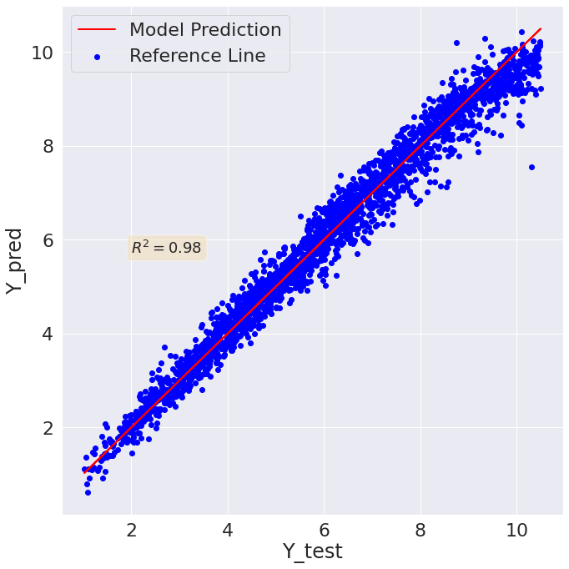
Figure 5: Correlation analysis for the light gradient boosting model

Conclusion
In this paper all of the state-of-the art machine learning techniques for the fire and safety problems have been explored analyzed and reported. Different classical machine learning algorithms have been explored, trained, tested and result have been reported in a comprehensive way. In addition to that in depth feature analysis using Pearson, Spearman, and Kindall correlation analysis has been performed and reported. Similarly, features sensitivity and selection analysis has been performed using LGBM and shap method. After the complete analysis it has been found that LGBM is the best model and time, epskfc, and nodline_Y are the best features for the model.

References
- M. Z. Naser, “AI-based cognitive framework for evaluating response of concrete structures in extreme conditions,” Eng. Appl. Artif. Intell., vol. 81, no. February, pp. 437–449, 2019, doi: 10.1016/j.engappai.2019.03.004.
- M. Z. Naser, Mechanistically Informed Machine Learning and Artificial Intelligence in Fire Engineering and Sciences. Springer US, 2021.
- J. Lee, S. Lee, and D. You, “Deep learning approach in multi-scale prediction of turbulent mixing-layer,” arXiv, pp. 1–21, 2018.
- T. P. Miyanawala and R. K. Jaimana, “An efficient deep learning technique for the Navier-Stokes equations: Application to unsteady wake flow dynamics,” arXiv, 2017.
- S. Lee and D. You, “Data-driven prediction of unsteady flow over a circular cylinder using deep learning,” J. Fluid Mech., vol. 879, no. Schmid 2010, pp. 217–254, 2019, doi: 10.1017/jfm.2019.700.
- C. W. Chang and N. T. Dinh, “Classification of machine learning frameworks for data-driven thermal fluid models,” Int. J. Therm. Sci., vol. 135, pp. 559–579, 2019, doi: 10.1016/j.ijthermalsci.2018.09.002.
- B. Y. Lattimer, J. L. Hodges, and A. M. Lattimer, “Using machine learning in physics-based simulation of fire,” Fire Saf. J., vol. 114, no. July, 2020, doi: 10.1016/j.firesaf.2020.102991.
- R. K. K. Yuen, E. W. M. Lee, S. M. Lo, and G. H. Yeoh, “Prediction of temperature and velocity profiles in a single compartment fire by an improved neural network analysis,” Fire Saf. J., vol. 41, no. 6, pp. 478–485, 2006, doi: 10.1016/j.firesaf.2006.03.003.
- R. K. Chaudhary, R. Van Coile, and T. Gernay, “Potential of Surrogate Modelling for Probabilistic Fire Analysis of Structures,” Fire Technol., 2021, doi: 10.1007/s10694-021-01126-w.

 

