On-Device Houseplant Species Classification with MobileNetV1 on Arduino Nano 33 BLE Sense

Asaf J Iron-Jobes

EE446 TinyML for Ultra Low-Power Edge Computing
Spring 2026

A six-class houseplant species classifier running entirely on-device on an Arduino Nano 33 BLE Sense, with no cloud or network dependency.

2. Team Member Contributions
This is a solo project. I built the data collection pipeline, data cleaning system, training architecture and code, compression pipeline, firmware, and host dashboard software. Python and TensorFlow were used throughout to maintain full control over design details and to practice an industry-relevant ML workflow. I performed all manual testing of the deployed system and designed the serial communication protocol between the Arduino and the host dashboard on my Mac.

3. Introduction and Project Objective
The problem and why it suits TinyML. At face value, identifying a houseplant species is a low-stakes task. The motivation comes instead from how this problem is usually solved today. Most plant-identification mobile apps require a paid subscription and a live internet connection, sending each photo to a server for inference. The goal of this project is a TinyML alternative that runs entirely on a microcontroller, so it is free, fully offline, and low-power. These three properties are exactly what TinyML provides, and each one matters in a realistic deployment.
A more capable version of this classifier could support field research in remote areas such as the Amazon rainforest. In that setting the offline capability is the critical feature, because inference must work with no connectivity and on battery power for extended periods.
A closer-to-home application is a self-caring smart planter. It would use a planter with an embedded MCU that automatically identifies the species it was planted with, looks up its care profile (water, light, fertilizer) from an on-device database, and drives a simple actuation system to water and tend the plant. Here both the low-power and offline properties make the device essentially set and forget, with no app, account, or network setup required.
This project is a proof-of-concept for that class of device: on-device, real-time houseplant classification with no cloud dependency.
Project goal, input/output, and target deployment. The system classifies a houseplant into one of six species chosen from plants available at home. The input is a live RGB image stream from an Arducam OV7675 camera. The output is the predicted species and a per-class confidence, produced entirely on-device. The target deployment platform is the Arduino Nano 33 BLE Sense (Nordic nRF52840, 256 KB RAM and 1 MB flash), with the model running under TensorFlow Lite for Microcontrollers and results streamed over serial to a live local dashboard. No network, server, or cloud inference is used at any point.
Success criteria. The project is considered successful if it meets three conditions. First, it runs the full capture, inference, and display loop on the Nano 33 BLE Sense in real time. Second, it fits within the device's memory budget, keeping the model and tensor arena within the 256 KB RAM and 1 MB flash limits. Third, it correctly identifies the six species on live camera frames at the demo, rather than only on held-out Python test data. Usability, meaning an immediate offline on-device prediction with no connectivity, is treated as a first-class goal alongside accuracy.

4. Dataset and experimental setup
Dataset source, sensor, classes, and collection. The task is a six-class image classification problem over six houseplant species: Aloe Vera, Asparagus Fern, Dumb Cane, Jade Plant, Money Tree, and Snake Plant. These species were chosen because all six were available at home, which made it possible to collect real photos and on-device camera data for each one. Three sources of data were used. The first is the public Kaggle "House Plant Species" image dataset, which provides the bulk of the training images (2,070 images across the six classes). The second is a set of phone photos that I took of my own plants (18 per class, 108 total), captured with a smartphone camera under typical indoor lighting. The third is camera data captured directly on the target hardware using the Arducam OV7675 module on the Arduino Nano 33 BLE Sense (100 images per class, 600 total). The OV7675 is a 0.3 MP CMOS sensor, and these frames are representative of what the model actually sees at deployment time: low resolution, indoor lighting, and short working distance.

Preprocessing, normalization, and augmentation. All images are converted to RGB and resized to a fixed 96 by 96 input. Because the phone photos carried EXIF orientation metadata that the training pipeline does not honor automatically, each image is passed through an EXIF transpose step during preparation so that it is stored upright; without this, several classes were fed in sideways and the model trained near chance. Files in mixed or hidden formats (WebP and MPO disguised as .jpg) are normalized to standard JPEG during the same pass. Pixel values are scaled into the range expected by the MobileNet backbone. Training-time augmentation includes standard geometric and photometric transforms (random flips, rotation, zoom, and brightness or contrast jitter). For the on-device fine-tuning stage, an additional "degrade" augmentation is applied probabilistically to roughly half of the samples to simulate OV7675 sensor characteristics (lower effective resolution, noise, and color shift), so the general-data model is pushed toward the look of the real camera. Labels are taken directly from the class folder names and encoded as integer class indices.

Train, validation, and test splits and leakage avoidance. The main dataset is split per class into 70 percent train, 15 percent validation, and 15 percent test (1,521 / 324 / 333). The Arduino camera dataset is split per class into 80 percent train, 10 percent validation, and 10 percent test (480 / 60 / 60). All splitting is done at the file level with a fixed random seed so the splits are reproducible, and the source folder of original images is never modified during preparation; the pipeline only ever copies out of it. To avoid data leakage, the splits are disjoint by file, augmentation is applied only after splitting (so no augmented copy of a test image can appear in training), and the validation and test sets are held out and never used for gradient updates. The one honest limitation is in the Arduino set: the 100 images per class were captured in the same sessions, so the camera test frames are correlated with the camera training frames. The camera test accuracy should therefore be read as optimistic, and the live demo is treated as the true measure of real-world performance.

Onboard-sensor data: collection and use. The Arduino camera data was collected through a dedicated capture pipeline that I wrote for this project. The Nano 33 BLE Sense runs a capture sketch that drives the OV7675, and on a request from a host-side Python script it returns one raw RGB565 frame over serial, framed with a magic-byte header for synchronization. The host script decodes the frame and saves it as an image, letting me build a labeled on-device dataset one species at a time. This onboard data is used in two ways. It serves as a dedicated camera test set to measure how the model performs on real sensor frames rather than only on clean Kaggle images, and it drives a second, environment-specific fine-tuning stage in which the model trained on the general data is adapted to the OV7675 domain. This directly satisfies the advanced component of fine-tuning a model using data collected from the target hardware, and the comparison of general-data versus camera-fine-tuned performance is reported in the results section.

5. Model development and advanced components
Big ML models trained offline. The core model is a convolutional neural network built on a MobileNetV1 backbone (width multiplier alpha = 0.25) pretrained on ImageNet, with a custom classification head (global average pooling, dropout 0.3, and a 6-way softmax dense layer). Input is 96x96 RGB. This single architecture is trained in three offline stages: a head-only stage on the general dataset, a backbone fine-tune stage, and an arducam domain-specialization stage. The fully-trained float Keras model is the "big" model, reaching 81.7 percent accuracy on the arducam test set and 69.4 percent on the general (Kaggle plus phone) test set. MobileNetV2 and V3 were also considered as alternatives but rejected before training for memory reasons (see the justification below), so the report compares them by analysis rather than by a separately trained model.
TinyML-ready models. The deployed model is a full-integer INT8 version of the trained network, produced by post-training quantization (PTQ) in TensorFlow Lite. All weights and activations are quantized to int8, and the input and output tensors are kept int8 to match the camera and the microcontroller. Calibration uses a representative dataset of arducam frames so the quantization ranges match the deployment camera. This compresses the model from 849 KB (float) to 303 KB (int8), a 2.8x reduction, while preserving arducam test accuracy exactly at 81.7 percent and slightly improving general test accuracy (69.4 to 71.5 percent). The int8 model is exported to a C header and run on-device under TensorFlow Lite for Microcontrollers.
Advanced components. The project includes two of the listed advanced components. First, fine-tuning on onboard-sensor data: the model is fine-tuned on images captured through the OV7675 camera on the target board, adapting it from clean internet photos to the real deployment domain. This stage uses layer freezing, a low learning rate, early stopping on the arducam validation set, and rehearsal (mixing a fraction of general data into each batch) to specialize without forgetting the general features. Second, a communication method beyond the Serial Monitor: inference results are streamed over serial to a live local dashboard that shows the predicted species, per-class confidence bars, and a reconstructed view of the model's input frame. Post-training quantization is a third compression component.
Training details. Loss is sparse categorical cross-entropy and the optimizer is Adam throughout. The schedule is: Stage 1 (head only, backbone frozen) at learning rate 1e-3 for up to 18 epochs; Stage 2 (top 30 backbone layers unfrozen) at 1e-5 for up to 10 epochs; Stage 3 (arducam specialization, top 20 layers unfrozen, rehearsal weight 0.25) at 1e-4 for up to 30 epochs. Batch size is 32. Early stopping is used in every stage (patience 4 on validation loss for the main stages, patience 6 on arducam validation accuracy for specialization, restoring the best weights). Class weighting handles the imbalance in the general dataset, and augmentation includes flips, light photometric jitter, and a probabilistic "degrade" transform that simulates OV7675 sensor characteristics. Software: TensorFlow and Keras for training, TensorFlow Lite for quantization and conversion, with NumPy and Pillow for data handling.
Why the deployed model was selected. The deployed INT8 MobileNetV1 was chosen over the float model and the V2/V3 alternatives mainly for fit on the hardware. MobileNetV1 fits within the 256 KB RAM budget while V2 and V3 do not (see section 8 for the memory analysis). INT8 was chosen over the float model because PTQ shrank the model 2.8x with no loss in arducam accuracy, making it both smaller in flash and faster, while remaining accurate on the deployment domain. The result is the smallest, fastest variant that meets the accuracy goal and fits the device's memory budget.

6. TinyML system design and deployment
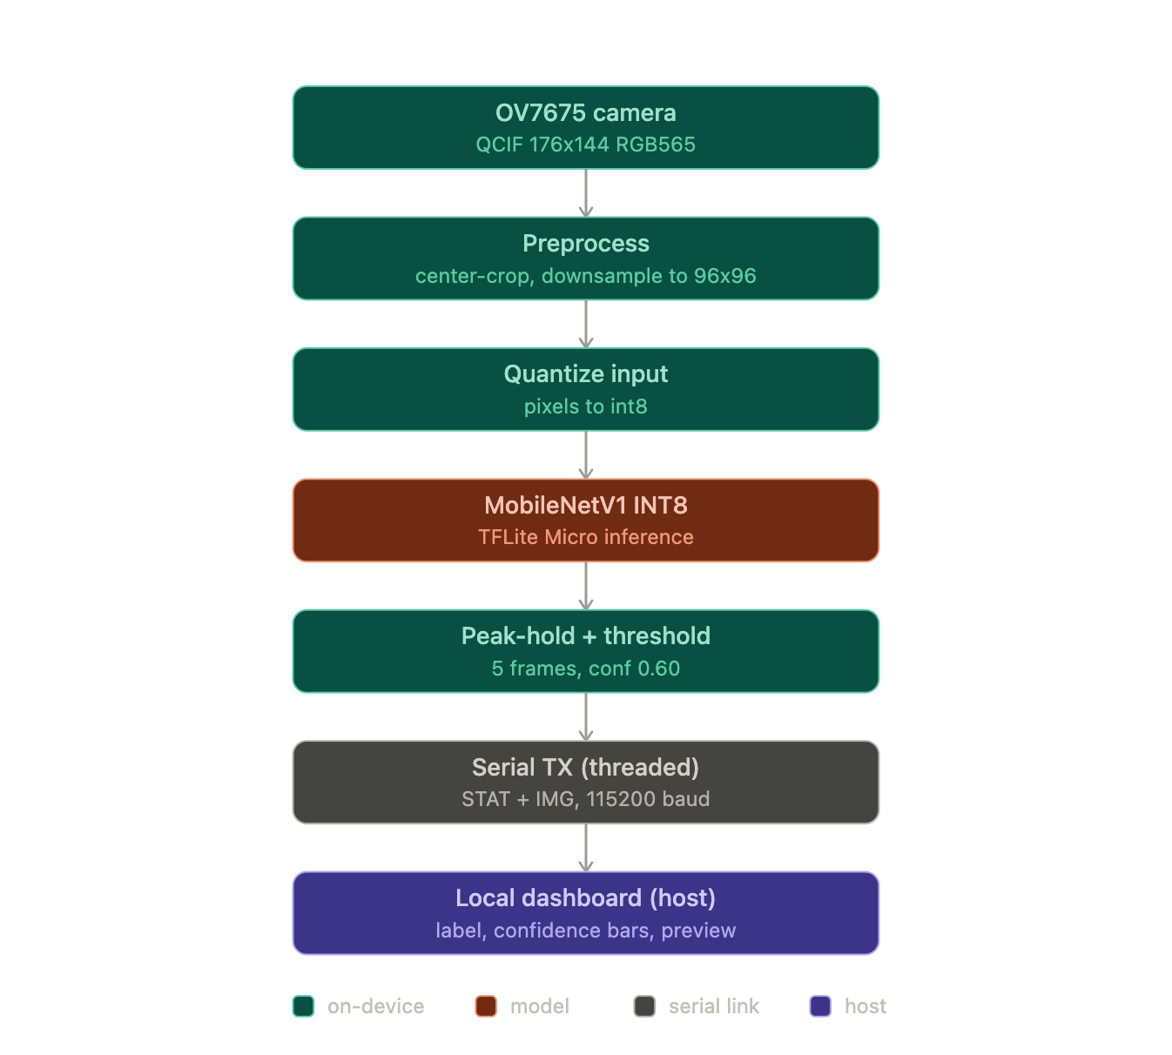
System pipeline. Each frame flows through a fixed pipeline on the Arduino. The OV7675 camera captures a QCIF (176x144) RGB565 frame. The frame is center-cropped to a square and downsampled to 96x96, then each pixel is quantized to int8 using the model's input scale and zero point. The INT8 MobileNetV1 runs under TensorFlow Lite for Microcontrollers and produces six softmax scores. A 5-frame peak-hold plus a 0.60 confidence threshold smooth the output and suppress low-confidence frames, after which the result and a downsampled preview of the model's input are streamed over serial to a local dashboard. The diagram below shows the full path from sensor to display.
[FIGURE PLACEHOLDER: Figure 1 (system diagram) -- Full pipeline from OV7675 capture to serial dashboard. Insert system diagram here.]
[FIGURE PLACEHOLDER: Figure 1 (system diagram) -- Full pipeline from OV7675 capture to serial dashboard. Insert system diagram here.]

Model conversion for deployment. The trained Keras model is converted to a full-integer INT8 TensorFlow Lite model with post-training quantization, using a representative dataset of arducam frames for calibration and keeping the input and output tensors int8. The resulting .tflite file is turned into a C source array with xxd -i and stored as model_int8.h. The array is marked alignas(16) const so it is placed in flash rather than RAM (an early bug placed it in RAM and broke the link). On the Arduino, the model is loaded with tflite::GetModel, and the needed operators are registered explicitly through a MicroMutableOpResolver holding eight ops (Conv2D, DepthwiseConv2D, FullyConnected, Add, Mul, Mean, Pad, and Softmax) rather than the full op set, which keeps the firmware small. A MicroInterpreter then calls AllocateTensors over a statically reserved tensor arena, and Invoke runs inference each frame. The build uses the Arduino_TensorFlowLite library on the Arduino Mbed OS Nano core.

Deployment constraints. The deployed INT8 model is 303 KB in flash (down from 849 KB float). The tensor arena reserves 112 KB and uses 100.4 KB as measured on-device by arena_used_bytes() at boot. This is the dominant RAM cost and fits within the Nano 33 BLE Sense's 256 KB of RAM, leaving room for the camera frame buffer, the preview buffer, and the TX thread's stack. MobileNetV1 was required because V2 and V3 exceed the RAM limit at 96x96 input (see section 8). Host-side inference latency is about 0.15 ms per frame for the INT8 model versus 0.28 ms for the float model, confirming the INT8 model is both smaller and faster; true on-device latency is bounded in practice by camera read and serial TX rather than by Invoke.

On-device inference evidence. On-device results are shown through a live local dashboard rather than only the Serial Monitor. Demo video (far more than 10 examples): [PLACEHOLDER: insert demo video URL here]. A board and camera photo is shown below. [FIGURE PLACEHOLDER: Figure 1 -- Photo of Arduino Nano 33 BLE Sense with Arducam OV7675 module. Insert here.]

Communication method and data format. Inference results are transmitted over USB serial at 115200 baud in a simple two-message protocol consumed by a Python (matplotlib) dashboard. A STAT line carries the smoothed result and the six per-class confidences as text: STAT <idx> <conf> <c0..c5>, where idx is the peak-hold class index or -1 when below threshold. An IMG message carries the model's-eye preview: a header IMG 96 96, a 4-byte magic marker 0x55AA55AA for resynchronization, then 96x96 RGB565 pixels. The dashboard parses these to display the predicted species and confidence, with a green bar on the detected class, and renders the preview image so the operator sees exactly what the model sees. To keep the interface smooth, the firmware uses two Mbed RTOS threads: the main thread captures and runs inference while a dedicated TX thread streams serial, with two semaphores pipelining them so transmission of one frame overlaps capture and inference of the next.

7. Results and analysis
Evaluation metrics. Accuracy and macro-averaged F1 score are reported for all conditions. The six-class distribution is balanced across the main test set and approximately balanced across the arducam test set, so accuracy is a meaningful primary metric. Macro-F1 is included because it weights each class equally regardless of count and catches any per-class imbalance in precision or recall that accuracy could mask.

Big-model vs. TinyML comparison. The table below compares the float (big) model and the INT8 (TinyML) model on both test sets.
Metric | Float model | INT8 model
Arducam test accuracy | 81.67% | 81.67%
Arducam macro-F1 | 0.816 | 0.814
Main test accuracy | 69.37% | 71.47%
Main macro-F1 | 0.690 | 0.715
Flash size | 849 KB | 303 KB
Size reduction vs. float | -- | 2.8x smaller
Tensor arena (used / reserved) | n/a | 100.4 KB / 112 KB
Host inference latency (estimate) | ~0.28 ms | ~0.15 ms
Table 1. Float vs. INT8 model comparison. Host latency is a Python-side estimate; on-device latency is dominated by camera capture and serial TX, not by model Invoke.

Per-class metrics. The tables below report precision, recall, and F1 for each class for both the float and INT8 models on both test sets. [PLACEHOLDER: insert per-class metrics tables from results/RESULTS.md in the project repository.]

Confusion matrices. Figures 2 through 5 show the normalized confusion matrices for the four conditions (float/arducam, float/main, INT8/arducam, INT8/main).
[FIGURE PLACEHOLDER: Figure 2 -- Float model, arducam test set confusion matrix. Insert figure from results/RESULTS.md.]
[FIGURE PLACEHOLDER: Figure 3 -- Float model, main test set confusion matrix. Insert figure from results/RESULTS.md.]
[FIGURE PLACEHOLDER: Figure 4 -- INT8 model, arducam test set confusion matrix. Insert figure from results/RESULTS.md.]
[FIGURE PLACEHOLDER: Figure 5 -- INT8 model, main test set confusion matrix. Insert figure from results/RESULTS.md.]

[FIGURE PLACEHOLDER: Figure 6 -- Dashboard screenshot showing live prediction, per-class confidence bars, and reconstructed model-input preview frame. Insert screenshot here.]

Deployment resources. Table 2 summarizes the flash, RAM, and latency costs for both model variants on the Arduino Nano 33 BLE Sense.
Resource | Float model | INT8 model
Flash (model size) | 849 KB | 303 KB
Tensor arena reserved | n/a | 112 KB
Tensor arena used (arena_used_bytes) | n/a | 100.4 KB
Host inference latency (estimate) | ~0.28 ms | ~0.15 ms
On-device inference latency | n/a (not deployed) | Bounded by camera + serial TX
Table 2. Deployment resource summary. Host latency is a Python-side estimate; on-device latency is not directly measured and is bounded by camera read and serial TX.

On-device inference evidence. Table 3 records 10 representative inference events observed during the live demo. Evidence column references the demo video at [PLACEHOLDER: insert demo video URL]. For the full set of on-device results, see the demo video (far more than 10 examples are shown).
Instance | Input (species held to camera) | Expected | Predicted | Correct | Evidence (video timestamp)
1 | Aloe Vera | Aloe Vera | [fill from demo] | [Y/N] | [PLACEHOLDER: timestamp]
2 | Asparagus Fern | Asparagus Fern | [fill from demo] | [Y/N] | [PLACEHOLDER: timestamp]
3 | Dumb Cane | Dumb Cane | [fill from demo] | [Y/N] | [PLACEHOLDER: timestamp]
4 | Jade Plant | Jade Plant | [fill from demo] | [Y/N] | [PLACEHOLDER: timestamp]
5 | Money Tree | Money Tree | [fill from demo] | [Y/N] | [PLACEHOLDER: timestamp]
6 | Snake Plant | Snake Plant | [fill from demo] | [Y/N] | [PLACEHOLDER: timestamp]
7 | Aloe Vera | Aloe Vera | [fill from demo] | [Y/N] | [PLACEHOLDER: timestamp]
8 | Dumb Cane | Dumb Cane | [fill from demo] | [Y/N] | [PLACEHOLDER: timestamp]
9 | Money Tree | Money Tree | [fill from demo] | [Y/N] | [PLACEHOLDER: timestamp]
10 | Snake Plant | Snake Plant | [fill from demo] | [Y/N] | [PLACEHOLDER: timestamp]
Table 3. On-device inference evidence. Predicted class and correctness to be filled in from the demo video. [PLACEHOLDER: insert demo video URL and fill predicted/correct columns from video timestamps.]

Analysis and key findings. The INT8 model matches the float model on arducam accuracy (81.67% on both) and slightly outperforms it on the main test set (71.47% vs. 69.37%), confirming that full-integer quantization introduces no meaningful accuracy degradation for this task. The 2.8x flash reduction (849 KB to 303 KB) is a direct result of INT8 post-training quantization and is the primary reason the model fits within the 1 MB flash budget. The arducam-specialized fine-tuning stage accounts for the difference between main-set and arducam-set accuracy (the arducam accuracy is higher because the model was specifically adapted to OV7675 image characteristics). Per-class results and confusion matrices are provided above; classes with lower recall tend to be visually similar pairs (for example, Money Tree and Jade Plant both have round succulent leaves).

8. Challenges, limitations, and future work
Challenges. Two design decisions were forced by the memory budget of the Arduino Nano 33 BLE Sense. The first is the 96x96 input resolution. The 256 KB RAM ceiling prevents using a larger input, which means the model sees a coarser, lower-detail view of each plant than a phone camera would provide. Training on clean, high-resolution Kaggle images under this constraint produced a model that generalized poorly to the blurry, noisy OV7675 sensor output. The solution was to collect dedicated on-device camera data and add a domain-specialization fine-tuning stage; without it, arducam test accuracy was significantly lower than the general-data accuracy, and the model would have failed on live hardware even while appearing to perform well on held-out Python test data. The second challenge was the backbone architecture choice. MobileNetV2 and V3 were the natural first choices because they are more accurate than V1 at equivalent width, but their inverted-residual expansion blocks push peak activation memory to roughly 293 KB at 96x96, which exceeds the 256 KB limit. Switching to MobileNetV1, whose activations measure roughly 100 KB at the same resolution, resolved the memory constraint (see section 6 for the deployment measurements).
Limitations. Three limitations constrain how confidently the reported results generalize. First, the arducam test set is correlated with the arducam training set: all 600 on-device images were captured in the same sessions and the same physical environment, so the 81.67% arducam test accuracy is optimistic relative to a truly independent test. The live demo is the honest measure of real-world performance. Second, the custom dataset is small: 18 phone images per class and 100 on-device images per class. A larger and more diverse collection of real-sensor images (different lighting, backgrounds, and plant ages) would improve robustness. Third, the classifier covers only six species. Plants outside these six classes receive a forced prediction within the known set, which may be misleading in a real deployment.

Future work. Several extensions would strengthen the system. Expanding to more species is the most direct improvement; the pipeline is parameterized so adding classes requires only new data collection and retraining. Adding on-device fine-tuning would allow the model to adapt to a new physical environment or new species without a PC, which is important for the self-caring planter use case. Measuring true on-device inference latency with microsecond-resolution timers around Invoke would replace the current host-side estimate with a hardware-accurate number. Finally, adding battery-powered operation and measuring current draw during inference would let the system report an energy cost per prediction, which is a core TinyML metric for real field deployment.

9. Reproducibility and references

The full implementation is available in the project GitHub repository at [PLACEHOLDER: insert GitHub repo URL]. The Python pipeline is organized as single-purpose scripts driven by a central config.py that sets all paths, image size, split ratios, learning rates, and the fixed random seed: prepare_data.py and prepare_arduino.py build the train, validation, and test splits; train.py runs the three-stage training; quantize.py performs INT8 post-training quantization and TFLite conversion; and report_metrics.py generates the results report. On-device, plant_infer.ino runs inference and dashboard.py is the host dashboard. Training environment: Python 3.11, TensorFlow 2.14, Keras 2.14. Deployment uses the Arduino_TensorFlowLite library on the Mbed OS Nano core. A fixed seed (42) makes the data splits and training reproducible across runs.

References
[1] "House Plant Species" image dataset, Kaggle.
[2] A. G. Howard et al., "MobileNets: Efficient Convolutional Neural Networks for Mobile Vision Applications," arXiv:1704.04861, 2017.
[3] M. Sandler et al., "MobileNetV2: Inverted Residuals and Linear Bottlenecks," CVPR 2018, arXiv:1801.04381.
[4] J. Deng et al., "ImageNet: A Large-Scale Hierarchical Image Database," CVPR 2009 (pretrained backbone weights).
[5] TensorFlow and Keras, model training framework, https://www.tensorflow.org.
[6] TensorFlow Lite and TensorFlow Lite for Microcontrollers, https://www.tensorflow.org/lite/microcontrollers.
[7] Arduino_TensorFlowLite library and Arduino Mbed OS Nano core, Arduino, https://www.arduino.cc.
[8] Harvard TinyMLx, TinyMLShield and Arduino_OV767X camera examples, https://github.com/tinyMLx (camera capture and TFLM examples adapted from EE446 Lab 5).
[9] NumPy, Pillow, pySerial, and Matplotlib, Python libraries.
[10] Anthropic, Claude Code (Opus 4.x), AI coding assistant, 2025, https://claude.com/claude-code (used for pipeline development, debugging, and report drafting).

