Asaf Iron-Jobes
EE446 HW2

Part 3 report output values
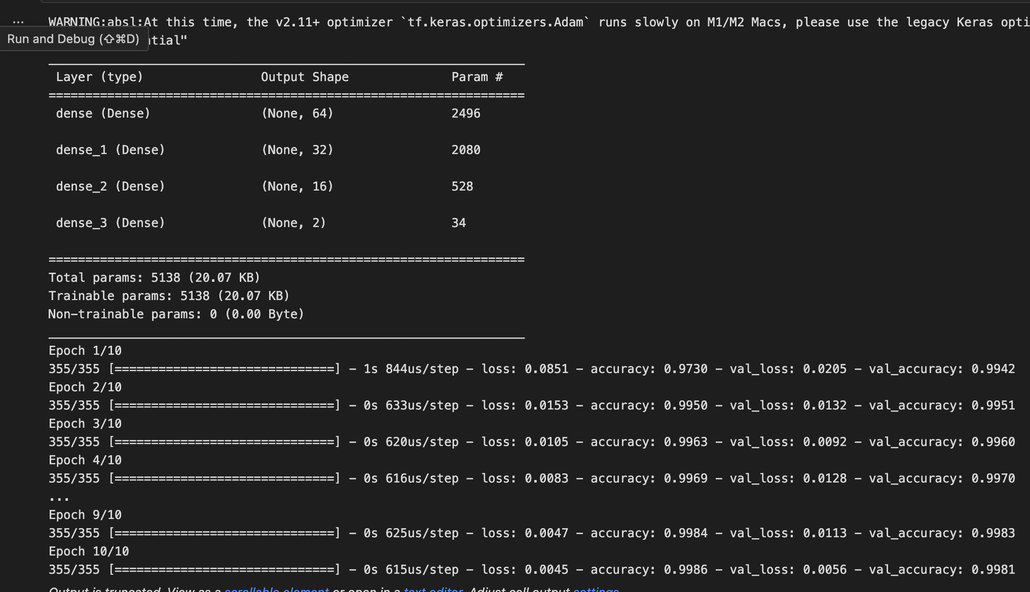

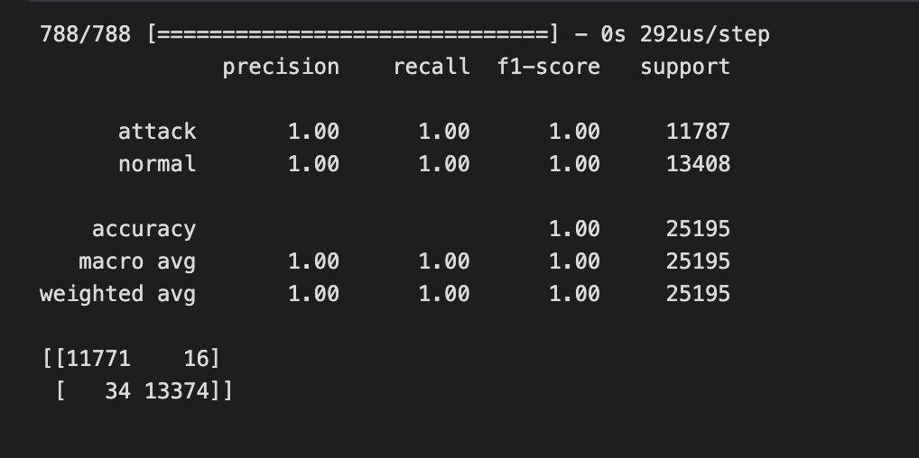
Part 4 report outputs

Original model size: 100.01 KB
Quantized model size: 9.54 KB
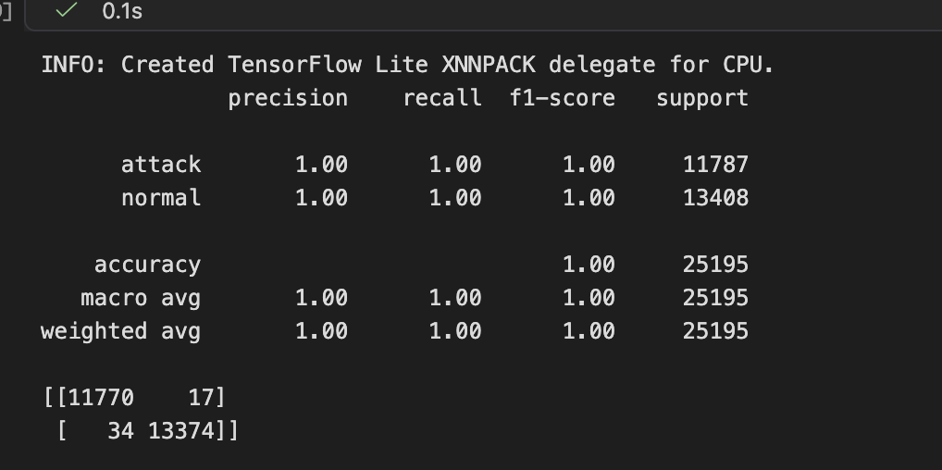

Part 5:
