EE 446: TinyML
Lab 2: TinyML Hardware and Sensor Setup
Spring 2026

Name: Asaf Iron-Jobes
Student ID: 2262052
GitHub Link: https://github.com/asafij1111/TinyML/tree/main/Lab2

Disclaimer: I used Claude co-work to organize my screenshots in this pdf but all answers are my own. I used Claude to comment and format my code but all logic and functional code was written by me.

Task 4 — Serial Monitor / Serial Plotter
Screenshot of Serial Monitor showing the counter output:
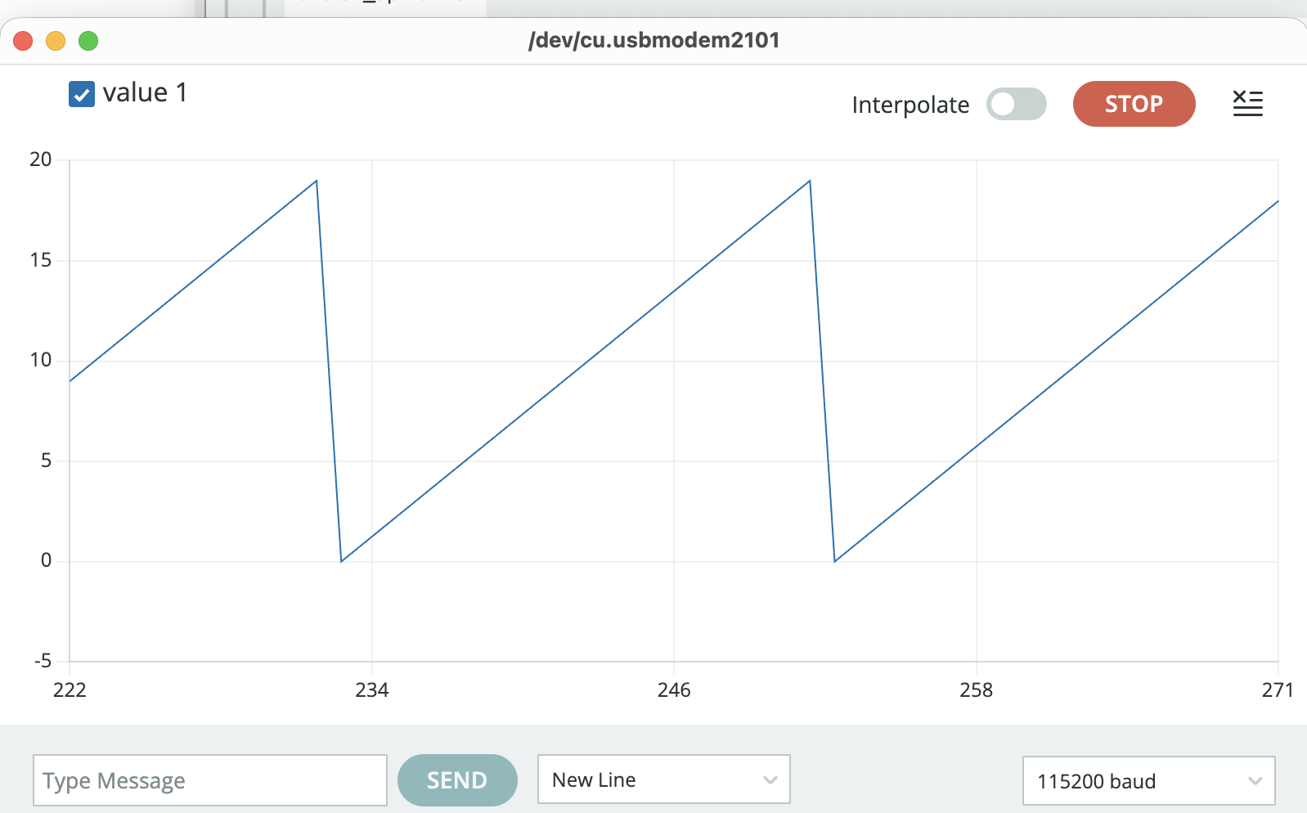

Screenshot of Serial Plotter showing the live trace:
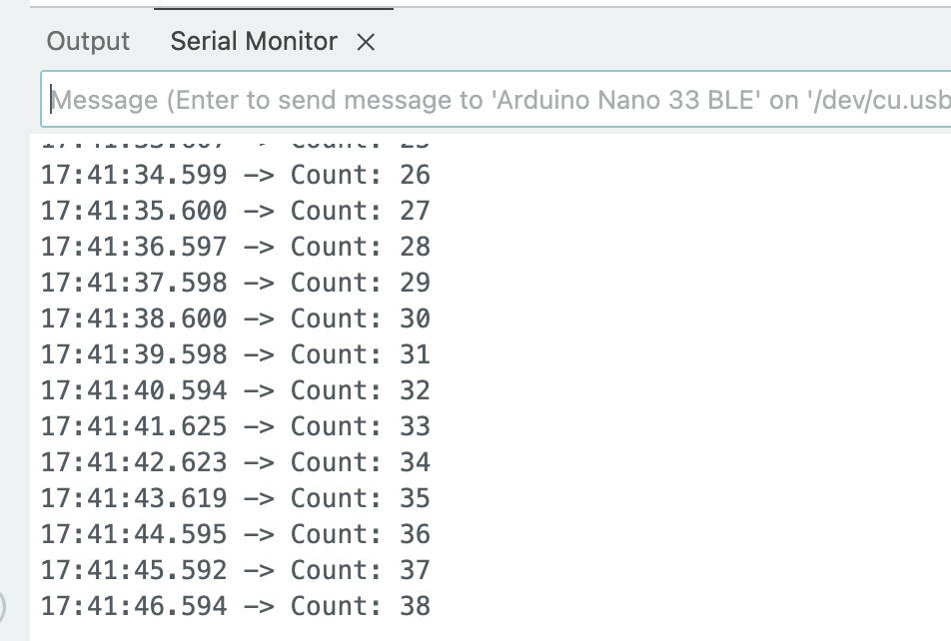

Task 5 — Microphone Verification
Screenshot of Serial Plotter while the environment is relatively quiet:
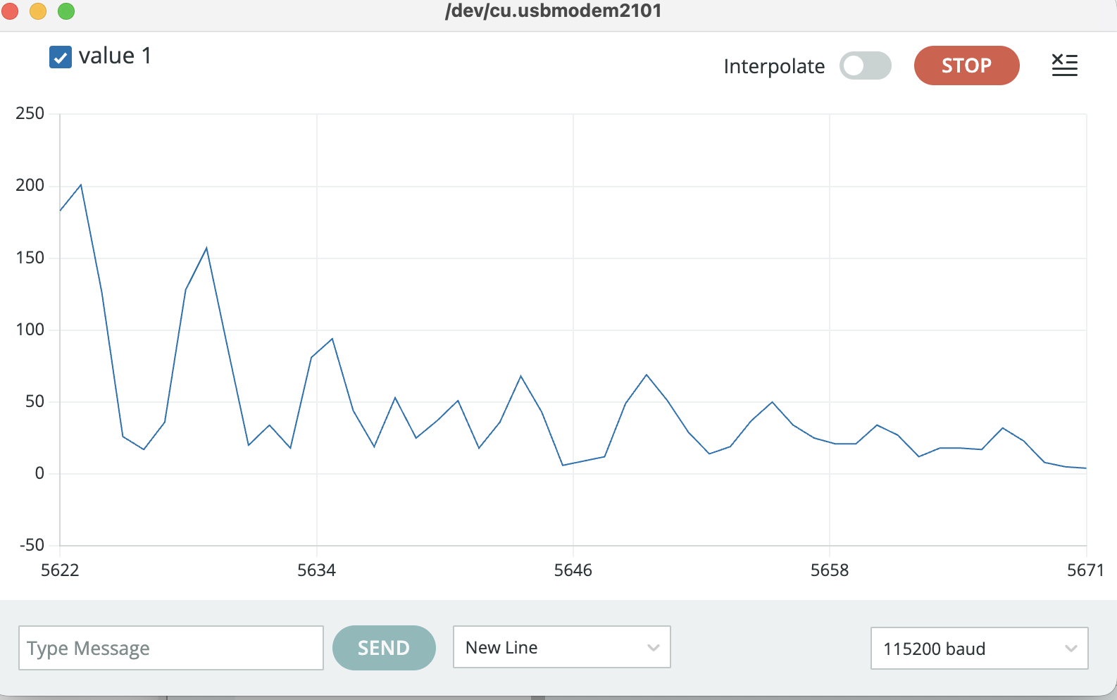

Screenshot of Serial Plotter while speaking, clapping, or tapping near the board:
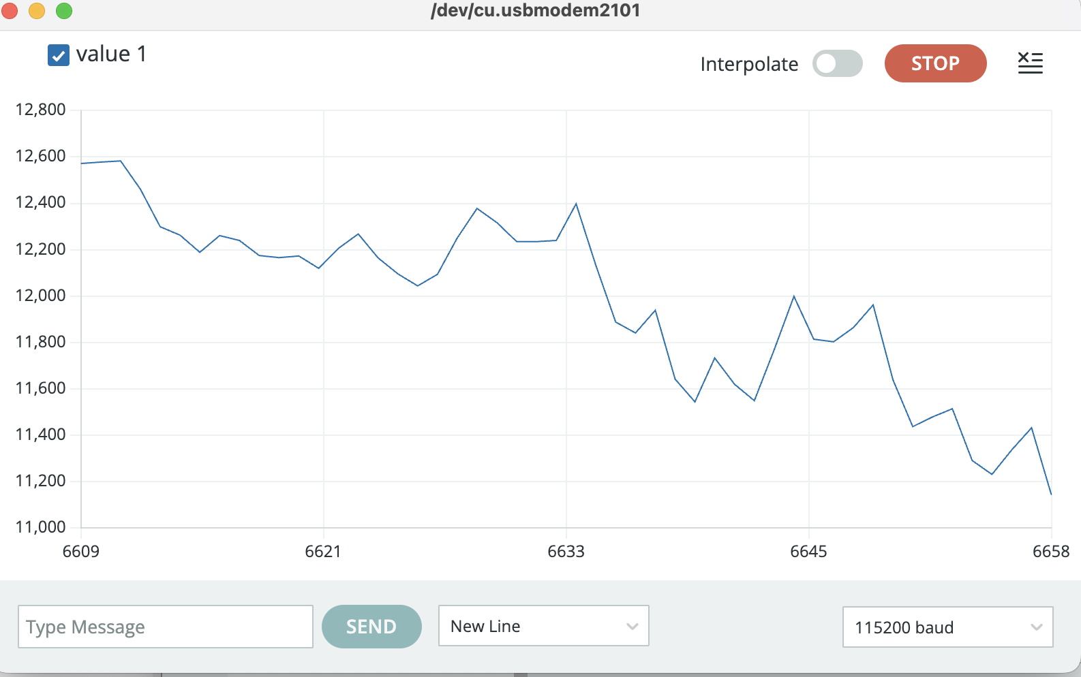

One short sentence describing what action caused the clearest change in the plotted signal:
Loudly humming or singing with the nano close to my mouth was the loudest and resulted in the high value of aboce 10,000.

Task 6A — IMU Verification (Accelerometer)
Screenshot of Serial Monitor showing changing accelerometer values:
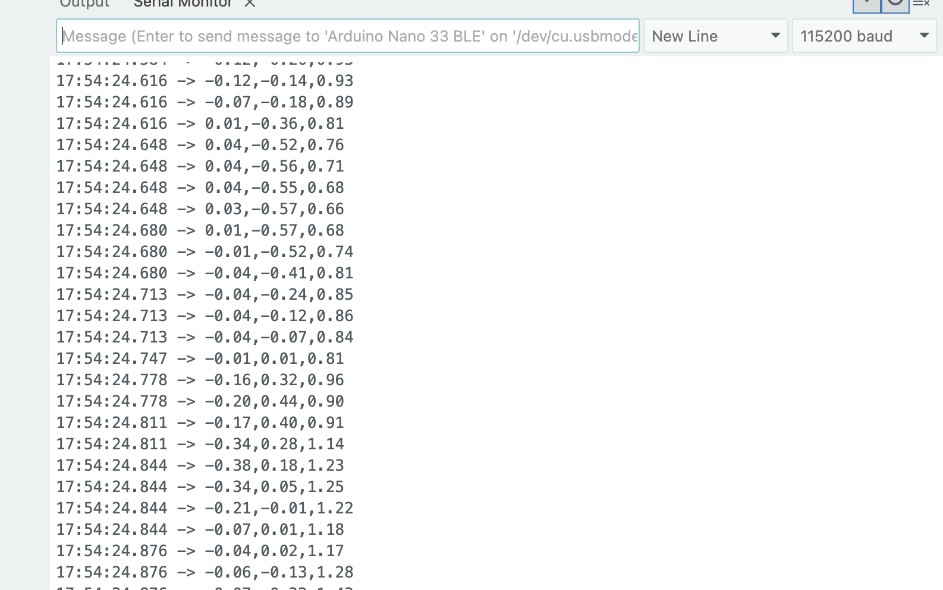

Screenshot of Serial Plotter showing the three changing channels:
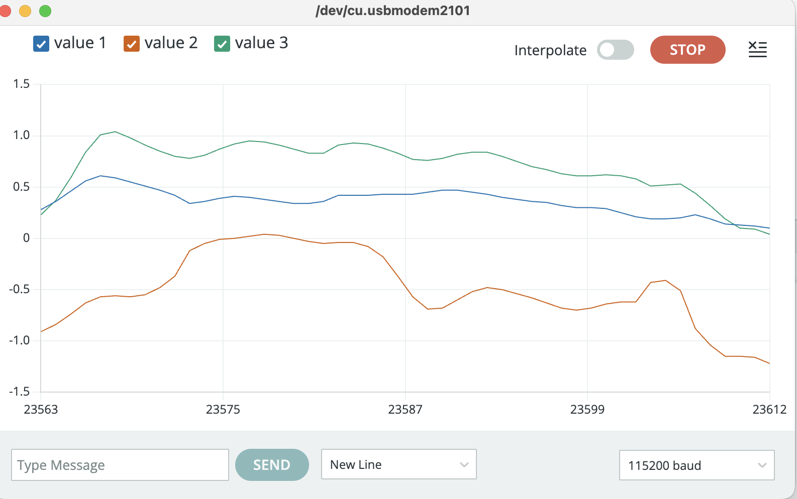

One short sentence explaining which movement produced the clearest change:
Shaking the Nano rapidly created the most substantial change.

Task 6B — Gyroscope Verification
Screenshot of Serial Monitor showing changing gyroscope values:
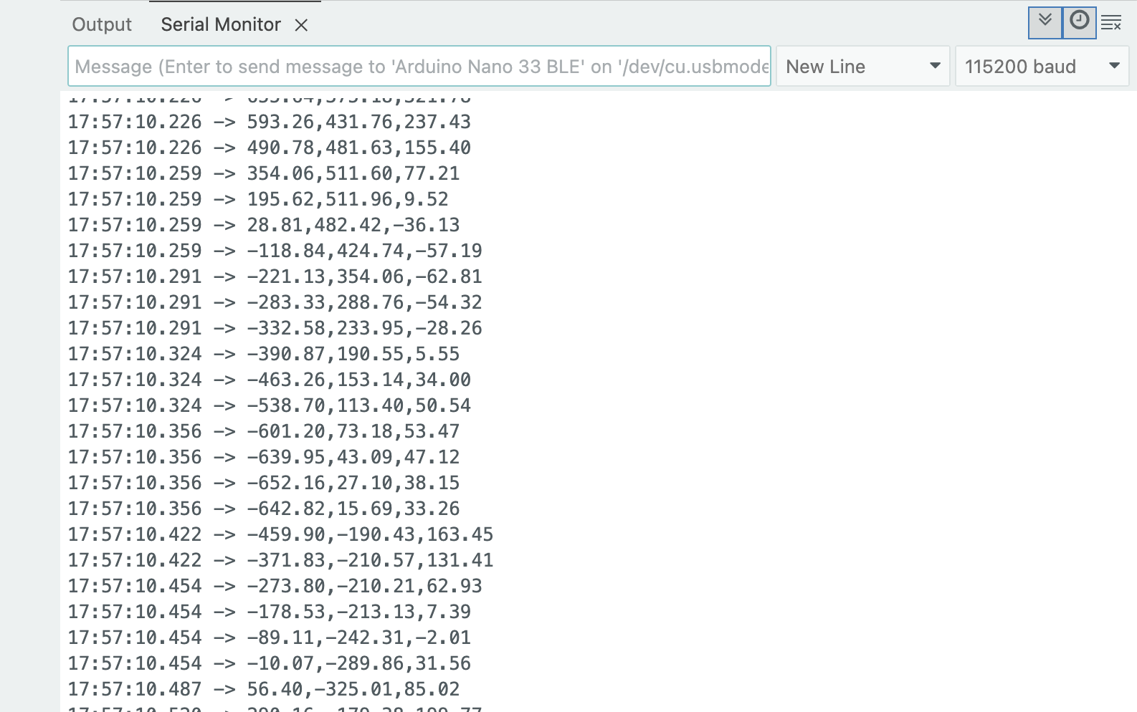

Screenshot of Serial Plotter showing the three changing channels:
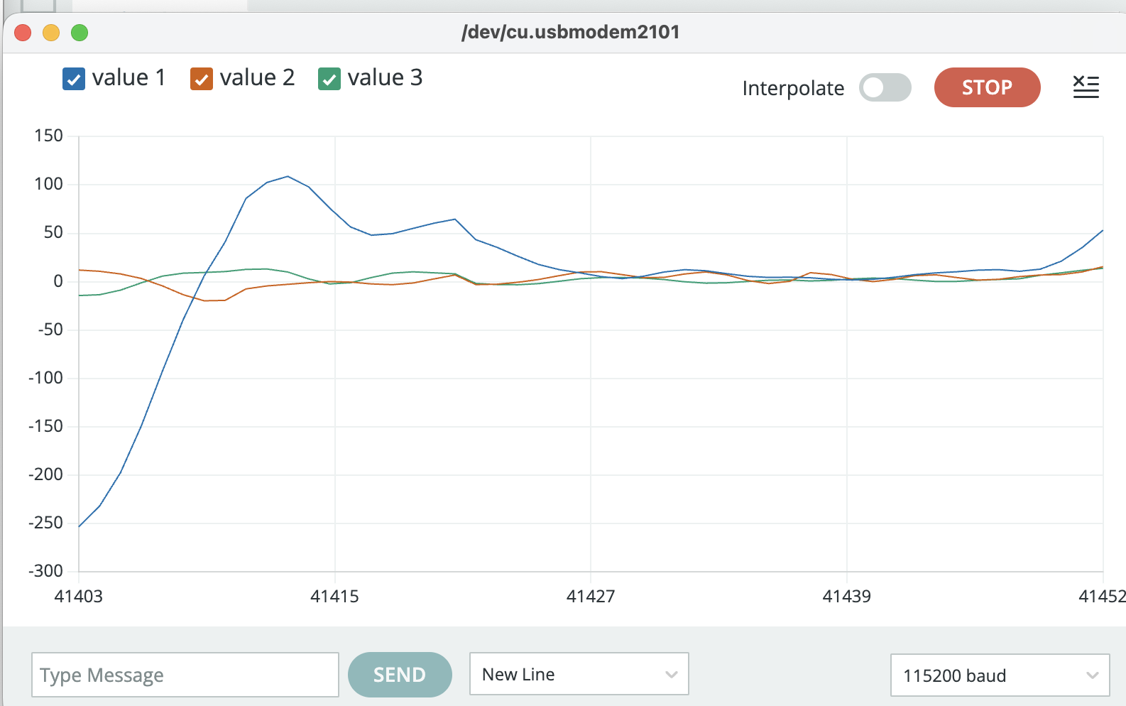

One short sentence describing which rotation produced the clearest change:
The most change came from rotating quickly along the axis of the port.

Task 6C — Magnetometer Verification
Screenshot of Serial Monitor showing changing magnetometer values:
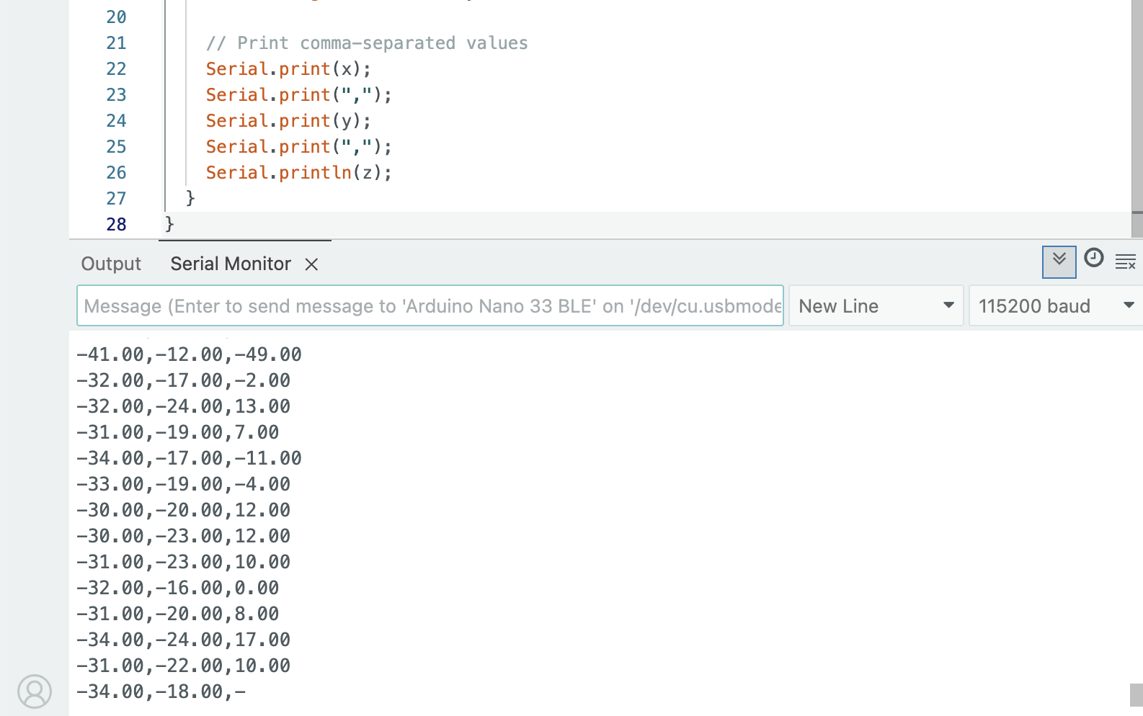

Screenshot of Serial Plotter showing the three changing channels:
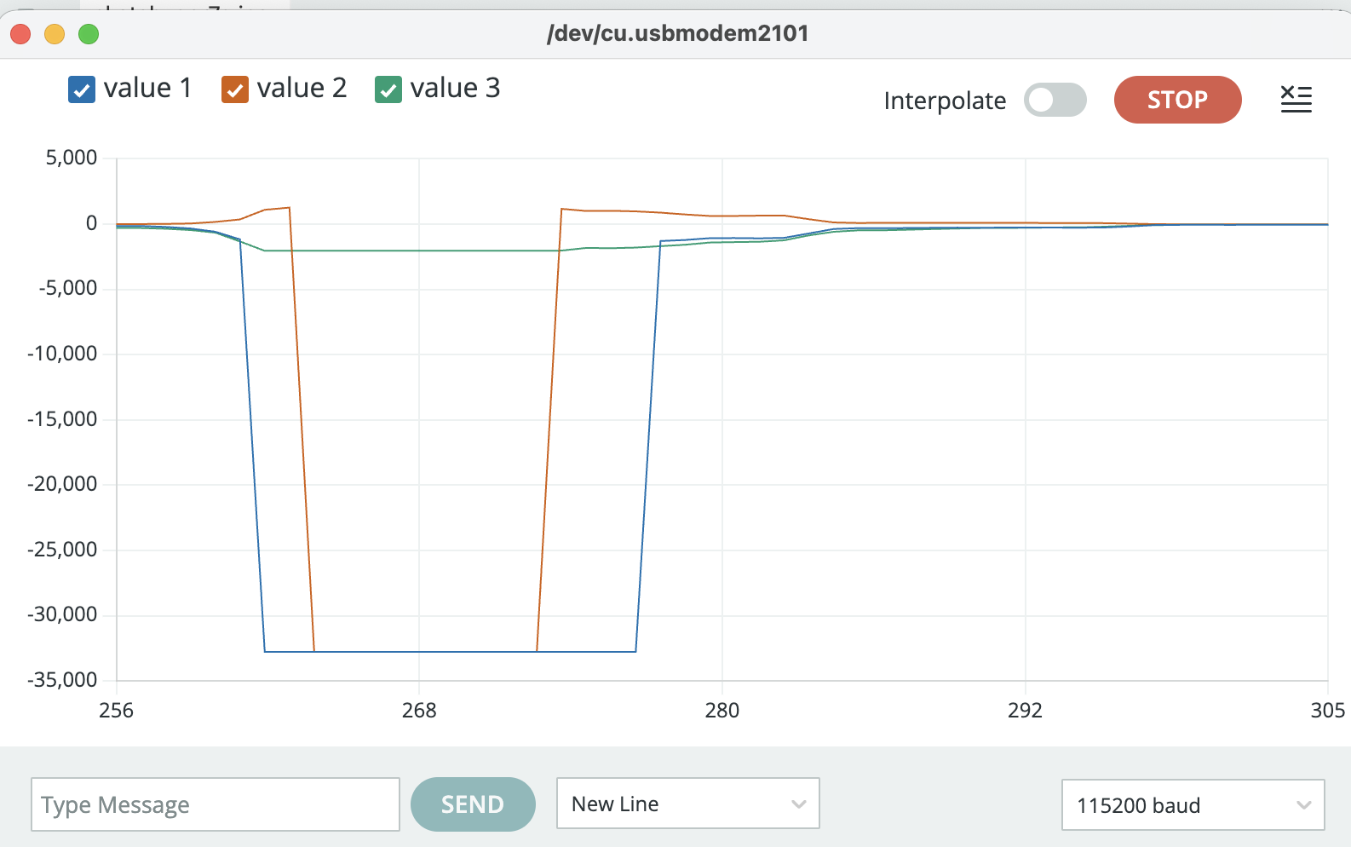

One short sentence describing what action produced the clearest change:
Putting the nano close to my computer battery made the largest different and resulted in the massive jump in the mag value.

Task 7 — Humidity and Temperature Verification
Screenshot of Serial Monitor showing stable humidity and temperature values:
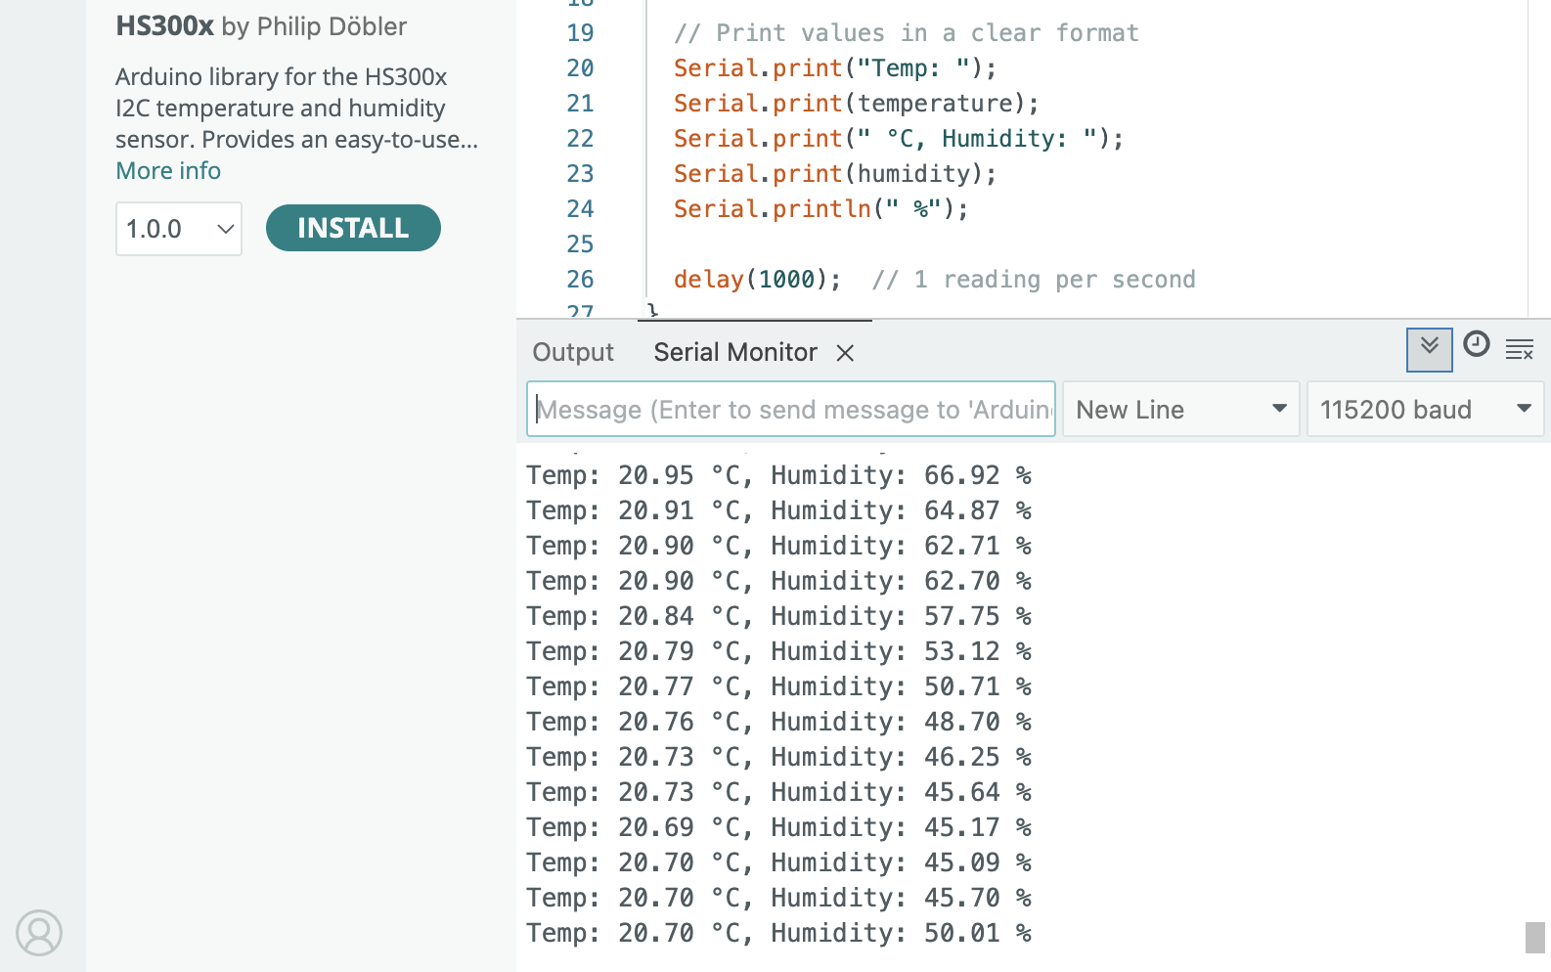

Screenshot showing changed values after introducing a nearby hand or gentle breath:
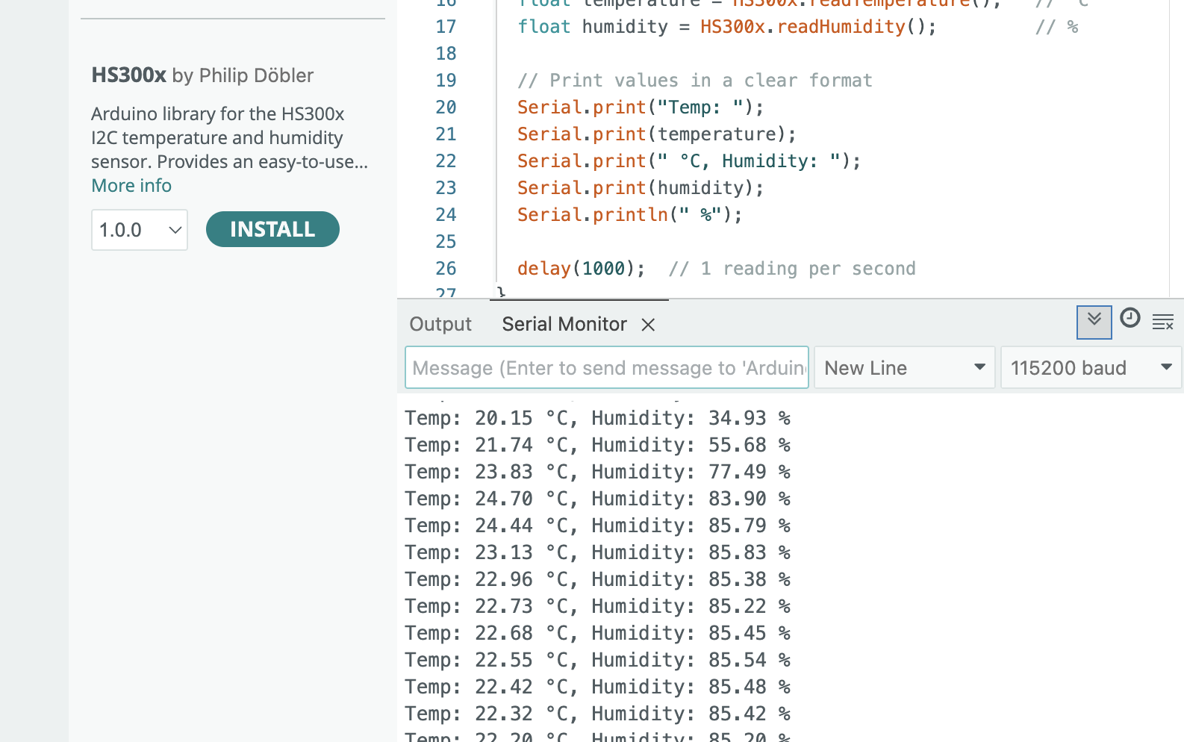

One short sentence describing what action produced the clearest change:
Humidity changed a lot when I put my hand on the nano completely covering it. It went up a lot because my hands were sweaty. Temp went up the most from breathing hot air on the sensors.

Task 8 — Barometric Pressure Verification
Screenshot of Serial Monitor showing pressure and temperature values:
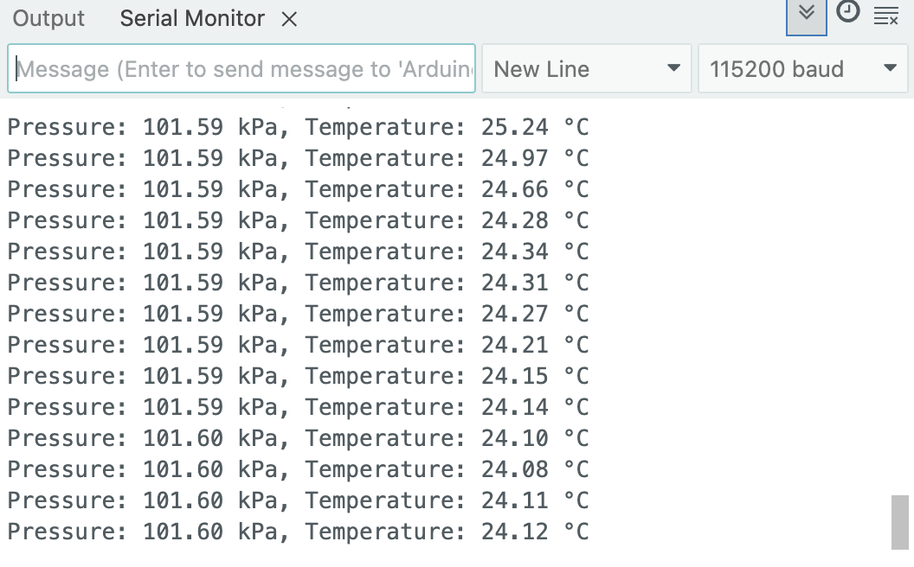

One short sentence stating whether the pressure reading was mostly stable or changed slightly during testing:
The pressure was extremely stable when still but could be changed by swinging the Nano or breathing on it.

Task 9A — Proximity Verification
Screenshot of Serial Monitor with the hand far from the board:
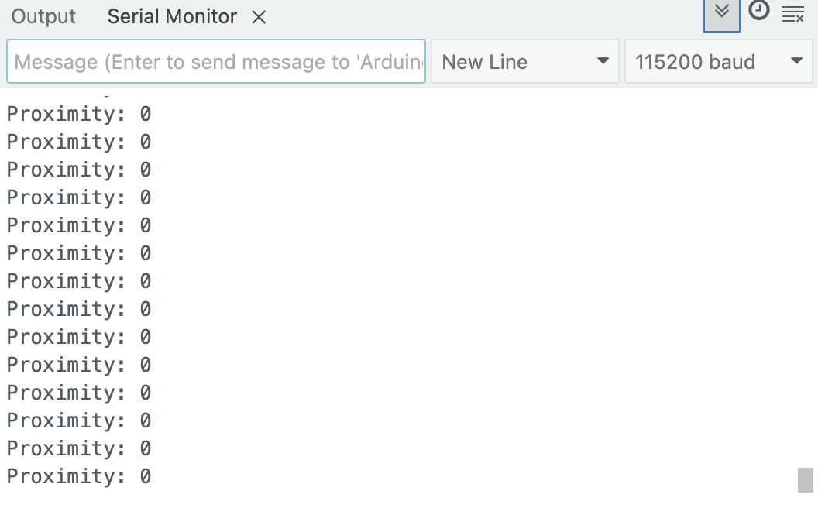

Screenshot of Serial Monitor with the hand close to the board:
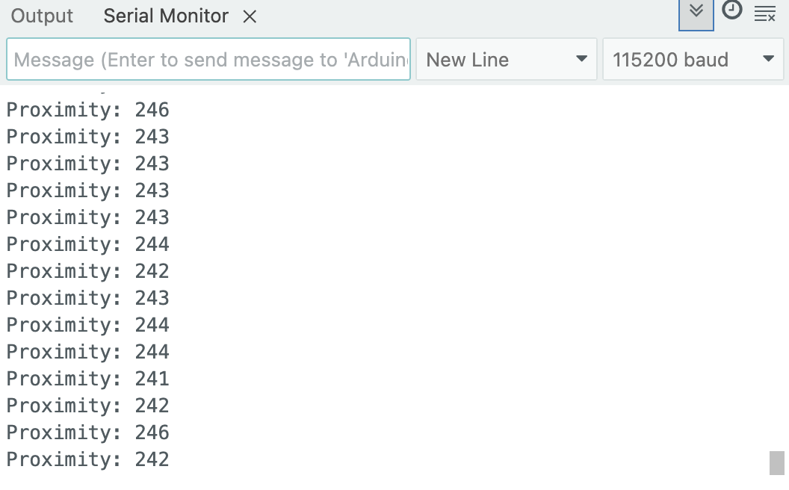

One short sentence describing how the value changed:
The value would be high from about a foot away but then rapindly go towards zero as my hand got within around a foot. From within 1-2 inches the value was 0 or less than 10.

Task 9B — Gesture Verification
Screenshot showing a recognized gesture in Serial Monitor:
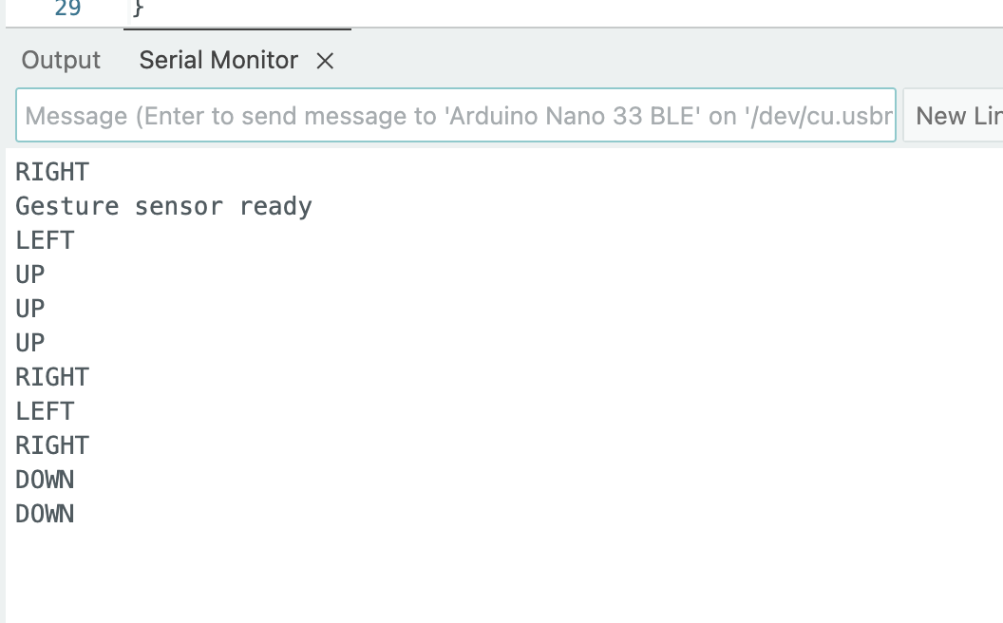

One short sentence stating which gesture was recognized most reliably:
All the gestures were relatively similar reliability. The most important factor was moving slowly enough and at the correct distance of about a foot away.

Task 9C — Ambient Light and RGB Color Verification
Screenshot of Serial Monitor under baseline room lighting:
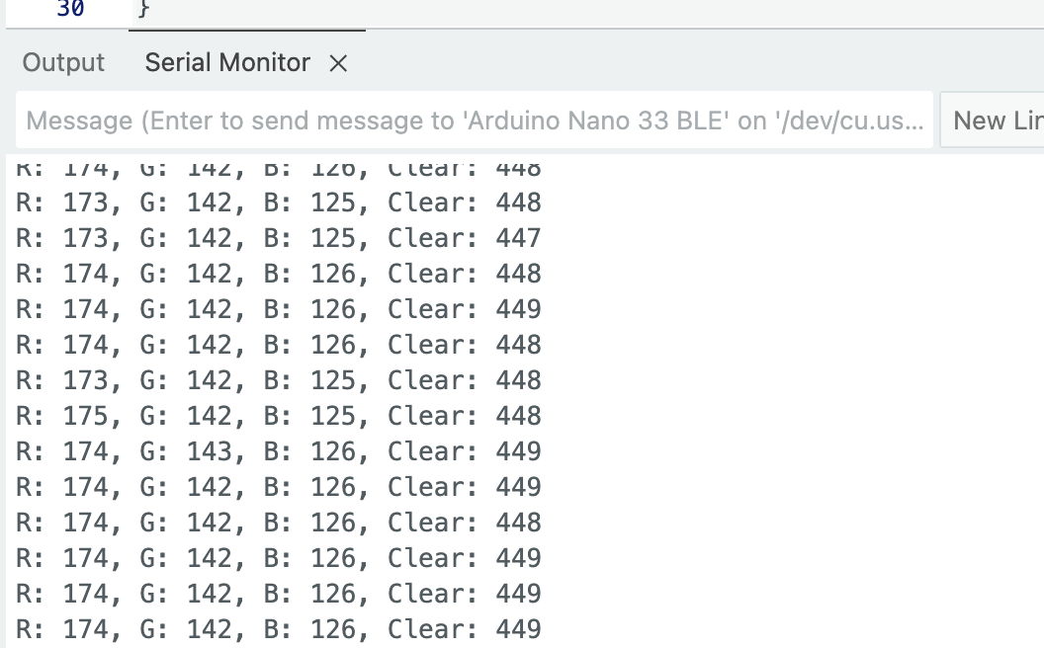

Screenshot of Serial Monitor after changing lighting conditions or presenting a colored object:
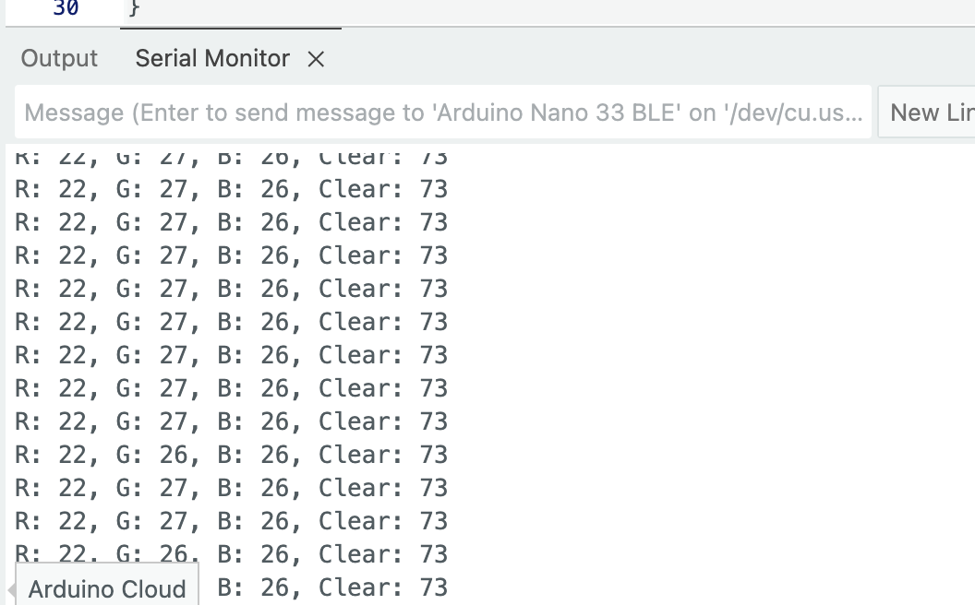

One short sentence describing which change produced the clearest difference:
Completely covering the Nano with my hand made a big difference but also putting my purple iPhone in front of it made a noticeable difference as well which is what is shown in the second image.

Task 10 — Smart Workspace Situation Classifier
GitHub link to Arduino code:

Screenshot for NOISY_BRIGHT_MOVING_NEAR:
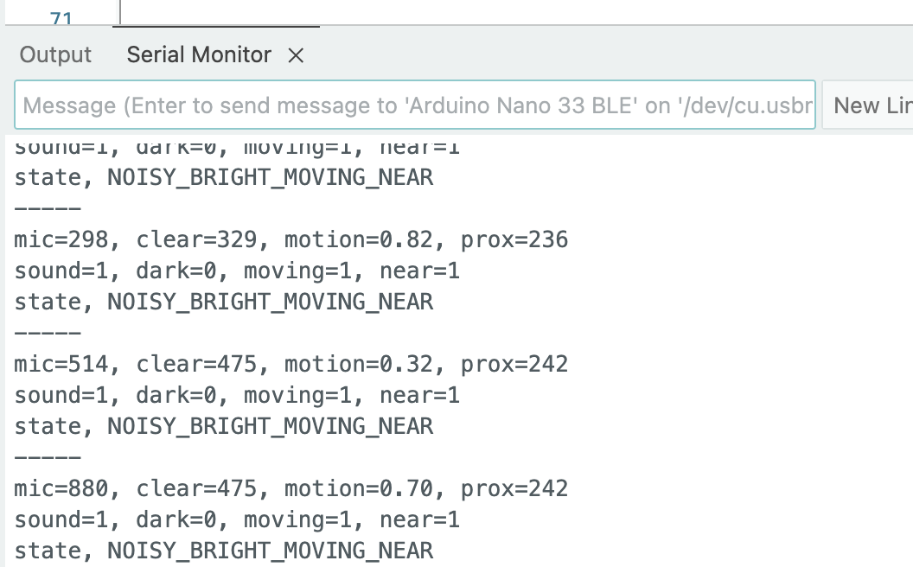

Screenshot for QUIET_BRIGHT_STEADY_FAR:
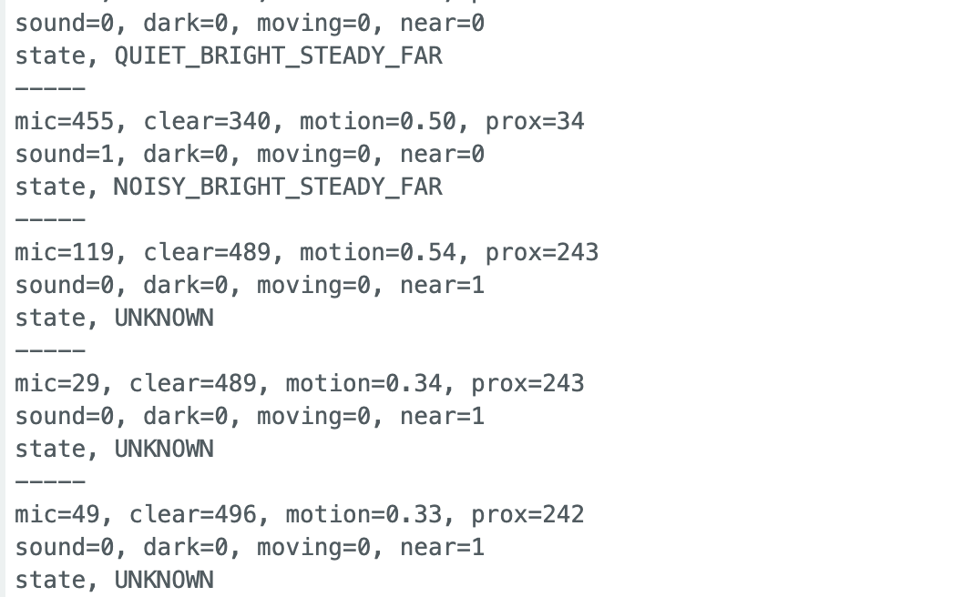

Screenshot for NOISY_BRIGHT_STEADY_FAR:
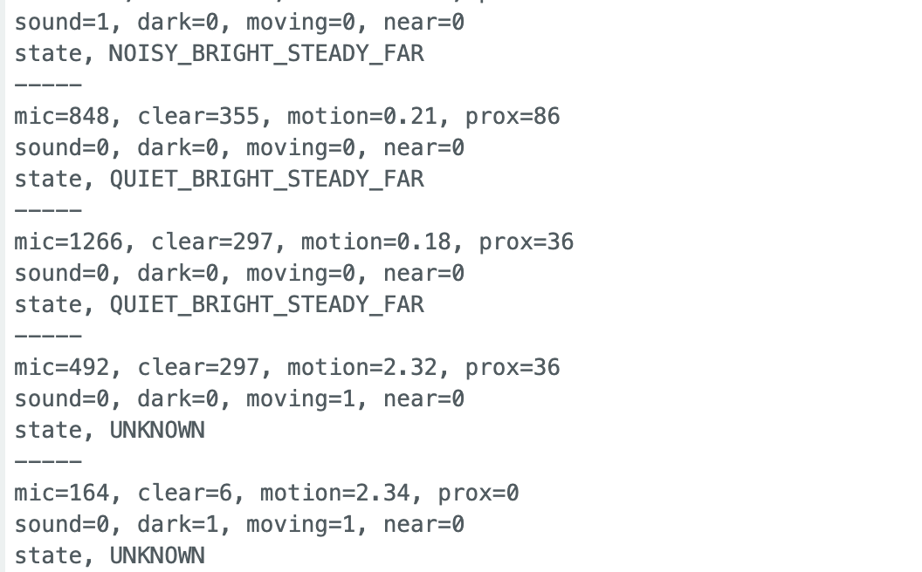

Screenshot for QUIET_DARK_STEADY_NEAR:
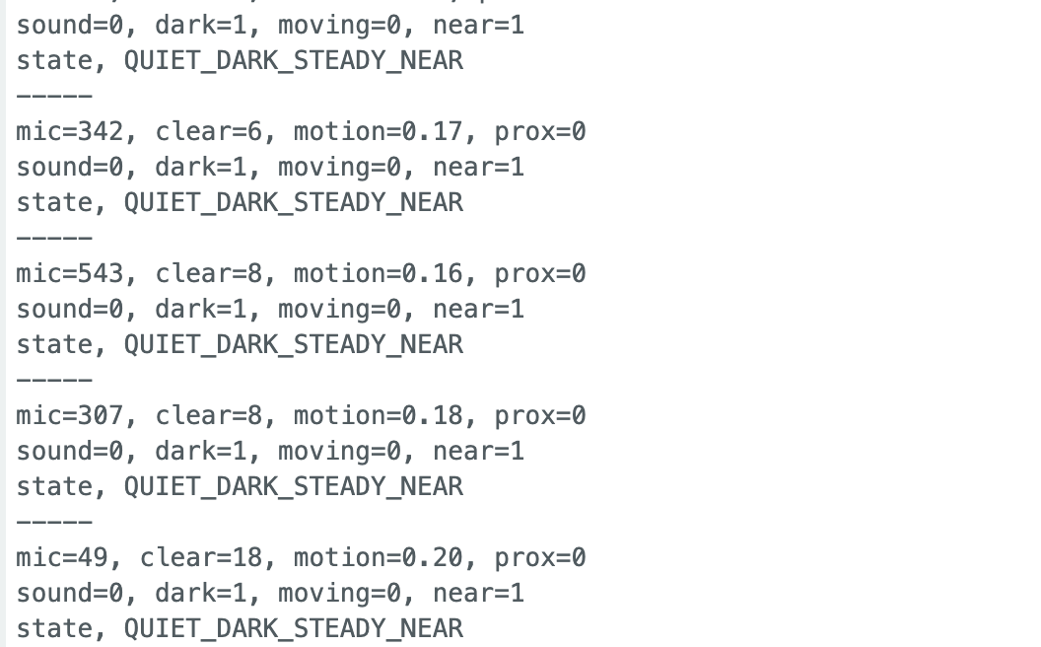

Short explanation of how you selected your thresholds:
I basically looked at each of the 4 categories outputs and put them at extremes such as up to the window vs covered from the light. I chose the threshold value as somewhere in the middle of the two. This way it was easy to clearly show one or the other. The values are all very different because of the way the different sensor outputs are formatted.

Task 11 — Environment Event Detector
GitHub link to Arduino code:

Screenshot for BASELINE_NORMAL:
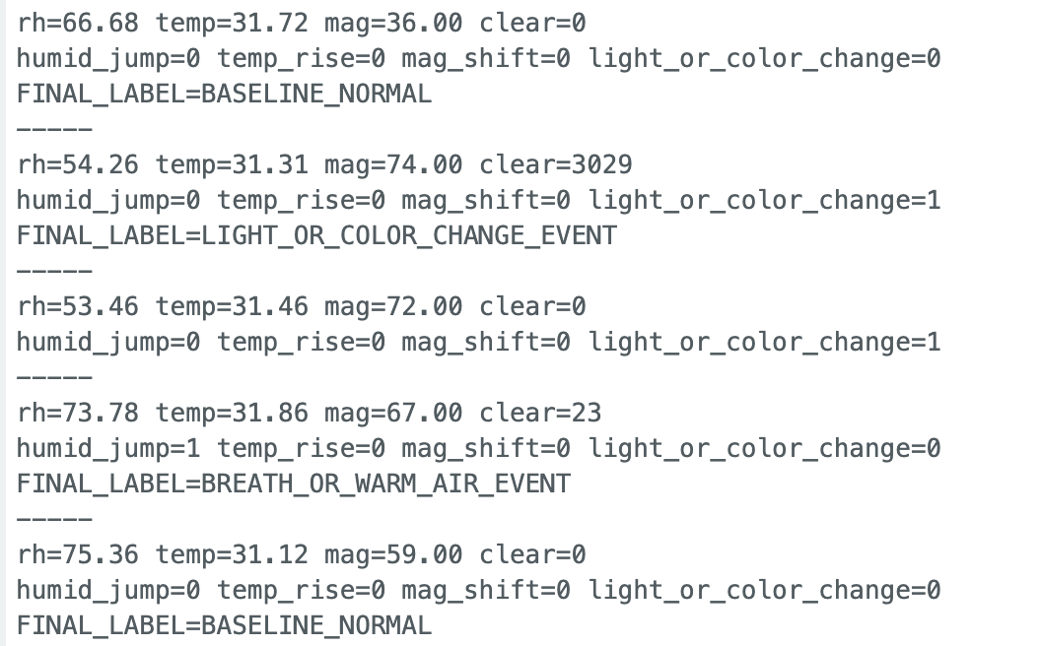

Screenshot for BREATH_OR_WARM_AIR_EVENT:
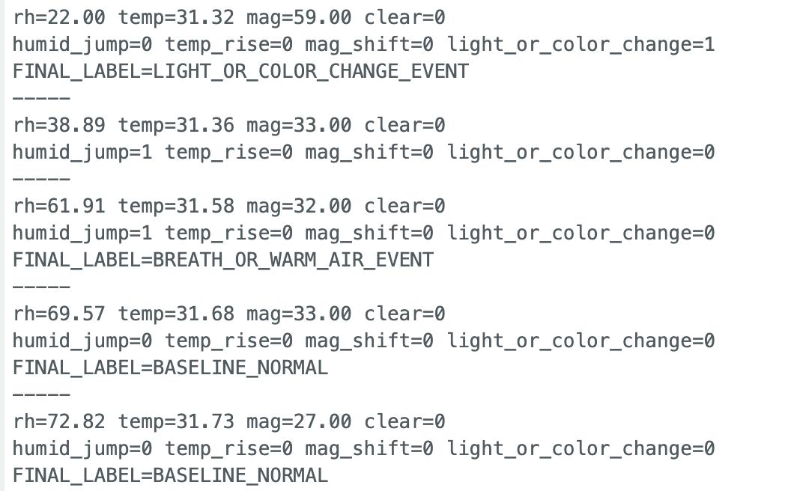

Screenshot for LIGHT_OR_COLOR_CHANGE_EVENT:
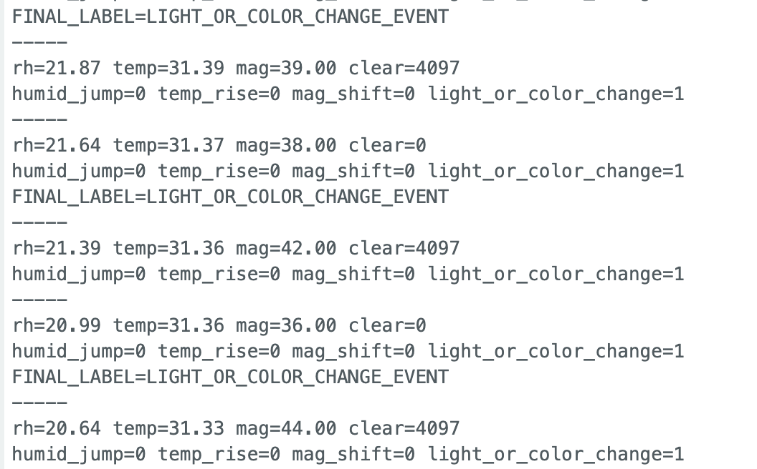

Screenshot for MAGNETIC_DISTURBANCE_EVENT:
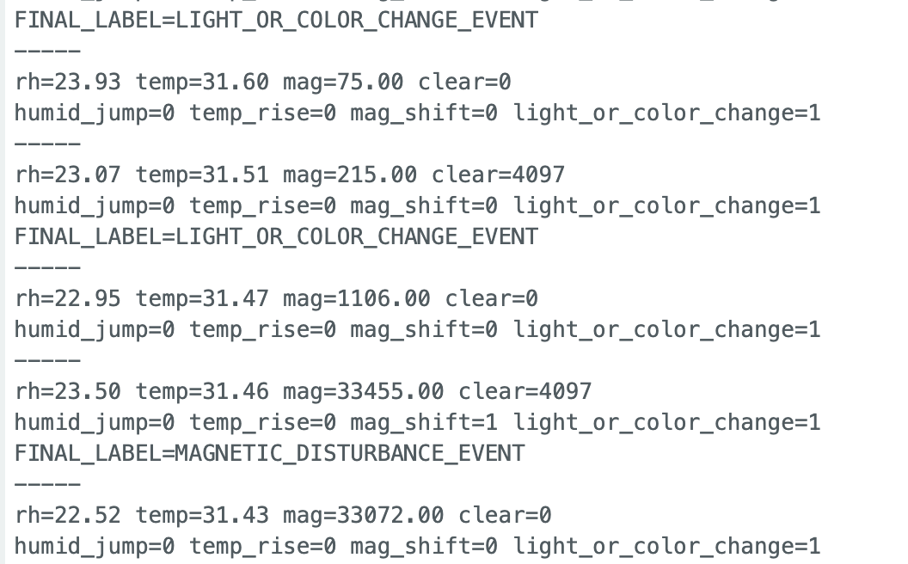

Short explanation of how you selected your thresholds and cooldown logic:
Similar to task 10 I chose my thresholds so that when I didn’t intend a change it would stay stable. I first looked at the outputs of each of the values and did an action to try to move it a lot. I then made the threshold a difference value that is less than that extreme change but more than the stable state jitter. I used a global cooldown of 1 second delay so that the output is very readable and there is enough time for the values to change meaningfully while I manipulate the sensor inputs.

