Ex 1 – SLAM
https://github.com/asaflob/VAN_SLAM.git :git repository
1.1)
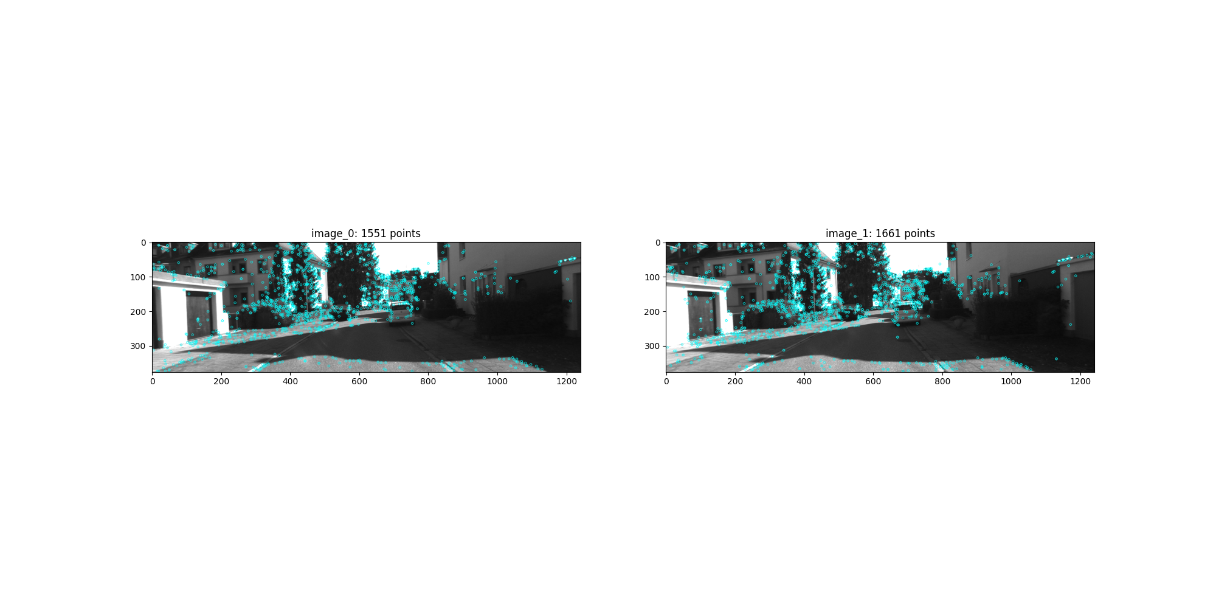

1.2)
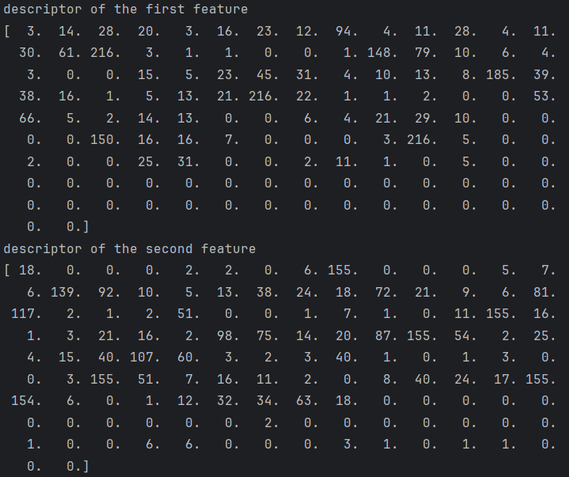

1.3)
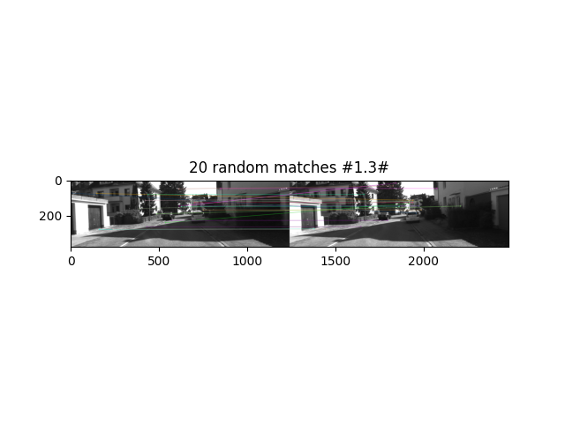
1.4)
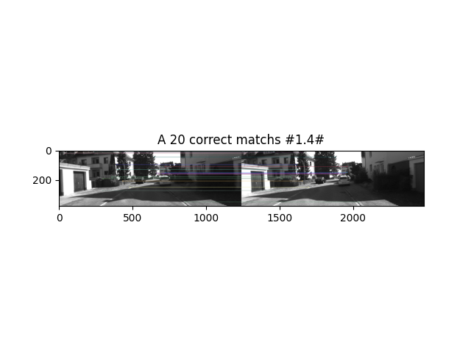

the ratio we use: 0.7
we discarded 828 matches
