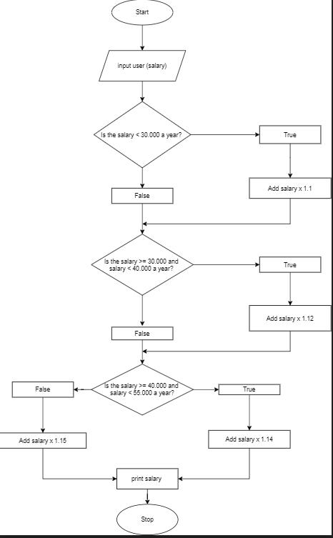

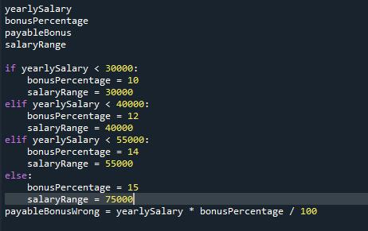

if Salary <30000:

bonus = 1.10

elif Salary <=30000 <= 40000:

bonus = 1.12

elif Salary <= 40000 <= 55000:

bonus = 1.14

else:

bonus = 1.15

salaryBonus = "{:.2f}".format((Salary \* bonus - Salary))