**int_klarna**

Version <1.0>





Table of Contents

1. Summary 4

1. Component Overview 5

1.1 Functional Overview 5

1.2 Use Cases 5

1.3 Limitations, Constraints 6

1.4 Compatibility 6

1.5 Privacy, Payment 6

2. Cartridge Setup 7

2.1 Cartridge Deployment 7

2.2 Importing Meta Data 8

2.3 Payment Module 8

3. Storefront integration 10

3.1 Checkout Pipelines 10

3.1.1 COBilling 10

3.1.2 COPlaceOrder 11

3.2 Checkout Templates 13

3.2.1 paymentmethods.isml 13

3.2.2 minibillinginfo.isml 13

3.2.3 orderdetails.isml 14

3.2.4 ordertotals.isml 15

3.3 Product Template 16

3.3.1 product.isml 16

4. Testing 17

4.1 Verify Setup 17

4.2 Making Test Purchases 17

4.2.1 Handling the order 17

5. Operations, Maintenance 18

5.1 Data Storage 18

5.2 Configuration 18

5.3 Support 19

6. User Guide 20

6.1 Roles, Responsibilities 20

6.2 Business Manager 20

6.2.1 Campaigns 20

6.2.2 Background Jobs 20

6.3 Storefront Functionality 21

7. Release History 22

# Summary

Klarna is Europe’s leading e-commerce provider of invoice-based payment solutions. Our customer-friendly checkout will increase your sales by letting your customers use only top-of-the-head information, such as their address, birthday, or phone number. With Klarna your customers always pay after receiving the goods. Klarna assumes all credit and fraud risks while guaranteeing that you, the merchant, get paid.

**Klarna Invoice**

Offer your customers a simpler buying process with one of Europe’s most popular payment methods – invoice. With Klarna Invoice, your customers can easily shop and place orders with the information they know by heart. Besides Klarna Invoice simplifying the buying process, it also increases the sense of security because payment is only due 14 days after order delivery. In this way your customers always feel assured that they are paying for what they have actually ordered.

**Klarna Account**

With Klarna Account, you give your customers the option of deciding how they would like to pay. By offering monthly installment payments beginning at €6.95 – but at least 1/24 of the total amount – you not only give your customers more buying power, you also clear the way for more purchases. With Klarna Account, you even give your customers the opportunity to gather all of their purchases on a single invoice, something that is in demand by those online shoppers with the greatest buying power – our 700,000 account customers.

# Component Overview

## Functional Overview

**Klarna Invoice – make things simpler for your customers**

**Here is how the service works:**

• The customer places an order by providing his or her personal information. An internal check is made to approve the purchase, taking about one second.

• The order is shipped.

• The customer receives an invoice along with the order. It’s due for payment within 14 days.

**Klarna Account – increases your customers’ buying power**

**Here is how the service works:**

• The customer places an order by providing his or her personal information. An internal check is made to approve the purchase, taking about one second.

• The order is shipped immediately and no further action by the customer is needed.

• We pay you.

• The customer receives a collective invoice with all the month’s purchases. The invoice is normally due at the end of the month. The first invoice however is always due at the end of the following month. (Shop in January for example, pay at the end of February.)

## Use Cases

* Klarna Invoice

|  |  |
| --- | --- |
| Use Case Scenario | Result |
| The user wants to checkout with Klarna Invoice | The user selects on the billing page the Klarna payment method. An input form for entering required data will be shown to the user with mandatory input. After the user has successfully filled out the form and submitted the order, the collected information is sent to Klarna for the internal check. On success the result will be saved and the customer sees the order confirmation page. |

|  |  |
| --- | --- |
| Use Case Scenario | Result |
| The user wants to checkout with  Klarna part payment (Klarna Account) | The user selects on the billing page the Klarna payment method. The order total is checked against the country rules, determining if the monthly payment is at least equal to the minimum monthly payment for the country selected. An input form for entering required data will be shown to the user with mandatory input. After the user has successfully filled out the form and submitted the order, the collected information is sent to Klarna for the internal check. On success the result will be saved and the customer sees the order confirmation page. |
| The user wants to know the monthly payment rates for a product | When the user visits the product detail page, a customizable  widget calculates dynamically the part payments and presents information about the Klarna payment method to the user.  The widget is only shown if the mandatory prerequisites have been met. This includes a country-currency valid combination as well as a price that is above the minimum limit of a part payment. |

* Klarna Account

* Klarna Special

|  |  |
| --- | --- |
| Use Case Scenario | Result |
| The user wants to checkout with  Klarna Special | The user selects on the billing page the Klarna payment method. An input form for entering required data will be shown to the user with mandatory input. After the user has successfully filled out the form and submitted the order, the collected information is sent to Klarna for the internal check. On success the result will be saved and the customer sees the order confirmation page. |

## Limitations, Constraints

The klarnapartpaymentinfo.isml template uses the current site locale to determine the country used for payment. While this works for most cases it may be desirable to write custom code in case the current locale should not be the country of payment. For example in cases where the shop is based in Sweden but locale is set to English this should set accordingly to reflect the real country.

## Compatibility

Compatible to Demandware version 2.10.6. Older versions may work but are untested.

Installation instructions and screenshots were taken from a 12.2 SiteGenesis Storefront.

## Privacy, Payment

This integration only accesses customer data that are mandatory for the completion of the order. As such it displays a special input form for entering extra mandatory information that Klarna requires. Furthermore each payment method comes with an easily visible link that can show the privacy terms of Klarna concerning customer data.

# Cartridge Setup

The integration is contained in the cartridge “int_klarna”; no other cartridges are required besides the storefront cartridge.

The cartridge contains the following components:

* 2 Pipeline files
* 3 Form files
* 10 Demandware script files
* 1 Business manager extension file
* 1 System object extension file
* 1 Custom object extension file
* 1 Payment methods definition file
* This documentation
* 12 Resource files
* 29 Template files

## Cartridge Deployment

In order to deploy the cartridge, import the cartridge into Demandware Studio by following these steps:

1. In Demandware Studio select from the menu File 🡪 Import and choose General 🡪 Existing Projects into Workspace then click next.
2. In the next window make sure the checkbox Select archive file: is selected and click on the Browse button on the right.
3. Select the archive file containing the integration and click Open then Finish.
4. If you have an active Demandware server connection the Studio will ask you to link the cartridge to it. Click on Yes.
5. To manually assign and deploy the cartridge to a server connection right click on it and click on Properties. Then select Project References and check the project containing the integration. The cartridge should now be automatically uploaded.

To activate the integration in SiteGenesis, the cartridge has to be assigned to the site and Business Manager. Please take note that the Business Manager integration is mandatory and vital to the correct working of the integration. In order to do this, follow these steps:

1. Login to Business Manager and click on Administration.
2. Click on Sites and then Manage Sites.
3. Click on the site name and then on the top tab menu on Settings.
4. In the text field Cartridges add in the beginning of the pre-existing text “**:int_klarna**”.
5. Repeat steps 3 to 4 for each Instance Type by selecting the appropriate type from the drop down menu (Production, Staging, Sandbox / Development).
6. For each Storefront site that Klarna Payment Module should be integrated into and the Business Manager site follow steps 3 to 5.

## Importing Meta Data

Inside the folder int_klarna/configuration you will find the following files:

* system-extensions.xml
* custom-extensions.xml

These files contain metadata information that has to be imported into the Demandware system. To do so follow the steps below:

1. Login to Business Manager and click on Administration.

2. Click on Site Development and then on Import & Export.

3. Click on the button Upload and in the next page click on the Browse button.

4. Navigate in the file system and select the system-extensions.xml file located in int_klarna/configuration folder then click on Open.

5. Click on the Upload button and then on the << Back button.

6. Click on the Import button and then select the system-extensions.xml file.

7. Click on the Next >> button in order to validate the xml file.

8. After the file is validated, click again to the Next >> button to import the metadata.

Repeat the above steps for the custom-extensions.xml file.

This is will prepare your system with the required configuration options for the Klarna module.

A description of the configuration options is provided in Chapter 5.

## Payment Module

Before you can import the actual payment method for Klarna Payment you need to create the payment processor that will handle this payment method. In order to do this, follow the instructions:

* 1. In Business Manager navigate to SiteGenesis Site 🡪 Ordering 🡪 Payment Processors.
  2. Click on the new button to create a new Payment Processor.
  3. Enter as ID: KLARNA (all capital letters) and then click on the apply button.

In the integration package a payment method definition is provided in the payment-methods.xml file. All import files can be found in the configuration folder within the int_klarna cartridge. To import this file follow the instructions:

1. In Business Manager navigate to SiteGenesis Site 🡪 Ordering 🡪 Import & Export.
2. Click on the upload button and in the next screen select the file by clicking on the browse button. Notice that the file is in the import subdirectory. After you have selected the file click on the upload button.
3. After the file has been uploaded click on the back button and in the Payment Methods area click on the Import button.
4. Select the file you just uploaded and click on the Next button.
5. After the file is successfully validated click on the Next button.
6. Make sure REPLACE is selected and click on the Import button.

Alternatively you could manually setup Klarna payment method from [Ordering ⇒ Payment Methods] and there select New and fill in the needed information, the IDs to use are KLARNA, KLARNA_PARTPAYMENT and KLARNA_SPECIAL. All should be configured to use the KLARNA payment processor.

# Storefront integration

A few steps have to be carried out to integrate your storefront with the klarna module. These instructions assume a standard storefront from Demandware, if you have a modified version apply these accordingly and with extra care.

## Checkout Pipelines

### COBilling

Open the SiteGenesis pipeline checkout/COBilling.xml. In the pipeline HandlePaymentSelection navigate to the marked node as shown in Figure 1.

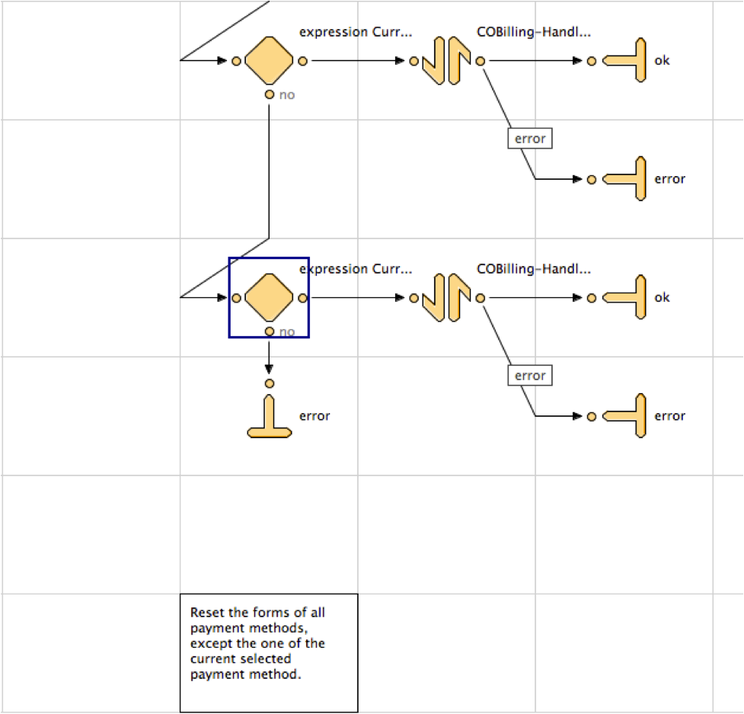

Figure 1

* Detach the error end node from the marked decision node, and move the end node down.
* In this space create a new Decision node with the expression
  + CurrentForms.billing.paymentMethods.selectedPaymentMethodID.value.indexOf('KLARNA') != -1
* Connected to the ‘yes’ anchor of the decision node create a new call to KlarnaPayment-Start.
* Insert two new end nodes labeled ‘ok’ and ‘error’.
* Connect the ‘ok’ anchor to the ‘next’ anchor of the call node
* Connect the ‘error’ anchor to the ‘error’ anchor of the call node.
* Connect the previously detached decision node and end node to the input and ‘no’ end of the new Klarna decision node respectively.

After this the relevant section of the pipeline should look like this in Figure 2.

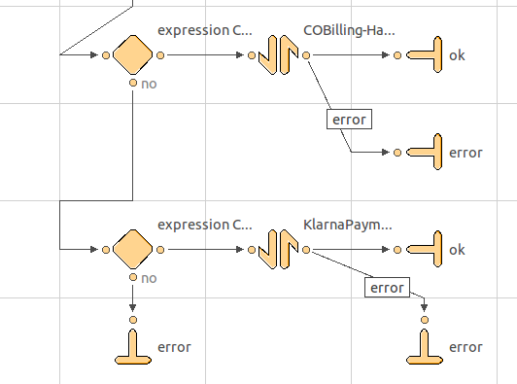

Figure 2

### COPlaceOrder

Open the SiteGenesis pipeline checkout/COPlaceOrder.xml and navigate to the HandlePayments pipeline as shown in Figure 3.

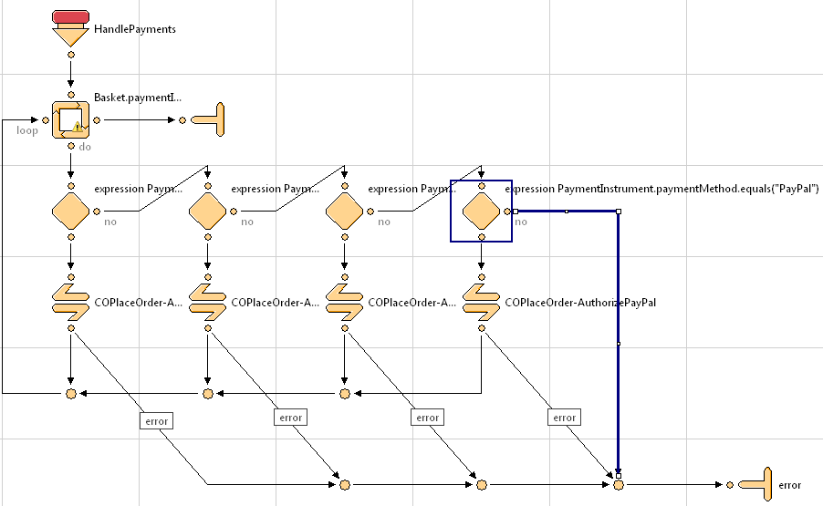

Figure 3

* Create a new Decision node with the expression
  + PaymentInstrument.paymentMethod.indexOf("KLARNA") != -1
* Create a new Call node calling KlarnaPayment-AuthorizeKlarna.
* Connect the new call node at the ‘yes’ anchor of the newly created decision node.
* Connect the ‘error’ anchor of AuthorizeKlarna and the ‘no’ anchor of the decision node to the ‘error’ end node of the HandlePayment pipeline
* Join the ‘next’ anchor of AuthorizeKlarna with the common success path.

After this the relevant section of the pipeline should look like Figure 4.

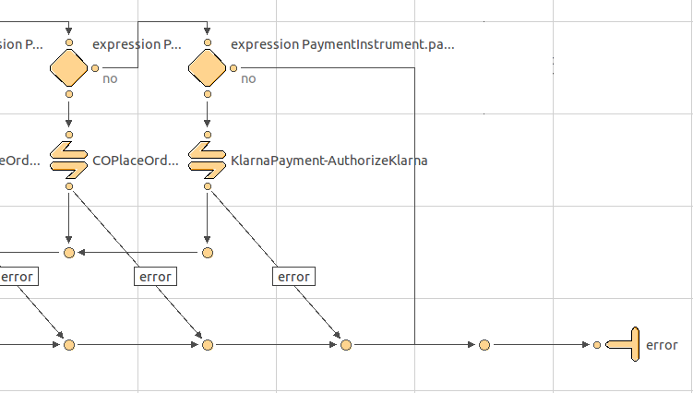

Figure 4

## Checkout Templates

This section describes the necessary storefront modifications for the Klarna integration.

### paymentmethods.isml

Open the SiteGenesis template checkout/billing/paymentmethods.isml and add these lines right below </div><!-- END: paymentmethods !--> (around line 21):

<iscomment>Include the template containg the klarna forms needed for checkout</iscomment>

<isinclude template="checkout/klarna_forms"/>

l

l

The template then should look like in Figure 5:

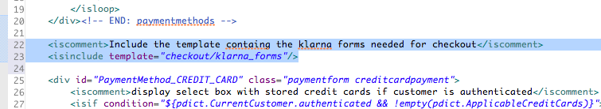

Figure 5

### minibillinginfo.isml

Open the SiteGenesis template checkout/billing/minibillinginfo.isml and navigate to line 71 as shown in Figure 6:

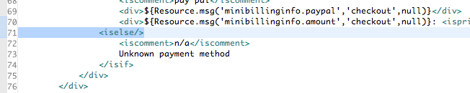

Figure 6

Add the following code lines:

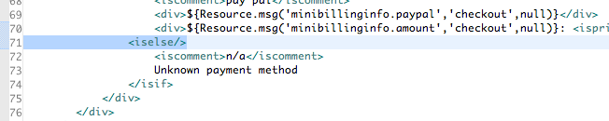

<iselseif condition="${'KLARNA'.equals(paymentInstr.paymentMethod)}"/>

<isinclude template="checkout/billing/klarna_invoice"/>

<iselseif condition="${'KLARNA_PARTPAYMENT'.equals(paymentInstr.paymentMethod)}"/>

<isinclude template="checkout/billing/klarna_partpayment"/>

<iselseif condition="${'KLARNA_SPECIAL'.equals(paymentInstr.paymentMethod)}"/>

<isinclude template="checkout/billing/klarna_special"/>

The template should then look like in Figure 7:

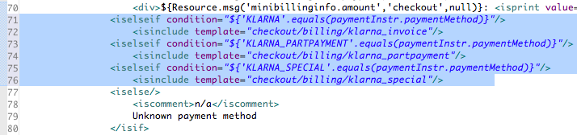

Figure 7

### orderdetails.isml

Open the SiteGenesis template components/order/orderdetails.isml and navigate to line 50 as shown in Figure 8:

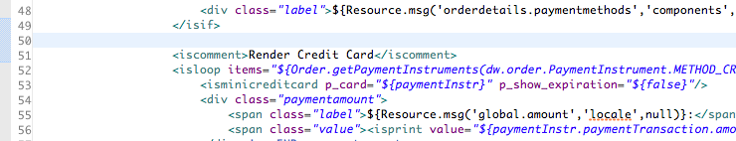

Figure 8

In Line 50 add then a new section for Klarna as follows:

<iscomment>Render Klarna</iscomment>

<isinclude template="components/order/klarnaorderdetails"/>

The template should then look like in Figure 9:

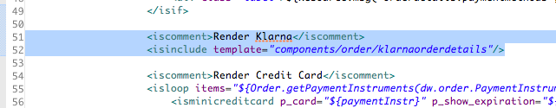

Figure 9

### ordertotals.isml

Open the SiteGenesis template “components/order/ordertotals.isml” and navigate to line 97 as shown in Figure 10.

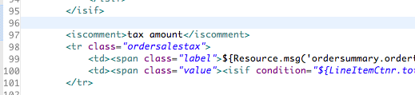

Figure 10

Above the tax amount section add the following code:

<iscomment>

If we have Klarna Invoice we add a new row with information, add the invoice fee tax to the tax totals

and the invoice fee to the order totals.

</iscomment>

<isinclude template="components/order/isklarna"/>

<isif condition="${isKlarnaInvoice}">

<isinclude template="components/order/klarnaordertotals"/>

<iselse>

The after the already existing order total table row (<tr class=”ordertotal”>...</tr>) add the following code in order to close the expression:

</isif>

The template should look like in Figure 11:

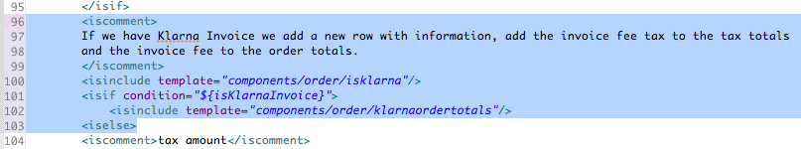

Figure 11

### Summary.isml

In the summary.isml file a small modification has to be made in order to show errors that occured during processing by the Klarna system. Open the SiteGenesis template “checkout/summary/summary.isml” and replace lines 20 to 22 shown here:

<isif condition=*"${pdict.PlaceOrderError != null}"*>

<div class=*"errorform"*>${Resource.msg(pdict.PlaceOrderError.code,'checkout',null)}</div>

</isif>

by the following code fragment:

<isif condition=*"${pdict.KlarnaOrderError != null}"*>

<div class=*"errorform"*><isprint value=*"${pdict.KlarnaOrderError}"*/></div>

<iselseif condition=*"${pdict.PlaceOrderError != null}"*>

<div class=*"errorform"*>${Resource.msg(pdict.PlaceOrderError.code,'checkout',null)}</div>

</isif>

## Product Template

### product.isml

Open the SiteGenesis template „product/product.isml“ and add in Line 233 the following code:

<iscomment>Klarna part payment info</iscomment>

<isinclude template="product/components/klarnapartpaymentinfo" />

As each country will have it’s own part payment plans, the country displayed is determined from the country of the default locale. However as this is an unreliable method it can be overridden by setting the KlarnaCountry variable in the klarapaymentinfo.isml template.

After applying this modification the template should look like in Figure 12:

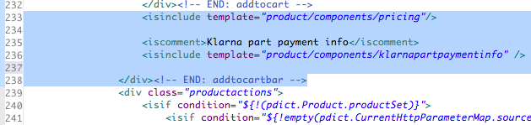

Figure 12

# Testing

## Verify Setup

The best way to verify that the modules were setup correctly is to try to make a purchase in the storefront using Klarna as your payment method. Please note that to be able to use Klarna's payment methods, the customer must use the correct country ↔ currency combination as explained in the table below. Therefore it is paramount to set up the storefront appropriately in Business Manager.

|  |  |
| --- | --- |
| **Customer Country** | **Store Currency** |
| Denmark | DKK |
| Finland | EUR |
| Germany | EUR |
| Netherlands | EUR |
| Norway | NOK |
| Sweden | SEK |

## Making Test Purchases

If you don’t want to do this with your own personal information, you can use a suitable test person from the Integration Guide: [http://integration.klarna.com/](http://integration.klarna.com/en/testing/test-persons)

Add a product to the basket and go to the checkout, choose a Klarna payment method and confirm the order.

### Handling the order

Klarna specific details of the order will be found in the Payment tab of the order if Klarna was used.

**Transaction**

The invoice number from Klarna, you can use this to find the order in Klarna Online.

*You can also find your order using the Order Number even in Klarna Online*

**Klarna Status**

Klarna may return a pending status when placing an order. The CheckOrderStatusJob may be used to do automatic checks of when the pending status has changed to either accepted or denied.

# Operations, Maintenance

## Data Storage

This integration uses custom objects for the Klarna campaign (pclass) storage. They are used in every operation concerning Klarna as they contain the specific options depending on the Country <-> Currency combination. This includes not only the checkout process, but furthermore operations such as the part payment info template displayed on the product detail page.

As the campaigns have to be read in order to calculate the part payment amounts for the product detail page, the queries to do so underlie the stability guidelines imposed by Demandware in form of quota limitations. Therefore the amount of Klarna campaigns should not exceed 500 per Country <-> Currency combination. As an extra measure this template is cached to minimize the total number of custom object queries.

## Configuration

After the integration has been successfully installed and particularly the custom site preferences imported, it is required to configure the site preferences using the data provided by Klarna. In order to do this, follow these instructions:

1. Login in Business Manager and select the relevant site that you want to configure.
2. Navigate to Site Preferences and click on Custom Preferences.
3. Click on the Klarna preferences group.
4. Enter the provided data and click on Apply to save any changes.

The Klarna settings are described below. Please note that all parameters are mandatory and are valid only for the specific site, repeat the above steps for each relevant site.

|  |  |
| --- | --- |
| Parameter Name | Description |
| **Merchant ID** | The merchant ID or estore ID (eid) is used to identify your store.  You should have received it from Klarna. |
| **Shared secret** | The shared secret is used to authenticate your store, which is connected to your Merchant ID.  You should have received it with your Merchant ID.  *Do not share this with anyone.* |
| **Target system** | Selects whether calls to Klarna should be directed to live or beta server. Note that your merchant ID only works for either LIVE or BETA. |
| **Send test flag** | Check this if you are using LIVE but still want to test new functionality, e.g. if you are customizing Demandware or similar. Any invoice created in testmode will not be paid or sent out. |
| **Invoice fee [Country]** | The invoice fee to use of each country Klarna supports |
| **Tax class** | The ID of the class tax to use for the invoice fee. |
| **Active countries for special campaign** | For which countries to show the special campaign option, the active country is determined from the users chosen shipping country. |
| **Integration mode** | This defines the integration mode. It can be in standard or advanced integration. |

After these settings have been set and all installation steps are complete, please update your Klarna campaigns (Pclasses) by using the instructions in Section 6.2.1.

## Support

To make it easier for you as a merchant we have created a couple of videos that describe the most common tasks that you will have to do in Klarna Online.

These videos can be found on this link:

[http://klarna.com/en/business/support/klarna-online/invoice-handling](http://www.google.com/url?q=http%3A%2F%2Fklarna.com%2Fen%2Fbusiness%2Fsupport%2Fklarna-online%2Finvoice-handling&sa=D&sntz=1&usg=AFQjCNE5lqz-aVABCTTq4tkpGDa_wQzx2A)

More information and downloads can be found at the Klarna Integration guide, located here:

[http://integration.klarna.com](http://www.google.com/url?q=http%3A%2F%2Fintegration.klarna.com&sa=D&sntz=1&usg=AFQjCNHuNbNW7qqflLUIll-KRHfEMLCHUA)

The changelogs can also be found there.

# User Guide

## Roles, Responsibilities

The integration requires at least one person to have the appropriate rights for the Klarna module in Business Manager. This can be done under [Administration 🡪 Organization 🡪 Roles and Permissions 🡪 Business Manager Modules], and then for each site check the Klarna module found under Ordering.

## Business Manager

This section contains information concerning operations in Business Manager.

### Campaigns

The interface for managing Klarna Campaigns is found at [Ordering ⇒ Klarna ⇒ View PClasses].

This displays an overview of the pclasses used for campaigns on your site. To get the latest version of pclass-data click “Update PClasses”. This communicates with Klarna and retrieves all necessary data.

Please note: This step is absolutely necessary before any Klarna functionality can be used, as all operations depend on the stored campaigns.

### Background Jobs

The Klarna module provides a job that communicates with Klarna for the status of any orders in your system labeled as PENDING. To configure this job go to [Operations ⇒ Job Schedules] and select New. Fill out the form like this:

* Name - anything you like e.g Klarna Check Order Status
* Pipeline - KlarnaJob
* Startnode - CheckOrderStatusJob
* Exception Scope - Sites
* Every - 60 minutes
* Enabled - Remember to check this!

After you filled the form out click on apply, then switch to the Site tab and check all sites for which Klarna is enabled.

Back in the overview select the new job and click Run to do a test run. Go to [Operations ⇒ Job History] and make sure the job is listed as Finished and with Error as None.

## Storefront Functionality

This integration allows the customers to pay by using the Klarna payment methods. As such in the billing page during checkout, three new options will appear Klarna, Klarna Special and Klarna part payment. All three of them communicate through server-to-server calls and therefore do not require any special interaction from the customer.

# Release History

|  |  |  |
| --- | --- | --- |
| **Version** | **Date** | **Changes** |
| 1.0.0 | 23.04.2012 | Initial release |