ECSE 323

LAB REPORT 2

Group No. - 20

Aditya Saha- 260453165

Shayan Ahmad- 260350431

# **g20_dayseconds**

## Objective

To make a circuit (g20_dayseconds) that takes in a time specified in hours, minutes and seconds and computes the time specified as the number of seconds since midnights.

This circuit is implemented using LPM modules lpm_multiply and lpm_add_sub to carry out the required arithmetic operations. The operation basic to the implementation of this circuit is given in the following:

DaySeconds = Seconds + (60*(Minutes + (60 * Hours)))

**this formulation gives a smaller circuit than fully expanded expression

The DaySeconds has three inputs and one output:

* 5-bit value input named ‘Hours’ which represents hours value of time
* 6-bit value input named ‘Minutes’ which represents minutes value of time
* 6-bit value input named ‘Seconds’ which represents seconds value of time
* 17-bit value output named ‘DaySeconds’ which represents the required time specified as the number of seconds since midnight

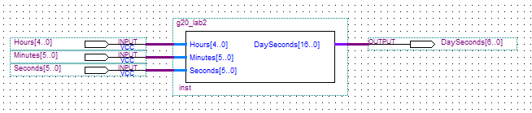

Fig: Higher abstraction for the converter circuit

## VHDL description

The VHDL description of the circuit has been attached as a separate file in the zipped folder. The VHDL implements lpm components, namely lpm_multiply and lpm_add_sub. In the architecture body of the code, four temporary signal variables have been introduced, which stores the signal values of each of the intermediate arithmetic operations. Throughout the implementation, multiple lpm_multiple and lpm_add_sub components have been declared to handle the operations involving varying bit lengths.

## Circuit testing

One fold circuit testing was carried out: functional simulation. The functional simulation was carried out on 217 different input values. These tests verified the robustness of the circuit. The simulation output diagrams are given in the following.

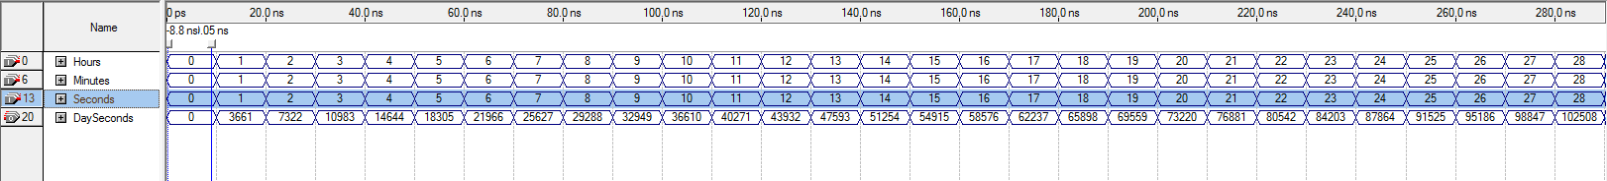

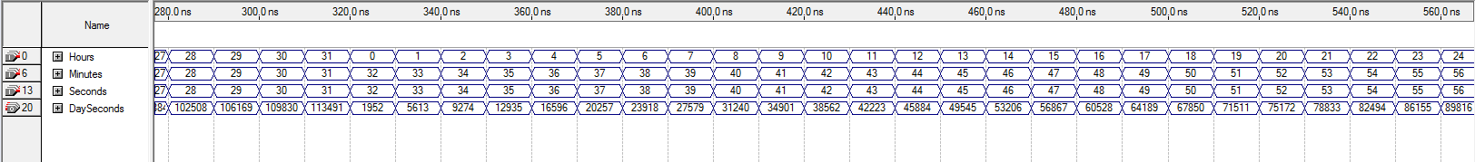

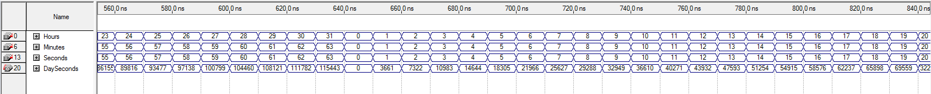

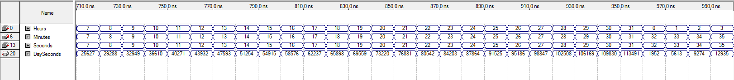

Fig: Functional simulation diagrams for 217 input values