Appendix I: Investigation of Training / Test Data Sets Mismatch

Introduction

It was suspicious that models with a high accuracy (over 98%) when run with cross validation on the training set should score barely better than chance (52-54%) on the test set. Prediction is only possible if both the training set and test set are drawn from the same underlying population and have features that have been identically preprocessed so it was hypothesised that there were some difference between the training data and test data that was causing this.

A comparison of the provided training set and test set was done and it appears that for some features the values in the tests set are considerably different from the values in the training set. The data sets provided had already been scaled so that all values lay in the interval 0 to 1 so a possible cause of the discrepancies was from errors introduced by this pre-processing.

Initial investigation - Kolmogorov-Smirnov test

To get an overview of the problem the Kolmogorv-Smirnov test[1] was used to compare each column in the training data with the same column in the test data. The k-s statistic tests the null hypothesis that two sample sets come from the same underlying distribution. First all columns with zero variance in either the test set or training set were removed, leaving 69 columns. The ks_2samp function from the scipy package[2] was used to compare the training data and test data for each of the remaining features. Of the 69 features 40 had a p-value at or close to zero (rejecting the null hypothesis) and 18 had a p-value at or close to 1. The remaining 11 features were somewhere in between. This gives an indication that there may be a problem but is not conclusive, particularly since the k-s test assumes that the underlying distribution is continuous.

Direct Comparison of Single Features

To investigate further individual features were selected so that they could be compared directly.

Feature 38

First to be compared was feature “38” (where “38” is the column header in the original CSV file). The distributions were compared by a kde plot for both the training and test data for the feature. 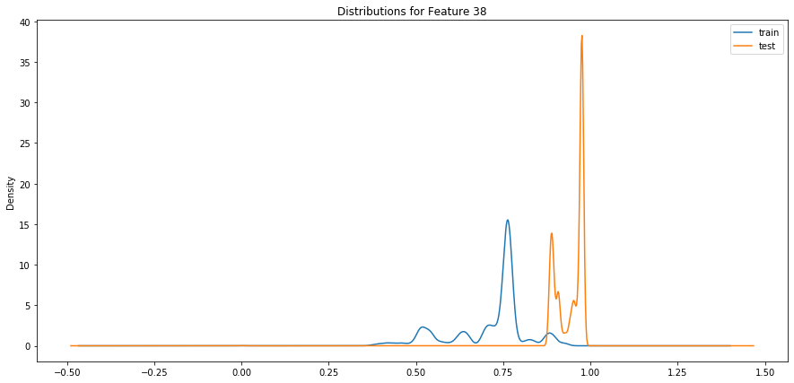 **Figure I.1**

From this plot it appears that the overall shapes are similar but shifted up on the test set. One possible reason for this could be that the data sets were wrongly scaled. You could get this effect if it the training set and test set had been scaled independently instead of the scaler being fit to the training data and applied to the test data - an outlier in the training set could push all the other values down after scaling. Unfortunately we do not have access to the original data to test this hypothesis.

Categorical Features

Several features were found that appeared to be categorical (they only took 2 or 3 values in both data sets) but the values for the categories were completely different. For example feature “129” has this distribution in the test set:

|  |  |
| --- | --- |
| value | count |
| 0.0 | 38897 |
| 1.0 | 1261 |

Which seems reasonable for a 2-value categorical feature. However the training data has

|  |  |
| --- | --- |
| value | Count |
| 0.0 | 94954 |
| 0.0000158 | 2090 |

The count ratios are similar, but the values are different by four orders magnitude.

Similar results have been found for other categorical features. For example feature “128” appears to have three categories and the training set is similarly mis-scaled:

|  |  |  |  |
| --- | --- | --- | --- |
| test set values | test set counts | training set values | training set counts |
| 0.0 | 38897 | 0.0 | 94954 |
| 0.5 | 141 | 0.0000155 | 147 |
| 1.0 | 1120 | 0.0000309 | 1943 |

Several other features were found to have similar problems, mostly in the range “108”-“129”.

Conclusion

It is seems from the above that some of the features have been corrupted by the scaling process.  
For this reason the data sets should be considered unfit for purpose and regenerated from the original raw data if available.

[1] J.L. Hodges Jr., “The Significance Probability of the Smirnov Two-Sample Test,” Arkiv fiur Matematik, 3, No. 43 (1958), 469-86.

[2] P.Virtanen et al (2019) “SciPy 1.0–Fundamental Algorithms for Scientific Computing in Python”. preprint arXiv:1907.10121 https://arxiv.org/abs/1907.10121