**Project Presentation:**

**Topics to Cover:**

1. **Features**
2. **User Interface and User-Use case**
3. **Software Design Description (Tasks and how they communicate with each other)**
4. **Demo.**

**MP3 Application Features:**

1. ***Display a menu of 7 songs*** at a time on the screen. Feature to wrap-up and being able to display previous/next list of available 7 or less songs on Up/Down if user’s current selection is first/last menu on the list, respectively.
2. ***Read songs from SD Card.***
3. ***Highlight the currently selected the song***.
4. ***Status Bar***– Display the progress of the song.
5. ***Play Button*** – Play currently selected song.
6. ***Pause Button*** – Pause the currently playing song.
7. ***Stop Button*** – Stop the currently playing song and reset the status.
8. ***Rewind Button*** – Rewind the currently playing by 10%.
9. ***Fast-Forward Button*** – Forward the currently playing by 10%.
10. ***Up Button*** – Go up in the list of menus.
11. ***Down Button*** – Go down in the list of menus.
12. ***Vol+ Button*** – Increase volume by one level.
13. ***Vol- Button*** – Decrease volume by one level.
14. ***Display buttons press response*** – By changing the background color of button on button press event.
15. ***Volume Bar*** – Show the current volume level.

Future Enhancement/Work in Progress Features.

1. ***Improving Task Synchronization*** – Need to use from tracing tool to determine timing requirements and transition time based on priority. (Current design run MP3 Streaming task at lowest, so streaming of MP3 file gets interrupted with Display/Touch Task – Noticeable to Human ear. Adding an interrupt line might improve the case)
2. ***Application Health Check*** – To monitor SD Card Status Reader and Device Inactivity, will be implemented using a watchdog timer – if the task cannot tickle watchdog in every 15 seconds, it will update user Device Fail Status and restart to recover.
3. ***Device Activity logging*** – Log device activity in SD card with timestamp (using preset RTC configuration).

**Device UI Outlook:**

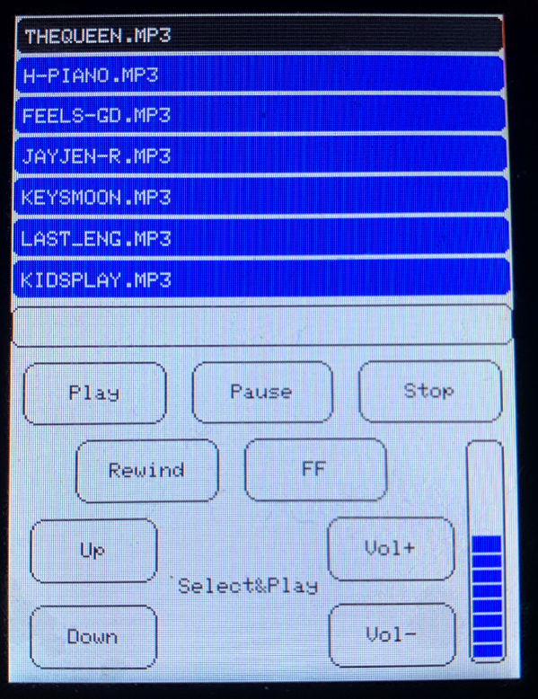

**MP3 Application Events and Desired Responses (Display Handler Activities):**

|  |  |
| --- | --- |
| List of Application Events | Event Response |
| Play Button Press | Notify user that the Button Press Event Occurred  i.e., Change the button background color and hold the state until Button Release Event |
| Play Button Release | * Reset Button background color. * Determine the state of current selection of song from the list.  1. If not playing, stop previously playing song and play the current selection. 2. If playing, continue playing/streaming the song in its current state. |
| Pause Button Press | Notify user that the Button Press Event Occurred  i.e., Change the button background color and hold the state until Button Release Event |
| Pause Button Release | * Reset Button background color. * Pause the Play/Streaming MP3 data, if song is on play. |
| Stop Button Press | Notify user that the Button Press Event Occurred  i.e., Change the button background color and hold the state until Button Release Event |
| Stop Button Release | * Reset Button background color. * Stop the Song if song is on play. Reset the Song Status bar. |
| Rewind Button Press | Notify user that the Button Press Event Occurred  i.e., Change the button background color and hold the state until Button Release Event |
| Rewind Button Release | * Reset Button background color. * Backward the streaming data pointer of MP3 file by 10% from current position and continue streaming |
| Fast-Forward Button Press | Notify user that the Button Press Event Occurred  i.e., Change the button background color and hold the state until Button Release Event |
| Fast-Forward Button Release | * Reset Button background color. * Forward the streaming data pointer of MP3 file by 10% from current position and continue streaming |
| Up Button Press | Notify user that the Button Press Event Occurred  i.e., Change the button background color and hold the state until Button Release Event |
| Up Button Release | * Reset Button background color. * Move up in the list of songs if there are files to display.   Note: Wrap-up and Display previous 7 songs if user is on top of the display.   * Highlight the song in current selection. |
| Down Button Press | Notify user that the Button Press Event Occurred  i.e., Change the button background color and hold the state until Button Release Event |
| Down Button Release | * Reset Button background color. * Move down in the list of songs if there are files to display.   Note: Wrap-up and Display next 7 songs if user is on top of the display.   * Highlight the song in current selection. |
| Vol+ Button Press | Notify user that the Button Press Event Occurred  i.e., Change the button background color and hold the state until Button Release Event |
| Vol+ Button Release | * Reset Button background color. * Set the next Volume Status-bar. * Increase the MP3 decoder volume level. |
| Vol- Button Press | Notify user that the Button Press Event Occurred  i.e., Change the button background color and hold the state until Button Release Event |
| Vol- Button Release | * Reset Button background color. * Reset the current Volume Status-bar. * Reduce the MP3 decoder volume level. |
| Status Bar Increment | * If song file pointer moves ahead by 10%, increment status bar. (In response to Fast-Forward and or song file pointer moves by 10% while streaming) |
| Status Bar Decrement | * If song file pointer moves retreats by 10%, decrement status bar. (In response to Rewind) |

**MP3 Application Design – Task Interaction:**

Touch Event Mailbox

Display Event Queue

MP3 Event Mailbox

**Command Handler Task:**

Start/Pause/Stop/Rewind/FF/Up/Down/Vol+/Vol- Button Press Event and Up/Down Release Event: Queue Events into Display Event Queue for Display Processing

Pend on Touch Event Mailbox

Is Current Song?

NO

Post MP3 Play Event in Mailbox

Start Release Event

YES

Set isStopSong Flag and Enqueue event in Display Queue

Set isPlaying Flag and Add Delay 50 ms

Reset isPlaying Flag and Enqueue event in Display Queue

Pause Release Event

isPlaying?

NO

Enqueue event in Display Queue

Stop Release Event

YES

Set isStopSong Flag

Enqueue event in Display Queue

Rewind Release Event Event

Set isRewind Flag

Enqueue event in Display Queue

Set isFastForward Flag

FF Release Event

isPlaying?

NO

Post MP3 Vol+/Vol- Events in Mailbox

Vol+/Vol- Release Event

YES

Enqueue event in Display Queue

Set isVolPlus/isVolMinus Flag

**Touch Handler Task:**

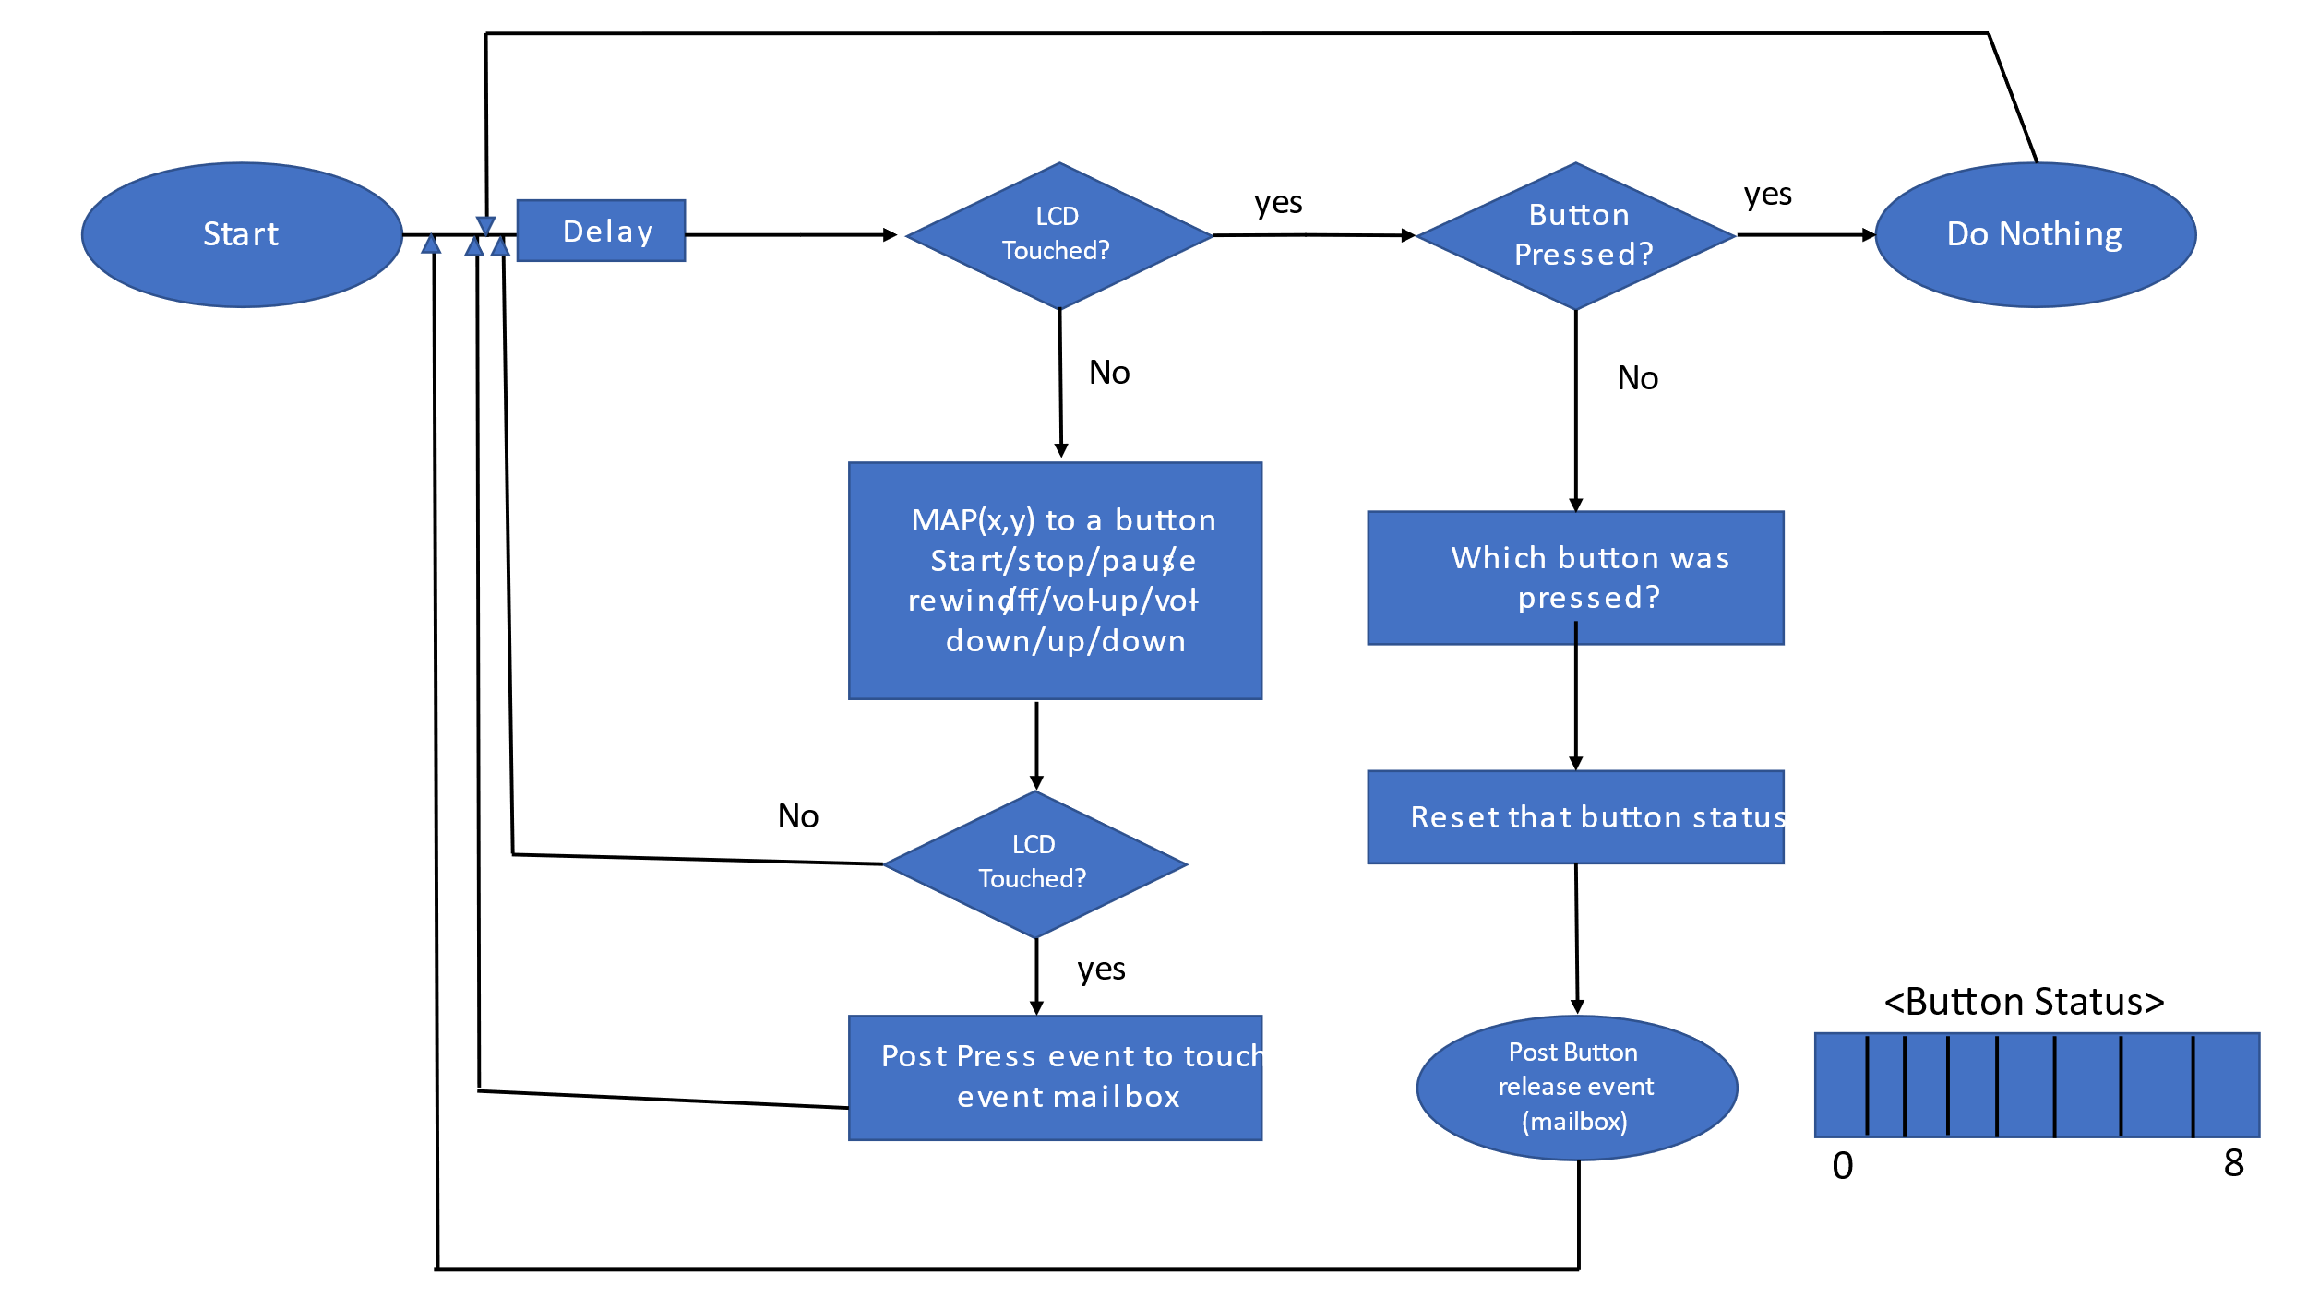

Note:

Setup LCD Touch Controller prior to intiation above Touch Event Generator function.Allows one event processing at a time. Prevents button press debouncing and facilitates a button press event to be followed by a corresponding button release event.

**MP3 Handler Task:**

Setup MP3 Decoder

Decrease Volume Level

Increase Volume Level

Vol+ Release Event

Vol- Release Event

Start Release Event

Pend on MP3 Event Mailbox

Note: Application supports 14 volume levels.

MP3 Stream Cycle:

Continue (Data Loop)[1]

Is Data Available?[1]

YES

Reset IsStopSong Flag

NO

Is StopSong?

YES

Increase/Decrease Volume Level. Reset IsVolUp/VolDown Flag

NO

Is VolUp/VolDown?

Move Data Pointer backwards by 10% and Enqueue Decrement Event to Display Queue

Is FastForward?

YES

YES

Move Data Pointer by 10% and Enqueue Increment Event to Display Queue

NO

NO

YES

Close Song File. Reset MP3 Decode

NO

Enqueue Stop Event to Display Queue and Reset IsStop Flag

Is Rewind?

YES

Enqueue Increment Event to Display Queue

Is 10% data processed?

Process a chunk of data for streaming

YES

Is Playing?

Initialize the control variables and open MP3 file to be read

Initialize MP3 Decoder with current volume Settings