Unit Testing with JUNit

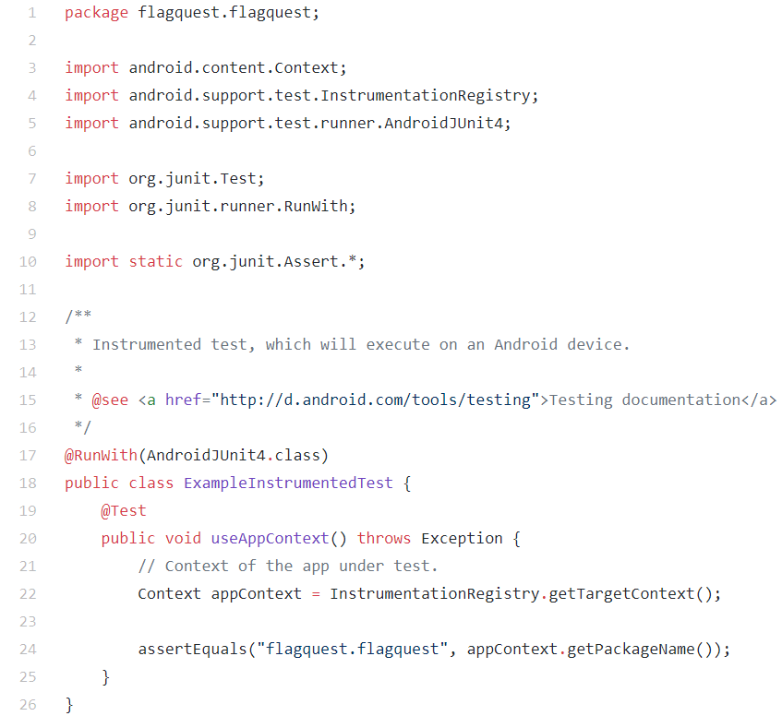

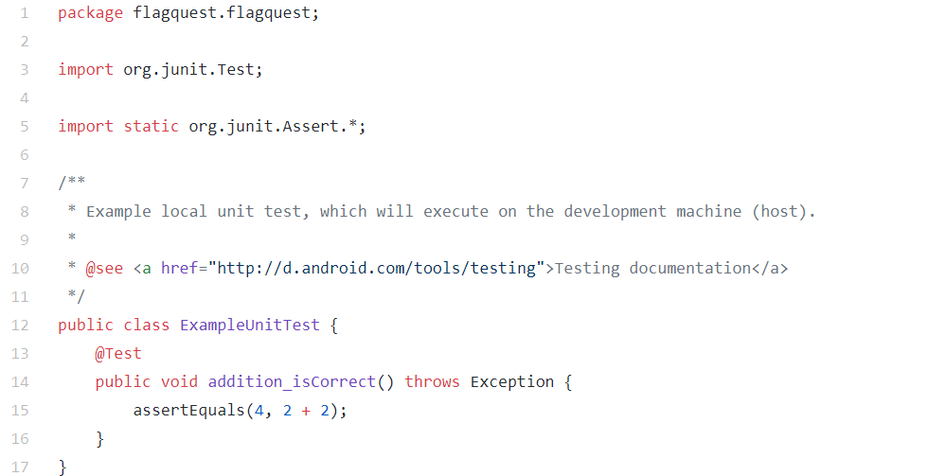

Use case: Flag Quest

Actor/s: Application User

Pre-conditions:

The application is downloaded and installed in the users phone

Normal Workflow:

1) The user will open the application

2) The user clicks on Play

3) The user selects difficulty

4) The user selects game mode

5) The user plays the game

6) The use case ends with a success

Alternate Workflow:

2a) The user clicks on high score

1) The application will display the high score

2b) The user clicks on settings

1) The user clicks on sound

2) The user clicks on turn on/off sound

3) The use case ends in a success

3a) The user clicks on “back”

1) The use case resumes at Step 2

4a) The user clicks “back”

1) The use case resumes at Step 3

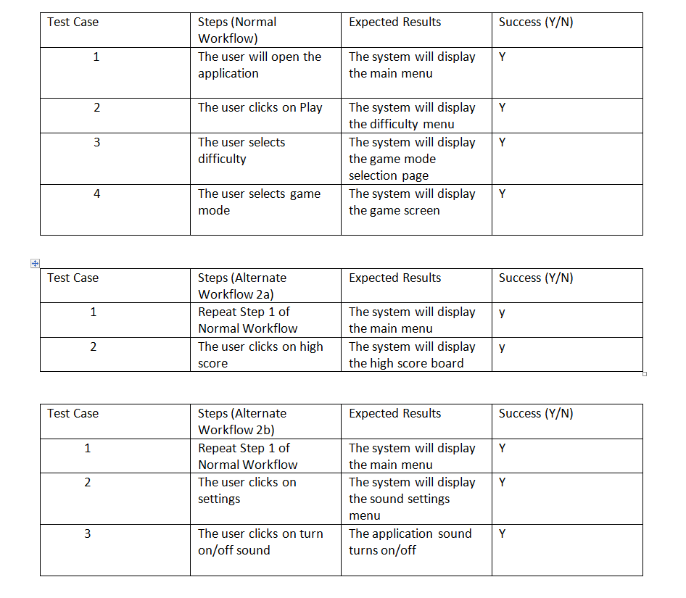

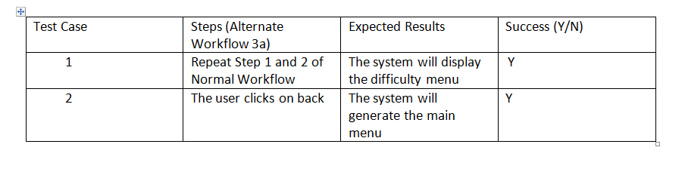

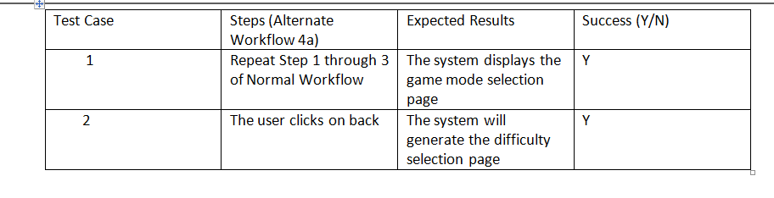

The above charts cover the following Test Situations

1) User wants to play time trial mode with easy settings

2) User wants to go back from difficulty selection menu

3) User wants to check high score

4) User wants to turn off the sound

5) User wants to go back from game mode selection menu

Test Coverage:

Base = 5

Test situations cover all 5 cases

100% coverage of use cases

