## 

The Leftovers

Flag Quest: Usability Study

04.14.2018

**─**

# 

# 

# Overview

Our Software Engineering Class has been divided into groups with the purpose of creating an app. We are making an app about matching Flags to their countries called Flag Quest. While making the app we need gather more information about what our customers may want to see in the final product. The purpose of this usability study is to improve our user-centered interaction design and come up with better solutions to those problems.

# Process

1. 4-6 people (clients) will participate and will sign permission forms giving their consent.
2. A group member will give a brief overview of the intention for creating the app and then will proceed to give them a phone with the app loaded up.
3. They will be asked to perform certain tasks within the app and we will study how easily they can navigate through the app.
4. Suggestions and notes will be recorded by group member.

# Permission Forms

The following are the copies of the form signed by the focus group participants:

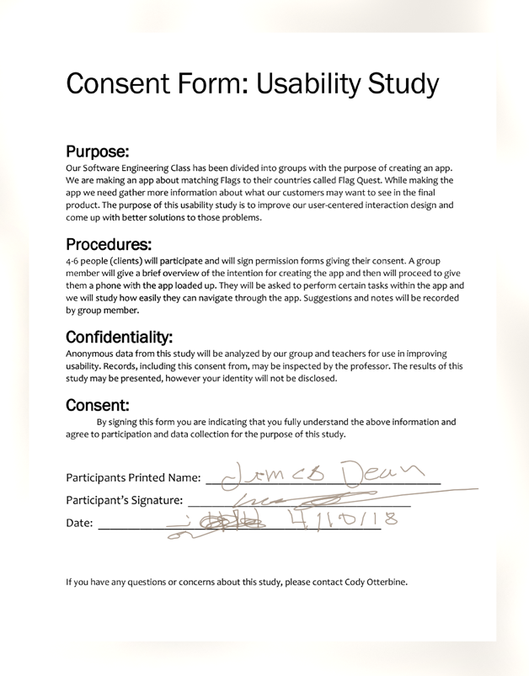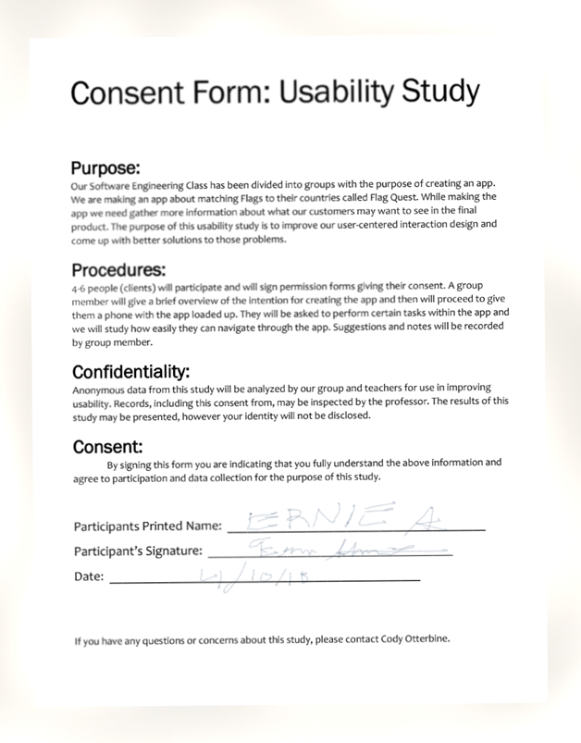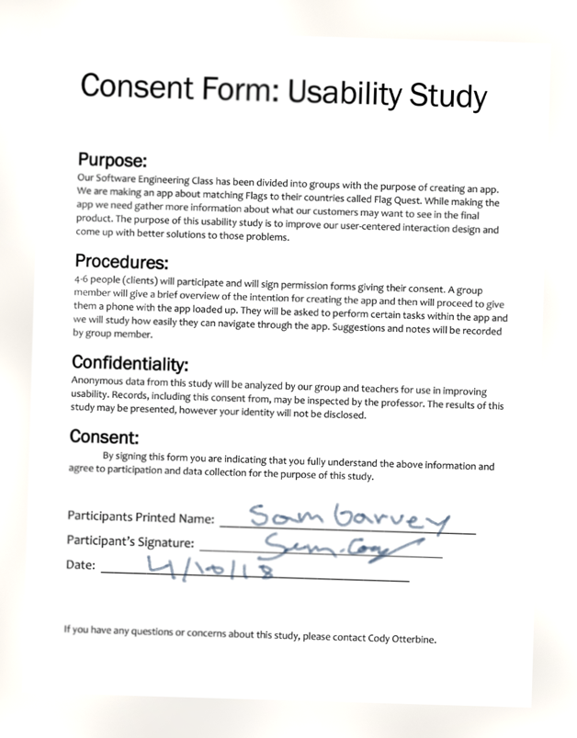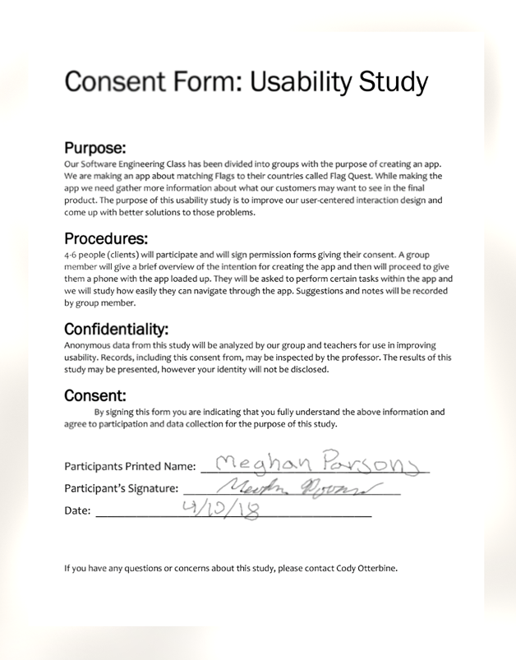

# Scripts

## Give general info about Flag Quest

Flag Quest is a game that tests your knowledge of international flags by gradually revealing more of the flag until you can successfully guess the correct country. Advance through levels of difficulty and go for the highest score possible. If you get stuck and need a hint, use your coins to help reveal the correct answer. Or, collect enough coins to unlock the next difficulty tier.

## Request participants to accomplish certain tasks:

* First, please attempt to start the game in the way that seems most intuitive.
* Attempt to view high scores after successfully playing a game.
* Exit out to the main menu and then try to re-enter into a game.
* Attempt to correctly guess a countries flag in the hang-man style gamemode.
* Open the settings an attempt to reduce the volume.
* Play through 4 successive levels of the standard gamemode.
* Complete a level section to completion.
* Can you find yourself on the scoreboard after playing.

## Questions to ask while tasks are being completed:

* Do you feel that the input method for the country guessing portion is intuitive?
* What part of the design confuses you the most?
* Can you understand the rules of the game after a short glance at the game screen?
* Does anything seem unintuitive?
* Are you able to easily move through the menus?
* Is the transition between game scenes jarring?

# Artifacts

## Main Menu

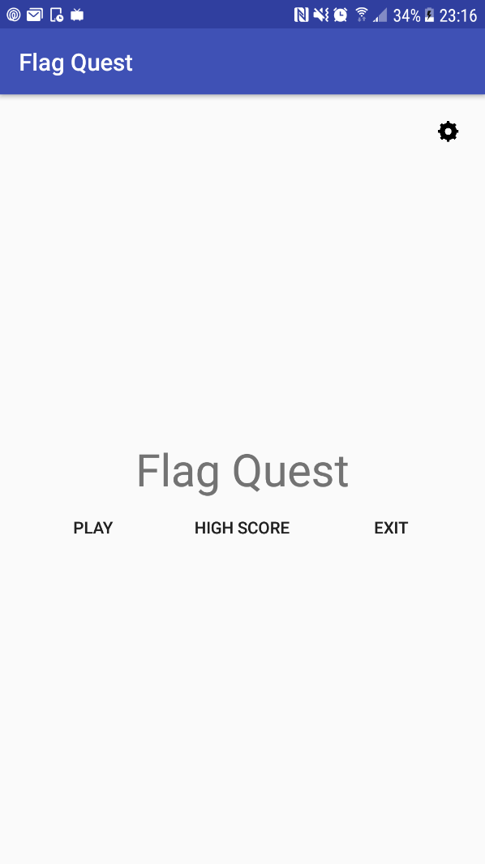

## Flag Quest Main Game

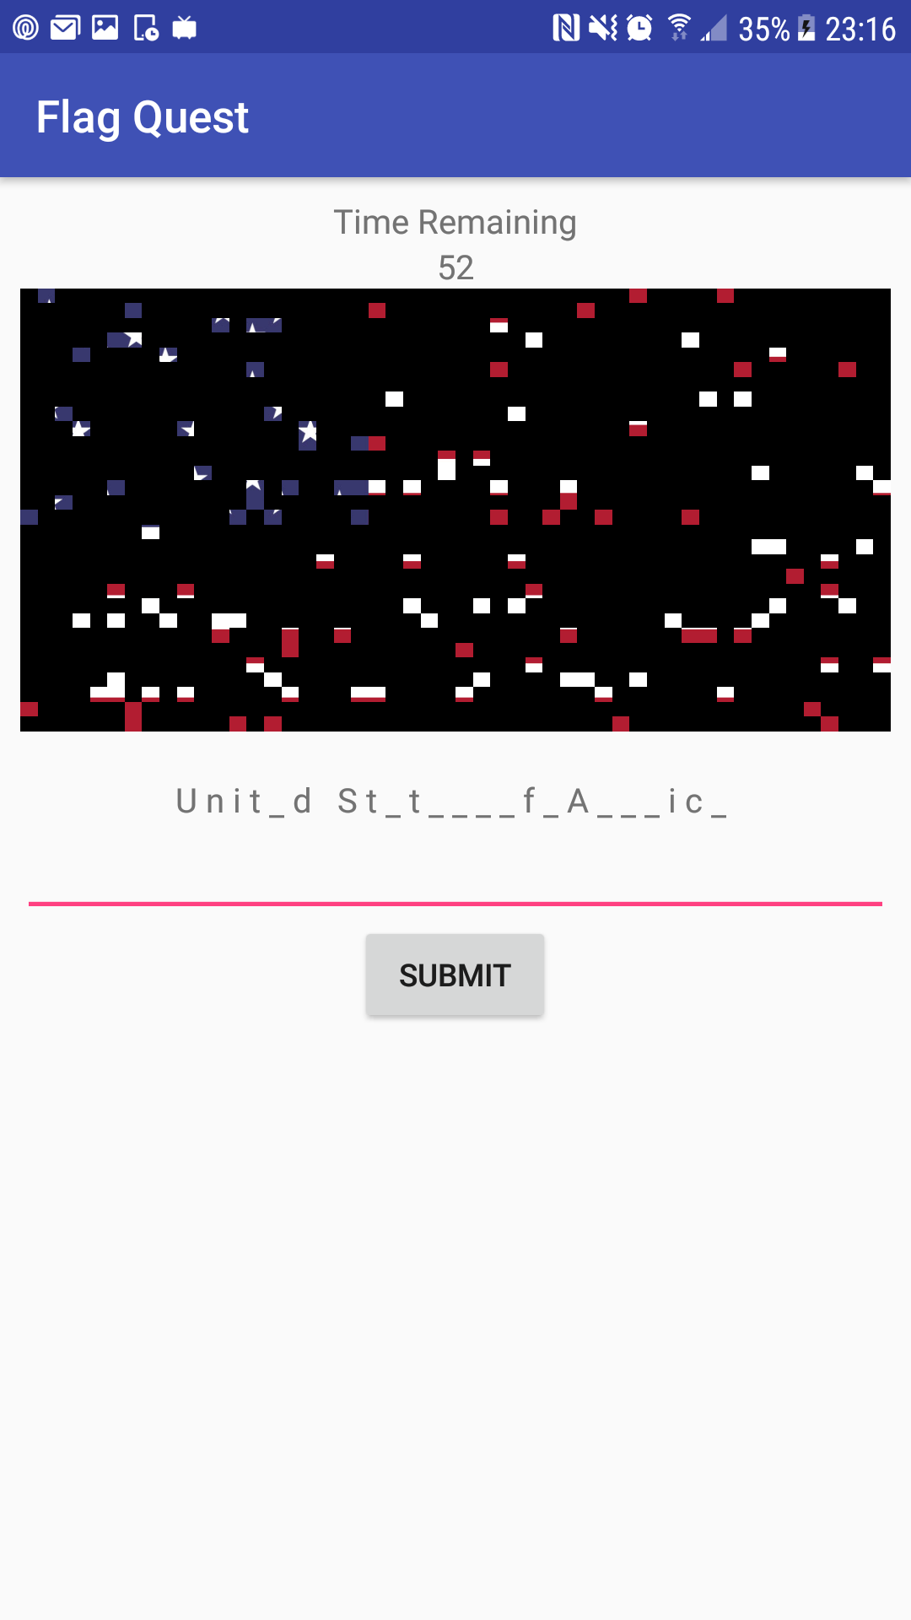

## Flag Quest High Score List

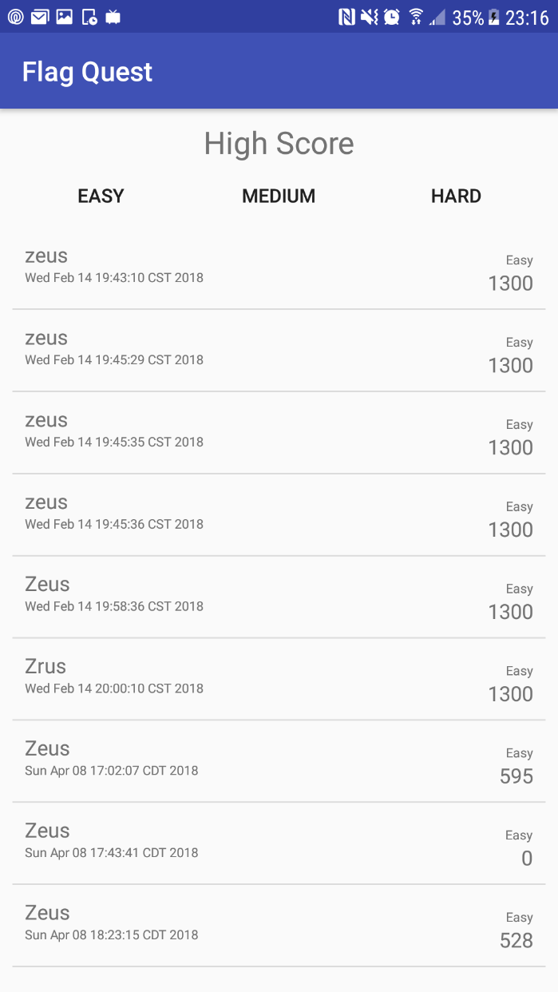

# Results

The results of this presentation came in form of suggestions given by the participants. The suggestions were received and recorded by each of the following anonymous participants:

## **Participant #1**

Male

Age 22

**Suggestions**

* User was unable to quickly understand the rules of the game from studying the UI, team member had to assist. (Make UI contain all rules info).
* Flag reveal mechanic could have a better transition because at the very beginning it is almost impossible to understand flag.
* User believed that the main menus made sense and was easy to navigate.
* User did not understand that he had a limited number of attempts at hangman style input (make errors apart of the game scene UI).
* User felt like the keyboard input was intuitive since the keyboard is already pre-displayed and does not need to be lifted up.
* User believed options menu should include more options.

## **Participant #2**

Female

Age 22

**Suggestions**

* Didn’t like how there were too many colors used on the main menu, distracting for the eyes
* Preferred more sans-serif fonts for the typefaces used on the menus
* Believed that the black squares method for flag revealing is unintuitive because there is no indicator that it is going to continue happening. Suggested a curtain opening up.
* Felt like randomization for the letter guessing leaves some answers too confusing and others too easy.
* User was disappointed in the lack of fan-fare after having successfully guessing a flag

## **Participant #3**

Male

Age 20

**Suggestions**

* Wanted the main menu to be easier to read, suggested better color choices
* Menu is horizontal even when the screen is vertical, goes off edges of screen.
* Add options for people with color blindedness.
* Was confused by hangman style input at first but after one game was able to easily understand the concept (improve first time players experience).
* Believed that the keyboard already being out was a big part of being able to understand the game’s input method.
* Was able to easily navigate the highscores list and find his name.

## **Participant #4**

Male

Age 19

**Suggestions**

* Was able to quickly and easily start a game but found it difficult understand the rules until after playing several rounds (improve first-time experience).
* Believed the main menu was intuitive and easily navigable but suggested visual improvements to ease navigation.
* Was able to easily understand the flag reveal mechanic but had a tough time gauging the time remain to guess.
* Was confused by how score was being calculated.
* Was able to easily play the game scene through several different flags after getting the hang of the game.
* Was easily able to navigate through the high scores and was satisfied by the range of different data shown.