.Date:22.10.25
TASK:11

Implementation of ROBOT TRAVERSAL
CO1, CO2, CO3 S3

PROBLEM STATEMENT

Design and implement an intelligent robot traversal system using the A* search algorithm to find the shortest path from a given start position to a target position in a grid-based environment containing obstacles.

AIM :
To implement an A* (A-star) search algorithm for robot traversal in a 2D grid environment, allowing the robot to find the shortest path from a start node to a goal node while avoiding obstacles.

OBJECTIVE :
- To develop an efficient pathfinding technique for robot traversal using the A* search algorithm.
- To enable the robot to identify the shortest and safest route from the start to the goal position.
- To handle obstacles intelligently while navigating through a grid-based environment.
- To demonstrate the effectiveness of heuristic-based search in artificial intelligence applications.

DESCRIPTION :
This project implements an A* search algorithm for robot traversal in a 2D grid environment. The robot starts from an initial point and finds the shortest path to the destination while avoiding obstacles. The algorithm uses both actual path cost and heuristic estimates to optimize the search process. This approach demonstrates the use of AI techniques in autonomous navigation and path optimization.

ALGORITHM :
- Start by comparing each pair of adjacent elements in the list.
- If the first element is greater than the second, swap them.
- Continue this process for all adjacent pairs in the list.
- Repeat the entire process for all elements until no swaps are needed.
- The list is now sorted in ascending order.

PROGRAM :
import heapq

# A* Search Algorithm for Robot Traversal

def heuristic(a, b):
# Manhattan distance
return abs(a[0] - b[0]) + abs(a[1] - b[1])

def astar_search(grid, start, goal):
rows, cols = len(grid), len(grid[0])
open_list = []
heapq.heappush(open_list, (0, start))
came_from = {}
g_score = {start: 0}

while open_list:
_, current = heapq.heappop(open_list)

if current == goal:
# reconstruct path
path = []
while current in came_from:
path.append(current)
current = came_from[current]
path.append(start)
path.reverse()
return path

for dx, dy in [(1,0), (-1,0), (0,1), (0,-1)]:
neighbor = (current[0] + dx, current[1] + dy)
if 0 <= neighbor[0] < rows and 0 <= neighbor[1] < cols and grid[neighbor[0]][neighbor[1]] == 0:
tentative_g = g_score[current] + 1
if tentative_g < g_score.get(neighbor, float('inf')):
came_from[neighbor] = current
g_score[neighbor] = tentative_g
f_score = tentative_g + heuristic(neighbor, goal)
heapq.heappush(open_list, (f_score, neighbor))
return None

# Example grid: 0 = free, 1 = obstacle
grid = [
[0, 1, 0, 0, 0],
[0, 1, 0, 1, 0],
[0, 0, 0, 1, 0],
[1, 1, 0, 0, 0],
]

start = (0, 0)
goal = (3, 4)
path = astar_search(grid, start, goal)

print("Shortest Path:", path)

OUTPUT:
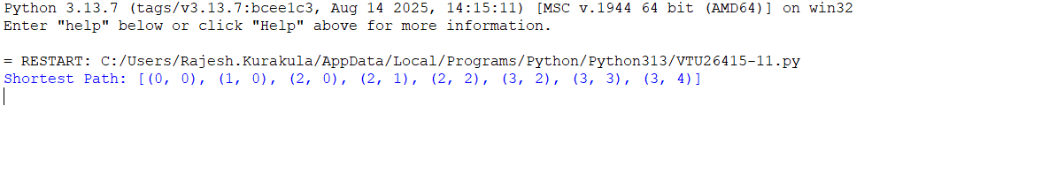

RESULT:
The Bubble Sort algorithm successfully arranges the given list in ascending order after multiple comparison and swap passes.

