Arjun Saini
Parallel Programing
600.320
20 February 2013
Homework Assignment #1
1.
a. Runtime averages for the 3x3, 5x5, 7x7 kernel sizes

b. The performance difference between the two functions comes from the

2.
a. Speedup plots for the first three parallelized methods from 1 to 32 threads.
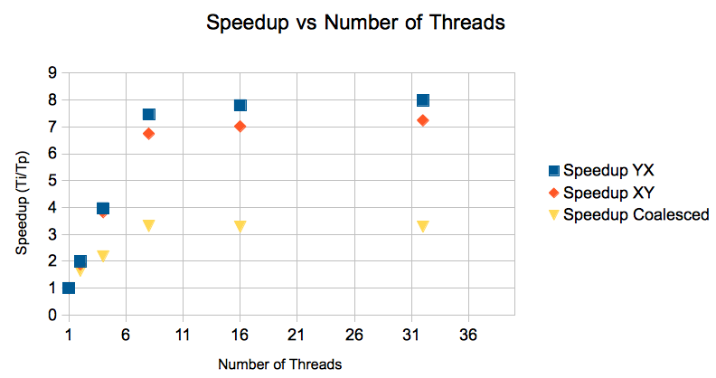
b. The speed up increased linearly till about 8 threads then it came to a plateau. The speed up could have tailed off for a few reasons. These programs were run on an 8 core EC2 Ubuntu instance using amazon's web services, so there is a cap of computing power due to the limited number of cores. Each core can only handle so much processing at a time and some of the parallel threads that we create in our code must wait till other threads have finished their computations before the next thread can begin.

c.

