CSD 304: Computer Networks
Lab Assignment : 04

Group:11
Team Members
1. Jagmeet Singh Oberoi 1410110166
2. Girik Malik 1310110140
3. Alapati Sai Varun 1410110037
4. Hithesh Sekhar 1310110097

Introduction :

This lab Assignment is based on IP multicast and multimedia traffic, especially, video traffic. Here video traffic is projected to be the main driver of mobile data traffic growth. We developed an Internet TV/Radio application that uses multicast. In this lab we use all the previous lab concepts such as (a) sending data over a TCP connection (b) sending multimedia data over UDP, and (c) sending data in structured manner so that applications implemented differently running on different platforms remain inter-operable.

We use Any Source Multicast (ASM) model. In this model, multicast messages are identified by the multicast group address alone, and more than one sender can exist in a group. Since in the ASM model, any message sent to a multicast address is received by all nodes that have joined the group,, so we use disjoint addresses to avoid getting streams mixed-up. Therefore, we are using the assigned multicast address. Further we assumed that the scope of multicast is limited to a LAN. The emphasis of Part-I is on socket programming, multicast and interoperability. Part-II is concerned with user interface and multimedia content management.

Extending into a variable project:
Multicast DNS (mDNS) provides the ability to perform DNS-like
operations on the local link in the absence of any conventional unicast DNS server. Extended mDNS (xmDNS) extends the specification of mDNS to site-local scope in order to support multi-hop LANs that forward multicast packets but do not provide a unicast DNS service. To extend to a variable product, just host it on a powerful server, capable of catering to a wider range of audience and support the traffic.

Implementation :
Based on the current bit rate which is 1382 bps we chose the following
1. BUFSIZE = 16384
2. time.sleep = 0.1 sec
3, Quesize in setsockopt is 10000000000.

Code :

#!/usr/bin/env python
#
# Send/receive UDP multicast packets.
# Requires that your OS kernel supports IP multicast.
#
# Usage:
# mcast -s (sender, IPv4)
# mcast -s -6 (sender, IPv6)
# mcast (receivers, IPv4)
# mcast -6 (receivers, IPv6)
# Updated:
# mcast [-s] multicast_addr path_to_video #sender
# mcast -r multicast_addr #receiver

import time
import struct
import socket
import sys

MYPORT = 8123
#MYGROUP_4 = '224.0.3.1' #'127.0.0.1' #
MYGROUP_4=sys.argv[2]
MYGROUP_6 = 'ff15:7079:7468:6f6e:6465:6d6f:6d63:6173'
MYTTL = 1 # Increase to reach other networks
BUFSIZE = 8192*2

#ff='toy.mp4'
try:
ff=sys.argv[3]
except IndexError:
rec=1

def main():
group = MYGROUP_6 if "-6" in sys.argv[1:] else MYGROUP_4

if "-s" in sys.argv[1:]:
sender(group)
else:
receiver(group)

def sender(group):
addrinfo = socket.getaddrinfo(group, None)[0]

s = socket.socket(addrinfo[0], socket.SOCK_DGRAM)

#'''
# Set Time-to-live (optional)
ttl_bin = struct.pack('@i', MYTTL)
if addrinfo[0] == socket.AF_INET: # IPv4
s.setsockopt(socket.IPPROTO_IP, socket.IP_MULTICAST_TTL, ttl_bin)
#s.setsockopt(socket.IPPROTO_IP, socket.IP_MULTICAST_TTL, 1000000)

else:
s.setsockopt(socket.IPPROTO_IPV6, socket.IPV6_MULTICAST_HOPS, ttl_bin)
#s.setsockopt(socket.IPPROTO_IPV6, socket.IPV6_MULTICAST_HOPS, 1000000)

#'''

with open(ff,'rb') as in_file:
while True:
#data = 'gm' #+ repr(time.time())
data=in_file.read(BUFSIZE)
s.sendto(data + '\0', (addrinfo[4][0], MYPORT))
if data=="":
break #EOF
#s.sendto(data)
time.sleep(0.1) #runs with 0.09 as well

def receiver(group):
# Look up multicast group address in name server and find out IP version
addrinfo = socket.getaddrinfo(group, None)[0]

# Create a socket
s = socket.socket(addrinfo[0], socket.SOCK_DGRAM)

# Allow multiple copies of this program on one machine
# (not strictly needed)
s.setsockopt(socket.SOL_SOCKET, socket.SO_REUSEADDR, 100000000)

# Bind it to the port
s.bind(('', MYPORT))

group_bin = socket.inet_pton(addrinfo[0], addrinfo[4][0])
# Join group
if addrinfo[0] == socket.AF_INET: # IPv4
mreq = group_bin + struct.pack('=I', socket.INADDR_ANY)
s.setsockopt(socket.IPPROTO_IP, socket.IP_ADD_MEMBERSHIP, mreq)
#s.setsockopt(socket.IPPROTO_IP, socket.IP_ADD_MEMBERSHIP, 1000000)
else:
mreq = group_bin + struct.pack('@I', 0)
s.setsockopt(socket.IPPROTO_IPV6, socket.IPV6_JOIN_GROUP, mreq)
#s.setsockopt(socket.IPPROTO_IPV6, socket.IPV6_JOIN_GROUP, 1000000)

fl=open('out.mp4','w')
# Loop, printing any data we receive
while True:
data, sender = s.recvfrom(BUFSIZE)
while data[-1:] == '\0': data = data[:-1] # Strip trailing \0's
#print (str(sender) + ' ' + repr(data))
#print (str(repr(data)))
fl.write(data)
print data
fl.close()

if __name__ == '__main__':
main()

Screenshots :
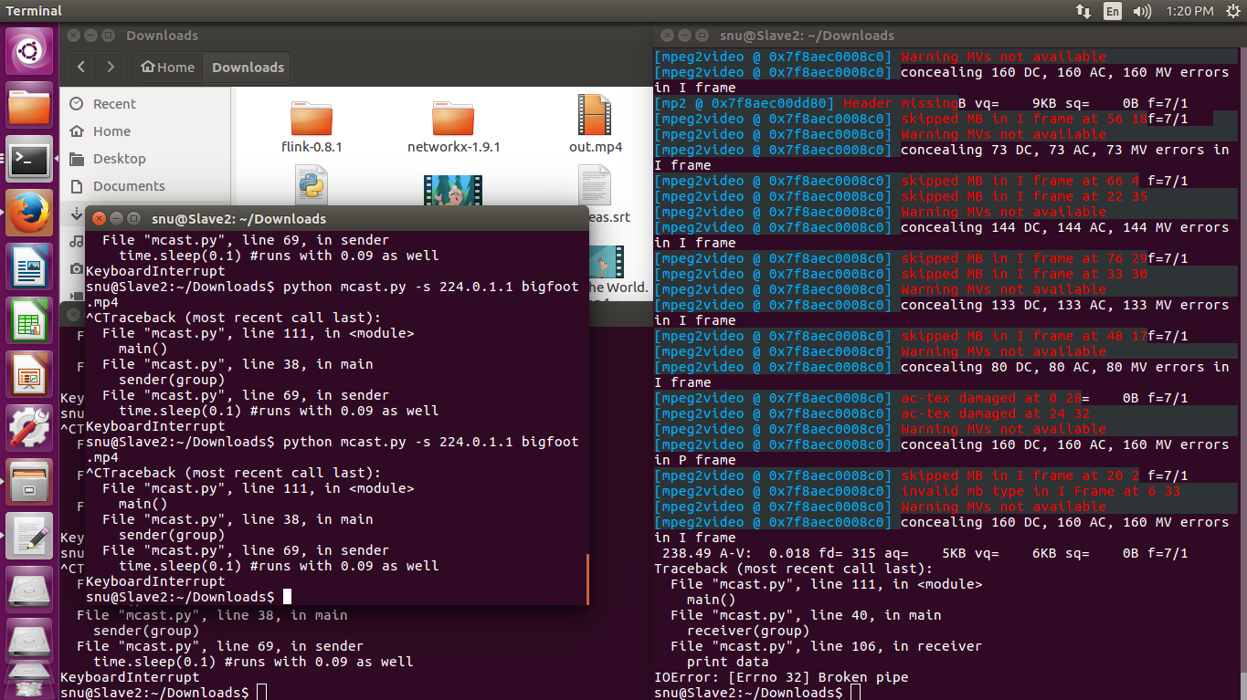

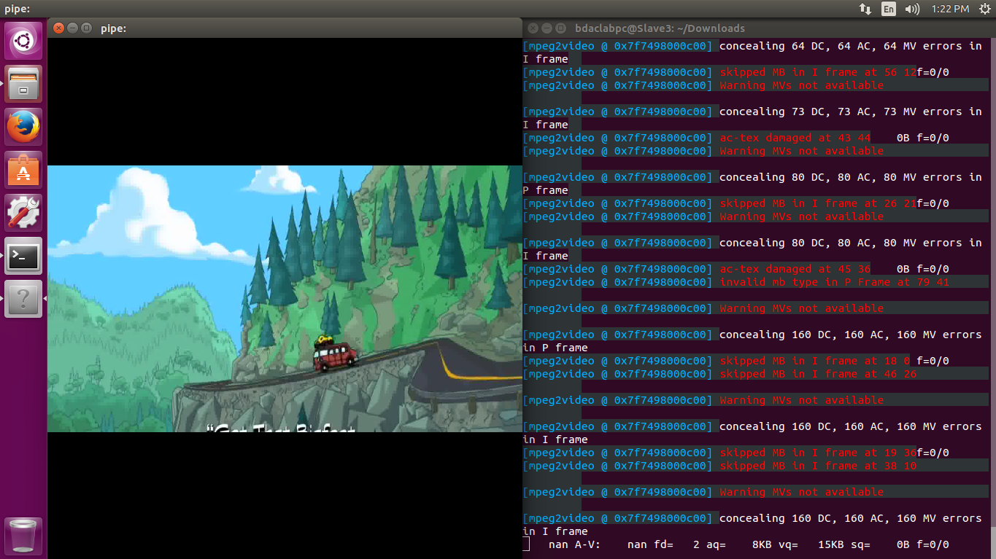

Team Number:
S.No. | Team Member Name | Contribution Detail
1. | Jagmeet Singh Oberoi 1410110166
2. | Girik Malik 1310110140
3. | Alapati Sai Varun 1410110037
4 | Hithesh Sekhar 1310110097

