**CSC272 Advanced Programming in Java**

**Assignment 3**

|  |  |
| --- | --- |
| **First Name** |  |
| **Last Name** |  |
| **ID#** |  |
| **Assignment Week#** |  |
| **Email Address** |  |

Contents

How to submit your Assignment 1

Problem 1 – *Generic Selection Sort Method* 2

Problem 2 – *Generic Class Pair* 2

Problem 3 – *Poly Line App* 2

# How to submit your Assignment

After filling all the parts in this file, please follow the following steps.

1. Add your name and ID to the first page.
2. Save the file in the original format (Docx or Doc)

(Please **do not** convert to other file formats e.g. PDF, ZIP, RAR, …).

1. Rename the file as

*YOUR* ***First*** *Name - YOUR* ***Last*** *Name- YOUR student ID-* CSC272*.docx*

**Example:**

John – Smith - 234566435 – CSC272.docx

1. Upload the file and submit it (only using Blackboard)

Please do not hesitate to contact me, should you have any questions.

# Problem 1 – *Generic Selection Sort Method*

Write a generic method selectionSort based on the sort program of Fig.19.4 . Write a test program that inputs, sorts and outputs an Integer array and a Float array..

|  |
| --- |
| Your code for this problem |
|  |

Run the code and insert the result in the following box.

|  |
| --- |
| Sample Run Result |
|  |

# Problem 2 – *Generic Class Pair*

Write a generic class Pair which has two type parameters—F and S—each representing the type of the first and second element of the pair, respectively. Add get and set methods for the first and second elements of the pair.

|  |
| --- |
| Your code for this problem |
|  |

Run the code and insert the result in the following box.

|  |
| --- |
| Sample Run Result |
|  |

# Problem 3 – *Poly Line App*

Create an app in which, as the user moves the mouse cursor around the window, a Circle and Polyline follow the cursor. The app should appear as shown in the following figure. There should always be a Circle centered at the current mouse-cursor location, and that location should also be the first point in the Polyline. As you respond to each mouse-move event, use the mouse cursor’s location as the Circle’s new center and insert that location at the *beginning* of the Polyline’s points collection. The Polyline’s length should not increase forever—once the Polyline reaches 50 points, remove the last point each time you insert a new first point.

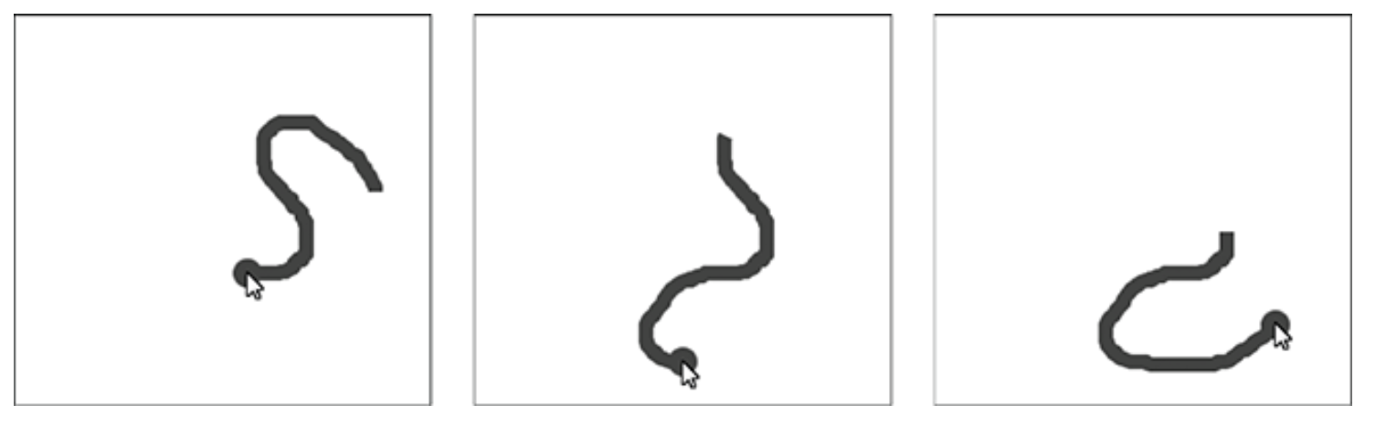

Circle and Polyline follow the mouse cursor inside the window.

|  |
| --- |
| Your code for this problem |
|  |

Run the code and insert the result in the following box.

|  |
| --- |
| Sample Run Result |
|  |

**The end**