AI WEATHERWISE
Phase 5. Project Development

Team Details
Team Head
Name | Email ID
Praveen Kumar S | PraveenSaravanan 006@gmail.com
Team Members
Name | Email ID
rithik Ragul H D | Ragulrithik18@gmail.com
Saicharan B | Sai15643@gmail.com
Sakthi A | Asakthi063@gmail.com

5. Project Development

Complete Source Code
The source describes the main implementation structure: index.js as entry point; routing, controllers, middleware, models and utility modules; REST APIs; MongoDB connection; authentication; weather and AI integrations. C:\Users\janani j\OneDrive\Desktop\janani\NM\Backend-20260924T142250Z-1-001.zip

Database Files
The source documents MongoDB/Mongoose configuration, User and Location schemas, and database connection.

Configuration Files
The project creates index.js, .env, package.json and .gitignore. Environment variables include PORT=5000, MONGO_URI, JWT_SECRET and GEMINI_API_KEY.

Screenshots
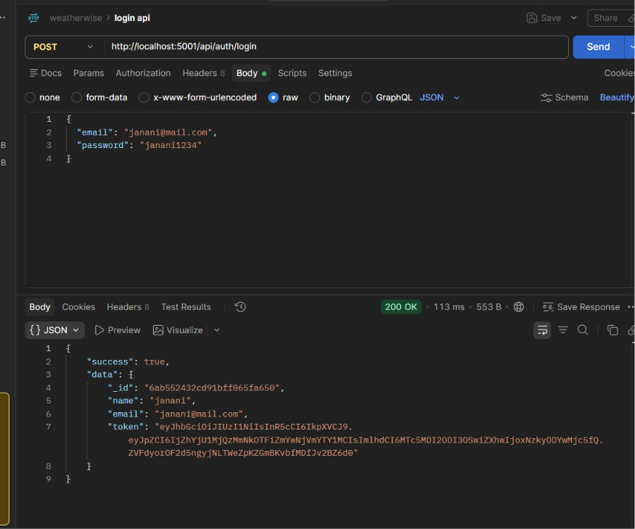
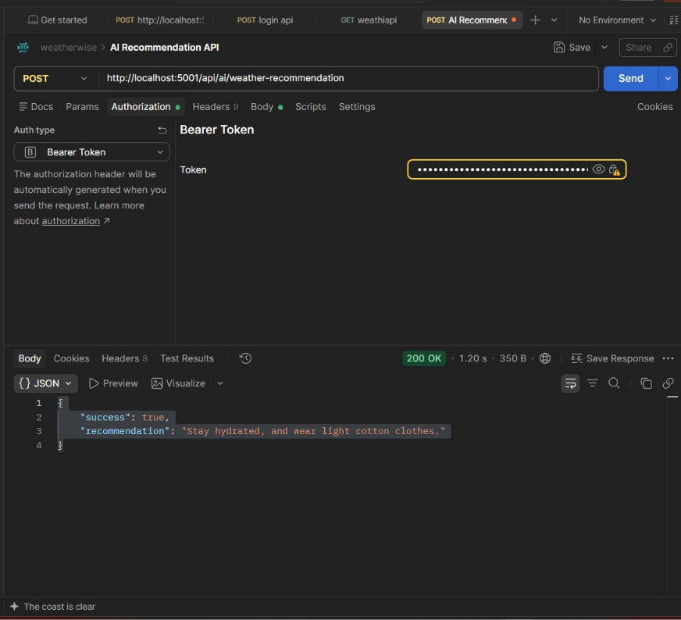

Project Files Link
C:\Users\janani j\OneDrive\Desktop\janani\NM\Backend

