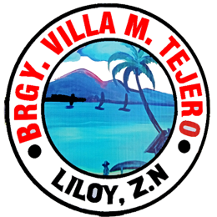
Republic of the Philippines
PROVINCE OF ZAMBOANGA DEL NORTE
Municipality of Liloy
BARANGAY VILLA M. TEJERO

OFFICE OF THE PUNONG BARANGAY

BARANGAY CLEARANCE

TO WHOM IT MAY CONCERN:

THIS IS TO CERTIFY THAT the person whose signature and thumb mark appears below has requested record Clearance from this office with the following findings;

NAME: [NAME]
SEX: [SEX]
DATE OF BIRTH: [BIRTHDATE]
AGE: [AGE]
CIVIL STATUS: [CIVILSTATUS]
ADDRESS: [ADDRESS]
BIRTHPLACE: [BIRTHPLACE]
FINDINGS: NO DEROGATORY RECORDS AS OF THIS DATE

PURPOSE: [PURPOSE]

RES. CERT. NO. [CONTROLNO]
Paid Under O.R. NO.: [ORNO]
ISSUED AT: VILLA M. TEJERO, LILOY, ZDN THUMBPRINT

__________________________
SIGNATURE

THAT [HE/SHE] HAS NOT been a subject of any complaint involving moral turpitude nor has been charged of any crime whatsoever in so far as the records of this office is concerned.

This Clearance is issued upon the request of the above-mentioned person.

ISSUED This [DATE] at the Office of the Punong Barangay, Villa M. Tejero, Liloy, Zamboanga del Norte, Philippines.

BARANGAY OFFICIALS

Councilors:

Hon. Robert C. Dionaldo Jr.

Hon. Eduardo F. Estrao

Hon. Jennifer S. Cubol

Hon. Diomedes F. Estrao

Hon. Vilma B. Sabac

Hon. Joy T. Sabac

Hon. Emilie C. Dumasapal

Hon. Bernardino S. Miranda
SK Chairman

Mr. Roger J. Bolando
Barangay Secretary

Mrs. Emmalyn J. Dulutallas
Barangay Treasurer

Certified By:
Not Valid without Seal
[CAPTAIN]
Punong Barangay

