Republic of the Philippines
PROVINCE OF ZAMBOANGA DEL NORTE
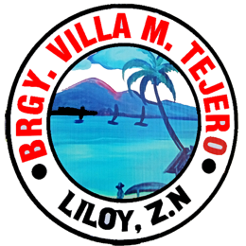
Municipality of Liloy
BARANGAY VILLA M. TEJERO

OFFICE OF THE PUNONG BARANGAY

BARANGAY CLEARANCE FOR BUSINESS

TO WHOM IT MAY CONCERN;

THIS IS TO CERTIFY that [NAME], a resident of Barangay Villa M. Tejero, Liloy, Zamboanga del Norte, is of good moral character and reputation, and according to the records of this Office, [HE/SHE] has not been indicted or convicted of any law, ordinance, or crime involving moral turpitude, and is cleared of all obligations in this Barangay; therefore [HE/SHE] may be issued the Business Clearance applied for, by this Office of Barangay Villa M. Tejero, Liloy, Zamboanga del Norte.

Issued this [DATE] at the office of the Punong Barangay, Barangay Villa M. Tejero, Liloy, Zamboanga del Norte, Philippines........

- [BUSINESSTYPE] [FEE]

BUSINESS TAX

- [BUSINESSTYPE] [BUSINESSTAX]

Certified By:

[CAPTAIN]
Punong Barangay

Signature: ____________________

CTC No. [CONTROLNO]
OR Number: [ORNO]
Issued On: [DATE]
Issued At: Villa M. Tejero, Liloy, ZN.

