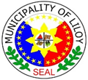
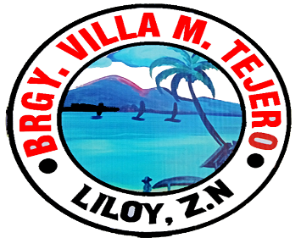
Republic of the Philippines
PROVINCE OF ZAMBOANGA DEL NORTE
Municipal of Liloy
BARANGAY VILLA M. TEJERO

OFFICE OF THE PUNONG BARANGAY
_________________________________________________________________

CERTIFICATE OF INDIGENCY

TO WHOM IT MAY CONCERN;

THIS IS TO CERTIFY that [NAME], [AGE] years old, [CIVILSTATUS], Filipino, and a bona fide resident of [ADDRESS], belongs to an indigent family based on their social and economic standing in the community.

Issued upon the request of the above-named person for [PURPOSE].

Given this [DATE] at the Office of the Punong Barangay of Villa M. Tejero, Liloy, Zamboanga del Norte, Philippines…….

Certified by:

[CAPTAIN]
Punong Barangay
NOT VALID WITHOUT SEAL

