
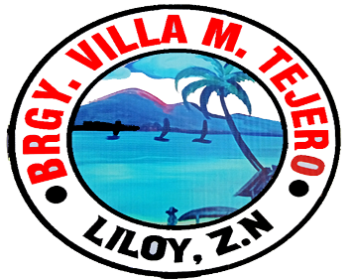
Republic of the Philipines
PROVINCE OF ZAMBOANGA DEL NORTE
Municipal of Liloy
BARANGAY VILLA M. TEJERO

OFFICE OF THE PUNONG BARANGAY
_____________________________________________________________________________

CERTIFICATE OF RESIDENCY

TO WHOM IT MAY CONCERN;

THIS IS TO CERTIFY that [NAME], [AGE] years old, [CIVILSTATUS], Filipino, and a bona fide resident of [ADDRESS].

THIS TO CERTIFY FURTHER that [NAME] is residing at [ADDRESS] and has established residency in this barangay.

This Certification is being issued upon the request of [NAME], for [PURPOSE] purposes that may serve [HIM/HER] best.

Given this [DATE] at the office of the Punong Barangay Villa M. Tejero, Liloy, Zamboanga del Norte, Philippines…….

Certified by:

[CAPTAIN]
Punong Barangay
__________________
Signature of Holder
Issued at VMT, LILOY, ZN

Not Valid Without Seal

