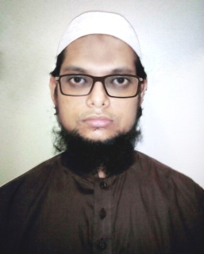

Fiercely comperative software engineer profetional I have more than 6 years of experience designing, developing. creative, analytical and enthusiastic; a productive team player with a deep passion for technology, I have a Bachelor Degree in Computer Engineering and a certified expert in oop and aws solution architechture.

**A. B. M. Abus Salam**

CONTACT

88 01673 60 55 24



asalam345@gmail.com

→





Badda, Dhaka, Bangladesh



asalam345.github.io

✶

| |

**EXPERIENCE**

asalam345

**Senior Software Engineer** **2020-present**

Hoxro Dev Center, Dhaka, Bangladesh

Legal Management System (angular10, asp.net core)

SKILLS

Web

asp.net mvc, aspl.net core, api, web service, bootstrap4, angular9, node.js

**Senior Software Engineer** **2018-2020**

HAL Technology Ltd., Dhaka, Bangladesh

Face Detector(open cv, fsdk)

Gateway (DPDC, DESCO, WASA Bill Pay)

ATM Machine software integration

Agent Banking Solution

MYCash Web Registration(EC Verification)

<http://103.121.78.28:106/> (e-commerce site)

Database

Ms sql server, Oracle, mysql, mongodb

Desktop

C#.net, electron

LANGUAGES

ENGLISH

◼◼◼◼◼

BANGLA

◼◼◼◼◼

**Senior Software Engineer** **2017-2018**

The Databiz Software Ltd., Dhaka, Bangladesh

ERP (Manufacturing) [Asp.net MVC]

ERP (Land Property) [Asp.net Web Form]

**Software Engineer** **2014-2017**

CloudeCoder, Dhaka, Bangladesh

bKash Solution [C#.net desktop base application], Modem based recharge(with USSD Code)

Auto poster in web forum & some desktop software Solution [C#.net desktop base application]

<http://developers.interboll.com> (Cross domain)

**EDUCATION**

**B.Sc. in CSE** **2009-2013**

Asian University of Bangladesh, Uttara, Dhaka

**Kamil** **2003-2008**